A Simplified GeoClaw Model of Landslide-Generated Waves in Lituya Bay: Development and Numerical Sensitivity
Vera M. Goldsmith
2026
In 1958, a magnitude 7.8 earthquake triggered a massive rockslide that crashed into Gilbert Inlet in Lituya Bay, Alaska [1]. The resulting wave destroyed forest on the opposite slope to an elevation of approximately 524 m above sea level. This often-cited elevation describes the upper extent of the documented forest trimline and is not the height of a wave traveling through the bay [2]. The 1958 Lituya Bay megatsunami is recognized as having the highest tsunami run-up recorded in modern history [1].
Recreating this unusual event provides a challenging setting for studying landslide-generated waves. The modeling challenges can be grouped into the following categories: topographic and bathymetric data limitations, computational demands, and numerical stability. The event significantly changed the bay’s shoreline and underwater terrain, and data from the 1926 bathymetric survey, now archived by NOAA, were too coarse on their own to reconstruct the bathymetry of the entire bay [3]. The physics of this event is highly complex and involves several interacting processes: rock fragments from the landslide entered the water and transferred energy to it, generating nonlinear waves that moved through the basin, reflected within it, ran onto land, and retreated [3, 4]. Historical reconstruction can require representing all these processes in sufficient detail, which could demand considerable computational power.
Additionally, high flow speeds add to this computational demand because the model must update water depth and momentum in each grid cell more frequently at a given grid spacing [5, 6]. A time step is the interval of simulated time between the model’s state updates. If the model’s time step is too large, a wave disturbance can travel over more grid cells than the calculation can account for in that step, making it difficult for the calculation to follow the movement correctly and potentially causing numerical instability [6]. Similarly, rapid changes in water depth can increase the possibility of numerical errors from one calculation step to another. For example, when waves are rushing onto the land, neighboring grid cells can have different water depths. One cell may contain a substantial depth of water, another a thin layer, and the next may be dry. In shallow-water equations, a model calculates how much water moves between grid cells and computes velocity by dividing the momentum variable by water depth [7]. When water depth is close to zero in a grid cell with shallow water, a small numerical error can produce an unrealistically large velocity for that cell [5].
To reduce the risk of numerical instability, GeoClaw applies a water-speed limit. The water-speed limit is a numerical stabilization feature that helps reduce the runtime error that crashes the simulation. The runtime error occurs when the simulation’s adaptive time-stepping algorithm fails to find a stable time step. Before each time step, the model checks the depth-averaged horizontal speed of the water in each wet grid cell. If the speed exceeds the selected limit, GeoClaw reduces the horizontal momentum in that cell while preserving the direction of flow and the water depth [5]. If the computed velocity magnitude $U=\sqrt{u^{2}+v^{2}}$ exceeds the user-defined threshold $U_{limit}$ , the momentum components (hu, hv) are scaled down by a factor of $U_{limit}$/$U$ [5]. Here, $h$ is water depth, $u$ and $v$ are the depth-averaged horizontal velocity components, $U$ is their resultant speed, and $U_{limit}$ is the selected water-speed limit. No scaling is applied when $U≤U_{limit}$.
This prevents the Courant number, a number relating how far a disturbance travels during one time step to the grid spacing, from spiking and also introduces an artificial dissipation of momentum. This adjustment can affect how much water moves into neighboring cells as the wave runs up the slope. If the speed limit is too conservative, it can prematurely blunt the kinetic energy of the leading edge, artificially underestimating the maximum onshore inundation and run-up limit. We therefore tested how sensitive the simulated run-up was to the choice of water-speed limit while keeping the prescribed landslide motion the same.
The numerical choice of how to mitigate these modeling challenges can affect the calculated run-up, even when a simulation remains stable and produces a plausible-looking wave. The captured maximum run-up can also depend on how the result is measured. For example, the reported maximum can vary depending on which locations and output times are examined and what water depth counts as wet [8, 9]. We therefore need to understand the influence of numerical choices before interpreting a simulated elevation as evidence of historical accuracy. This brings us to the central question of this study. How much confidence can we place in a pattern observed across numerical comparisons, even when the exact run-up value remains uncertain?
The focus is on how much the results change under different numerical settings. Additionally, we investigate whether the main patterns persist across numerical and measurement choices, evaluating the robustness of our findings. We apply numerical acceptance and consistency checks and examine sensitivity to selected numerical settings. Historical evidence provides context, while validation against the 1958 event remains future work.
This study was inspired by the work of Franco et al. (2020) [3]. They reconstructed the pre-event terrain and bathymetry and investigated the event using the three-dimensional computational fluid dynamics software FLOW-3D. They chose to represent the landslide as a fluid denser than seawater, allowing the mass to change shape and interact with the water. Franco et al. examined the effects of the computational domain and grid resolution on the resulting waves and run-up [3]. We adapted their published reconstruction [10] to provide the pre-event terrain, bathymetry, and landslide geometry for our simplified model.
For this study, we chose GeoClaw instead of FLOW-3D to provide a simpler, open-source framework for repeated numerical experiments [11]. It simplifies the representation of three-dimensional water flow by using two-dimensional, depth-averaged shallow-water equations [7, 11]. A three-dimensional grid-based model divides the water into cells stacked both vertically and horizontally, each with its own calculated flow values. A depth-averaged model uses a horizontal grid without a vertical stack of cells and therefore requires fewer values to be stored and updated at every time step when the horizontal resolution is comparable.
However, we acknowledge that the shallow-water simplification limits the model’s ability to represent all underlying physics. For example, this model cannot represent the landslide entering the water in detail, since the impact would likely cause splashing, vertical water movement, and overturning waves [3, 11].
Model Development and Setup
This study adopted the reconstructed pre-event basin, bathymetry, and landslide geometry from Franco et al. [3, 10] to build a baseline model in GeoClaw. Franco et al. provided their reconstructed terrain and bathymetry as surfaces made up of triangles [10]. To use these surfaces in GeoClaw, we needed to represent their elevations on a horizontal grid [12]. We placed a horizontal grid over the reconstruction, with points spaced 15 m apart in both directions. At each grid point, we calculated where a vertical line intersected the reconstructed surface. Where several natural terrain surfaces overlapped, we used the highest intersection [8]. This gave us one elevation at each sampled location, representing the bay floor or the land surface. Differences in elevation between neighboring points showed the slopes of the terrain.
For the baseline simulation, the solver used a fixed horizontal grid of 227 by 453 cells, with a resolution of approximately 30 m [8]. Although GeoClaw supports adaptive mesh refinement [11], we used uniform spatial grids, which allowed us to change grid resolution explicitly in later experiments.
Instead of modeling the landslide as individual rock fragments or as a dense fluid, we selected a prescribed moving-bed disturbance as the simplest representation that could support the study’s numerical comparisons. The GeoClaw documentation notes that prescribed moving topography can generate tsunami waves and can be applied to landslide-generated events [13]. Additionally, it explains when a coupled landslide–water model is needed and refers to D-Claw for this type of modeling [13]. However, using only a moving-bed source was a deliberate simplification because it was useful for the sensitivity study.
The projected slide-thickness distribution was moved approximately 1,400 m across the reconstructed terrain over 30 seconds in a smooth motion from rest to rest. The prescribed motion followed the reconstructed cross-inlet direction, toward decreasing local Y [8]. The travel distance and duration were assumed values and did not represent the exact historical landslide trajectory. The modeled slide had a geometric volume of approximately 51 million m³ [8]. The landslide motion was kept fixed across all experiments.
Before starting our experiments, we checked that the water remained at rest by using a still-water control [8]. GeoClaw calculated the water response to the prescribed moving-bed disturbance by solving the depth-averaged shallow-water equations as the prescribed landslide disturbance moved through the model. We used a Manning friction coefficient of 0.025 to account for friction of the underlying ground surface because GeoClaw documentation stated that this coefficient is often used for generic tsunami modeling [5]. Each moving-landslide simulation covered 420 s of simulated time [8].
GeoClaw uses a Fortran solver with run configurations set up in Python [8, 11]. As such, we used Python scripts to build the model inputs, verify the simulations, and post-process the results. We used AI tools to help write and debug scripts, develop tests, analyze model output, and draft and revise portions of the project documentation in the repository. However, the author edited the code manually, investigated errors during local runs, and manually tested the changes. The author also identified the numerical comparisons, selected and performed the checks for each run, and reviewed the diagnostics to decide which results to include and how to interpret them. For the manuscript, we used AI assistance to edit the author’s text for grammar and clarity, and to format references.
In our first experiment, the 50 m/s run with the prescribed landslide served as the baseline simulation. Keeping the landslide motion, geometry, grid, friction, and other physical settings the same, we compared the water-speed limits [8].
GeoClaw uses the Courant – Friedrichs – Lewy (CFL) condition, which relates time-step size to grid spacing and wave speed, to guide its choice of time step [6]. We reviewed the recorded CFL values to identify potential stability problems and to determine which simulation runs were suitable for comparison.
Experiments and Numerical Checks
Our first numerical experiment investigated what impact GeoClaw’s water-speed limit had on the simulated run-up. We used GeoClaw’s default water-speed limit of 50 m/s as the baseline and tested two higher limits of 100 and 200 m/s. Each successive value doubled the preceding limit, allowing us to examine how the simulated run-up responded to progressively less restrictive speed limits.
We compared limits of 50, 100, and 200 m/s while keeping the same basin and landslide configuration. These numerical limits only affected the simulated water, while the landslide setup remained unchanged. Each simulation had a total run time of 420 s, with the prescribed landslide motion occurring during the first 30 s [8].
We measured run-up as the highest sampled natural-land elevation reached by at least 0.1 m of water within our monitored area. We chose to use 0.1 m (10 cm) as a reporting cutoff for identifying wetted land because it is a convenient round-number threshold. Our postprocessing excluded cells with maximum water depths below 10 cm from the run-up measurement. This was used as a consistent criterion across all simulations.
Elevations were measured relative to model sea level. We excluded the moving landslide region and artificial cells from the run-up measurement. Artificial cells in this context refer to added features, such as virtual walls, that do not represent the bay’s natural terrain [8].
The first run gave a monitored run-up of 339.72 m at a water-speed limit of 50 m/s. The second run reached 469.85 m at a water-speed limit of 100 m/s, as shown in Table 1 and Figure 1. Raising the limit increased the run-up by 130.12 m, or approximately 38.3%. Although the original 200 m/s run reached 420 s, it did not pass the recorded CFL/time-step checks and was excluded from the comparison (Table 1) [8].
Water-speed cap (m/s) | Expanded-monitor run-up (m) | Recorded outcome
50 | 339.72425 | Passed basic checks
100 | 469.84918 | Passed basic checks
200 | Unavailable | Failed CFL/time-step checks
Table 1. Monitored run-up and numerical checks in the original speed-limit experiment [8].

Figure 1. Effect of the numerical water-speed limit on monitored run-up [8].
The wave-evolution sequence shows the water response at six times between 20 and 420 s for the two accepted original runs (Figure 2). Both cases show the disturbance spreading from the source region through the bay. The snapshots give spatial and temporal context to the run-up comparison, showing how the water response developed beyond the location of the highest monitored run-up.
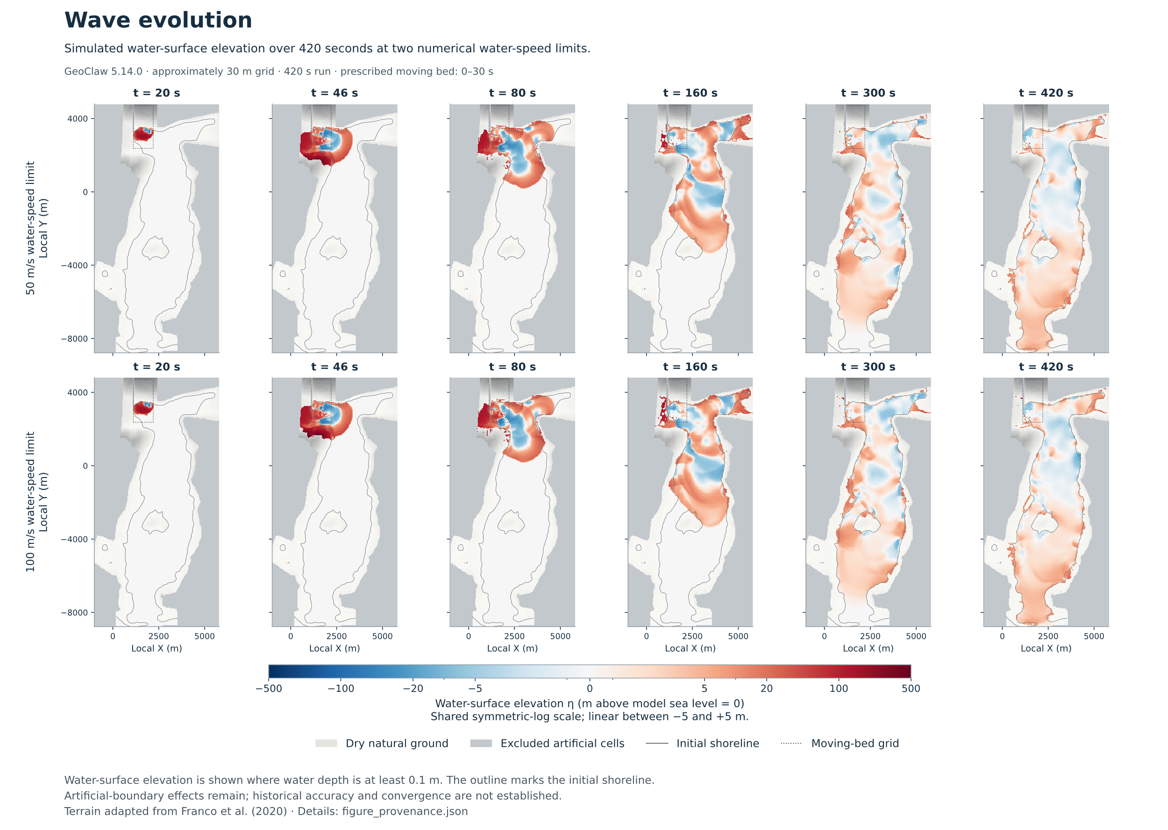
Figure 2. Simulated water-surface elevation at six times for the 50 and 100 m/s runs [8].
We wanted to see whether the way we measured the run-up affected the maximum height we reported. Our first question for follow-up analysis was whether the original monitoring area was large enough. During the speed-limit simulations, GeoClaw checked water depth at each time step and recorded the maximum at each monitored location in both the original area and a larger area that included it [8, 9]. Using the saved monitoring results, we compared the two areas to see whether water had reached higher ground outside the original boundary.
In the 100 m/s case, the simulated water had reached higher ground outside the original monitoring area. The measured run-up was 464.00 m in the original area and 469.85 m in the larger area, a difference of approximately 5.85 m (Table 2 and Figure 3). However, this does not tell us the maximum run-up across the whole bay. Artificial cells were excluded from both measurements. It is possible that artificial boundaries had some influence on the simulated water flow.
Quantity and units | Earlier study  Original grid  100 m/s | Follow-up  Original grid  50 m/s | Follow-up  Original grid  100 m/s | Follow-up  Original grid  200 m/s | Follow-up  Finer grid  50 m/s | Follow-up  Finer grid  100 m/s | Follow-up  Finer grid  200 m/s
Highest monitored run-up, expanded area (m) | 469.85 | 317.08 | 449.33 | 449.33 | 338.24 | 492.84 | 492.84
Highest monitored run-up, original area (m) | 464.00 | 317.08 | 448.97 | 448.97 | 338.24 | 492.84 | 492.84
Land area wetted at any time, expanded area (km²) | 1.269397 | 1.034757 | 1.159719 | 1.159719 | 1.077909 | 1.224222 | 1.224222
Maximum water depth on monitored land, expanded area (m) | 126.876 | 119.274 | 125.378 | 125.378 | 127.477 | 125.290 | 125.273
Peak water level at P2 (m) | 196.045 | 196.045 | 196.045 | 196.045 | 200.513 | 200.513 | 200.513
Peak water level at P3 (m) | 78.134 | 73.835 | 77.161 | 77.161 | 74.050 | 85.553 | 85.551
Peak water level at P5 (m) | 22.342 | 21.508 | 21.441 | 21.441 | 23.701 | 23.456 | 23.459
Table 2. Comparison across speed limits and grid resolutions, including the earlier 100 m/s simulation [8].
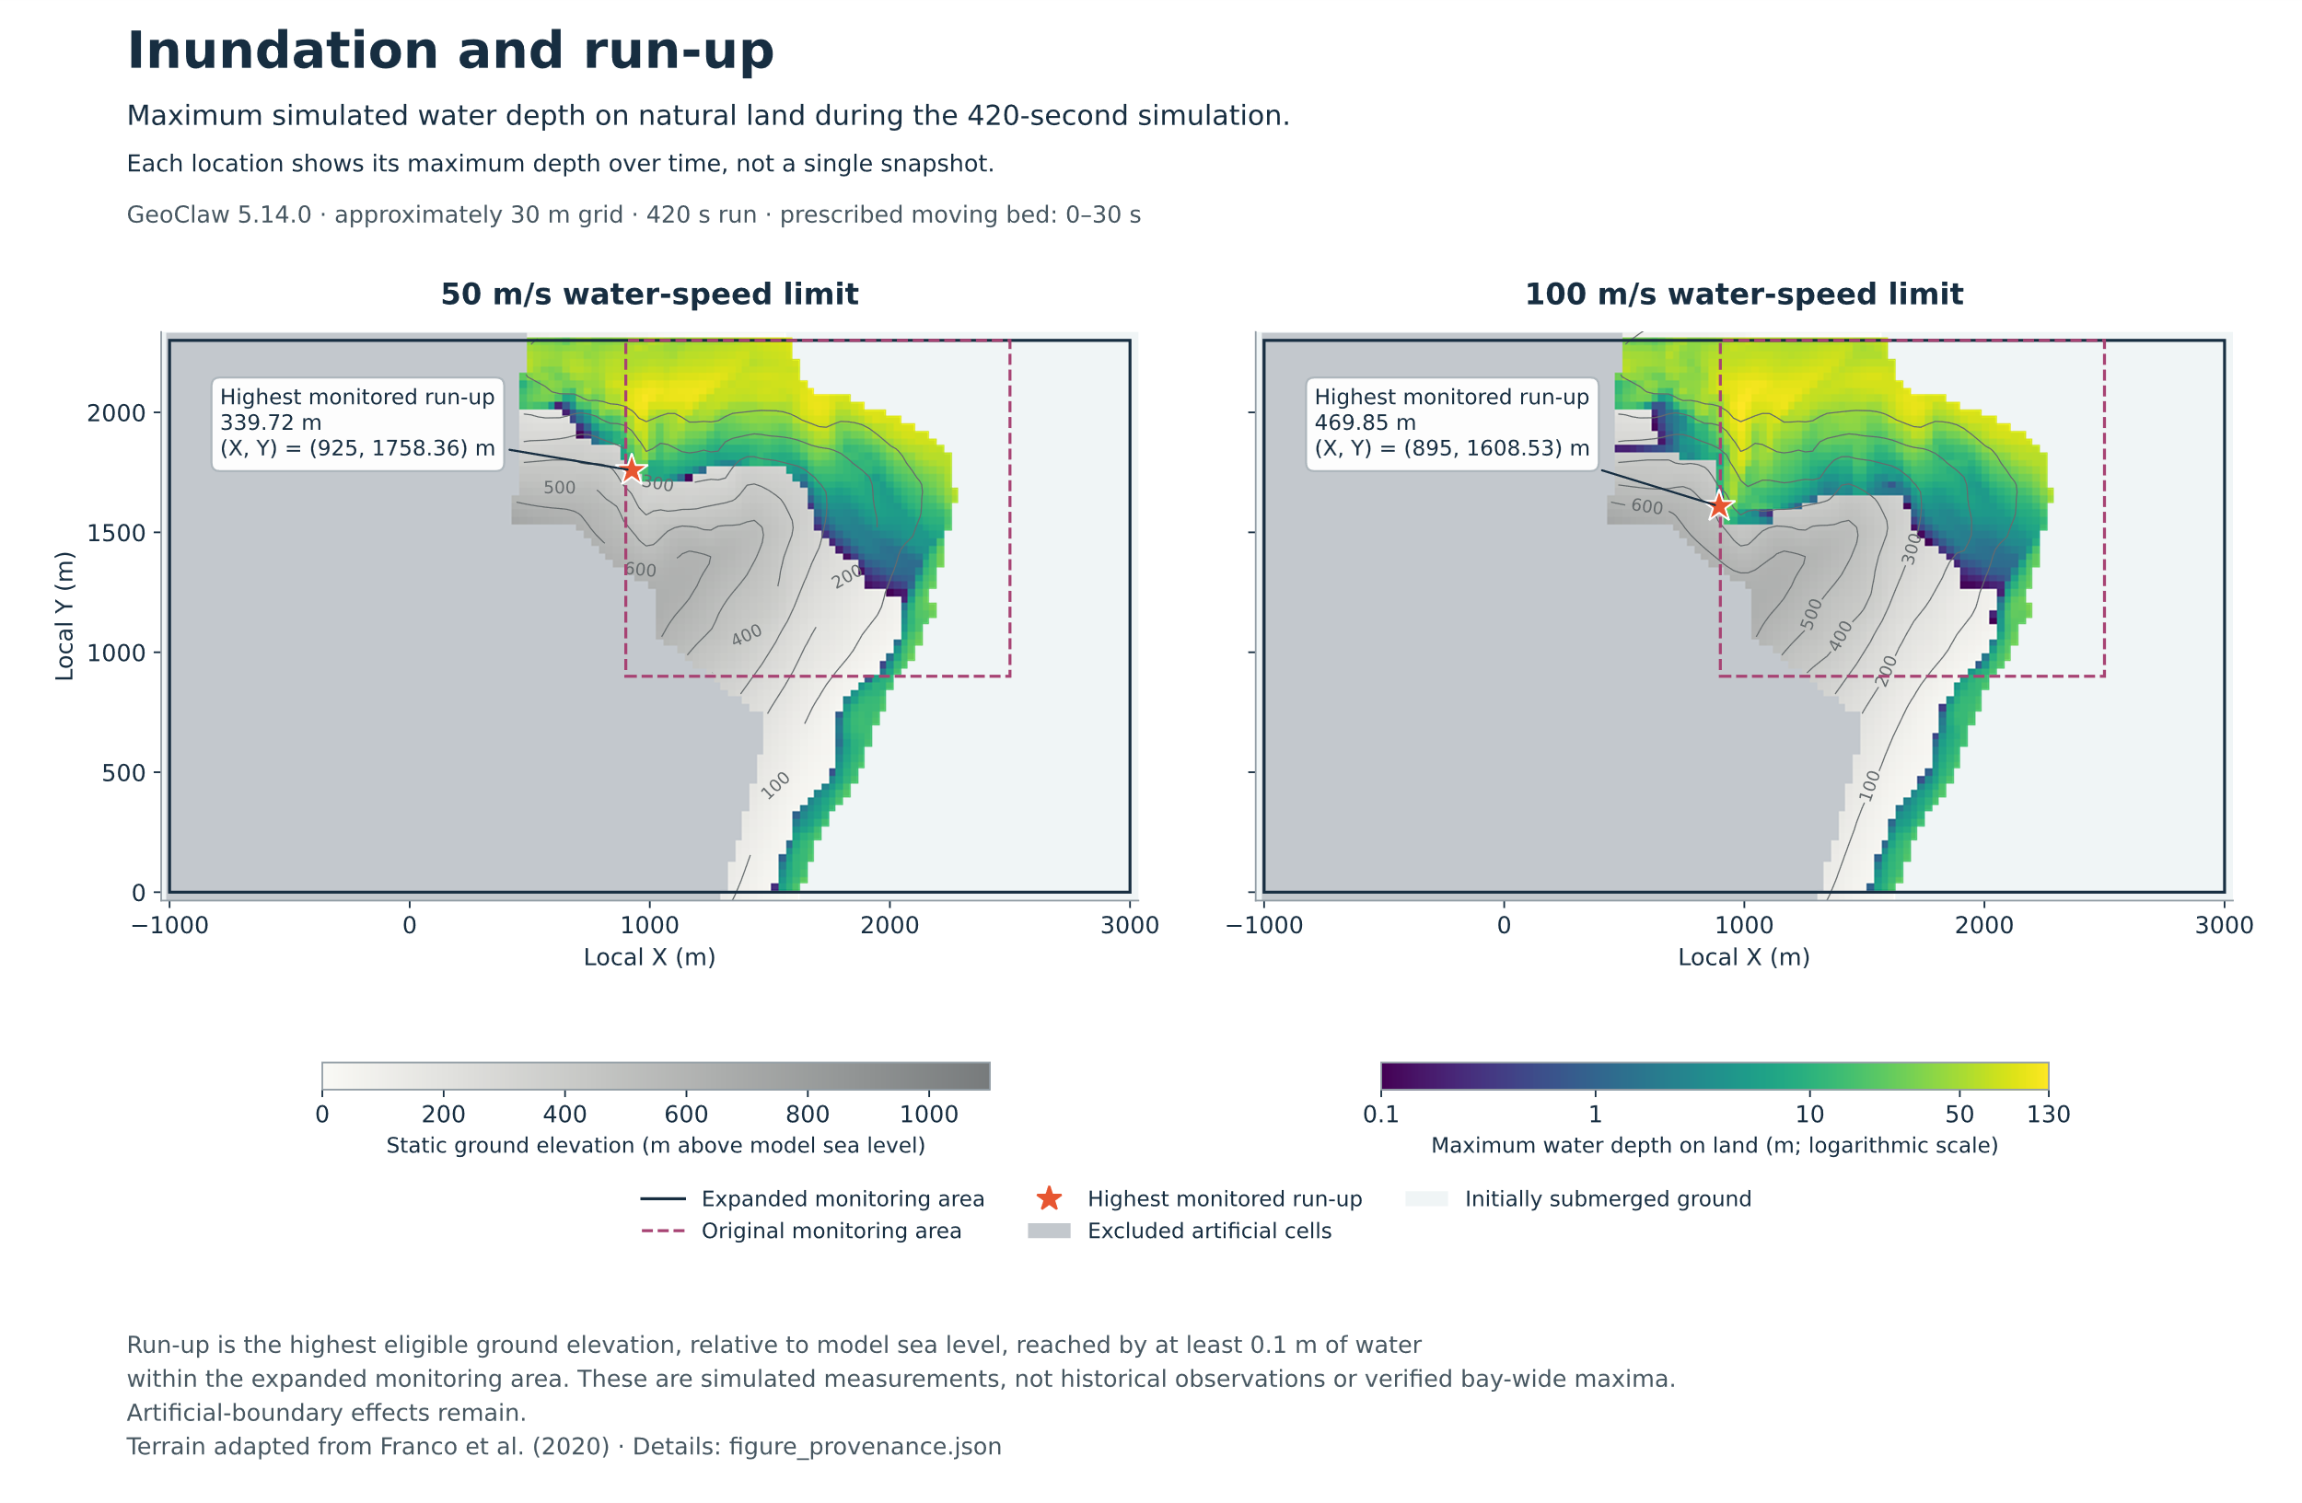
Figure 3. Maximum water depth on natural land and highest monitored run-up in the original 50 and 100 m/s runs [8].
In our second experiment, we wanted to see whether the simulated run-up was still sensitive to the water-speed limit on a finer spatial grid. We ran six simulations, repeating the 50, 100, and 200 m/s cases on two grids. The original grid had approximately 30 m cell spacing, and the finer grid had approximately 15 m spacing. All simulations used the same physical setup.
Since the original 200 m/s run failed the CFL/time-step checks, we also decided to reduce the target CFL to leave a larger margin below the configured CFL acceptance limit of 1.0 [8]. For all six follow-up simulations, the target CFL number was reduced from 0.75 to 0.50 and the global maximum time step from 2.0 to 0.1 s. The initial time step and the 0.1 s limit during source motion were retained. Actual time steps remained adaptive in both experiments [8].
We first compared the initial and follow-up 100 m/s runs on the original grid to see how much the revised time-stepping settings affected the measured run-up. With the grid and water-speed limit fixed, the highest monitored run-up decreased from 469.85 m to 449.33 m, with a difference of 20.52 m (4.37%). The new 200 m/s runs passed the numerical checks on both grids, and we included them in the follow-up comparison (Table 2).
We tested what happened when we raised the water-speed limit on each grid (Table 2). Increasing the limit from 50 to 100 m/s raised the highest monitored run-up from 317.08 m to 449.33 m on the original grid and from 338.24 m to 492.84 m on the finer grid. Raising the limit again to 200 m/s gave the same highest run-up as the 100 m/s case on each grid.
The cell size, or grid spacing, made a difference. At both 100 and 200 m/s, the water reached a maximum monitored ground elevation of 492.84 m on the finer grid compared with 449.33 m on the original grid. At either speed limit, using the finer grid increased the measured maximum by 43.51 m, or about 9.7%.
Discussion and Conclusion
This project demonstrated that simplification of the physical system and the choice of the numerical settings could significantly affect the outcome of the simulation. Achieving a stable numerical result does not establish the reliability of the model or the historical reproduction.
We used a simplified GeoClaw model of Lituya Bay to examine how numerical settings affect simulated run-up, while preserving the prescribed landslide motion. We focused on GeoClaw’s water-speed limit, a numerical stabilization feature designed to prevent run-time error. In the grid-resolution experiment, raising the water-speed limit from 50 to 100 m/s increased the highest monitored run-up by about 132 m on the original grid and 155 m on the finer grid. Raising the limit again to 200 m/s produced no further increase on either grid. This pattern persisted across both grid resolutions, although the run-up estimates themselves changed with grid spacing and time-step settings.
Raising the water-speed limit produced a substantial difference in run-up, which suggests that numerical stabilization choices can materially change the predicted inundation. One explanation is that this stabilization feature alters momentum of the simulated flow which directly affects how far the simulated water travels inland. We can conclude that numerical stability alone cannot establish the physical accuracy of the simulation. However, our experiments did not isolate this mechanism, and determining the effect on observed run-up would require additional diagnostics.
Additionally, the finer grid did not change the underlying physical assumptions of the model. GeoClaw uses a simplified numerical representation that does not resolve some of the processes of large-scale fluid dynamics. Increasing grid resolution alone could not eliminate these limitations.
Interestingly, increasing the speed limit from 100 to 200 m/s did not change the run-up. This suggests that the simulated run-up became less sensitive to the speed limit feature above 100 m/s under the tested conditions. However, we cannot confirm that we identified convergence, since other aspects of the solution may be sensitive to time stepping and grid resolution.
The historical run-up of approximately 524 m was not achieved. This study was not able to establish how closely the model reproduces the 1958 event and could not identify what was preventing us from historical recreation. A more comprehensive validation would require further testing and additional historical observation.
The results illustrate the importance of evaluating numerical assumptions when using simplified physical models. Although the simplification makes complex simulations computationally manageable, the prediction remains sensitive to numerical settings. In our study, the water-speed limit had a substantial influence on our results, demonstrating that it is important to distinguish numerical stability from physical accuracy when interpreting model results.
References
[1] U.S. Geological Survey, Pacific Coastal and Marine Science Center. (2021, October 15). Coastal and marine geohazards of the U.S. West Coast and Alaska. https://www.usgs.gov/centers/pcmsc/science/coastal-and-marine-geohazards-us-west-coast-and-alaska
[2] Miller, D. J. (1960). Giant waves in Lituya Bay, Alaska. U.S. Geological Survey Professional Paper 354-C, 51–86. https://doi.org/10.3133/pp354C
[3] Franco, A., Moernaut, J., Schneider-Muntau, B., Strasser, M., and Gems, B. (2020). The 1958 Lituya Bay tsunami – pre-event bathymetry reconstruction and 3D numerical modelling utilising the computational fluid dynamics software Flow-3D. Natural Hazards and Earth System Sciences, 20, 2255–2279. https://doi.org/10.5194/nhess-20-2255-2020
[4] González-Vida, J. M., Macías, J., Castro, M. J., Sánchez-Linares, C., de la Asunción, M., Ortega-Acosta, S., and Arcas, D. (2019). The Lituya Bay landslide-generated mega-tsunami – numerical simulation and sensitivity analysis. Natural Hazards and Earth System Sciences, 19, 369–388. https://doi.org/10.5194/nhess-19-369-2019
[5] Clawpack Development Team. (n.d.). Setting a speed limit to avoid instabilities. Clawpack 5.14.x documentation. https://www.clawpack.org/v5.14.x/speed_limit.html
[6] Clawpack Development Team. (n.d.). Specifying classic run-time parameters in setrun.py. Clawpack 5.14.x documentation. https://www.clawpack.org/v5.14.x/setrun.html
[7] Ketcheson, D. I., LeVeque, R. J., and del Razo, M. J. (2020). Riemann Problems and Jupyter Solutions: Theory and Approximate Solvers for Hyperbolic PDEs. Society for Industrial and Applied Mathematics. Shallow-water chapter. https://doi.org/10.1137/1.9781611976212
[8] Goldsmith, V. M. (2026). Lituya Bay simulation [Computer software and research records]. GitHub. Revision 92d80322f4d0b44e0b049f6e3902168a8332f538. https://github.com/VeraMGoldsmith/lituya-bay-simulation/tree/92d80322f4d0b44e0b049f6e3902168a8332f538
[9] Clawpack Development Team. (n.d.). Fixed grid monitoring. Clawpack 5.14.x documentation. https://www.clawpack.org/v5.14.x/fgmax.html
[10] Franco, A. (2020). Lituya Bay 1958 Tsunami – pre-event bathymetry reconstruction and 3D-numerical modelling utilizing the CFD software Flow-3D (Version 1) [Data set]. Zenodo. https://doi.org/10.5281/zenodo.3831448
[11] Berger, M. J., George, D. L., LeVeque, R. J., and Mandli, K. T. (2011). The GeoClaw software for depth-averaged flows with adaptive refinement. Advances in Water Resources, 34(9), 1195–1206. https://doi.org/10.1016/j.advwatres.2011.02.016
[12] Clawpack Development Team. (n.d.). Topography data. Clawpack 5.14.x documentation. https://www.clawpack.org/v5.14.x/topo.html
[13] Clawpack Development Team. (n.d.). Moving topography displacement files. Clawpack 5.14.x documentation. https://www.clawpack.org/v5.14.x/dtopo.html

