**C# Group Internship Project**

**February 2021**

Your assignment for the next 3 weeks will be to create a web application that works as a ***notes keeping application*** using the C# programming language. You will be divided randomly in two groups and each group will be a separate development team. The software teams will work under the supervision of Bojidar. As not all team members will be located at the same physical location you will be working as a remote development team - an approach widely used in the industry nowadays. You will be required to assign each other roles and follow the [SCRUM development process](https://github.com/imalitavakoli/learn-scrum).

The SCRUM team roles: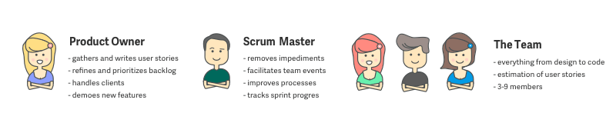

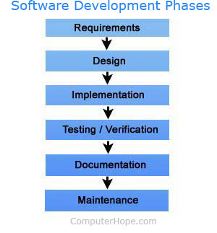

The project will be performed in 3 stages.

1. *Requirements Gathering and Application Design*
2. *Implementation and Verification*
3. *Documentation and Reflection*

Each of the three stages (sprints) will take around one week starting on 21.02.2020. At the end of every stage you are supposed to write a short self-reflection on what you did and what were the biggest challenges you faced throughout the process. The self-reflections should be sent to your supervisor.

**WEEK 1 - STAGE 1**

**15.06.2021 - Setting-up the team**

* Setup communication channel (Skype, Google Hangouts..)
* Forming the SCRUM development team. Decide on team name.
* Assigning roles and responsibilities
* Setting up an agile board- **TODO, IN PROGRESS, DONE, VERIFIED**
* Sprint Planning
* Read this article <https://thedigitalprojectmanager.com/requirements-gathering-guide/>
* Start the Requirements Gathering Process (Plan the client interview on Monday)

**16.06.2021 - Start the Requirements Gathering Phase**

* Daily Stand Up and meeting and interview with the client (Christo)
* Research client requirements
* Research similar solutions (Pros and Cons Table for 5 competing products)

**17.06.2021**

* Daily Stand Up

**-** Write down business, user and system requirements. Set requirement priorities.

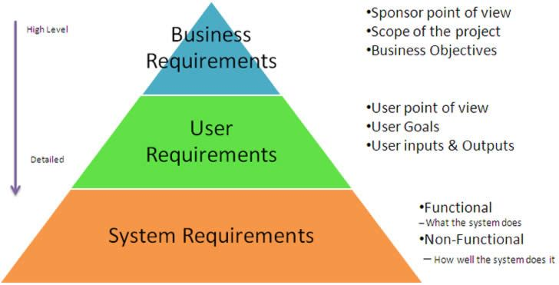

**18.06.2021**

* Daily Stand Up
* Draw wireframes using Moqups
* Write down **self-reflection** for the first stage

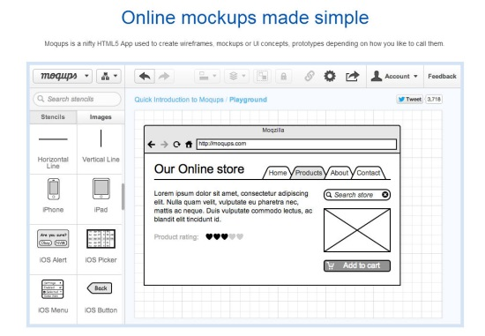

**WEEK 2 - STAGE 2**

**21.06.2021**

* Daily Stand Up
* Finalize Design Mockups of all screens

**22.06.2021**

* Daily Stand Up
* Write down technical architecture.
* Finalize requirements and design document and upload in Github
* Write down **self-reflection** for the first stage

**24.06.2021**

* Sprint Retrospective
* Sprint Planning.
* Setup C# application infrastructure (DB, UI, BE)

**25.06.2021**

* Daily Stand Up
* Start coding and implementing features
* Write down **self-reflection** for the second stage

***WEEK 3 -* STAGE 3**

**28.06.2021**

* Daily Stand Up
* Implementing features

**29.06.2021**

* Daily Stand Up
* Implement features and test

**30.06.2021**

* Daily Stand Up
* Implement features and test

**01.07.2021**

* Daily Stand Up
* Implement features and tests.
* Sprint Retrospective.

**02.07.2021**

* Daily Stand Up
* Writing maintenance and evolution document - GitHub
* preparing for DEMO
* Write down **self-reflection** for the third stage

**EXAM AND DEMO DAY**

**07.07.2020**

You will present your application and project documentation in 40 minutes in front of the client Christo - the CEO of Motion Software.

.

**Self-reflection template**

In your self-reflection you should answer the following questions.

1. What were my tasks and objectives in the past week?
2. What I managed to do good during the past week?
3. What I did not manage to do good during the past week?
4. What was the most important thing I learned in the past week?
5. What was my impression of the team as a whole and do I think that my team did well during the past week?