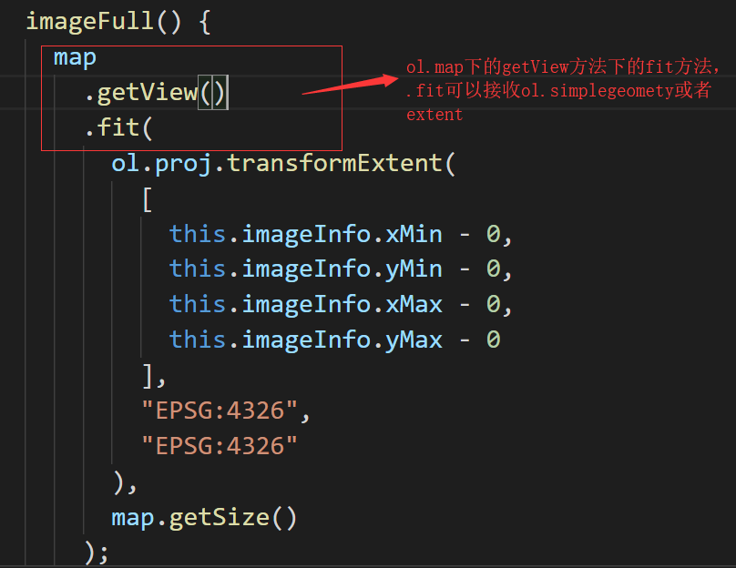

**fit**(geometryOrExtent, opt_options)

[**src/ol/view.js**](https://github.com/openlayers/openlayers/blob/v4.6.5/src/ol/view.js)**,**[**line 861**](https://github.com/openlayers/openlayers/blob/v4.6.5/src/ol/view.js#L861)

Fit the given geometry or extent based on the given map size and border. The size is pixel dimensions of the box to fit the extent into.

In most cases you will want to use the map size, that is map.getSize(). Takes care of the map angle.

fit()函数可以直接传入map.getSize()即插入的这个map的大小

|  |
| --- |
|  |

|  |
| --- |
|  |

