透明度的调节

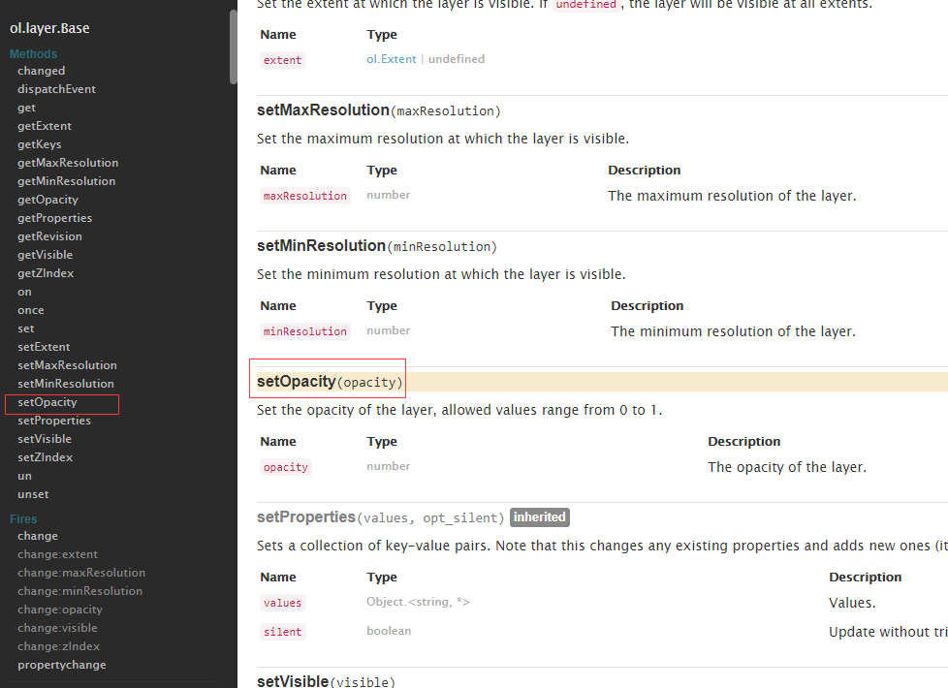

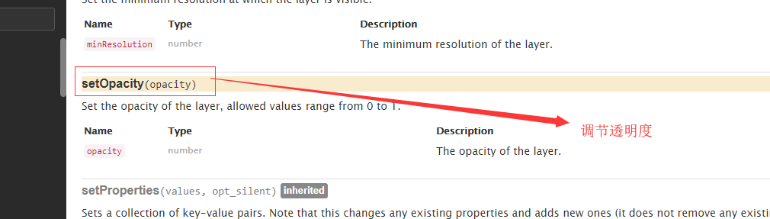

<https://openlayers.org/en/latest/apidoc/ol.layer.Base.html#setOpacity>

<http://openlayers.org/en/latest/examples/tile-transitions.html?q=opacity>

**这样不能实现两个图层叠加显示的效果**

如果在加载完成后修改，需要先getlayer 或者setlayer

具体代码

var withoutTransition = new ol.layer.Tile({
source: new ol.source.XYZ({url: url, transition: 0}),
visible: false
});

