显示控件

显示控件

TextView


字体
1.在字体大小配置上,系统提供了Large、Medium、NORMAL、Small等模式,对应的字体实际大小分别为20sp、18sp、16sp、14sp.在默认情况下,字体大小模式为NORMAL.
//中等字体
android:textAppearance=”?android:attr/textAppearanceMedium”
android:textSize=”20sp”

2.在字体特效上支持normal、bold、italic、bold_italic等特效.
android:textStyle=”bold”

3.在字体颜色上,Android支持多种系统颜色
1)/res/values/color.xml
<?xml version="1.0" encoding="utf-8"?>
<resources>
<color name="red">#FF0000</color>
<color name="white">#FFFFFF</color>
<color name="blue">#000000</color>
</resources>

<TextView
android:layout_width="match_parent"
android:layout_height="wrap_content"
android:textSize="30sp"
android:gravity="center"
android:textColor="@color/blue"
android:text="登录 www.google.com,拨打400-1234455."/>

2)使用代码设置文本颜色
Resources resources = getBaseContext().getResources();
Drawable hippoDrawable = resources.getDrawable(R.color.darkgray);
tv.setBackgroundDrawable(hippoDrawable);
tv.setBackgroundColor(Color.BLUE);

4.Android支持4种字体normal、sans、serif、monospace.
android:typeface=”sans”

使用指定的字体文件
Typeface tf = Typeface.createFromAsset(getAssets(),”fonts/HandmadeTypewriter.ttf");
textView.setTypeface(tf); //断言重单个文件的大小不应该超过1M

内容
1.内容排列方法
android:singleLine=”true” //单行
android:maxLines=”2” //最大行数
android:minWidth=”64dip” //最小宽度
android:scrollbars=”vertical” //垂直滚动条
android:ellipsize="start" //省略号在开头或者在程序中可通过setEillpsize显式设置.
android:ellipsize="marquee" 跑马灯显示或者在程序中
tv.setMovementMethod(ScrollingMovementMethod.getInstance());
注:EditText不支持marquee这种模式.

android:textIsSelectedable="true"

跑马灯效果
<TextView
android:id="@+id/tv"
android:layout_width="match_parent"
android:layout_height="wrap_content"
android:ellipsize="marquee"
android:singleLine="true"
android:marqueeRepeatLimit="marquee_forever" 在ellipsize指定marquee的情况下，设置重复滚动次数
android:focusableInTouchMode="true"//是否在触摸模式下获得焦点
android:focusable="true"//控件是否能够获取焦点
android:text="登录 www.google.com,拨打400-1234455就能进入我们的世界了."/>

2.HTML脚本显示 WebView
String tmp =
"<b>text2:</b> This is some other text, with a <a href=\"http://www.google.com\">link</a>specified " +
"via an &lt;a&gt; tag. Use a \"tel:\" URL to <a href=\"tel:4155551212\">dial a phone number";
TextView tv = (TextView)findViewById(R.id.textView);
tv.setText(Html.fromHtml(tmp));
tv.setMovementMethod(LinkMovementMethod.getInstance());

3.动态显示内容
<string name="my_str_spaces">you found ALL PAIRS ! on %d flips !</string>

String message_all_pairs_found = String.format(getString(R.string.my_str_spaces1), 200);
TextView tv = (TextView)findViewById(R.id.tv);
tv.setText(message_all_pairs_found);

SpannableString
作业

ImageView

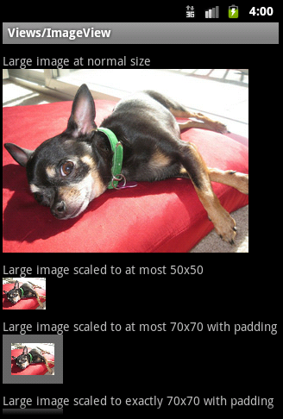
android:src android:background
ImageView用来显示任意图像图片,可以自己定义显示尺寸,显示颜色等等.

public class MainActivity extends Activity {
private static final int[] imageArrays =
{R.drawable.b1,R.drawable.b2,R.drawable.b3,R.drawable.b4};
private ImageView imageView;
private int index = 0;
private int screenWitch;

@Override
protected void onCreate(Bundle savedInstanceState) {
super.onCreate(savedInstanceState);
setContentView(R.layout.activity_main);

screenWitch = getWindowManager().getDefaultDisplay().getWidth();

imageView = (ImageView)findViewById(R.id.imageView);
imageView.setImageResource(imageArrays[index]);

imageView.setOnTouchListener(new View.OnTouchListener(){
@Override
public boolean onTouch(View v, MotionEvent event) {
int x = (int) event.getX();
ImageView image = (ImageView) v;
if(x > screenWitch/2){ //触摸图片右侧
if(index == (imageArrays.length-1)){
index = -1;
}
image.setImageResource(imageArrays[++index]);
}else{//触摸图片左侧
if(index == 0){
index = imageArrays.length-1;
}
image.setImageResource(imageArrays[--index]);
}
return false;
}
});
}
}

ImageView用法
android:maxWidth 设置View的最大宽度.
android:scaleType 设置图片的填充方式.
android:src 设置View的图片或颜色
android:tint 将图片渲染成指定的颜色.

android:adjustViewBounds 是否保持宽高比.需要与maxWidth、MaxHeight一起使用,单独使用没有效果.、
android:cropToPadding 是否截取指定区域用空白代替.单独设置无效果,需要与scrollY一起使用
android:maxHeight 定义View的最大高度,需要与AdjustViewBounds一起使用,单独使用没有效果.

如果想设置图片固定大小,又想保持图片宽高比,需要如下设置: 100*200
1) 设置AdjustViewBounds为true;
2) 设置maxWidth、MaxHeight;
3) 设置设置layout_width和layout_height为wrap_content.

android:scaleType
background会根据ImageView组件给定的长宽进行拉伸，而src就存放的是原图的大小，不会进行拉伸。src是图片内容（前景），bg是背景，可以同时使用。此外：scaleType只对src起作用；bg可设置透明度，比如在ImageButton中就可以用android:scaleType控制图片的缩放方式，示例

<ImageView
android:id="@+id/img"
android:src="@drawable/logo"
android:scaleType="centerInside"
android:layout_width="120dip"
android:layout_height="100dip"
android:layout_centerVertical="true"/>
说明：centerInside表示按比例缩放图片，使得图片长 (宽)的小于等于视图的相应维度。
注意：控制的图片为资源而不是背景，即android:src="@drawable/logo"，而非
android:background="@drawable/logo"。程序中动态加载图片也类似，如：应该imgView.setImageResource(R.drawable.*);而非imgView.setBackgroundResource(R.drawable.*);
ImageView的Scaletype决定了图片在View上显示时的样子，如进行何种比例的缩放，及显示图片的整体还是部分，等等。
设置的方式包括：
1. 在layout xml中定义android:scaleType="CENTER"
2. 或在代码中调用imageView.setScaleType(ImageView.ScaleType.CENTER);


1)CENTER /center
SetScaleType(ImageView.ScaleType.CENTER);
按图片的原来size居中显示，当图片长/宽超过View的长/宽，则截取图片的居中部分显示


2)CENTER_CROP / centerCrop 按比例扩大图片的size居中显示,使得图片长(宽)等于或大于View的长(宽)
SetScaleType(ImageView.ScaleType.CENTER_CROP);
按比例扩大图片的size居中显示，使得图片长(宽)等于或大于View的长(宽)


3)CENTER_INSIDE / centerInside 将图片的内容完整居中显示,通过按比例缩小或原来的size使得图片长/宽等于或小于View的长/宽
setScaleType(ImageView.ScaleType.CENTER_INSIDE);
将图片的内容完整居中显示，通过按比例缩小或原来的size使得图片长/宽等于或小于View的长/宽


4)FIT_CENTER / fitCenter 把图片按比例扩大/缩小到View的宽度,居中显示
setScaleType(ImageView.ScaleType.FIT_CENTER);
把图片按比例扩大/缩小到View的宽度，居中显示


5)FIT_END / fitEnd 把图片按比例扩大/缩小到View的宽度,显示在View的下部分位置
6)FIT_START / 把图片按比例扩大/缩小到View的宽度,显示在View的上部分位置
FIT_START, FIT_END在图片缩放效果上与FIT_CENTER一样，只是显示的位置不同，FIT_START是置于顶部，FIT_CENTER居中，FIT_END置于底部。

7)FIT_XY / fitXY 把图片 不按比例 扩大/缩小到View的大小显示
不按比例缩放图片，目标是把图片塞满整个View。


8)MATRIX / matrix 用矩阵来绘制,动态缩小放大图片来显示.

<?xml version="1.0" encoding="utf-8"?>
<LinearLayout xmlns:android="http://schemas.android.com/apk/res/android"
android:layout_width="match_parent"
android:layout_height="match_parent"
android:orientation="vertical">
<ImageView
android:layout_width="wrap_content"
android:layout_height="wrap_content"
android:maxHeight="100dp"
android:maxWidth="100dp"
android:adjustViewBounds="true"
android:src="@drawable/n_preview_hero" />
<ImageView
android:layout_width="120dp"
android:layout_height="100dp"
android:scaleType="center"
android:src="@drawable/n_preview_hero" />
<ImageView
android:layout_width="120dp"
android:layout_height="100dp"
android:scaleType="centerCrop"
android:src="@drawable/n_preview_hero" />
<ImageView
android:layout_width="120dp"
android:layout_height="100dp"
android:scaleType="centerInside"
android:src="@drawable/n_preview_hero" />
<ImageView
android:layout_width="120dp"
android:layout_height="100dp"
android:scaleType="fitXY"
android:src="@drawable/n_preview_hero" />
</LinearLayout>

SeekBar
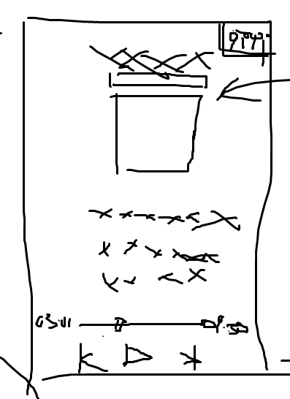

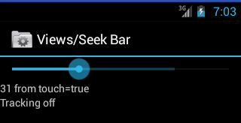

res/layout/main.xml
<?xml version="1.0" encoding="utf-8"?>
<LinearLayout xmlns:android="http://schemas.android.com/apk/res/android"
android:orientation="vertical"
android:layout_width="match_parent"
android:layout_height="match_parent">
<SeekBar android:id="@+id/seek"
android:layout_width="match_parent"
android:layout_height="wrap_content"
android:max="100"
android:progress="50"
android:secondaryProgress="75" />
<TextView android:id="@+id/progress"
android:layout_width="wrap_content"
android:layout_height="wrap_content" />
<TextView android:id="@+id/tracking"
android:layout_width="wrap_content"
android:layout_height="wrap_content" />
</LinearLayout>

TestActivity.java
public class TestActivity extends Activity{
private SeekBar seekBar;
private TextView progressTextView;
private TextView trackingTextView;

protected void onCreate(Bundle savedInstanceState) {
super.onCreate(savedInstanceState);
setContentView(R.layout.main);

seekBar = (SeekBar)findViewById(R.id.seek);
progressTextView = (TextView)findViewById(R.id.progress);
trackingTextView = (TextView)findViewById(R.id.tracking);

seekBar.setOnSeekBarChangeListener(new OnSeekBarChangeListener(){
//拖动进度条后,进度发生改变时的回调事件
public void onProgressChanged(SeekBar seekBar, int progress,
boolean fromUser) {//fromUser标识变化是否来自用户
progressTextView.setText(progress + " " + "from touch");
}

public void onStartTrackingTouch(SeekBar seekBar) {//开始触摸手势
trackingTextView.setText("tracking_on");
}

public void onStopTrackingTouch(SeekBar seekBar) {//结束触摸手势
trackingTextView.setText("tracking_off");
}

});
}
}

RatingBar
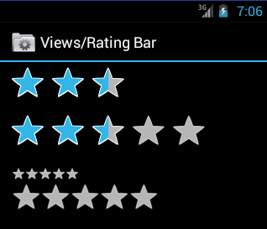

res/layout/ratingbar.xml
<?xml version="1.0" encoding="utf-8"?>
<LinearLayout xmlns:android="http://schemas.android.com/apk/res/android"
android:orientation="vertical"
android:paddingLeft="10dip"
android:layout_width="match_parent"
android:layout_height="match_parent">
<RatingBar android:id="@+id/ratingbar1"
android:layout_width="wrap_content"
android:layout_height="wrap_content"
android:numStars="3"
android:rating="2.5" />
<RatingBar android:id="@+id/ratingbar2"
android:layout_width="wrap_content"
android:layout_height="wrap_content"
android:numStars="5"
android:rating="2.25" />
<LinearLayout
android:layout_width="match_parent"
android:layout_height="wrap_content"
android:layout_marginTop="10dip">
<TextView android:id="@+id/rating"
android:layout_width="wrap_content"
android:layout_height="wrap_content" />
<RatingBar android:id="@+id/small_ratingbar"
style="?android:attr/ratingBarStyleSmall"
android:layout_marginLeft="5dip"
android:layout_width="wrap_content"
android:layout_height="wrap_content"
android:layout_gravity="center_vertical" />
</LinearLayout>
<RatingBar android:id="@+id/indicator_ratingbar"
style="?android:attr/ratingBarStyleIndicator"
android:layout_marginLeft="5dip"
android:layout_width="wrap_content"
android:layout_height="wrap_content"
android:layout_gravity="center_vertical" />
</LinearLayout>

RatingBarActivity.java
public class RatingBarActivity extends Activity implements RatingBar.OnRatingBarChangeListener {
RatingBar mSmallRatingBar;
RatingBar mIndicatorRatingBar;
TextView mRatingText;

@Override
protected void onCreate(Bundle savedInstanceState) {
super.onCreate(savedInstanceState);

setContentView(R.layout.ratingbar_1);

mRatingText = (TextView) findViewById(R.id.rating);

// We copy the most recently changed rating on to these indicator-only
// rating bars
mIndicatorRatingBar = (RatingBar) findViewById(R.id.indicator_ratingbar);
mSmallRatingBar = (RatingBar) findViewById(R.id.small_ratingbar);

// The different rating bars in the layout. Assign the listener to us.
((RatingBar)findViewById(R.id.ratingbar1)).setOnRatingBarChangeListener(this);
((RatingBar)findViewById(R.id.ratingbar2)).setOnRatingBarChangeListener(this);
}

public void onRatingChanged(RatingBar ratingBar, float rating, boolean fromTouch) {
final int numStars = ratingBar.getNumStars();
mRatingText.setText("Rating:" + rating + "/" + numStars);

// Since this rating bar is updated to reflect any of the other rating
// bars, we should update it to the current values.
if (mIndicatorRatingBar.getNumStars() != numStars) {
mIndicatorRatingBar.setNumStars(numStars);
mSmallRatingBar.setNumStars(numStars);
}
if (mIndicatorRatingBar.getRating() != rating) {
mIndicatorRatingBar.setRating(rating);
mSmallRatingBar.setRating(rating);
}
final float ratingBarStepSize = ratingBar.getStepSize();
if (mIndicatorRatingBar.getStepSize() != ratingBarStepSize) {
mIndicatorRatingBar.setStepSize(ratingBarStepSize);
mSmallRatingBar.setStepSize(ratingBarStepSize);
}
}
}

ProgressBar
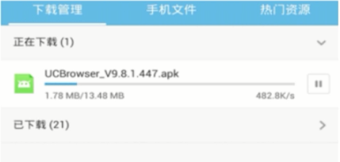
ProgressBar是表示播放、下载、缓冲进度的一种可视化控件.根据适用场景不同,ProgressBar有4中风格,即progressBarStyle、progressBarStyleHorizontal、progressBarStyleLarge和progressBarStyleSmall.其中progressBarStyle是默认风格和progressBarStyleLarge、progressBarStyleSmall一样,是环形的进度条,这种进度条的好处是可用在无法明确进度值的场景中.progressBarStyleHorizontal风格的ProgressBar为水平进度条,具有主进度和辅进度两个状态,特别适合于具有缓冲的场景,设计上充分考虑了网络需求.

ProgressBar显示风格
style="?android:attr/progressBarStyleHorizontal" 长条形ProgressBar
style="?android:attr/progressBarStyleLarge" 大号圆形ProgressBar
style="?android:attr/progressBarStyleSmall" 小号圆形ProgressBar
style="?android:attr/progressBarStyleSmallTitle" 标题型圆形ProgressBar

长条形ProgressBar 可以精确显示进度(显示刻度或者百分比)
圆形ProgressBar 不可以精确显示进度

ProgressBar+Handler

res/layout/main.xml
<?xml version="1.0" encoding="utf-8"?>
<LinearLayout xmlns:android="http://schemas.android.com/apk/res/android"
android:orientation="vertical"
android:layout_width="match_parent"
android:layout_height="match_parent">
<TextView
android:id="@+id/textView"
android:layout_width="match_parent"
android:layout_height="wrap_content"
android:text="进度条演示" />
<ProgressBar
android:id="@+id/horProgressBar"
style="?android:attr/progressBarStyleHorizontal"
android:visibility="gone"
android:layout_width="match_parent"
android:layout_height="wrap_content"/>
<Button
android:id="@+id/startButton"
android:layout_width="wrap_content"
android:layout_height="wrap_content"
android:text="开 始"/>
</LinearLayout>

ProgressbarActivity.java
public class ProgressbarActivity extends Activity {

private TextView textView;
private ProgressBar horProgressBar;
private Button startButton;

private static final int STOP = 0;
private static final int NEXT = 1;

private Handler mHandler = new Handler() {
public void handleMessage(Message msg) {
switch (msg.what) {
case STOP:// 到了最大值
textView.setText(String.valueOf(msg.arg1) + "%" + "完成");
horProgressBar.setVisibility(View.GONE);
break;
case NEXT:
textView.setText(String.valueOf(msg.arg1) + "%");
horProgressBar.setProgress(msg.arg1);
break;
}

super.handleMessage(msg);
}
};

public void onCreate(Bundle savedInstanceState) {
super.onCreate(savedInstanceState);
setContentView(R.layout.main);

textView = (TextView)findViewById(R.id.textView);
horProgressBar = (ProgressBar) this.findViewById(R.id.horProgressBar);
startButton = (Button) this.findViewById(R.id.startButton);

startButton.setOnClickListener(new OnClickListener() {
public void onClick(View v) {
horProgressBar.setVisibility(View.VISIBLE);
horProgressBar.setMax(100);// 设置最大值
horProgressBar.setProgress(0); // 设置当前值

new Thread(new Runnable() {
public void run() {
for (int i = 0; i < 10; i++) {
try {
int iCount = (i + 1) * 10;
Thread.sleep(1000);

if (i == 9) {
Message msg = new Message();
msg.what = STOP;
msg.arg1 = iCount;
mHandler.sendMessage(msg);
break;
} else {
Message msg = new Message();
msg.what = NEXT;
msg.arg1 = iCount;
mHandler.sendMessage(msg);
}
} catch (Exception ex) {
ex.printStackTrace();
}
}
}

}).start();
}
});
}
}

ProgressBar Smooth

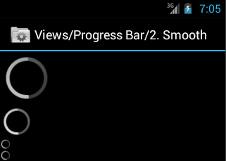

res/layout/main.xml
<LinearLayout xmlns:android="http://schemas.android.com/apk/res/android"
android:orientation="vertical"
android:layout_width="match_parent"
android:layout_height="wrap_content">
<ProgressBar android:id="@+android:id/progress_large"
style="?android:attr/progressBarStyleLarge"
android:layout_width="wrap_content"
android:layout_height="wrap_content" />
<ProgressBar android:id="@+android:id/progress"
android:layout_width="wrap_content"
android:layout_height="wrap_content" />
<ProgressBar android:id="@+android:id/progress_small"
style="?android:attr/progressBarStyleSmall"
android:layout_width="wrap_content"
android:layout_height="wrap_content" />
<ProgressBar android:id="@+android:id/progress_small_title"
style="?android:attr/progressBarStyleSmallTitle"
android:layout_width="wrap_content"
android:layout_height="wrap_content" />
</LinearLayout>

ProgressActivity.java
public class ProgressBarActivity extends Activity {
@Override
protected void onCreate(Bundle savedInstanceState) {
super.onCreate(savedInstanceState);
requestWindowFeature(Window.FEATURE_INDETERMINATE_PROGRESS);
setContentView(R.layout.main);
setProgressBarVisibility(true);
}
}

In Title Bar
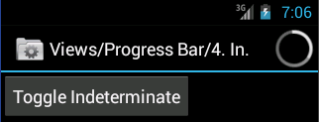

res/layout/main.xml
<?xml version="1.0" encoding="utf-8"?>
<LinearLayout xmlns:android="http://schemas.android.com/apk/res/android"
android:orientation="vertical"
android:layout_width="match_parent"
android:layout_height="wrap_content">
<Button android:id="@+id/toggle"
android:layout_width="wrap_content"
android:layout_height="wrap_content"
android:text="toggle" />
</LinearLayout>

ProgressActivity.java
public class ProgressBarActivity extends Activity {
private boolean mToggleIndeterminate = false;

@Override
protected void onCreate(Bundle savedInstanceState) {
super.onCreate(savedInstanceState);
requestWindowFeature(Window.FEATURE_INDETERMINATE_PROGRESS);
setContentView(R.layout.main);
setProgressBarIndeterminateVisibility(mToggleIndeterminate);

Button button = (Button) findViewById(R.id.toggle);
button.setOnClickListener(new Button.OnClickListener() {
public void onClick(View v) {
mToggleIndeterminate = !mToggleIndeterminate;
setProgressBarIndeterminateVisibility(mToggleIndeterminate);
}
});
}
}

requestWindowFeature(featrueId),它的功能是启用窗体的扩展特性.参数是Window类中定义的常量
1.DEFAULT_FEATURES:系统默认状态,一般不需要指定
2.FEATURE_CONTEXT_MENU:启用ContextMenu,默认该项已启用,一般无需指定
3.FEATURE_CUSTOM_TITLE:自定义标题.当需要自定义标题时必须指定.如:标题是一个按钮时
4.FEATURE_INDETERMINATE_PROGRESS:不确定的进度
5.FEATURE_LEFT_ICON:标题栏左侧的图标
6.FEATURE_NO_TITLE:吴标题
7.FEATURE_OPTIONS_PANEL:启用“选项面板”功能,默认已启用.
8.FEATURE_PROGRESS:进度指示器功能
9.FEATURE_RIGHT_ICON:标题栏右侧的图标

