FROM WORKSHOP TO WORLDWIDE
━━━━

FROM WORKSHOP
TO WORLDWIDE
━━━━
A Step-by-Step Guide to Building a Profitable Business From the Things You Make and the Services You Provide

THE SKILL JUNKY
● VERDANT LIFE LLC ●

From Workshop to Worldwide
A Step-by-Step Guide to Building a Profitable Business From the Things You Make and the Services You Provide
Copyright © 2026 by The Skill Junky. All rights reserved.
Published by Verdant Life LLC.
No part of this book may be reproduced, stored in a retrieval system, or transmitted in any form or by any means — electronic, mechanical, photocopying, recording, or otherwise — without prior written permission from the publisher, except for brief quotations in reviews. Purchasers of this book may photocopy the worksheets and templates for use in their own business.
Disclaimer: This book is designed to provide general information and practical guidance about starting and running a small business. It is sold with the understanding that the author and publisher are not providing legal, tax, accounting, or financial advice. Laws, regulations, platform policies, and fees vary by location and change over time; consult qualified professionals and official sources for advice specific to your situation. Results vary, and no particular level of income is promised. The example entrepreneurs in this book, Maya and Marcus, are illustrative composites, not real individuals.
Product and company names mentioned in this book are the trademarks of their respective owners. Their mention does not imply endorsement by, or affiliation with, the author or publisher.
Illustrations created for this book.
First Edition, 2026

For everyone who has ever been told,
"You should sell these,"
or "You should charge for that" —
and is finally ready to do it.
✦

CONTENTS
━━━
Introduction 1
How to Use This Book 4
PART ONE · FOUNDATIONS 9
1 Start With the Right Offer 10
2 Validate Before You Build 18
3 Understanding the Economics of Your Business 23
PART TWO · MAKING IT REAL 33
4 Making It Official 34
5 Building a Brand People Remember 41
6 Creating Consistent Quality 48
PART THREE · GETTING READY TO SELL 55
7 Choosing Where to Sell 56
8 Becoming Your Own Salesperson Through Photography 61
9 Writing Listings That Sell 67
10 Launching Your Store 73
PART FOUR · CUSTOMERS AND MARKETING 77
11 Finding Your First Customers 78
12 The Power of Consistent Marketing 84
13 Shipping and the Customer Experience 90
PART FIVE · RUNNING AND GROWING 97
14 Managing Money Like a Business Owner 98
15 Creating Systems for Growth 105
16 Growing Beyond the First Sale 111
17 Mistakes Every Entrepreneur Should Avoid 115
18 From Side Hustle to Sustainable Business 118
PART SIX · THE ENTREPRENEUR'S TOOLKIT 123
19 The 30-Day Launch Plan 124
20 The First-Year Success Plan 132
21 Scorecards and Templates 136
Final Thoughts 145
A Final Note From the Author 147
About the Author 148
About Verdant Life LLC 149
Notes 150

Introduction
━━━

Every successful business begins with a simple idea.
Not a business plan. Not a logo. Not a website.
An idea.
Somewhere, a person looks at a problem, a passion, or a skill and asks a simple question:
"Could I make a living doing this?"
For most people, the question ends there. For entrepreneurs, it becomes a journey.
The truth is that we live in one of the greatest periods in history to build a business. A woodworker in Washington can sell a handcrafted sign to a customer in Florida. A leatherworker can build a global customer base from a garage workshop. A hobbyist with a 3D printer can reach thousands of buyers without ever opening a storefront. A person who is good at fixing things, organizing closets, tutoring math, editing résumés, grooming dogs, or detailing cars can fill a calendar with paying clients using little more than a phone and a reputation.
For the first time in history, an individual craftsperson or skilled professional can compete with large companies.
Not because they have more money. Not because they have more resources.
But because customers crave authenticity.
People want products with stories. They want products made by real people. They want craftsmanship instead of mass production. And when they hire someone to help them, they want a real person who shows up, cares about the result, and stands behind the work.
Customers are not just buying a thing or a service. They are buying the person behind it.
This book is not about becoming an internet celebrity.
It is not about getting rich overnight.
It is about building a real business — a business built on your skills, your work ethic, and your willingness to create value for others.

Products, Services, or Both
Throughout this book you will see two kinds of entrepreneurs.
Makers create physical products: signs, candles, jewelry, furniture, soap, prints, clothing, pottery, leather goods, 3D-printed parts, baked goods, and a thousand other things.
Service providers sell their skills and time: repairs, cleaning, lawn care, photography, tutoring, bookkeeping, pet care, design, coaching, installation, event help, and countless other ways of solving problems for people.
Many of the most resilient small businesses are both. The woodworker who sells signs also offers custom installation. The photographer who sells sessions also sells prints. The baker who sells cookies also teaches decorating classes.
The principles in this book apply to all three. Where the steps differ, you will find guidance for each path, marked clearly so you can follow the one that fits you.

Two Entrepreneurs to Learn From
To make the steps concrete, we will follow two example entrepreneurs throughout the book. They are composites — built from the patterns that show up again and again in real small businesses — and they represent the two paths you might take.
EXAMPLE
Meet Maya — The Maker
Maya works full time and spends her evenings in a small garage workshop. She loves working with cedar and has been making signs as gifts for friends for years. Everyone tells her she should sell them. She has never run a business, and she is not sure where to start.

EXAMPLE
Meet Marcus — The Service Provider
Marcus is the person his whole neighborhood calls when something breaks. He can hang shelves, assemble furniture, fix a leaky faucet, and patch drywall. He has been helping neighbors for free or for a few dollars. He wonders whether his skills could become a real side business — and maybe someday a full-time one.

You will see how Maya and Marcus apply each chapter. Their decisions will not be perfect. Neither will yours. That is part of the point.
If you are ready to turn what you make — or what you know how to do — into what you sell, this book will show you how, one step at a time.

How to Use This Book
━━━
This is a working book. It is meant to be written in, marked up, dog-eared, and carried to your workbench or your truck.
It is organized into six parts that follow the natural order of building a business:
- Foundations — choosing what to sell, proving that people want it, and understanding the money.
- Making It Real — setting up your business legally, building a brand, and creating consistent quality.
- Getting Ready to Sell — choosing where to sell, photographing your work, writing listings, and launching.
- Customers and Marketing — finding your first customers, marketing consistently, and delivering an experience people talk about.
- Running and Growing — managing money, building systems, growing, and deciding when to go full time.
- The Entrepreneur's Toolkit — the 30-Day Launch Plan, the First-Year Success Plan, scorecards, and ready-to-use templates.
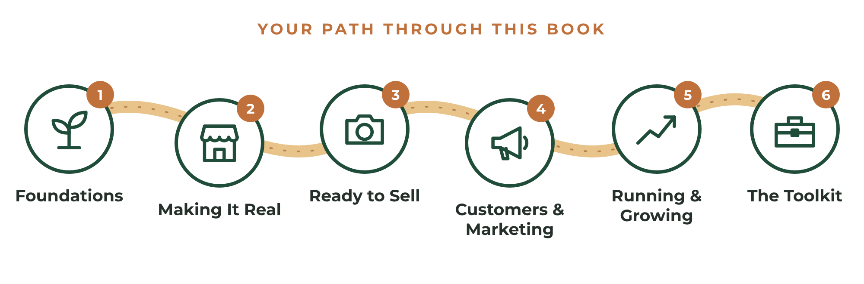
FIGURE 1 The six parts of this book follow the natural path from idea to sustainable business.

Each Chapter Follows the Same Pattern
- The idea — why the step matters and what successful owners do differently.
- The steps — specific actions, in order.
- Product and service notes — guidance for your specific path.
- The worksheet — decisions you make on paper before you make them with money.
- Your action steps — a short checklist so you know exactly what to do next.

Do the Worksheets
It is tempting to read straight through and promise yourself you will come back to the exercises later.
Please don't.
Reading creates understanding. Writing creates decisions. A business is built out of decisions.
If you are reading the eBook edition, keep a dedicated notebook beside you and copy each worksheet's questions into it. If you are reading the paperback, write directly on the pages. Use a pencil if you like — your answers will change as you learn, and that is exactly how it should be.
PRO TIP
A Note on Laws and Taxes
This book includes general information about business registration, taxes, and insurance, written primarily for readers in the United States. Rules vary by state, county, city, and country, and they change over time. Treat this information as a starting map, not legal or tax advice. When in doubt, a short conversation with a local accountant, attorney, or your Small Business Development Center can save you money and stress.

WORKSHEET
The Entrepreneur's Declaration
Complete this before you read the rest of the book.

WHY DO I WANT THIS BUSINESS?
Write your answer in one sentence.

WHAT AM I PLANNING TO SELL?
☐ Products I make
☐ Services I provide
☐ Both

WHAT FINANCIAL GOALS AM I PURSUING?
My first monthly sales goal: $
My first monthly profit goal: $
My 12-month revenue goal: $
Hours per week I can commit:
WHAT WILL SUCCESS LOOK LIKE ONE YEAR FROM TODAY?

WHAT IS THE BIGGEST FEAR OR OBSTACLE STANDING IN MY WAY?

MY COMMITMENT
I commit to completing the worksheets in this book and taking one action toward my business every week.
Signature: Date:

PART ONE

FOUNDATIONS
━━━━
Choose the right offer, prove people want it, and understand the money before you spend it.


1
CHAPTER

Start With the Right Offer
━━━
The first decision you make will influence every decision that follows.
Choose the right offer, and growth becomes easier. Choose the wrong one, and every sale feels like an uphill battle.
The greatest mistake new entrepreneurs make is assuming that the thing they enjoy making — or the work they enjoy doing — is automatically the thing customers want to buy.
Sometimes that is true. Often it is not.

The Sweet Spot
Successful businesses sit at the intersection of three important factors:
- What you enjoy creating or doing.
- What you can deliver consistently.
- What customers will pay for.
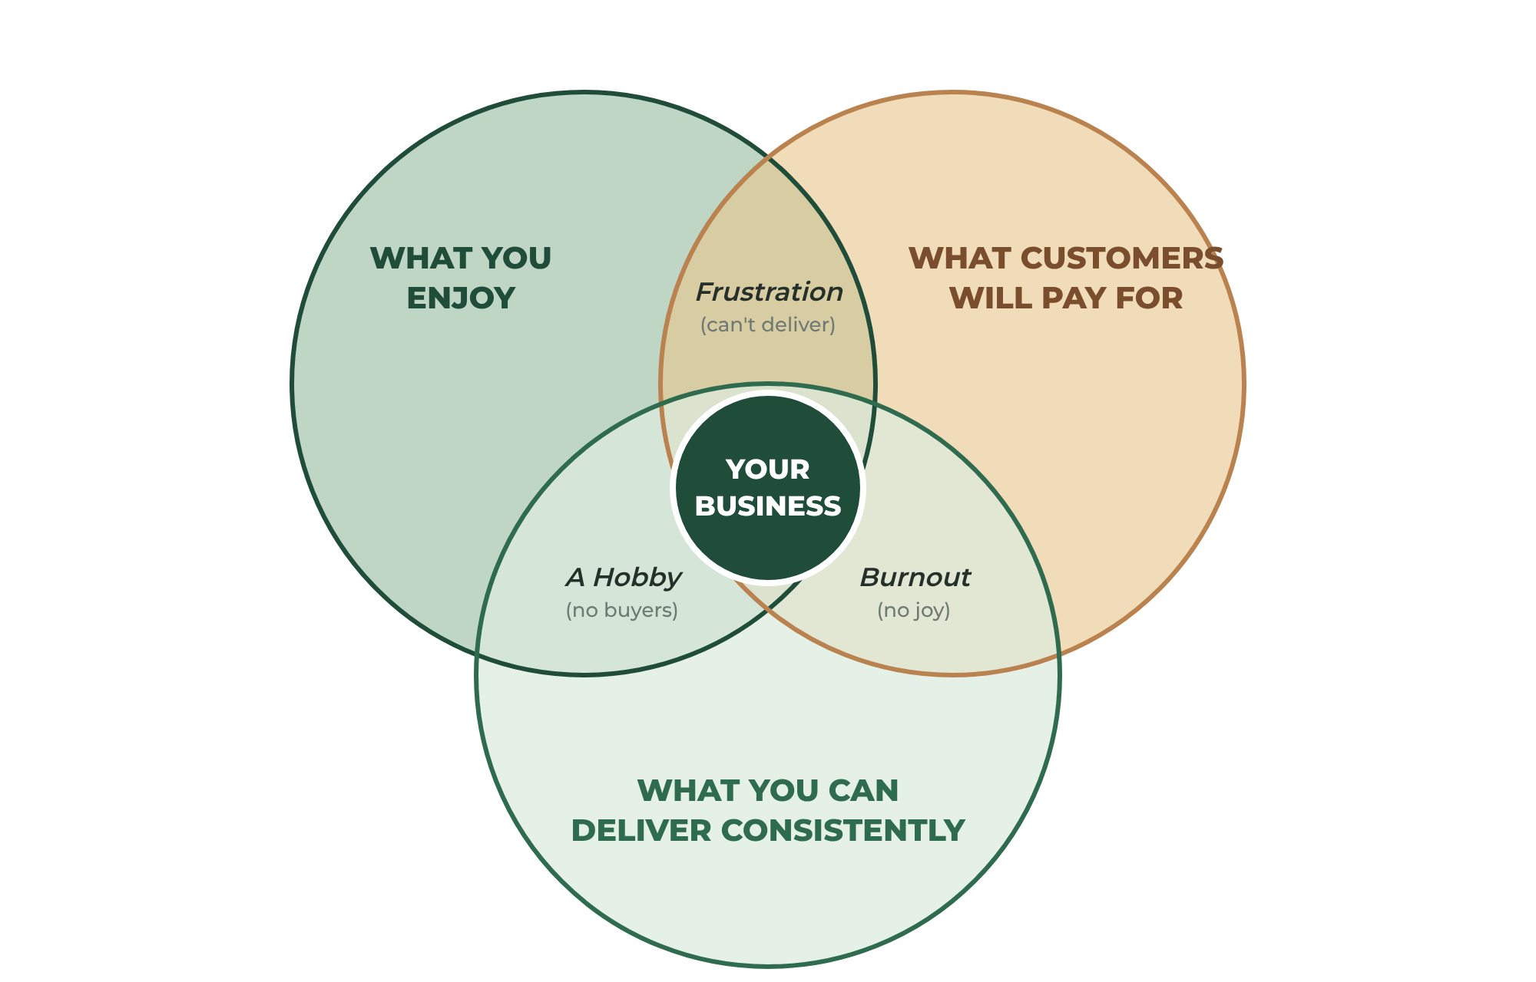
FIGURE 1.1 Your business lives where enjoyment, consistency, and customer demand overlap.
All three matter.
If you love making something that nobody wants to buy, you have a hobby.
If customers want it but you dislike making it, you will eventually burn out.
If you love it and people want it, but you cannot produce it consistently — because the materials are unreliable, the process is too slow, or the quality varies — you will disappoint the customers you work so hard to attract.
A profitable business requires passion, demand, and the ability to deliver.

Step 1: Take Inventory of Your Skills
Before you decide what to sell, take an honest inventory of what you can do. Most people underestimate themselves here. Skills you take for granted are often skills other people would gladly pay for.
Think in four categories:
- Hands — things you build, make, repair, or physically do. Woodworking, sewing, baking, cleaning, landscaping, assembling, painting.
- Head — things you know. Bookkeeping, tutoring, writing, software, organizing, planning, teaching.
- Eye — things you see that others don't. Design, photography, decorating, color, style, layout.
- Heart — ways you care for people, animals, or places. Pet sitting, senior help, childcare, coaching, event hosting.
Ask the people who know you best: "What do you always ask me to help with?" Their answers are market research.

Step 2: Decide — Products, Services, or Both?
Products and services are built differently, and each has real advantages.
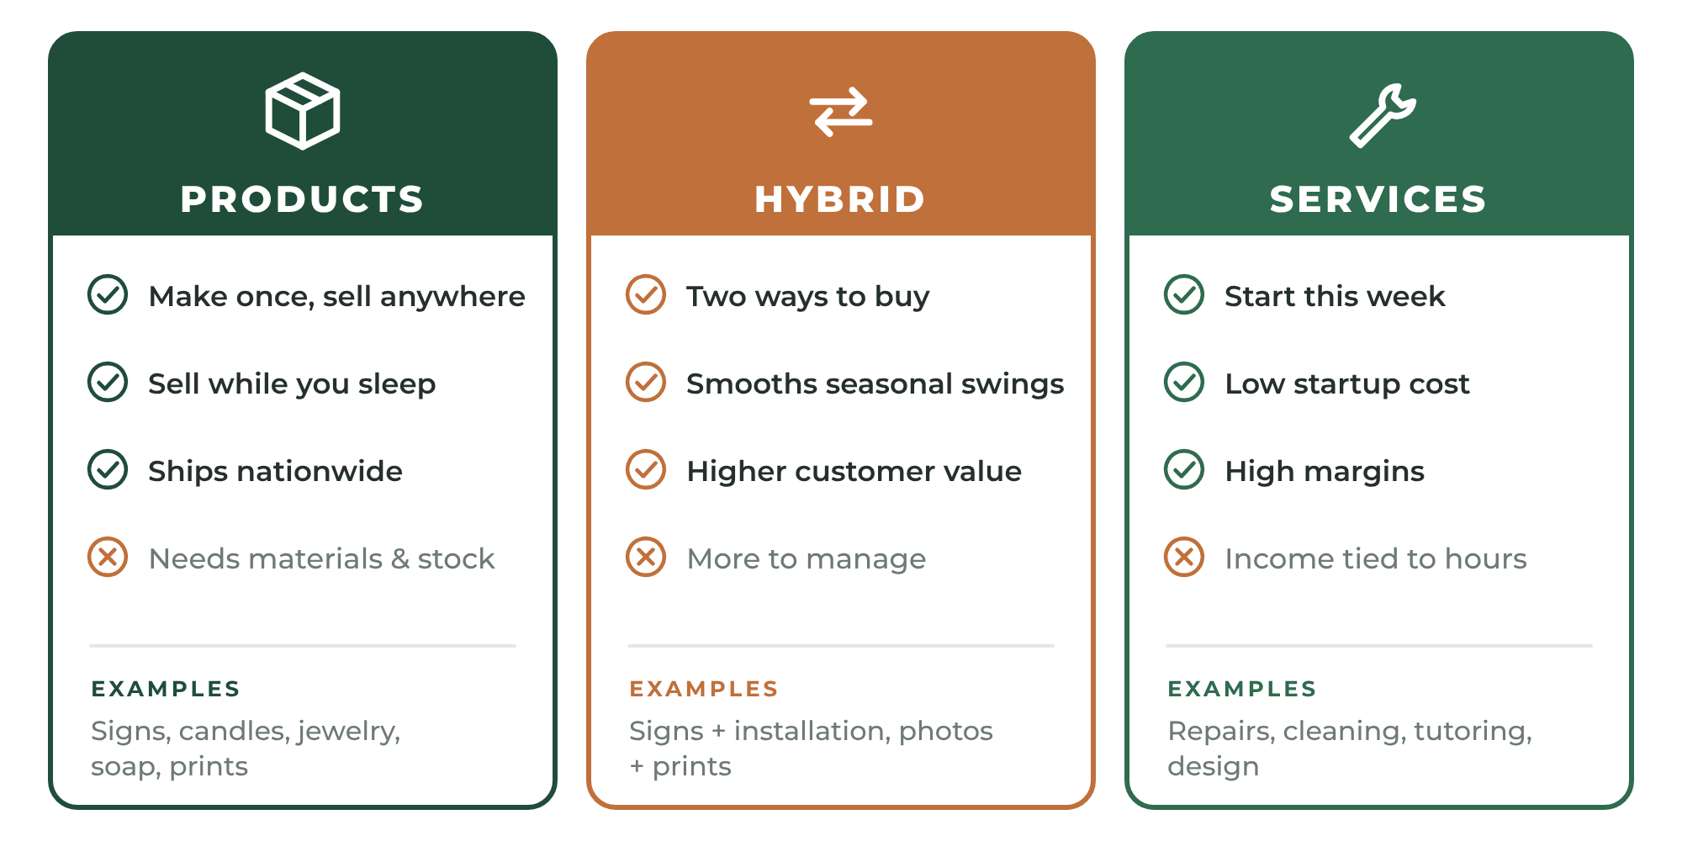
FIGURE 1.2 Products, services, and hybrids each have distinct strengths. Many durable businesses combine both.
Products can be made once and sold anywhere. They can ship across the country while you sleep. They can be photographed, listed, and discovered online. But they require materials, inventory, packaging, and shipping — and they tie up money before you are paid.
Services usually require little upfront money. You can start this week with tools you already own. Margins are often high because you are selling your skill, not raw materials. But your income is tied to your hours, and most services are limited to a geographic area or a time zone.
Hybrids combine both. A product business adds a service — custom design, installation, repair, or workshops. A service business adds a product — maintenance kits, prints, templates, or branded supplies. Hybrids smooth out seasonal swings and give customers more ways to buy from you.
PRO TIP
Starting Advice
If you have limited money to invest, a service is often the fastest path to your first dollar. If you have limited time to trade, a product is often the better long-term path. Many entrepreneurs start with a service to fund the product side of the business.

Step 3: Brainstorm Without Judging
Now generate options. Write down at least twenty products or services you could realistically offer. Don't edit yourself yet. Quantity creates quality — the best idea is rarely the first one.
Good prompts:
- What do people already ask me to make or do for them?
- What do I own (tools, equipment, a vehicle, a space) that could produce income?
- What do I see people complaining about that I could solve?
- What could I make or do better than what is currently available?
- What could I teach?

Step 4: Research Before You Build
Before investing hundreds of dollars in materials or equipment, spend time researching.
For products, look at online marketplaces such as Etsy, Amazon Handmade, eBay, and Facebook Marketplace. For services, search Google Maps, Nextdoor, Thumbtack, Angi, local Facebook groups, and freelance marketplaces like Upwork or Fiverr.
Study offers similar to yours. Pay attention to:
- Pricing
- Customer reviews
- Product or service descriptions
- Popular variations and packages
- Common customer complaints
Reviews are particularly valuable. Customers often tell you exactly what they wish a product or provider had done differently. Those comments can become your competitive advantage.
TRY THIS
Mine the Reviews
Pick five competitors. Read their three-, two-, and one-star reviews. Write down every complaint that appears more than once. Each repeated complaint is a promise you can make that they are not keeping: "Arrives without damage." "Shows up on time." "Answers messages the same day."

Step 5: Start Small
Many first-time sellers believe they need an entire catalog before launching. Many first-time service providers believe they must offer every possible service.
They do not.
A single excellent product can build an entire business. A single clearly defined service can fill a calendar.
Focus on one item or one service that people genuinely want and that you can deliver repeatedly with consistent quality.
Master one offer. Expand later.
EXAMPLE
Maya Chooses Her Offer
Maya lists twenty-three ideas — cutting boards, planters, coat racks, signs, and more. Her research shows that personalized cedar house-number signs sell steadily, ship easily, and draw complaints about faded paint and cracked wood. Maya knows how to seal cedar so it lasts outdoors. She chooses a single launch product: a personalized cedar address sign.

EXAMPLE
Marcus Chooses His Offer
Marcus could offer a dozen services, but he notices most requests from neighbors are the same: assembling furniture and mounting TVs and shelves. These jobs are quick, need only tools he already owns, and don't require a contractor's license in his area for small work. He chooses one clearly defined service: "Furniture Assembly & Wall Mounting."

YOUR ACTION STEPS
☐ Complete the Skills Inventory by asking three people what they always ask you to help with.
☐ Decide whether you are starting with a product, a service, or a hybrid.
☐ Brainstorm at least twenty ideas.
☐ Research five competitors and record their repeated complaints.
☐ Choose one launch offer.

WORKSHEET
Chapter 1: Offer Discovery
List at least 20 products or services you could realistically offer.

# | PRODUCT OR SERVICE IDEA | PRODUCT, SERVICE, OR BOTH?
1
2
3
4
5
6
7
8
9
10
11
12
13
14
15
16
17
18
19
20

WORKSHEET
Chapter 1: Offer Evaluation Matrix
Score your top five ideas from 1 (poor) to 10 (excellent) in each category.

CRITERIA | IDEA 1 | IDEA 2 | IDEA 3 | IDEA 4 | IDEA 5
Idea name
Customer demand
Profit potential
Ease of delivery
Startup cost (10 = low)
Shipping or travel simplicity
Personal enjoyment
Repeat purchase potential
TOTAL

The highest total becomes your launch offer. If two ideas tie, choose the one you can start with the least money.
My launch offer is:
Why I chose it:

2
CHAPTER

Validate Before You Build
━━━
The most expensive words in business are "I'm sure people will buy this."
Validation is the process of proving — with evidence instead of hope — that real customers will pay real money for your offer. It is the cheapest insurance you will ever buy.
You don't need a perfect answer. You need enough evidence to justify the next step.
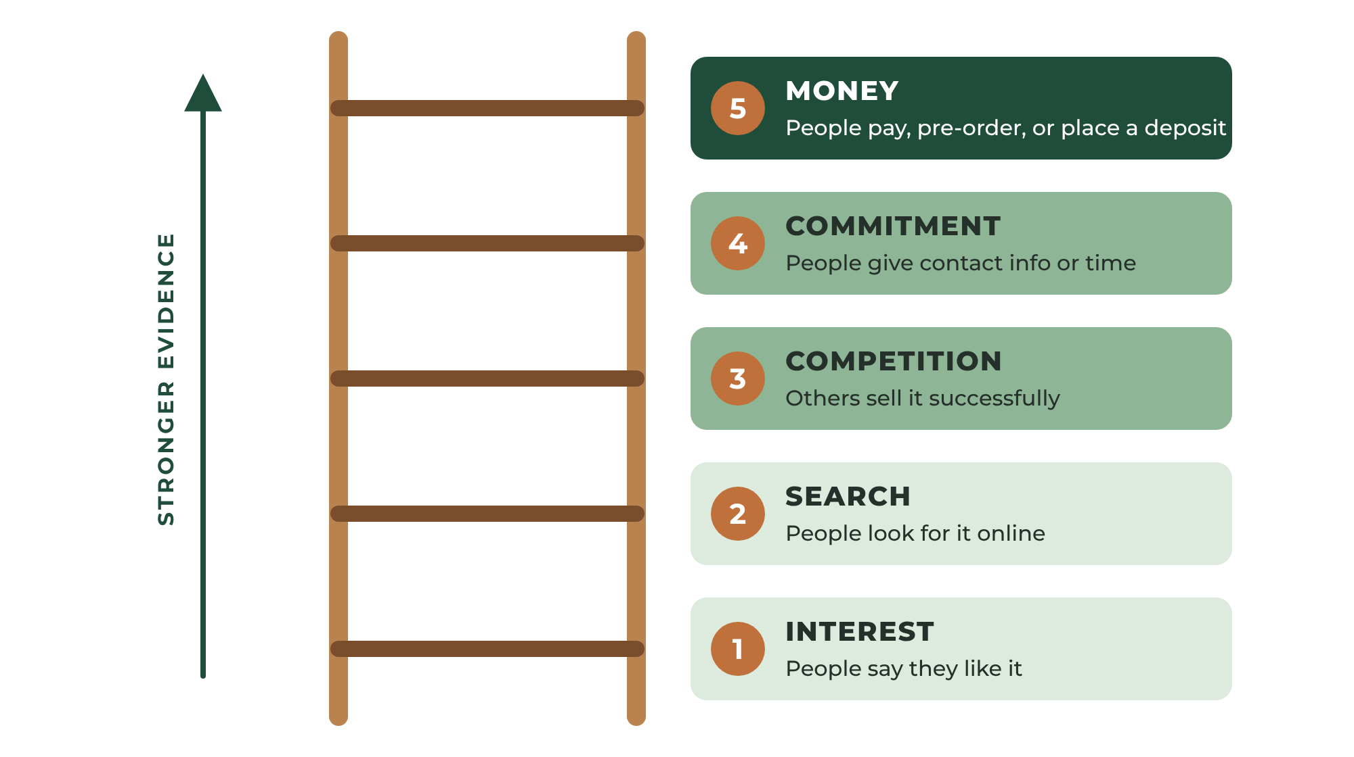
FIGURE 2.1 Validation moves from cheap signals to strong proof. Each step costs a little more and tells you a lot more.

The Validation Ladder
Think of validation as a ladder. Each rung gives stronger evidence than the one below.
- Interest — People say they like it. (Weak evidence. Friends are polite.)
- Search — People are actively looking for it online. (Better.)
- Competition — Others are already selling it successfully. (Good. Competition proves a market exists.)
- Commitment — People give you their email, phone number, or time. (Strong.)
- Money — People pay, place a deposit, or pre-order. (The only proof that truly counts.)
Climb as high as you can before spending serious money.

Step 1: Check Search Demand
Type phrases your customers would use into the search bars of Etsy, Amazon, Google, and Pinterest. Watch the suggestions that appear as you type. Those suggestions show what people actually search for.
For services, search "[your service] near me" and "[your service] [your town]." Look at how many local businesses appear, how many reviews they have, and how recently those reviews were written. Lots of recent reviews means steady local demand.

Step 2: Study Competitors Without Fear
Many new entrepreneurs panic when they find competitors.
Don't.
Competition is evidence. If nobody is selling what you plan to sell, it may be because nobody wants it.
Your job is not to find an empty market. Your job is to find a way to be clearly better for a specific customer. Better can mean:
- Higher quality or longer lasting
- Faster delivery or quicker response
- More personal or more customizable
- Better communication and reliability
- Serving a group others ignore (pet owners, seniors, small offices, left-handed people, a particular hobby)

Step 3: Define Your Ideal Customer
You can't sell to everyone. Trying to do so makes your message vague and your marketing expensive.
Picture one specific person who would love your offer. Give them a name. Where do they live? What do they care about? What problem are they trying to solve? Where do they spend time online and in person? What would make them hesitate?
The clearer this picture, the easier every later chapter becomes — branding, photography, listings, and marketing all speak to this one person.

Step 4: Test With Real People
Before you build inventory or print business cards, test.
For products: build a prototype and show it to people who match your ideal customer — not just family. Ask what they would pay, what they would change, and who they would buy it for. Better yet, offer it for pre-order.
For services: offer your service to three to five people at an introductory price in exchange for honest feedback and a review. Time yourself. Note every question they ask. Those questions will become your website's FAQ.
IMPORTANT
Beware of Polite Feedback
"That's so cute!" is not validation. "I'll take two — can you have them by Friday?" is validation. Pay attention to what people do, not what they say.

Step 5: Get to the First Dollar
The strongest validation is a sale. Find a way to collect real money as early as possible, even on a small scale: a pre-order, a deposit, a paid pilot job, a booth at a local market, or a post in a community group.
The first dollar changes everything. It turns a hobby into a business in your own mind.
EXAMPLE
Maya and Marcus Validate
Maya posts a photo of her prototype sign in a local community group with the words "Taking five pre-orders for October." She gets nine requests and collects deposits from six people. Marcus offers three neighbors a 50%-off introductory assembly job in exchange for honest reviews. Two of them book him again within a month. Both have climbed to the top rung: money.

YOUR ACTION STEPS
☐ Search for your offer on at least three platforms and record what you find.
☐ Write a one-paragraph description of your ideal customer.
☐ Test your offer with five people who match that description.
☐ Collect your first pre-order, deposit, or paid job.

WORKSHEET
Chapter 2: Validation Scorecard
Record evidence, not opinions.

VALIDATION STEP | WHAT I DID | WHAT I LEARNED | DONE?
Searched online marketplaces
Searched Google and maps
Studied 5 competitors
Defined my ideal customer
Tested with 5 real people
Collected a pre-order, deposit, or payment

MY IDEAL CUSTOMER
Name (imaginary):
Age range and life situation:
The problem they want solved:
Where they spend time online:
Where they spend time locally:
What would make them hesitate to buy:
What would make them say "yes":
HOW I WILL BE CLEARLY BETTER

3
CHAPTER

Understanding the Economics of Your Business
━━━
A business exists for one purpose: to generate profit.
That statement often surprises makers and service providers because they focus on creating and helping. Creation is important. Helping is important. But a business that does not make money eventually stops creating and stops helping.
One of the most dangerous habits among new entrepreneurs is underpricing.
They calculate the cost of materials — or they compare themselves to the cheapest competitor — and ignore everything else.
Unfortunately, materials are often the smallest expense.

The True Cost of What You Sell
The real costs of a product or service include:
- Materials — everything that goes into the product or is used up on the job
- Labor — your time, at a fair hourly rate
- Packaging and shipping supplies — boxes, mailers, tape, labels, inserts
- Marketplace and payment fees — listing fees, transaction fees, card processing fees
- Travel — fuel, vehicle wear, parking, and travel time for services
- Advertising — paid promotion, samples, business cards
- Equipment wear and tear — tools, blades, bits, machines, and software that eventually need replacing
- Overhead — insurance, licenses, phone, internet, website, utilities
- Taxes — income tax, self-employment tax, and any sales tax you must collect
Every one of these costs matters.
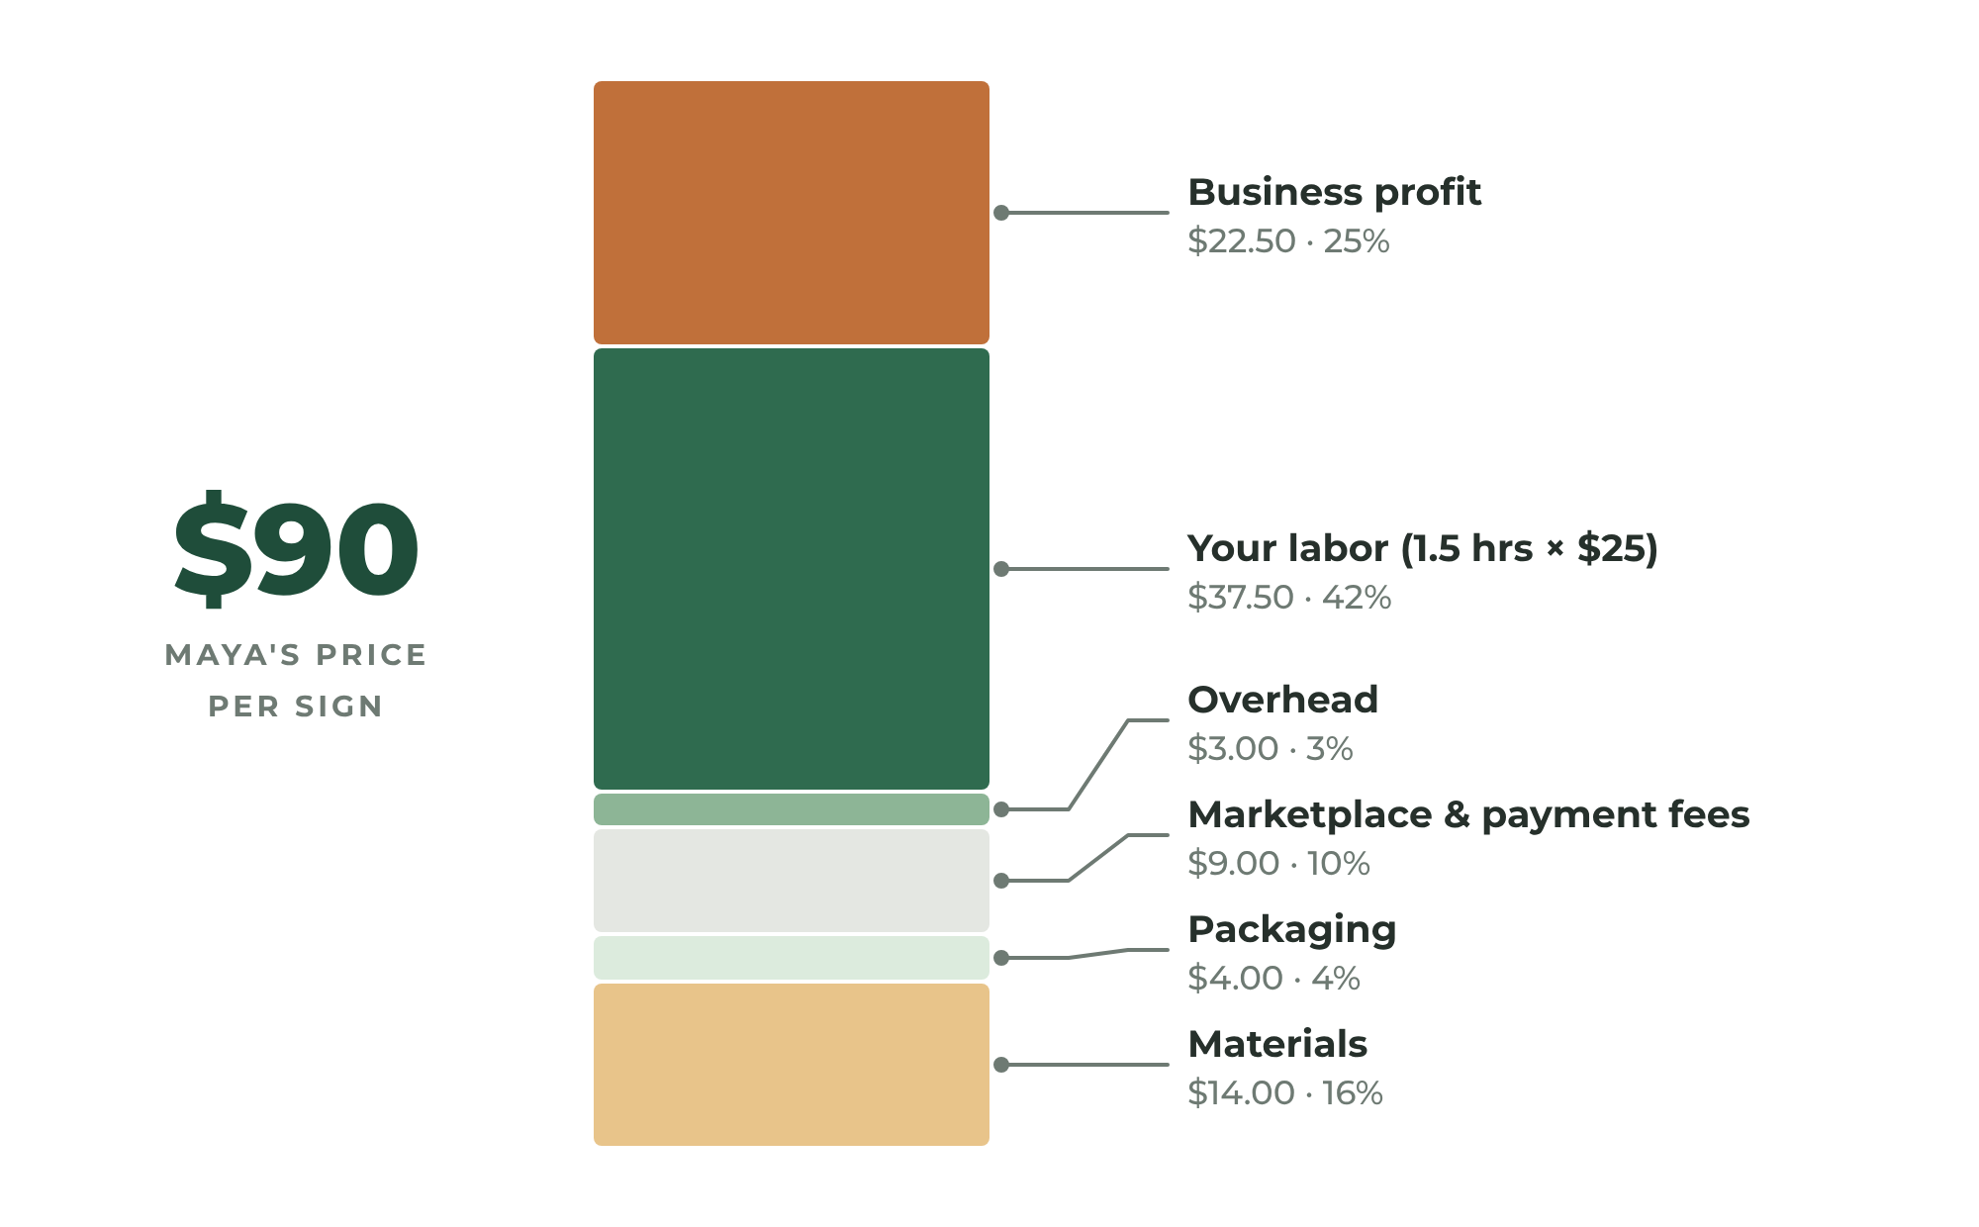
FIGURE 3.1 What is really inside a fair price. Materials are often the smallest slice.

Pay Yourself Properly
Your time has value.
If a project takes three hours to build, those three hours must be included in your pricing. If a service call takes two hours plus forty minutes of driving, all two hours and forty minutes must be paid for.
Too many makers and service providers unintentionally create jobs that pay less than minimum wage.
A business should create freedom. Not exhaustion.
Choose an hourly rate that reflects your skill and what you would expect to earn working for someone else with similar skills — then add to it, because as a business owner you carry risks and costs that an employee does not.
When customers buy from you, they are not merely buying wood, leather, metal, plastic, or an hour of work. They are buying:
- Your knowledge
- Your craftsmanship
- Your experience
- Your reliability
- Your time
Never apologize for charging appropriately.

Pricing Products: The Cost-Plus Method
The simplest reliable way to price a handmade product is to add up your true costs and then add profit.
- Materials — add up the cost of every material used in one unit.
- Labor — multiply your production hours by your hourly rate.
- Overhead per unit — estimate monthly overhead and divide by the number of units you expect to sell in a month.
- Fees — estimate marketplace and payment fees as a percentage of your price (check your platform's current fee schedule).
- Profit — add a profit margin, typically 20% to 50%, so the business earns money in addition to paying you for your labor.
EXAMPLE
Maya Prices Her Sign
Materials (cedar, sealant, paint, hardware): $14. Labor: 1.5 hours at $25 per hour = $37.50. Packaging: $4. Overhead per sign: about $3. Subtotal: $58.50. Allowing roughly 10% of the selling price for fees and a 25% profit margin brings her to about $90. Her cheapest competitors charge $45 — but their reviews mention fading and cracking. Maya prices at $89, explains why her sign lasts, and sells out her first batch.

PRO TIP
Wholesale and Retail
If you ever plan to sell to shops, remember that retailers typically buy at about half of the retail price. Price your products so that you can still make a profit at wholesale. If you can't, your retail price is probably too low.

Pricing Services: Four Models
Services can be priced in several ways. Each fits different situations.
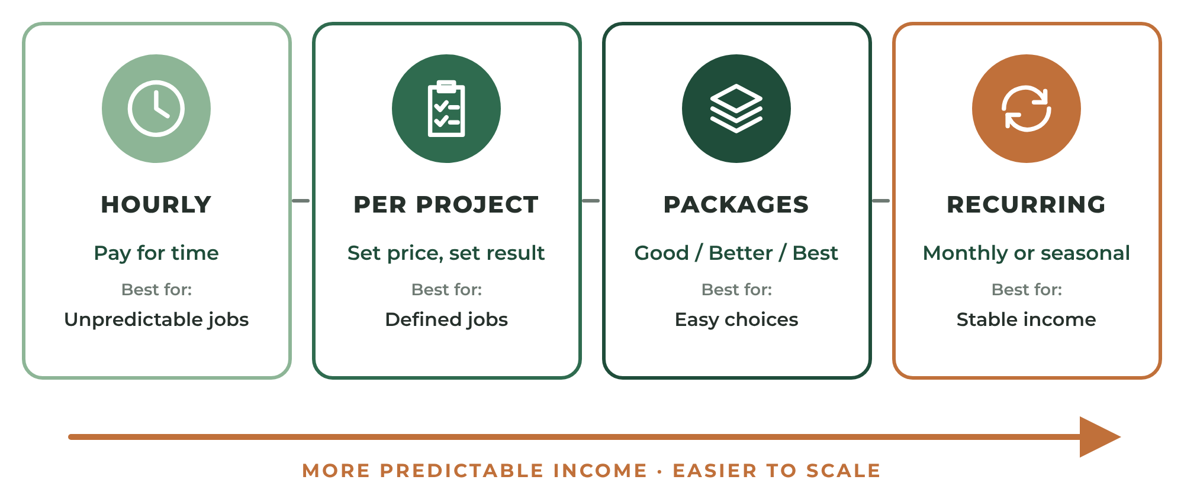
FIGURE 3.2 Four common ways to price a service, from simplest to most scalable.
- Hourly — simple and fair for unpredictable work. The downside: customers watch the clock, and you earn less as you get faster.
- Per project (flat rate) — a set price for a defined result. Customers love the certainty, and you earn more as you become more efficient. You must define the scope carefully.
- Packages — bundles of services at tiered prices, such as Basic, Standard, and Premium. Packages make choosing easy and naturally encourage customers to spend more.
- Recurring (retainer or subscription) — a fixed monthly fee for ongoing service, such as lawn care, cleaning, bookkeeping, or maintenance. Recurring revenue is the most stable income a small business can have.
Whatever model you choose, include travel time, preparation, cleanup, communication, and invoicing. A "one-hour" job almost never takes one hour.
EXAMPLE
Marcus Moves to Flat Rates
Marcus started at $30 per hour. He soon realized he was assembling a standard bookcase in 40 minutes — and earning $20 for it. He switched to flat rates: $65 for a standard bookcase, $85 for a TV mount, $45 for each additional item. His customers prefer knowing the price in advance, and his average earnings per hour more than doubled.

Know Your Break-Even Point
Your break-even point is the number of sales you need each month just to cover your fixed costs. Every sale above that number produces profit.
Break-even sales = Monthly fixed costs ÷ Profit per sale
If your fixed costs (insurance, software, phone, website, equipment payments) are $300 per month and each sale earns $30 after materials and fees, you need 10 sales per month to break even. Sale number eleven is your first profitable sale of the month.
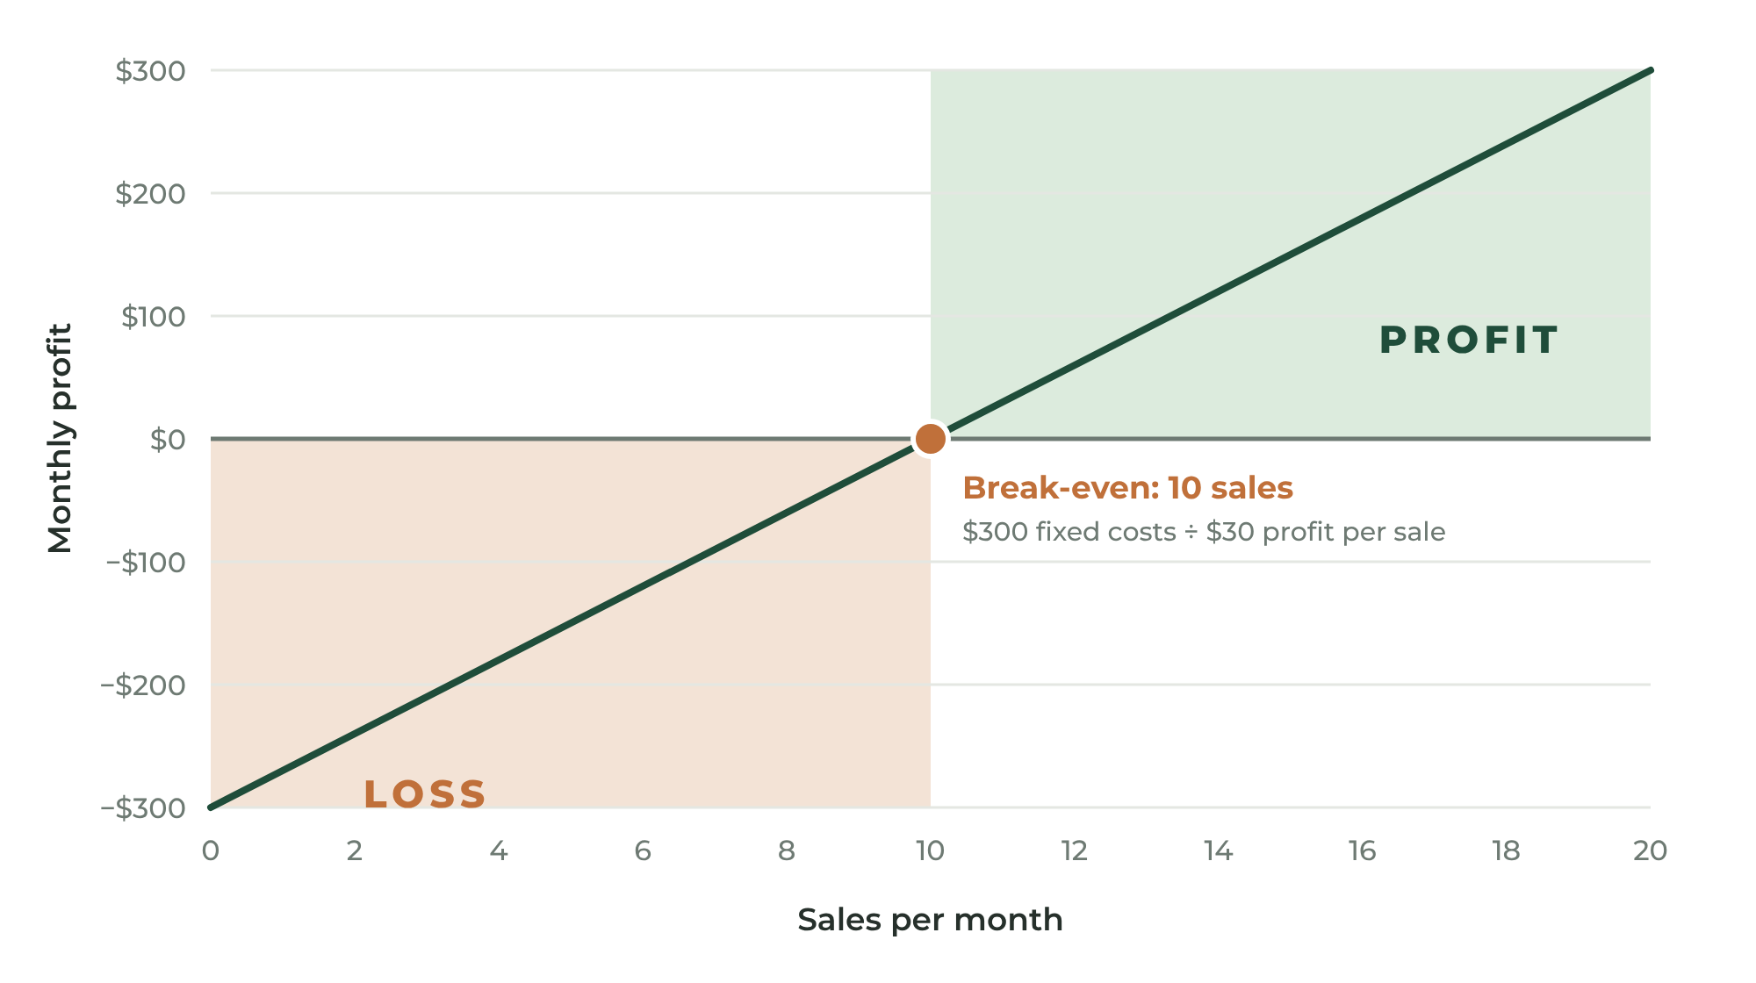
FIGURE 3.3 Below the break-even point you lose money. Above it, every sale adds profit.

Psychology of Price
Price communicates quality. A price that is too low can make customers wonder what is wrong with your work.
- Don't compete on being cheapest. Someone can always charge less. Compete on value.
- Offer three options. When customers see a good, better, and best option, most choose the middle — and some choose the best.
- Raise prices as demand grows. If you are booked solid or selling out, your prices are too low.
- Explain your price. Tell customers what makes your work last longer, look better, or save them time.

YOUR ACTION STEPS
☐ Calculate the true cost of your launch offer, including your time.
☐ Set a price that includes profit — not just costs.
☐ If you offer a service, choose a pricing model and create three packages.
☐ Calculate your monthly break-even point.

WORKSHEET
Chapter 3: Product Pricing Calculator
Complete one calculator for each product.

Product:
MATERIALS COST (PER UNIT)
Primary material: $
Paint / finishing / supplies: $
Hardware / components: $
Packaging: $
Other: $
Total materials: $
LABOR
Hours required: Hourly rate goal: $
Labor cost (hours × rate): $
BUSINESS EXPENSES (PER UNIT)
Marketplace & payment fees: $
Advertising: $
Equipment & overhead: $
Total business expenses: $
PRICE
True product cost (materials + labor + expenses): $
Desired profit (20%–50%): $
Recommended retail price: $
Wholesale price (if applicable): $

WORKSHEET
Chapter 3: Service Pricing Calculator
Complete one calculator for each service.

Service:
TIME
Hands-on time (hours): Travel time (hours):
Prep / cleanup time: Admin & communication time:
Total time per job (hours):
COSTS
Hourly rate goal: $
Labor cost (total time × rate): $
Materials / supplies used: $
Travel cost (fuel, mileage): $
Overhead per job: $
Total cost per job: $
PRICE
Desired profit (20%–50%): $
Recommended flat rate: $
PACKAGE IDEAS
PACKAGE | WHAT'S INCLUDED | PRICE
Basic
Standard
Premium

WORKSHEET
Chapter 3: Break-Even Calculator
Know the number you must hit every month.

FIXED MONTHLY COST | AMOUNT
Insurance
Phone & internet (business share)
Website & software
Licenses & permits (monthly share)
Equipment payments
Marketing
Other
TOTAL FIXED COSTS

Average profit per sale (price − materials − fees): $
Break-even sales per month (fixed costs ÷ profit per sale):
My monthly sales goal (must exceed break-even):

PART TWO

MAKING IT REAL
━━━━
Set up your business properly, build a brand people remember, and create quality you can repeat.
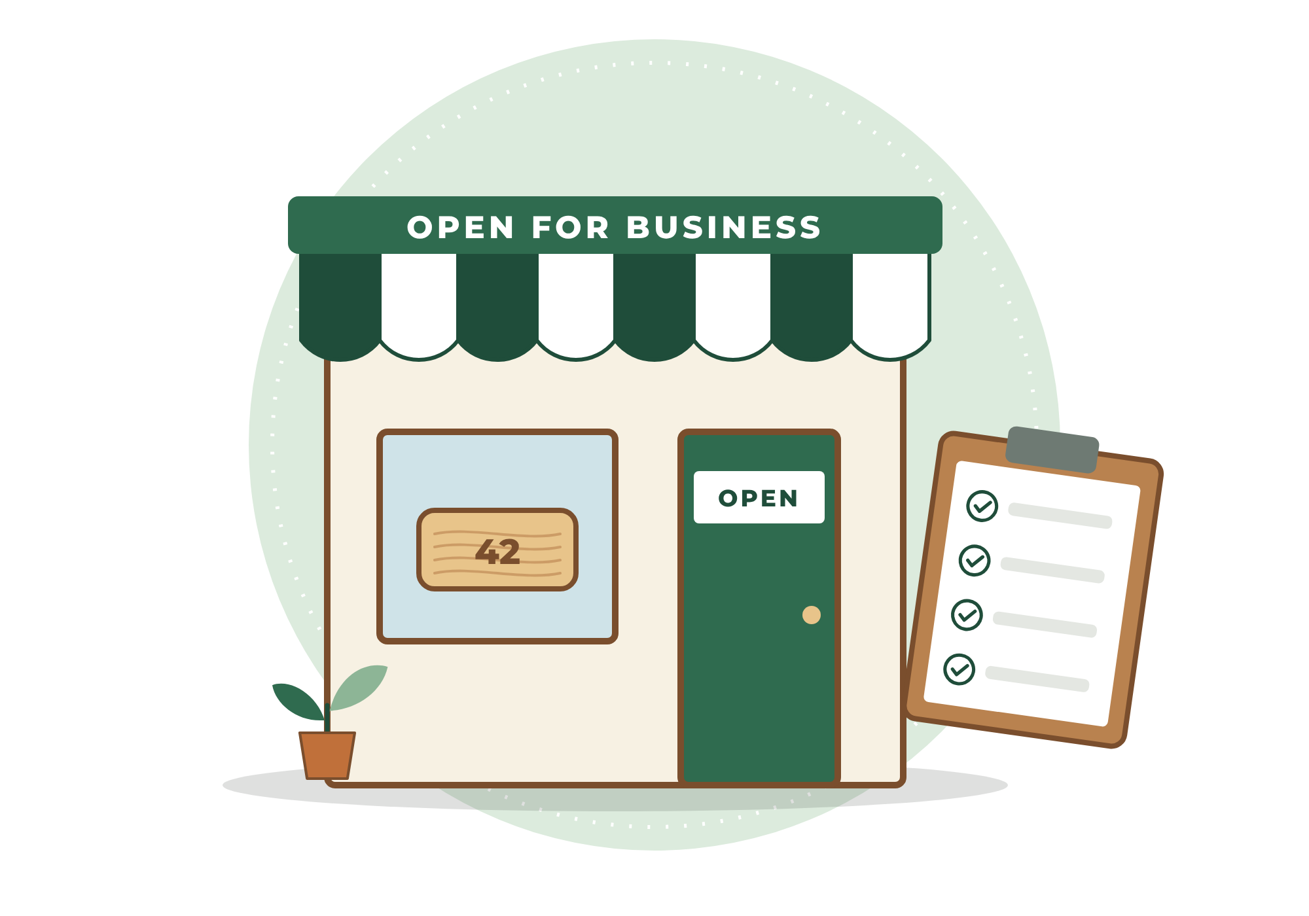

4
CHAPTER

Making It Official
━━━
There is a moment when a side project becomes a business. Usually it happens quietly — the first time a stranger pays you.
From that moment, you have responsibilities: to your customers, to the government, and to yourself. The good news is that setting up a small business properly is far simpler and less expensive than most people fear. Most of it can be done online in a weekend.
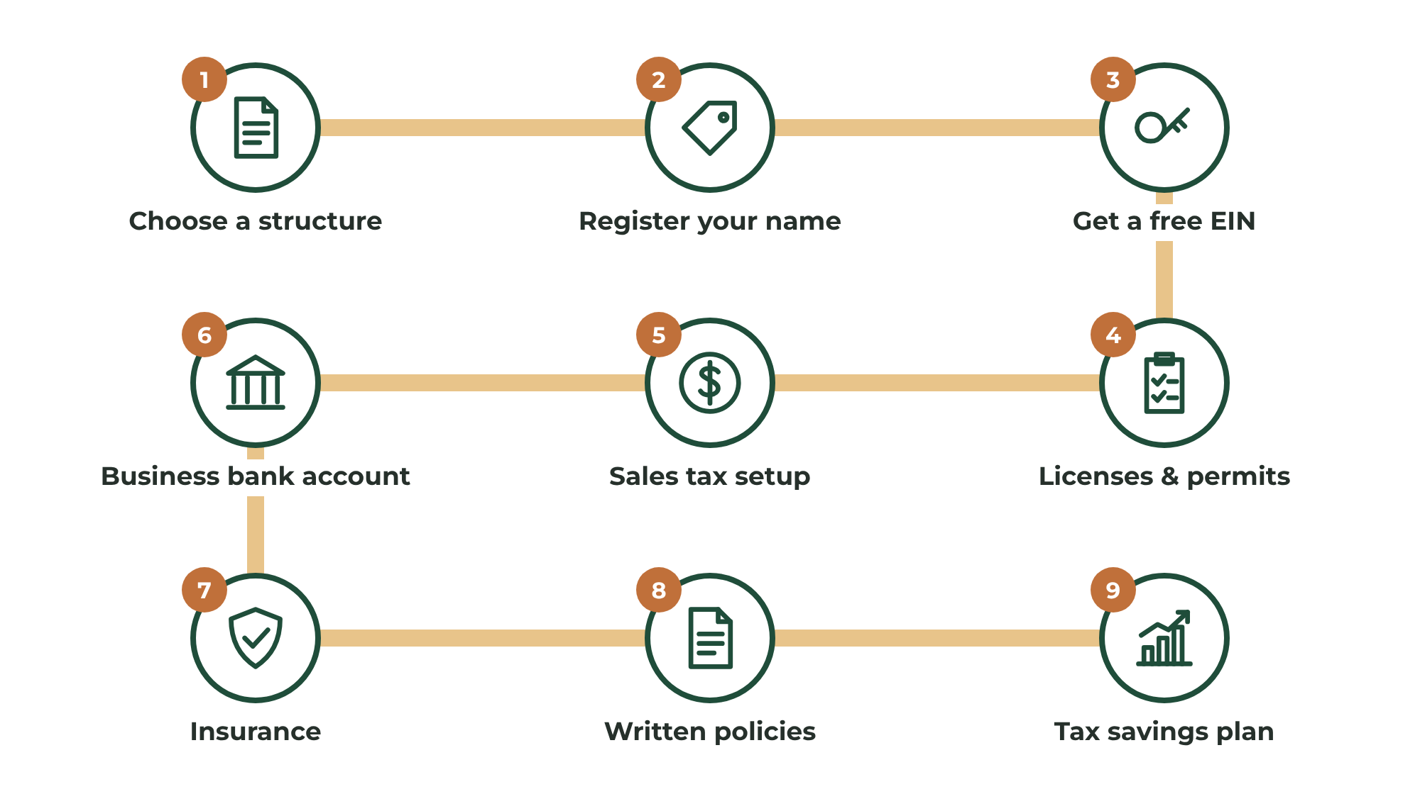
FIGURE 4.1 The typical setup path for a small business. Each step builds on the one before it.
IMPORTANT
Not Legal or Tax Advice
The information in this chapter is general and written primarily for readers in the United States. Requirements vary by state, county, city, and country, and they change over time. Always confirm requirements with your state and local government, and consider a brief consultation with an accountant or attorney. Your local Small Business Development Center (SBDC) or SCORE chapter offers free or low-cost guidance.

Step 1: Choose a Business Structure
Your business structure determines how you are taxed and how much personal liability you carry.
- Sole proprietorship — The default. If you start selling without registering anything, you are a sole proprietor. It is simple and inexpensive, but there is no legal separation between you and the business. If the business is sued, your personal assets may be at risk.
- Limited Liability Company (LLC) — Registered with your state for a filing fee that varies widely by state. An LLC creates a legal separation between your personal assets and business debts, as long as you keep business and personal finances separate. For tax purposes, a single-member LLC is usually treated much like a sole proprietorship, which keeps taxes simple.
- Corporations (S-corp or C-corp) — More paperwork and formality. Usually not necessary at the start, though some growing businesses elect S-corp tax treatment later to manage taxes. This is a conversation for your accountant.
Many makers and service providers start as sole proprietors and form an LLC once sales are steady or once they take on work with higher risk — such as working inside customers' homes or selling products people use with children, food, or the body.

Step 2: Register Your Business Name
If you operate under any name other than your own legal name, most states and counties require you to register it. This is often called a DBA ("doing business as"), an assumed name, or a fictitious business name. If you form an LLC, your LLC name is registered as part of the formation.
Before you fall in love with a name, check that it is available:
- Your state's business entity search
- The U.S. Patent and Trademark Office trademark search
- Domain name availability
- Social media handle availability
- A simple web search for businesses using similar names in your field

Step 3: Get an EIN
An Employer Identification Number (EIN) is like a Social Security number for your business. It is free from the IRS and can be obtained online in minutes. Even if you have no employees, an EIN lets you open a business bank account and keeps you from handing out your Social Security number on forms. Only apply directly through the IRS website — you never need to pay a third party for an EIN.

Step 4: Licenses, Permits, and Special Rules
Depending on your location and what you sell, you may need:
- A general business license from your city or county
- A home occupation permit if you operate from home
- A sales tax permit (also called a seller's permit) from your state
- Professional or trade licenses for certain services such as electrical, plumbing, HVAC, cosmetology, childcare, or general contracting above certain dollar thresholds
Some products have special rules:
- Food — Many states have "cottage food" laws that allow certain low-risk foods to be made at home and sold directly to customers, often with labeling requirements and sales limits. Rules vary greatly by state.
- Children's products — Products designed primarily for children 12 and under are subject to federal safety requirements in the U.S., including testing and certification for things like lead content. Research this before selling toys, kids' clothing, or children's décor.
- Cosmetics, candles, and soaps — Labeling rules and ingredient requirements may apply, and claims about health benefits can trigger additional regulation.
- Electrical and safety items — Products that plug in, hold weight, or could cause injury carry higher liability.
Call or visit your city or county clerk's office and simply ask: "I'm starting a small business selling [your offer] from home. What licenses or permits do I need?" Clerks answer this question every day.

Step 5: Understand Sales Tax
Sales tax rules depend on your state and on where you sell.
- In most U.S. states, large online marketplaces such as Etsy, Amazon, and eBay collect and remit sales tax on your behalf for sales made through their platforms.
- When you sell through your own website, at craft fairs, or directly to local customers, you are usually responsible for collecting and remitting sales tax yourself.
- Many states do not tax most services, but some do. Check your state's rules for your specific service.
Your state's department of revenue website explains how to register, what to collect, and how often to file.

Step 6: Open a Separate Bank Account
This is one of the most important steps in this entire book.
Never mix business and personal money. Open a dedicated business checking account and route every business dollar in and out of it. A separate account:
- Makes bookkeeping and taxes dramatically easier
- Helps protect the liability shield of an LLC
- Shows you, at a glance, whether your business is actually making money
- Makes you look professional to customers and payment platforms

Step 7: Protect Yourself With Insurance
Insurance protects everything you are building.
- General liability insurance covers injuries or property damage you cause — essential for service providers working in customers' homes.
- Product liability insurance covers harm caused by a product you made. Some craft fairs and retailers require it.
- Home-based business coverage — Most homeowner's and renter's policies exclude business equipment and inventory. Ask your agent about a business endorsement or a separate policy.
- Commercial auto — If you drive to jobs, confirm that your personal auto policy covers business use.
Many insurers offer affordable policies designed for makers, artisans, and small service businesses.

Step 8: Put Your Policies in Writing
Clear policies prevent most disputes. Before your first sale, write down:
- For products: processing time, shipping methods, returns and exchanges, damaged-item procedure, and custom-order policies (custom orders are usually non-refundable once production begins).
- For services: what is and is not included, how you quote, deposits, cancellation and rescheduling terms, payment terms, and what happens if the customer is not satisfied.
For larger service jobs, use a simple written agreement or quote that the customer signs or approves in writing. It does not need to be complicated. It needs to be clear.

Step 9: Understand Your Tax Responsibilities
When you work for yourself, no one withholds taxes from your income. In the U.S., you are generally responsible for income tax and self-employment tax (which covers Social Security and Medicare) on your business profit. Once you expect to owe a meaningful amount, the IRS expects estimated tax payments during the year, typically quarterly.
A simple habit protects you: set aside a percentage of every payment for taxes in a separate savings account. Many small business owners set aside 25% to 30% of profit. Chapter 14 shows you how.
EXAMPLE
Maya and Marcus Make It Official
Maya registers a DBA for "Cedar & Pine Sign Co.," gets a free EIN, registers for a state sales tax permit for her craft fair sales, opens a business checking account, and adds a business endorsement to her homeowner's insurance. Marcus forms an LLC because he works inside customers' homes, purchases a general liability policy, confirms the size of jobs he can legally take without a contractor's license, and writes a one-page service agreement.

YOUR ACTION STEPS
☐ Choose your business structure and register your name.
☐ Get your free EIN directly from the IRS.
☐ Ask your city or county which licenses and permits apply to you.
☐ Open a separate business bank account.
☐ Get insurance quotes and write your policies.

WORKSHEET
Chapter 4: Business Setup Checklist
Check off each step as you complete it.

STEP | NOTES / ACCOUNT NUMBERS / DATES | DONE
Chose business structure
Searched name availability
Registered DBA or LLC
Obtained EIN
City or county business license
Home occupation permit (if needed)
Sales tax permit (if needed)
Trade or professional license (if needed)
Product-specific rules researched
Opened business bank account
Purchased insurance
Wrote shop or service policies
Created tax savings account
Chose a bookkeeping method

HELPFUL CONTACTS
City / county clerk:
State business registration office:
Accountant or tax preparer:
Insurance agent:
Local SBDC or SCORE mentor:

5
CHAPTER

Building a Brand People Remember
━━━
Most people misunderstand branding. They think branding means a logo.
A logo is part of branding. It is not branding.
A brand is the emotional experience customers associate with your business — what they feel, expect, and say about you when you're not in the room.
Think about the businesses you trust. Why do you trust them?
Because they consistently meet expectations.
Trust is the foundation of every strong brand.
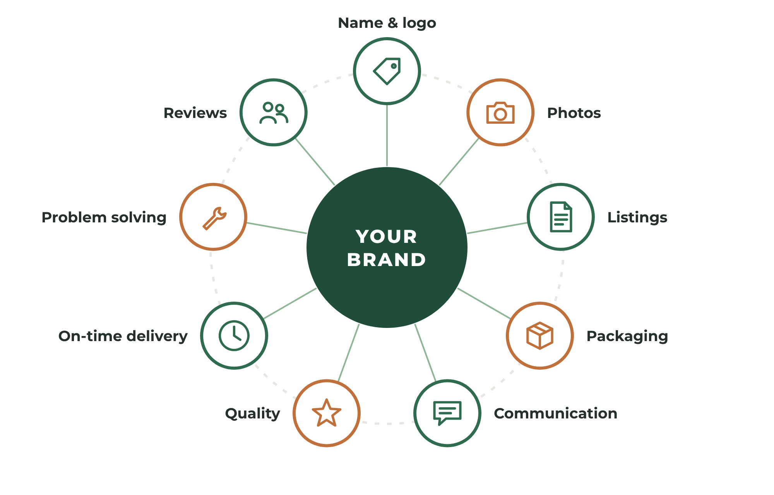
FIGURE 5.1 Your brand is built at every touchpoint, not just in your logo.

Step 1: Choose a Simple Name
The best business names are:
- Easy to spell
- Easy to remember
- Easy to pronounce
- Available as a domain and on social media
A customer should be able to hear your business name once and remember it later.
Avoid complicated names, trendy misspellings, and long phrases. Be cautious about names that limit your future — "Bob's Birdhouses" is a hard name to grow if you later sell furniture.
Simple almost always wins.
Naming approaches that work:
- Your name — "Lisa Martin Pottery." Personal and trustworthy, especially for services.
- Descriptive — "Northside Furniture Assembly." Instantly clear about what you do and where.
- Evocative — "Cedar & Pine Sign Co." Creates a feeling and a style.
- Place-based — "Blue Ridge Candle Works." Builds local pride and connection.

Step 2: Write Your Mission Statement
A mission statement explains who you serve and why you exist. Keep it to one sentence:
"We create __________ for __________ so they can __________."
Examples:
- "We create handcrafted cedar décor for homeowners so they can personalize and beautify their property."
- "We assemble and install furniture for busy families so they can enjoy their homes without the frustration."
Your mission statement guides every decision. When you are unsure whether to add a product, accept a job, or try a marketing idea, ask: Does this serve our mission?

Step 3: Define Your Brand Personality
If your business were a person, how would it talk and dress? Choose three words that describe your brand's personality — for example, rustic, warm, and dependable or modern, playful, and bold.
Those three words guide your colors, fonts, photos, packaging, and the way you write messages to customers.

Step 4: Create Simple Visual Identity
You don't need an expensive designer to start. You need consistency.
- Logo — A clean wordmark (your business name in a good font) is enough to begin. It should be readable at small sizes, on a phone screen, and in one color.
- Colors — Choose two main colors and one accent color. Use them everywhere.
- Fonts — Choose one font for headings and one for body text.
- Photo style — Decide on backgrounds, lighting, and mood, and keep them consistent.
Write these choices down in a one-page brand guide so that everything you create looks like it belongs together.

Step 5: Write a Tagline
A tagline is a short phrase that captures your promise. Examples:
- Handcrafted With Purpose.
- Built To Last.
- Made By Hand. Made To Matter.
- On Time. Done Right.
- We Show Up.

Step 6: Deliver on Your Promise
Your brand is built through actions. Customers remember:
- Product quality and workmanship
- Communication and responsiveness
- Packaging and presentation
- Delivery speed and punctuality
- How you handle problems
Every customer interaction strengthens or weakens your reputation. Over time, reputation becomes your greatest advertising asset.
Your logo gets attention. Your reputation gets referrals.
FOR SERVICE PROVIDERS
For Service Providers: You Are the Brand
In a service business, customers often meet you before they meet your work. Your appearance, your vehicle, how quickly you reply, whether you arrive on time, and whether you leave the space cleaner than you found it all communicate your brand. A branded shirt and a clean, professional message cost little and build enormous trust.

YOUR ACTION STEPS
☐ Choose a business name and confirm it is available.
☐ Write your one-sentence mission statement.
☐ Choose three brand personality words.
☐ Create a simple wordmark logo, color palette, and font pair.
☐ Write your tagline and a one-page brand guide.

WORKSHEET
Chapter 5: Business Identity Builder
Shape the brand customers will remember.

BUSINESS NAME IDEAS
# | NAME IDEA | DOMAIN AVAILABLE? | SOCIAL AVAILABLE?
1
2
3
4
5
6

My chosen business name:
MISSION STATEMENT
"We create / provide ____________________ for ____________________ so they can ____________________."

BRAND PERSONALITY — THREE WORDS
Word 1: Word 2: Word 3:
VISUAL IDENTITY
Main color 1: Main color 2: Accent color:
Heading font: Body font:
Photo style (background, lighting, mood):
TAGLINE
Examples: Handcrafted With Purpose. Built To Last. On Time. Done Right.
My tagline:

6
CHAPTER

Creating Consistent Quality
━━━
Launching too early creates unnecessary pressure. Launching without standards creates unhappy customers.
Before you open your doors, you need to know that you can deliver the same excellent result — every time, for every customer.

For Makers: Build Inventory Before You Launch
Creating some inventory before opening your store gives you confidence and flexibility. Producing several examples of your product teaches valuable lessons. You discover:
- Production bottlenecks
- Material needs and supplier issues
- Common defects
- Packaging challenges
Most importantly, you learn your true production time. Knowing exactly how long something takes to make is essential for pricing and planning.

Batch Your Work
Making one item at a time from start to finish is slow. Professionals work in batches: cut all the pieces, then sand all the pieces, then finish all the pieces, then package everything. Each setup happens once instead of five times, and your hands get faster through repetition.
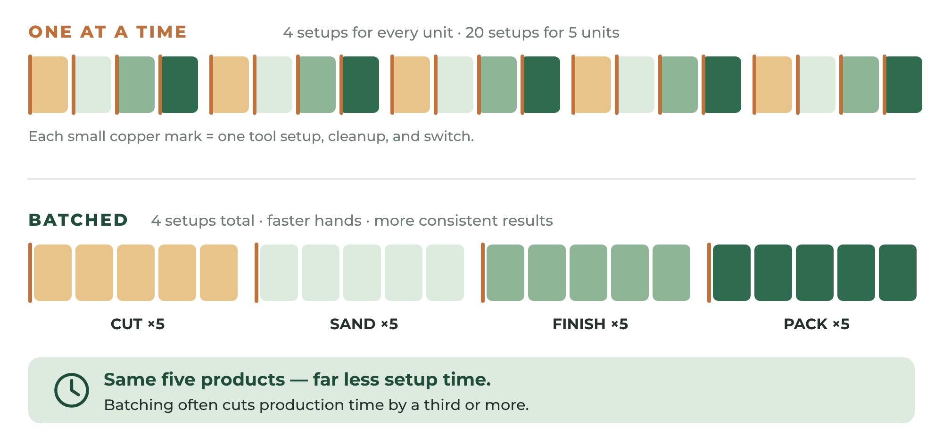
FIGURE 6.1 Batching groups the same task across many units, saving setup time and improving consistency.

For Service Providers: Design Your Service Delivery
A service is a product too — it just happens in real time. Map every step a customer experiences, from the first message to the final payment:
- Inquiry received and answered
- Quote or estimate given
- Appointment booked and confirmed
- Reminder sent the day before
- Arrival on time, introduction, and walk-through
- Work completed to standard
- Cleanup and final walk-through with the customer
- Payment collected
- Thank-you and review request sent
- Follow-up for future service
When every job follows the same steps, quality becomes predictable. Predictable quality becomes reputation.
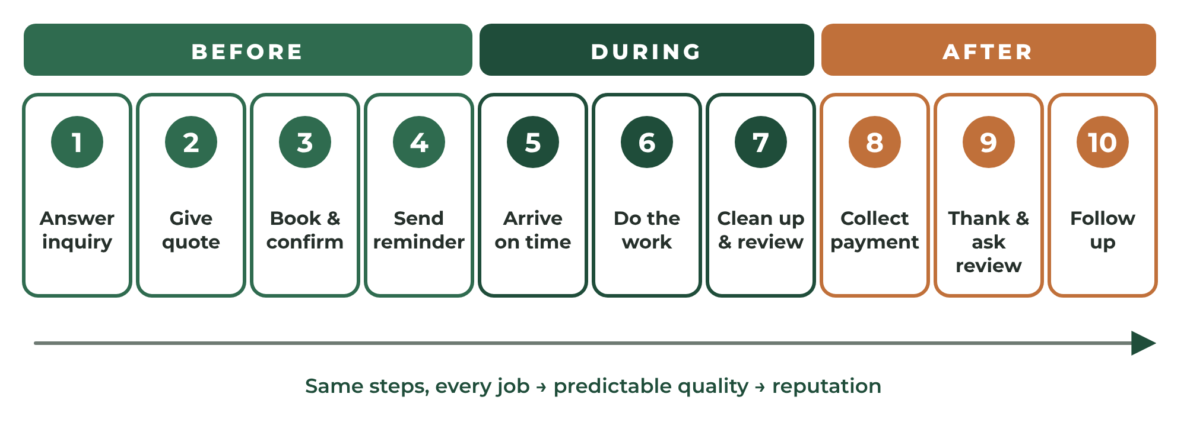
FIGURE 6.2 A service blueprint maps every step from first contact to follow-up.

Create Quality Standards
Professional businesses operate using standards. Every product or job should meet those standards before it is considered finished.
Ask yourself:
- Would I proudly display this product in my own home?
- Would I give it as a gift?
- Would I pay full price for this job if I were the customer?
- Would I feel comfortable if this product or job represented my business online?
If not, improve it.
Turn your standards into a written quality checklist. For a product, it might include finish smoothness, color accuracy, hardware secure, no visible glue, and clean packaging. For a service, it might include all items level and secure, all packaging removed, area vacuumed, and customer walk-through completed.
Customers notice details. Quality creates repeat buyers.

Source Materials Reliably
Consistency depends on your suppliers. Identify at least two sources for every critical material. Buy samples before buying in bulk. Keep a supplier list with prices, lead times, and contact information. As you grow, buying in larger quantities can significantly reduce your cost per unit — but don't buy in bulk until your product is proven.
EXAMPLE
Maya Finds Her Bottleneck
Maya's time study reveals that painting letters takes twice as long as anything else. She buys a set of reusable stencils and switches to batch painting on Sundays. Her production time drops from 90 minutes to 55 minutes per sign — a 39% improvement that goes straight to her profit.

YOUR ACTION STEPS
☐ Produce at least five units (or complete at least three jobs) before your official launch.
☐ Complete a time study and identify your bottleneck.
☐ Write a quality checklist.
☐ Map your service blueprint or production flow.
☐ Create a supplier list with backups.

WORKSHEET
Chapter 6: Production Planning & Time Study
Map your process and measure it.

Product or service:
STEP | DESCRIPTION | TIME (1ST TRY) | TIME (5TH TRY) | TOOLS / MATERIALS NEEDED
1
2
3
4
5
6
7
8

Total time (1st): Total time (5th):
My biggest bottleneck is:
How I can batch or simplify it:

WORKSHEET
Chapter 6: Quality Standards Checklist
Every item must pass before it goes to a customer.

QUALITY STANDARD | HOW I CHECK IT

SUPPLIER LIST
MATERIAL | SUPPLIER | PRICE | LEAD TIME | BACKUP SUPPLIER

PART THREE

GETTING READY TO SELL
━━━━
Choose where to sell, let your photos do the talking, write listings that sell, and launch.
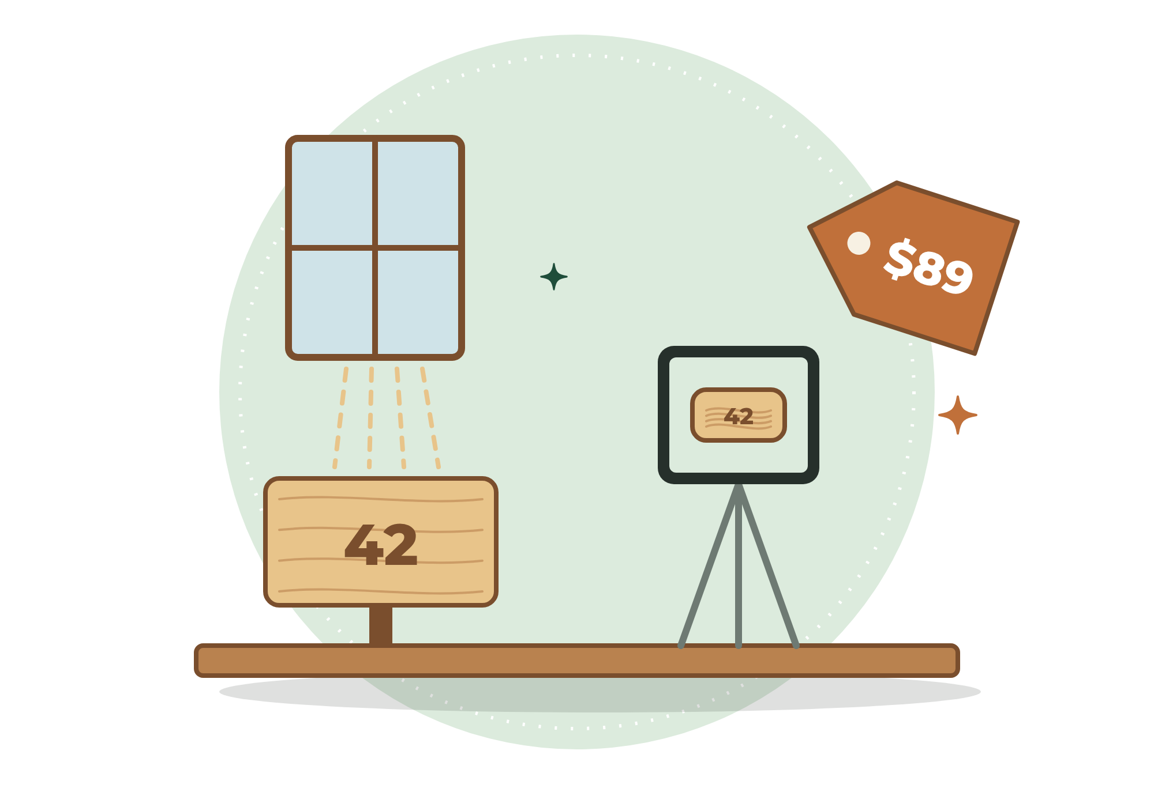

7
CHAPTER

Choosing Where to Sell
━━━
You don't need to be everywhere. You need to be where your customers already look.
Every sales channel has strengths and trade-offs. The right choice depends on what you sell, who buys it, and how much time you have.
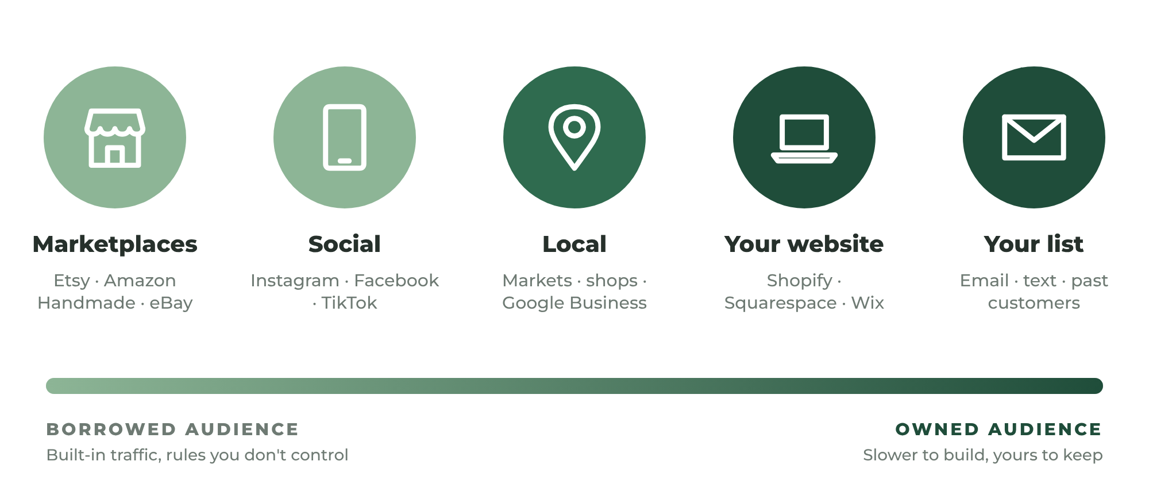
FIGURE 7.1 Sales channels range from borrowed audiences (marketplaces) to owned audiences (your website and email list).

Online Marketplaces
Marketplaces such as Etsy, Amazon Handmade, and eBay come with millions of shoppers already searching. You pay for that access through listing fees, transaction fees, payment processing fees, and optional advertising.
- Strengths: built-in traffic, trusted checkout, sales tax often handled for you, fast setup.
- Trade-offs: fees, intense competition, rules that can change, and limited control over your customer relationships.
Etsy is the natural home for handmade, vintage, personalized, and craft-supply items. Amazon Handmade requires an application but offers enormous reach. eBay works well for unique, collectible, and refurbished items.

Social Commerce
Facebook Marketplace, Facebook and Instagram shops, Pinterest, and TikTok Shop let customers discover and buy where they already spend time. Local Facebook Marketplace and community groups are especially powerful for bulky items that are expensive to ship and for local services.

Your Own Website
Platforms such as Shopify, Squarespace, Wix, and WooCommerce let you build your own store. You keep more control and more of each sale, and you own the customer relationship — but you are responsible for bringing in your own traffic.
Most successful handmade businesses eventually use both: a marketplace for discovery and their own website for repeat customers, custom orders, and higher margins.

Local and In-Person Sales
Craft fairs, farmers' markets, holiday markets, pop-up events, and consignment in local shops let customers touch your work and meet you. In-person sales are excellent for getting feedback, building a local following, and collecting email addresses.

Wholesale
Selling in bulk to boutiques and gift shops can produce larger orders, but at roughly half your retail price. Make sure your pricing supports it before you pursue wholesale (see Chapter 3).

Channels for Service Providers
Service customers usually search locally and rely on trust. The most important channels are:
- Google Business Profile — Free, and often the single most valuable listing for a local service. It puts you on Google Maps and in local search results, and it collects reviews.
- Neighborhood platforms — Nextdoor and local Facebook groups, where neighbors ask each other for recommendations every day.
- Lead marketplaces — Thumbtack, Angi, TaskRabbit, Care.com, Rover, and similar platforms that connect customers with providers, usually for a fee per lead or per job.
- Freelance marketplaces — Upwork, Fiverr, and similar platforms for services delivered remotely, such as design, writing, editing, bookkeeping, and virtual assistance.
- Referral partners — Real estate agents, property managers, furniture stores, interior designers, and other businesses whose customers need your service.
- Your own website — Even a simple one-page site with your services, service area, reviews, and a booking or contact form makes you look established.

Choosing Your Launch Channels
Start with one primary channel and one secondary channel. Master them before adding more.
A good rule of thumb:
- Products that ship easily: Etsy (primary) + Instagram or Pinterest (secondary)
- Bulky or local products: Facebook Marketplace and local markets (primary) + your own website (secondary)
- Local services: Google Business Profile (primary) + Nextdoor or local Facebook groups (secondary)
- Remote services: A freelance marketplace (primary) + LinkedIn or a simple website (secondary)
PRO TIP
Rent Attention, Own Relationships
Marketplaces and social media are rented land — the rules can change overnight. From day one, invite customers onto land you own: an email list, a text list, or your own website. A list of 500 happy customers is one of the most valuable assets a small business can have.

EXAMPLE
Maya and Marcus Choose Their Channels
Maya opens an Etsy shop as her primary channel and uses Instagram to show her process. She also books a booth at two fall craft fairs. Marcus creates a Google Business Profile, joins three neighborhood Facebook groups, and introduces himself to two local furniture stores whose customers often ask, "Do you know anyone who can assemble this?"

YOUR ACTION STEPS
☐ Research the fees and rules of your top two channels.
☐ Choose one primary and one secondary channel.
☐ Set up your Google Business Profile if you offer a local service.
☐ Decide how you will collect customer emails from day one.

WORKSHEET
Chapter 7: Sales Channel Planner
Choose where you will sell first.

CHANNEL | ARE MY CUSTOMERS HERE? | COST / FEES | EFFORT REQUIRED | SCORE (1–10)
Etsy
Amazon Handmade
eBay
Facebook Marketplace
Instagram
Pinterest
TikTok
My own website
Craft fairs & markets
Local shops
Google Business Profile
Nextdoor & local groups
Lead or freelance marketplaces

My primary channel:
My secondary channel:
How I will build a list I own (email, text, website):

8
CHAPTER

Becoming Your Own Salesperson Through Photography
━━━
Online customers cannot touch your products. They cannot feel the weight. They cannot examine the craftsmanship. They cannot meet you before they hire you.
The camera must do all of that work for you.
Product and portfolio photography is not a luxury. It is one of the most important sales tools available.
Often, the difference between poor sales and strong sales is not the product itself. It is the presentation.

You Already Own the Camera
A modern smartphone is more than enough to take professional-looking photos. What matters far more than the camera is light, background, and consistency.

Step 1: Master Natural Light
Use natural light whenever possible. Set up near a large window with indirect daylight — not harsh direct sun. Turn off overhead lights, which add yellow tints and uneven shadows.
Place a piece of white foam board on the side opposite the window. It acts as a reflector, bouncing light back into the shadows. This one inexpensive trick makes photos look dramatically more professional.
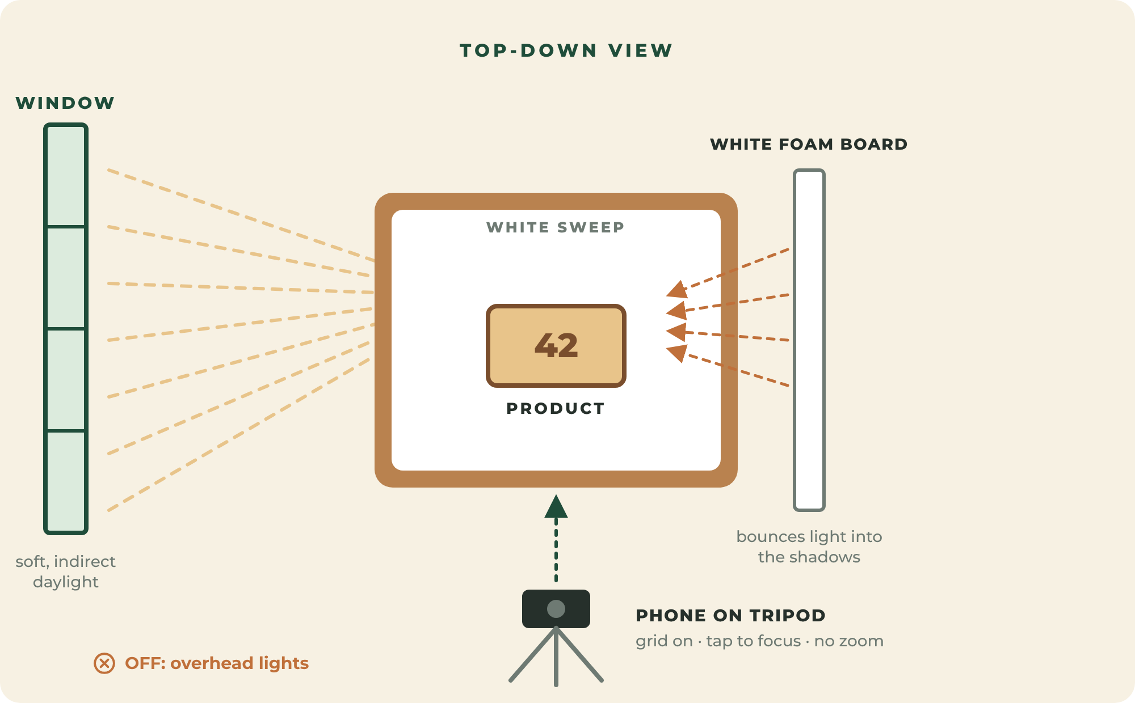
FIGURE 8.1 A simple window-light setup. A white foam board bounces light into the shadows.

Step 2: Choose a Clean Background
- White or light gray for clean, catalog-style photos. A sheet of poster board curved from the table up the wall (a "sweep") creates a seamless background with no visible horizon line.
- Natural textures — wood, linen, slate, or concrete — for lifestyle and mood shots that match your brand.
Keep backgrounds simple. The product is the star.

Step 3: Take the Essential Shots
Every product listing should include a complete set of images that answers customers' questions before they ask.
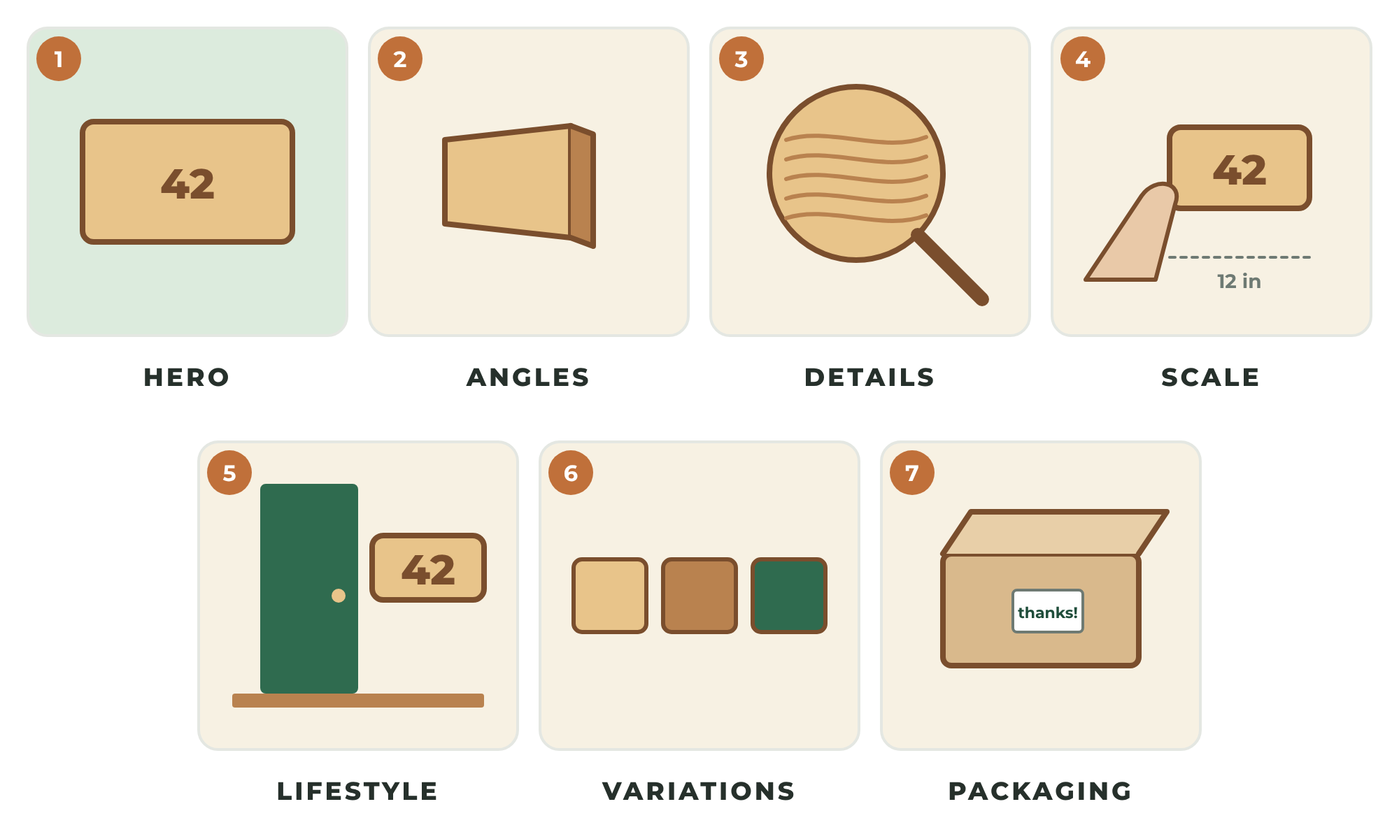
FIGURE 8.2 The essential product shot list. Together, these images replace the experience of holding the product.
- Hero shot — the product, front and center, on a clean background. This is your thumbnail.
- Angles — side and back views.
- Details — close-ups of texture, joinery, stitching, finish, or materials.
- Scale — the product in a hand, beside a common object, or in use, so customers understand its size.
- Lifestyle — the product in a real setting, such as a sign by a front door or a necklace being worn.
- Variations — available colors, sizes, or personalization options.
- Packaging — what the customer will receive, especially if it makes a good gift.

Step 4: Use Your Phone Like a Pro
- Wipe the lens before every session.
- Turn on the grid lines to keep the horizon straight and use the rule of thirds.
- Tap the screen to focus on the most important detail.
- Don't use digital zoom — move closer instead.
- Shoot from your customer's natural viewing angle.
- Use a small tripod and a timer to avoid blur.
- Take many shots; keep the best.

Step 5: Edit Lightly and Honestly
Use a free editing app to straighten, crop, brighten, and correct white balance so whites look white. Keep colors accurate. Never edit a photo so heavily that the real product disappoints — that creates returns and bad reviews.

Focus on Clarity
Every photograph should clearly communicate:
- Size
- Quality
- Color
- Materials
- Details
Customers should understand exactly what they will receive. Uncertainty reduces sales. Clarity increases them.
Photography is not about artistic perfection. It is about building confidence.

For Service Providers: Show the Transformation
Service customers can't hold your work in advance, so your photos must prove your results and introduce you as a person.
- Before-and-after photos — Take them from the same angle, in the same light. They are the most persuasive images a service business can have. Always ask the customer's permission and avoid showing personal information, house numbers, or faces.
- Work in progress — Shows skill, care, and professionalism.
- A friendly, professional headshot — People hire people. Smile, look at the camera, and wear what you wear on the job.
- Your tools, vehicle, and uniform — Signals that you are an established business.
TRY THIS
Build a Photo Station
Dedicate one corner of your home to photography: a table near a window, a white sweep, two foam boards, a phone tripod, and a small box of props that match your brand. When the station is always ready, you photograph new work immediately instead of putting it off.

YOUR ACTION STEPS
☐ Set up a permanent photo station near a window.
☐ Photograph your launch offer using the complete shot list.
☐ Edit lightly for accuracy and consistency.
☐ If you offer a service, collect before-and-after photos from every job.

WORKSHEET
Chapter 8: Photography Checklist
Use this before and during every photo session.

BEFORE TAKING PHOTOS
☐ Product cleaned and inspected
☐ Background clean and wrinkle-free
☐ Natural window light available (no harsh sun)
☐ Overhead lights turned off
☐ Reflector board in place
☐ Camera lens cleaned
☐ Tripod and timer ready
REQUIRED PRODUCT PHOTOS
☐ Hero shot (front, clean background)
☐ Side and back angles
☐ Close-up details
☐ Scale comparison
☐ Lifestyle image
☐ Variations
☐ Packaging image
SERVICE PROVIDER PHOTOS
☐ Before-and-after pairs (with permission)
☐ Work-in-progress shots
☐ Professional headshot
☐ Tools, vehicle, and uniform

9
CHAPTER

Writing Listings That Sell
━━━
Good listings answer questions. Great listings eliminate doubts.
Every product description or service page should help a customer move closer to a buying decision. It should explain what the offer is, who it is for, why it is better, and exactly what happens next.
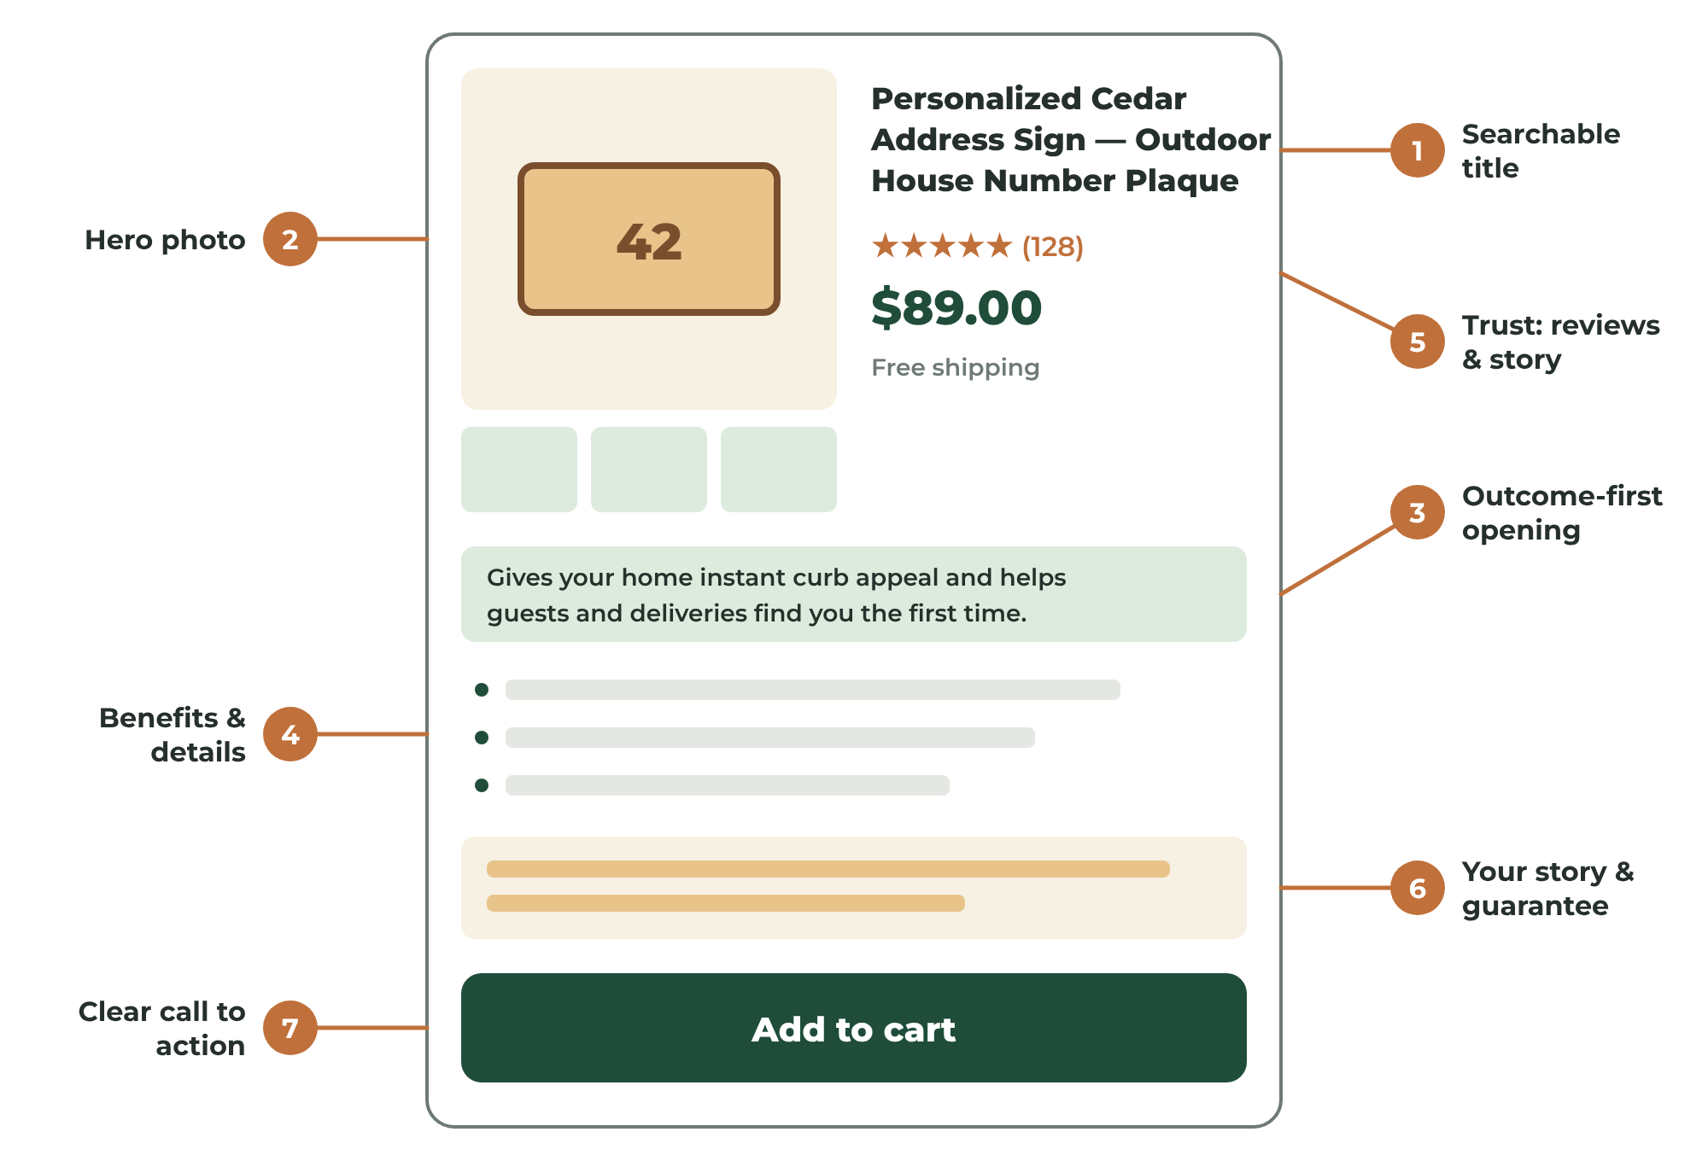
FIGURE 9.1 The anatomy of a listing that sells. Each part answers a question in the customer's mind.

Step 1: Write a Searchable Title
On marketplaces, your title helps customers find you. Use the words customers actually type — the phrases you discovered in Chapter 2.
Lead with the most important words. Be specific.
- Weak: "Beautiful Sign"
- Strong: "Personalized Cedar Address Sign — Outdoor House Number Plaque, Handmade Wood Sign"
For services, put your service and location together: "Furniture Assembly & TV Mounting in Springfield — Same-Week Appointments."

Step 2: Open With the Outcome
The first sentence matters most. Many shoppers read only the first line or two. Tell customers what the offer will do for them.
"This handcrafted cedar address sign gives your home instant curb appeal — and helps guests and deliveries find you the first time."

Step 3: Sell Benefits, Not Just Features
A feature is a fact about your product or service. A benefit is what that fact does for the customer.
Instead of saying:
"This sign is made of cedar."
Explain:
"This cedar sign is designed to withstand outdoor weather conditions while maintaining its rustic appearance."
Instead of saying:
"I bring my own tools."
Explain:
"I arrive fully equipped, so there is nothing for you to buy, borrow, or prepare."
People buy outcomes. They buy solutions. They buy benefits.

Step 4: Answer Every Question
After the benefits, provide the details that remove doubt:
- Dimensions and weight
- Materials and finishes
- Colors and personalization options
- Care instructions
- Production time and shipping time
- What's included and what isn't
- Service area, availability, and how to book
- Your guarantee or return policy

Step 5: Add Trust
Include your story in a few sentences, the number of happy customers or five-star reviews, and your guarantee. A short, honest story about why you make what you make or why you started your service creates a human connection that big companies cannot match.

Step 6: Make the Next Step Obvious
End with a clear call to action:
- "Choose your size and color, add your house number, and click Add to cart."
- "Message me a photo of your item for a flat-rate quote within 24 hours."
- "Book your appointment online — most jobs are scheduled within a week."
Always write with the customer in mind.
PRO TIP
Read It Out Loud
Read your listing out loud before you publish it. If you stumble, simplify the sentence. If a friend can't explain what you sell after reading it once, rewrite it.

YOUR ACTION STEPS
☐ Write a searchable title using real customer search phrases.
☐ Rewrite every feature as a benefit.
☐ Answer every common question in your listing or service page.
☐ Add your story, your guarantee, and a clear call to action.

WORKSHEET
Chapter 9: Product Listing Template
Fill in the blanks, then polish.

Product title (searchable keywords):
OPENING DESCRIPTION
"This handcrafted ____________________ is designed for ____________________ who want ____________________."

FEATURES (FACTS) | BENEFITS (WHAT IT DOES FOR THE CUSTOMER)

Dimensions: Materials:
Colors / options: Care instructions:
Production time: Shipping time:
My story (2–3 sentences):

Guarantee / return policy:
Call to action:

WORKSHEET
Chapter 9: Service Page Template
A clear page that turns visitors into bookings.

Service name and location:
The problem I solve:
The result the customer gets:
What's included:
What's not included:
Service area:
Pricing (or "starting at"):
How to book:
My guarantee:
Why customers trust me (reviews, experience, insurance):

10
CHAPTER

Launching Your Store
━━━
At some point, preparation must become action.
This moment is where many people hesitate. They worry their store is not ready. Their photos are not perfect. Their listings need improvement. Their logo could be better.
The reality is simple.
A store that launches imperfectly can still improve. A store that never launches cannot make a sale.
Progress beats perfection. Launch, learn, and improve.

Progress Beats Perfection
Build a store that is professional, honest, and complete. Then launch. Gather real customer feedback. Improve from there.
Business growth comes from action, not endless preparation.

The Minimum Launch Standard
You are ready to launch when you have:
- At least one offer with excellent photos and a complete listing or service page
- Clear pricing that includes profit
- Written policies for shipping, returns, cancellations, or service terms
- A way to accept payment
- Inventory on hand or a clear production or booking timeline
- Your business setup basics from Chapter 4
- A short list of people you will tell on launch day
That's it. Everything else can be improved after you open.

Plan a Launch Week, Not a Launch Day
A launch is not one announcement. It is a series of reasons for people to pay attention:
- Before launch: Share behind-the-scenes photos and tell people the date.
- Launch day: Announce that you're open, with a clear link and a simple offer.
- Days two to five: Share the story behind your business, a customer's reaction, a process video, and a reminder that a launch offer ends soon.
- End of week: Thank everyone who supported you and share what's next.

Consider a Launch Offer
A limited-time incentive gives people a reason to act now: free shipping, a small discount for the first ten customers, a free add-on, or priority booking. Keep it simple, and give it a clear end date.

Get Your First Reviews
Reviews are the currency of online trust. Your first few customers are your most important. Over-deliver for them, follow up personally, and politely ask for an honest review. Never offer payment or discounts in exchange for positive reviews — it violates most platforms' rules and erodes trust.
EXAMPLE
Launch Week
Maya announces on Instagram that her Etsy shop opens Saturday at 9 a.m., with free shipping for the first ten orders. She sells seven signs in the first week — five to people she knows and two to strangers who found her through Etsy search. Marcus announces his business in three neighborhood groups with before-and-after photos from his pilot jobs and books five appointments.

YOUR ACTION STEPS
☐ Confirm you meet the Minimum Launch Standard.
☐ Choose a launch date and put it on your calendar.
☐ Plan a full launch week of announcements.
☐ Launch — even if it isn't perfect.

WORKSHEET
Chapter 10: Launch Readiness Checklist
You are ready when everything essential is checked.

ESSENTIAL
☐ At least one complete, well-photographed listing or service page
☐ Pricing that includes profit
☐ Shipping, return, cancellation, or service policies written
☐ Payment method set up and tested
☐ Inventory ready or production/booking timeline set
☐ Business setup basics complete (Chapter 4)
☐ Launch announcement written
☐ List of at least 25 people to tell
HELPFUL (BUT NOT REQUIRED)
☐ Launch offer with a clear end date
☐ Social media profiles complete
☐ Email or text signup in place
☐ Thank-you note or card for orders
My launch date:
My launch offer:

PART FOUR

CUSTOMERS AND MARKETING
━━━━
Find your first customers, market consistently, and deliver an experience people talk about.


11
CHAPTER

Finding Your First Customers
━━━
Your first customers are the hardest to obtain.
Your tenth customer is easier. Your hundredth customer is easier still.
Momentum matters.
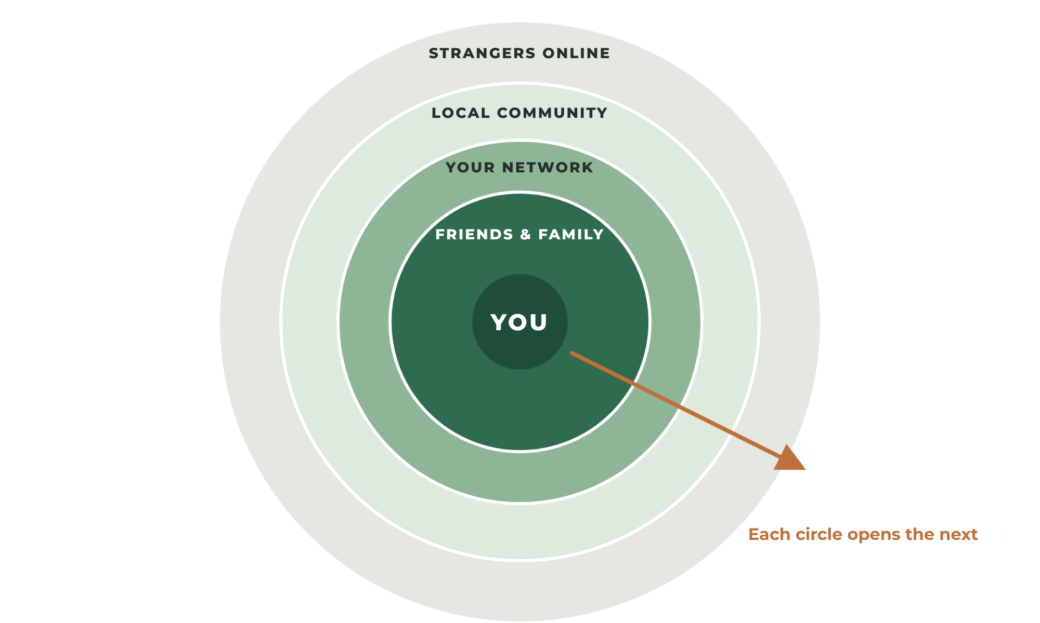
FIGURE 11.1 Start with the people closest to you and work outward. Each circle opens the next.

Start With Your Existing Network
Friends, family members, coworkers, neighbors, church or club members, local groups, and social media followers all represent potential supporters. They may not all buy, but many will share, recommend, and cheer you on.
Many entrepreneurs feel uncomfortable promoting themselves. That reluctance is natural.
However, if you genuinely believe your product or service provides value, sharing it is not selfish.
It is service.
People cannot buy what they do not know exists.

Make a List of 50
Write down fifty people you know. Next to each name, write whether they might buy, might refer someone, or might simply share your post. Then contact them personally — not with a mass message, but one at a time.
A personal message works far better than a public post:
"Hi Jenna! I wanted you to be one of the first to know — I've officially started a business making personalized cedar signs. I'd love for you to take a look, and if you know anyone who's moved into a new home recently, I'd be so grateful if you passed it along."

Go Where Your Customers Gather
Return to your ideal customer description from Chapter 2. Where do they spend time?
- Online communities — local Facebook groups, Nextdoor, Reddit communities, hobby forums. Be helpful first. Follow each group's rules about promotion.
- Local events — craft fairs, farmers' markets, school fundraisers, community festivals, home shows.
- Complementary businesses — gift shops, coffee shops, real estate agents, wedding planners, hardware stores, property managers.

Use Direct Outreach for Services
Service businesses can grow quickly with simple, respectful outreach:
- Introduce yourself to five businesses whose customers need your service, and leave a card or a flyer.
- Offer real estate agents and property managers a dependable person for move-in and move-out tasks.
- Ask every satisfied customer, "Do you know anyone else who could use help with this?"
- Post a helpful tip in a neighborhood group with a before-and-after photo.

Turn Customers Into Referrals
Your best marketing department is your list of happy customers. Make referrals easy:
- Include two business cards in every order or leave two after every job — one to keep and one to share.
- Offer a simple referral thank-you, such as a discount on the next order for both the customer and the friend they refer.
- Follow up after the purchase and ask how everything is going. Happy customers often offer referrals without being asked.
PRO TIP
The Follow-Up Is Where the Money Is
Most small businesses never follow up with past customers. A short, friendly message thirty days after a purchase — "How is the sign holding up?" or "How's the new bookshelf?" — generates reviews, repeat purchases, and referrals at almost no cost.

YOUR ACTION STEPS
☐ List fifty people you know and contact them personally.
☐ Join three places where your ideal customers gather.
☐ Contact five potential referral partners.
☐ Create a simple referral thank-you offer.

WORKSHEET
Chapter 11: My First 50
Who will you personally tell about your business?

# | NAME | BUY / REFER / SHARE | CONTACTED?
1
2
3
4
5
6
7
8
9
10
11
12
13
14
15
16
17
18
19
20
21
22
23
24
25

WORKSHEET
Chapter 11: Where My Customers Gather
Plan where you will show up.

PLACE (ONLINE OR LOCAL) | WHAT I WILL DO THERE | DATE

REFERRAL PARTNERS
BUSINESS | CONTACT PERSON | WHY THEIR CUSTOMERS NEED ME | CONTACTED?

12
CHAPTER

The Power of Consistent Marketing
━━━
Marketing is not manipulation. Marketing is communication.
Your goal is simply to show people what you do.
Many makers and service providers disappear into their workshops — or into their workdays — and assume great work will automatically attract customers.
Unfortunately, markets do not work that way.
Visibility creates opportunity. Consistency creates visibility.

You Don't Need to Be a Content Creator
You do not need to become a full-time content creator. You simply need to regularly show:
- What you make or do
- How you make it or do it
- Why you make it or do it
Customers enjoy seeing craftsmanship. The process often sells as effectively as the product.

The Four Content Pillars
When you don't know what to post, choose one of these four pillars. Rotate through them, and you'll never run out of ideas.
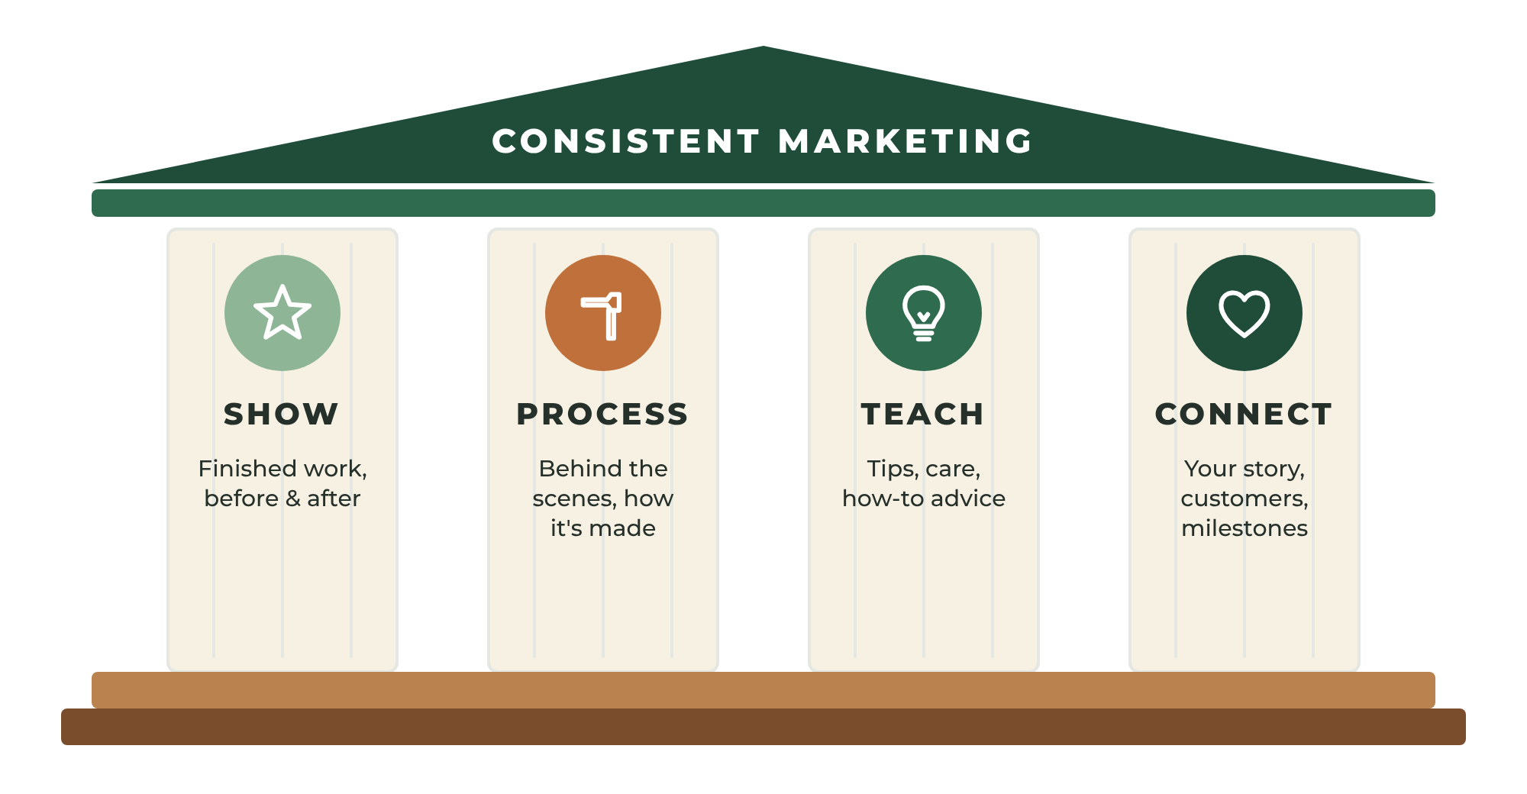
FIGURE 12.1 Four content pillars. Rotate through them and you'll always have something meaningful to share.
- Show — finished products, completed jobs, before-and-after photos.
- Process — behind the scenes, time-lapse videos, your workshop, your tools, your materials.
- Teach — tips, care instructions, how-to advice, common mistakes to avoid.
- Connect — your story, customer stories and reviews, milestones, lessons learned, and the people behind the business.

Pick One Platform and Show Up
It is better to post three times a week on one platform than once a month on five. Choose the platform where your ideal customers spend time:
- Instagram and Pinterest — visual products, home décor, jewelry, art, food.
- Facebook — local customers, community groups, and older audiences.
- TikTok and YouTube Shorts — process videos and personalities.
- Google Business Profile posts — local services.
- LinkedIn — business-to-business and professional services.

Build an Email List
Email remains one of the most effective — and least expensive — ways to reach customers, because you own the list. Social platforms can change their algorithms overnight. Your email list stays yours.
Collect emails at checkout, at craft fairs, on your website, and after service jobs (with permission). Then send a simple, friendly email once or twice a month: a new product, a seasonal reminder, a helpful tip, or a behind-the-scenes story.

Reviews and Testimonials
Reviews are marketing that customers write for you. After every positive experience, ask for a review on the platform that matters most — your marketplace shop or your Google Business Profile. Share your best reviews (with permission) in your posts and on your website.
Respond to every review, positive or negative, politely and promptly. A calm, helpful response to a negative review often builds more trust than a page full of perfect ratings.

Paid Advertising — Later
Paid ads can amplify what already works. They rarely fix what doesn't. Wait until you have proven offers, good photos, strong reviews, and a clear idea of your profit per sale. Then start small, test one ad at a time, and track every dollar.

Create a Simple Marketing Rhythm
Consistency beats intensity. A simple weekly rhythm might be:
- Monday — share a finished product or completed job (Show)
- Wednesday — share a behind-the-scenes clip (Process)
- Friday — share a tip or a customer review (Teach or Connect)
- Once a month — send an email to your list
Batch your content: take photos and short videos while you work, then schedule a week's posts in a single sitting.
EXAMPLE
Marcus Shows His Work
Marcus doesn't enjoy social media, so he keeps it simple. After each job he takes one before-and-after photo, and every Monday he posts the best one to his Google Business Profile and his neighborhood group with a two-sentence caption. Within three months, his profile has 31 five-star reviews, and new customers often tell him, "I've been seeing your posts."

YOUR ACTION STEPS
☐ Choose one main marketing platform.
☐ Fill your content idea bank with twenty ideas.
☐ Plan four weeks of content and schedule it.
☐ Start an email list and ask every happy customer for a review.

WORKSHEET
Chapter 12: Content Idea Bank
Fill each pillar with at least five ideas.

SHOW | PROCESS | TEACH | CONNECT

WORKSHEET
Chapter 12: 4-Week Content Calendar
Plan one month of consistent marketing.

WEEK | DAY 1 POST | DAY 2 POST | DAY 3 POST | EMAIL?
Week 1
Week 2
Week 3
Week 4

My main platform:
My posting days and times:
How I collect email addresses:

13
CHAPTER

Shipping and the Customer Experience
━━━
The purchase experience does not end when payment is received.
It ends when the customer receives the product — or when the job is finished and the customer is happy.
Everything in between is part of what they are paying for.
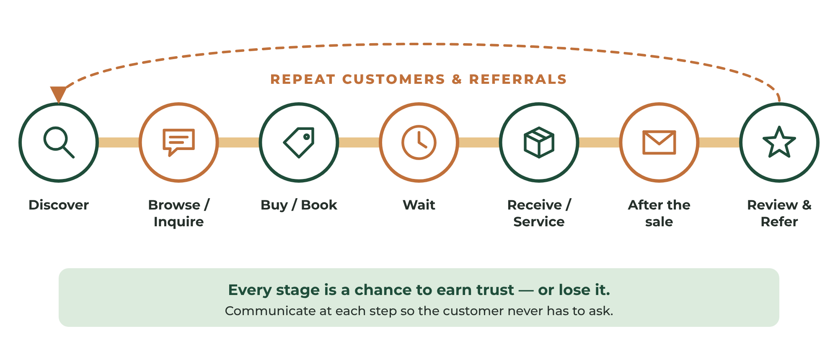
FIGURE 13.1 The customer journey. Every stage is a chance to earn trust — or lose it.

For Makers: Pack It Like It Matters
A damaged shipment can destroy weeks of effort. Protect products properly.
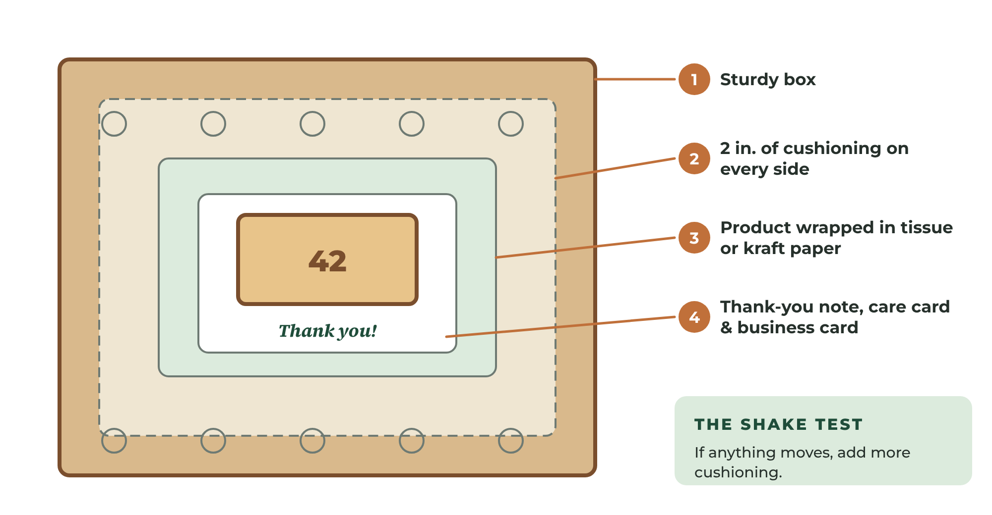
FIGURE 13.2 Protective packaging in layers: a sturdy box, cushioning, a protected product, and a personal touch.
- Use sturdy boxes with at least two inches of cushioning on every side for fragile items.
- Wrap the product in tissue, kraft paper, or bubble wrap, and fill empty space so nothing shifts.
- Shake test: Close the box and shake it gently. If anything moves, add more cushioning.
- Add a personal touch: a handwritten thank-you note, care instructions, and a business card. These small details turn a delivery into an experience.
- Seal and label clearly, and keep a copy of your shipping label.

Shipping Methods and Costs
Compare carriers — USPS, UPS, FedEx, and regional carriers — for your typical package size and weight. Most marketplaces and e-commerce platforms offer discounted shipping labels. Weigh and measure your packed product before setting shipping prices, since carriers charge for both weight and size.
Decide how you will present shipping costs:
- Calculated shipping — the customer pays the exact rate.
- Flat-rate shipping — one simple price for all orders.
- Free shipping — the cost is built into your product price. Many shoppers prefer this, and some marketplaces favor listings that offer it.

Communicate at Every Step
Customers relax when they know what's happening. Send a message when:
- The order is received (and when production begins, for custom work)
- The order ships, with tracking information
- A delay occurs — before the customer has to ask
- A few days after delivery, to make sure everything arrived safely

For Service Providers: The Experience Is the Product
For a service business, customer experience is everything. Customers judge you on far more than the finished work:
- Response time — Reply to inquiries quickly, ideally the same day.
- Clear quotes — Explain what is included and what it costs, in writing.
- Punctuality — Arrive in your promised window. If you're running late, call before the window starts.
- Respect for the space — Wear shoe covers, protect floors, and clean up completely.
- The final walk-through — Show the customer the finished work and ask, "Is there anything you'd like me to adjust?"
- Easy payment — Accept cards and digital payments, and send a professional receipt.

Handling Problems Gracefully
Problems will happen. A package will get lost. A product will arrive damaged. A job will not go perfectly.
How you respond defines your brand far more than the problem itself.
- Respond quickly and acknowledge the problem.
- Apologize sincerely, without blame or excuses.
- Fix it — replace, repair, refund, or redo.
- Follow up to make sure the customer is satisfied.
- Learn — change the process so it doesn't happen again.
A positive experience often leads to:
- Reviews
- Repeat customers
- Referrals
The customer experience is part of the product. Treat it that way.
How you handle a problem defines your brand more than the problem itself.

YOUR ACTION STEPS
☐ Create a packing process that passes the shake test, or a service-day checklist.
☐ Choose your shipping strategy and carriers.
☐ Write messages for each stage of the customer journey.
☐ Write your problem-resolution policy.

WORKSHEET
Chapter 13: Shipping & Packaging Plan
For makers.

PRODUCT | PACKED WEIGHT | BOX SIZE | PACKAGING COST | SHIPPING COST | CARRIER

Shipping price strategy (calculated / flat / free):
Processing time I promise:
UNBOXING EXPERIENCE
☐ Thank-you note
☐ Care instructions
☐ Business card (two — one to share)
☐ Branded sticker or tissue
☐ Review request card

WORKSHEET
Chapter 13: Customer Experience Map
Make every stage excellent.

STAGE | WHAT HAPPENS NOW | HOW I CAN MAKE IT BETTER
Discover
Inquire or browse
Buy or book
Wait (production or appointment)
Receive or service day
After the sale
Review and referral

MY PROBLEM-RESOLUTION POLICY

PART FIVE

RUNNING AND GROWING
━━━━
Manage money like an owner, build systems, grow wisely, and decide when to go full time.


14
CHAPTER

Managing Money Like a Business Owner
━━━
Many entrepreneurs love making products or serving customers. Few enjoy accounting.
Unfortunately, success requires both.
Money measures reality. Your feelings about how the business is doing can be wrong. Your numbers can't.

Track Everything
Monitor:
- Revenue
- Expenses
- Profit
- Advertising costs
- Shipping costs
- Inventory
- Taxes owed and set aside
Financial clarity allows smart decisions. Business owners who understand their numbers are more resilient during difficult periods.

Choose a Simple Bookkeeping System
Your system should be simple enough that you actually use it.
- Spreadsheet — fine for very small businesses. Record every sale and expense with the date, amount, category, and a note.
- Accounting software — tools such as QuickBooks, Xero, Wave, or FreshBooks connect to your business bank account and categorize transactions automatically. Most save more time than they cost.
- Marketplace reports — Etsy, Amazon, Shopify, and payment processors provide sales and fee reports. Download them monthly.
Set a weekly money hour — the same time every week — to record transactions, file receipts, and review your numbers. Fifteen minutes a week is far easier than fifteen hours in April.

Keep Your Receipts
Save receipts for every business expense, ideally as photos or scans in a dedicated folder or app. Common deductible expenses for small businesses may include materials, tools, equipment, packaging, shipping, software, advertising, business mileage, a portion of phone and internet, and a home office that meets IRS requirements. Ask your tax professional what applies to you.

Track Mileage
If you drive for your business — to jobs, suppliers, the post office, or markets — record the date, destination, purpose, and miles for every trip. A mileage-tracking app makes this almost automatic. For service businesses, business mileage can be one of the largest deductions.

Use a Simple Money System
One of the easiest ways to stay in control is to divide every dollar that comes in among a few separate bank accounts, each with a job.
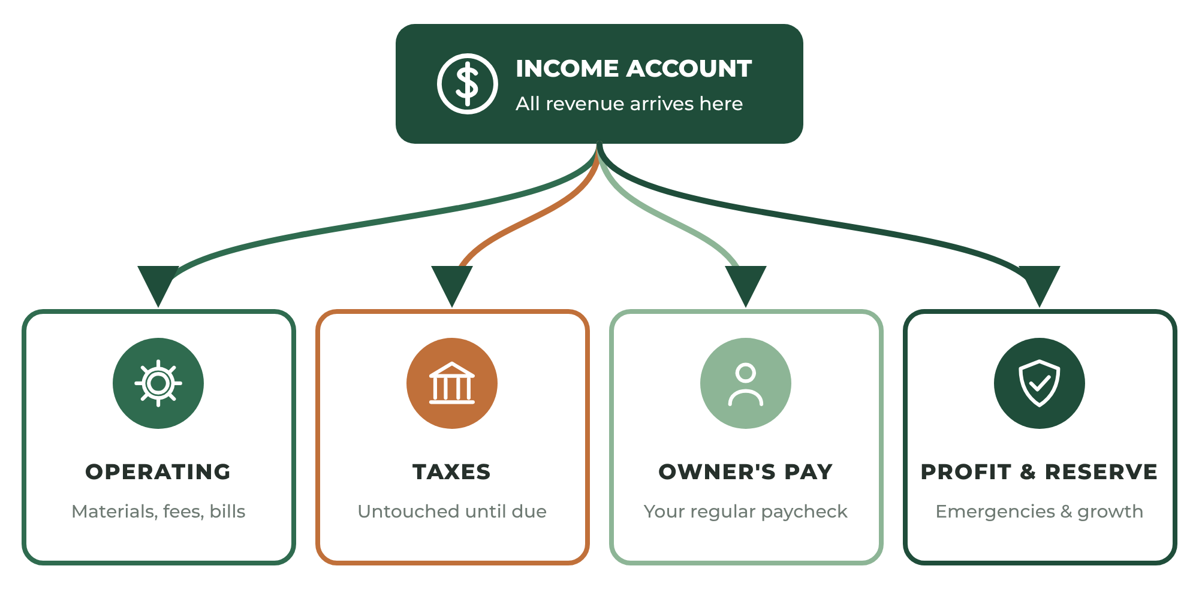
FIGURE 14.1 Divide incoming revenue among accounts with specific jobs so taxes, profit, and your paycheck are never an afterthought.
- Income — all revenue arrives here.
- Operating expenses — money for materials, fees, supplies, and bills.
- Taxes — a fixed percentage of every payment, set aside and untouched until tax time.
- Owner's pay — what you pay yourself on a regular schedule.
- Profit and reserve — savings for emergencies, slow seasons, and future investment.
Start with small percentages if money is tight — even 5% to profit builds the habit. Adjust the percentages as the business grows.

Know Your Key Numbers
Every month, calculate these five numbers:
- Revenue — total sales.
- Cost of goods sold — materials and direct costs for what you sold.
- Gross profit — revenue minus cost of goods sold.
- Net profit — gross profit minus all other expenses.
- Profit margin — net profit divided by revenue. This shows how much of every dollar you keep.
Also track your average order value, your best-selling product or service, and your customer acquisition cost — how much you spend on marketing to gain each new customer.

Plan for Taxes
Remember from Chapter 4: when you work for yourself, no one withholds taxes for you. Set money aside from every payment, make estimated payments as required, and keep organized records. Working with a tax professional for your first year or two is one of the best investments a new business can make.
IMPORTANT
Watch Cash Flow
Profit and cash are not the same thing. A business can be profitable on paper and still run out of cash if money is tied up in inventory, customers pay late, or a big expense arrives all at once. Keep a reserve, collect deposits on custom work, and invoice promptly.

EXAMPLE
Maya's Money Hour
Every Sunday evening, Maya spends twenty minutes on her business finances. She downloads her Etsy sales report, photographs her receipts, and moves 25% of the week's profit into her tax savings account. At the end of her first quarter, she knows exactly what she earned, what she owes, and which sign sizes are most profitable. Her small signs, she discovers, earn twice the profit per hour of her large ones.

YOUR ACTION STEPS
☐ Choose a bookkeeping system and schedule your weekly money hour.
☐ Set up separate accounts for taxes and profit.
☐ Begin tracking receipts and mileage today.
☐ Complete your first Monthly Financial Scorecard.

WORKSHEET
Chapter 14: Monthly Financial Scorecard
Complete at the end of every month.

Month:
CATEGORY | AMOUNT
Sales revenue
Cost of goods (materials)
Shipping & packaging costs
Marketplace & payment fees
Advertising
Other expenses
NET PROFIT
Profit margin (net profit ÷ revenue)
Amount set aside for taxes
Owner's pay
Added to profit reserve

Number of orders or jobs: Average order value:
Best-selling product or service:
Biggest lesson learned:

WORKSHEET
Chapter 14: Money System Setup
Give every dollar a job.

ACCOUNT | PURPOSE | PERCENTAGE OF REVENUE | OPENED?
Income
Operating expenses
Taxes
Owner's pay
Profit & reserve

My weekly money hour (day and time):
Bookkeeping tool I will use:
Mileage tracking method:
Tax professional:

15
CHAPTER

Creating Systems for Growth
━━━
Success creates new challenges. More orders require more organization.
Without systems, growth becomes chaos.
A system is simply a repeatable way of doing something. Systems transform businesses because they allow you to deliver the same quality faster, with less stress — and eventually, they allow someone else to help you.

Document Every Process
Anything done repeatedly should be documented. Record:
- Production steps
- Packaging procedures
- Shipping workflow
- Booking and scheduling steps
- Customer communication templates
- Quality checks
- Weekly and monthly administrative tasks
These written instructions are called standard operating procedures (SOPs). They don't need to be fancy. A checklist with photos is often perfect. A short video of you doing the task works too.
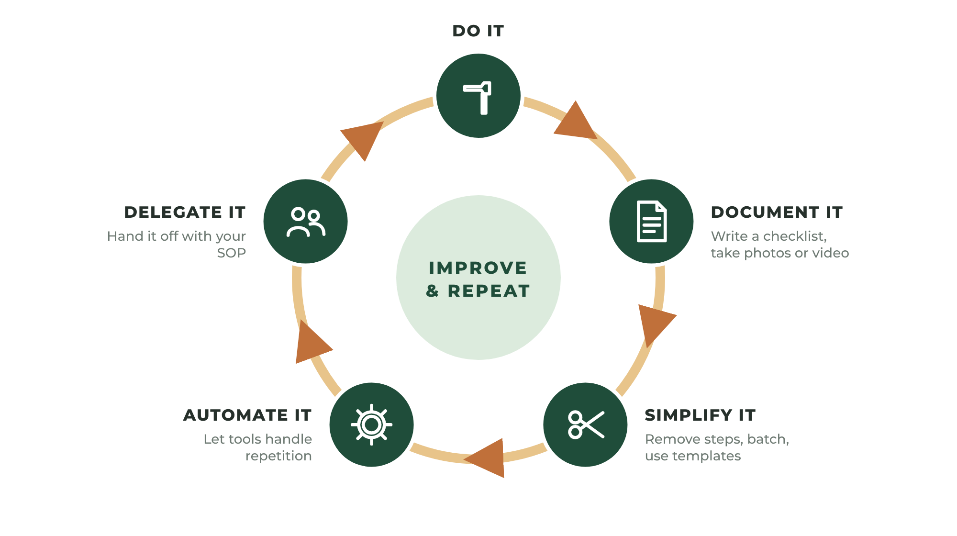
FIGURE 15.1 The system improvement cycle: do it, document it, simplify it, and eventually delegate it.

Templates Save Hours
Write your most common messages once and reuse them: order confirmations, shipping notices, quote responses, booking confirmations, review requests, and answers to frequently asked questions. You'll find ready-to-use templates in Part Six.

Use Simple Tools
The right tools remove repetitive work:
- Scheduling and booking tools let service customers book and receive automatic reminders.
- Invoicing and payment apps send professional invoices and accept cards.
- Shipping label tools connect to your store and print labels in batches.
- Accounting software categorizes transactions automatically.
- A shared calendar and task list keep production and appointments organized.
Choose tools that solve a problem you actually have. Don't adopt software just because it's popular.

Protect Your Time
Your time is the scarcest resource in your business. Protect it with time blocking: assign specific blocks of your week to specific types of work.
- Production or service delivery
- Packing and shipping
- Marketing and content
- Administration and money
- Learning and improvement
Doing similar tasks together, in protected blocks, is far more efficient than switching between them all day.

When to Get Help
Eventually, you won't be able to do everything yourself. Signs that it is time to get help include turning down profitable work, slipping quality, and working long hours on low-value tasks.
Start by outsourcing the tasks that are least valuable for you to do personally: bookkeeping, packing, cleaning, sanding, social media scheduling, or administrative work. Your documented systems make training much easier.
Before hiring anyone, learn the rules about employees versus independent contractors in your state. Misclassifying workers can be costly. This is another good conversation for your accountant.
EXAMPLE
Marcus Builds a System
Marcus noticed that he spent nearly an hour a day answering texts about pricing and availability. He created an online booking page with his flat-rate menu, wrote five saved text replies, and set up automatic appointment reminders. He got back about five hours a week — time he now uses to take two more paid jobs.

YOUR ACTION STEPS
☐ Write SOPs for your three most repeated tasks.
☐ Save templates for your five most common messages.
☐ Choose tools that remove repetitive work.
☐ Create a weekly time-blocking plan.

WORKSHEET
Chapter 15: Standard Operating Procedure Template
Document one process at a time.

Process name: Last updated:
When this process is used:
Tools and materials needed:
STEP | INSTRUCTIONS | QUALITY CHECK
1
2
3
4
5
6
7
8
9
10

Common mistakes to avoid:

WORKSHEET
Chapter 15: Weekly Time-Blocking Plan
Protect time for every part of your business.

TIME BLOCK | MONDAY | TUESDAY | WEDNESDAY | THURSDAY | FRIDAY | SATURDAY | SUNDAY
Morning
Midday
Afternoon
Evening

TASKS I COULD DELEGATE OR AUTOMATE
TASK | HOURS PER WEEK | AUTOMATE OR DELEGATE? | TOOL OR PERSON

16
CHAPTER

Growing Beyond the First Sale
━━━
The first sale proves your concept. The next goal is consistency.
Ask yourself: How can this business become easier to buy from?

Grow Smart, Not Just Big
There are only a few ways to grow a business:
- More customers — reach new people.
- More purchases per customer — help customers buy more often.
- Larger purchases — increase the average order value.
- Better margins — earn more profit from each sale.
Growth does not always require new customers. Often it starts by serving existing customers better.
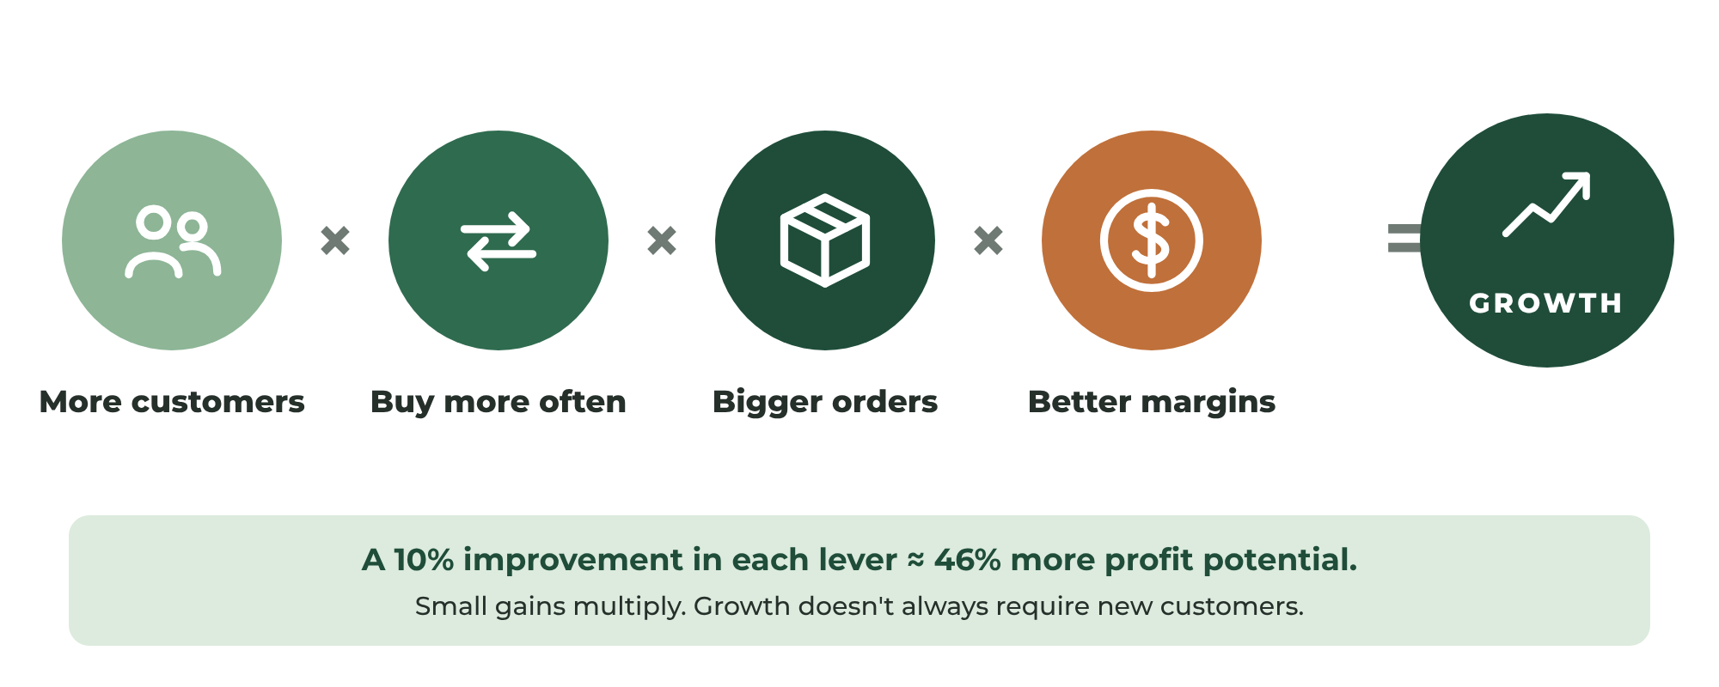
FIGURE 16.1 Four levers of growth. Pulling more than one creates compounding results.

Growth Ideas for Makers
- Product variations — new sizes, colors, finishes, and personalization options.
- Product bundles — matching sets and gift sets at a slightly better value.
- Seasonal offerings — holiday, wedding season, back-to-school, and graduation designs.
- Personalization options — names, dates, and custom messages often support higher prices.
- Wholesale and consignment — placing products in local shops.
- Custom and commission work — premium projects for customers who want something unique.
- Workshops and classes — teach your craft in person or online.
- Digital products — patterns, plans, templates, or tutorials based on your expertise.

Growth Ideas for Service Providers
- Recurring plans — monthly or seasonal maintenance at a predictable price.
- Add-on services — related services offered during the same visit.
- Premium packages — faster scheduling, extra care, or extended guarantees.
- New service areas — expand to nearby neighborhoods or remote clients.
- Partnerships — steady referrals from businesses with the same customers.
- Products — sell related supplies, kits, or branded items.
- Team growth — bring in help to take more jobs simultaneously.

Raise Your Prices
As your skills, reputation, and demand grow, your prices should grow too. If you are consistently sold out or fully booked, your prices are too low. Raise prices in reasonable steps, communicate them in advance to loyal customers, and pay attention to the results. Most businesses lose far fewer customers than they fear — and earn more for less work.

Listen to Your Customers
Your customers will tell you how to grow. Notice the requests that come up again and again. Ask your best customers what else they wish you offered. Then test new ideas with a small batch or a pilot before you fully commit — the same validation process you learned in Chapter 2.
EXAMPLE
Maya's Bundle
Customers kept asking Maya for a matching mailbox number. She created a "Curb Appeal Set" — her address sign plus a small matching mailbox plaque — priced at $119. One in three customers now chooses the set, raising her average order value by more than 10%.

YOUR ACTION STEPS
☐ Identify one idea for each of the four growth levers.
☐ Create one bundle, package, or recurring plan.
☐ Review your prices and plan your next increase.
☐ Ask five customers what else they wish you offered.

WORKSHEET
Chapter 16: Growth Planner
Brainstorm ideas for every growth lever.

GROWTH LEVER | IDEAS | COST TO TEST | PRIORITY (1–5)
More customers
More frequent purchases
Larger purchases
Better margins

MY NEXT THREE GROWTH EXPERIMENTS
EXPERIMENT | START DATE | HOW I'LL MEASURE SUCCESS | RESULT
1
2
3

17
CHAPTER

Mistakes Every Entrepreneur Should Avoid
━━━
Every business makes mistakes. The goal is not perfection. The goal is learning.
Here are the most common mistakes new makers and service providers make — and how to avoid them.
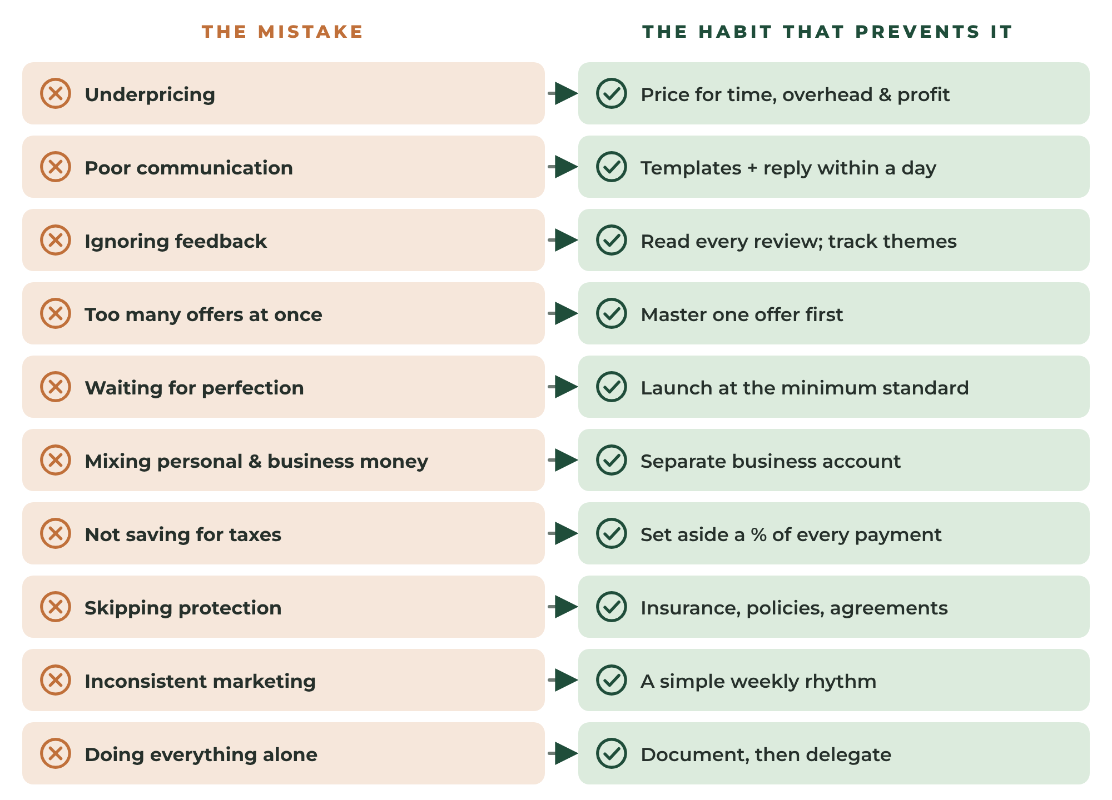
FIGURE 17.1 The ten most common early mistakes — and the habit that prevents each one.
- Underpricing. Charging too little attracts difficult customers, leaves no room for growth, and burns you out. Fix: Use the pricing calculators in Chapter 3 and include your time, overhead, and profit.
- Poor communication. Slow replies and silence during delays destroy trust faster than almost anything. Fix: Use templates and reply within one business day.
- Ignoring customer feedback. Customers tell you what to fix and what to create next. Fix: Read every review and record repeated themes.
- Launching too many products or services at once. It spreads your time, money, and marketing too thin. Fix: Master one offer, then expand.
- Waiting for perfection. Perfectionism is often fear in disguise. Fix: Launch at the Minimum Launch Standard and improve from there.
- Mixing personal and business money. It hides the truth about profit and creates tax headaches. Fix: Open a separate business account immediately.
- Not setting aside taxes. A large, unexpected tax bill can sink a young business. Fix: Set aside a percentage of every payment.
- Skipping the basics of protection. No insurance, no written policies, no agreements. Fix: Complete the Business Setup Checklist in Chapter 4.
- Inconsistent marketing. Posting in bursts, then disappearing. Fix: Follow a simple weekly rhythm.
- Trying to do everything alone forever. Growth stalls when every task depends on you. Fix: Document systems and delegate low-value tasks.
The most successful entrepreneurs learn quickly and adapt constantly.
Failure is information. Use it.
Failure is information. Use it.

WORKSHEET
Chapter 17: Mistake Audit
Be honest. Every "yes" is an opportunity.

MISTAKE | AM I MAKING IT? (Y/N) | WHAT I WILL CHANGE
Underpricing
Poor communication
Ignoring feedback
Too many offers at once
Waiting for perfection
Mixing personal and business money
Not setting aside taxes
Skipping insurance or policies
Inconsistent marketing
Doing everything alone

18
CHAPTER

From Side Hustle to Sustainable Business
━━━
Eventually, a question begins to emerge:
Could this become my full-time income?
The answer depends on consistency.
Not excitement. Not hope. Not one unusually good month.

Look for Evidence
A business becomes sustainable when it continues performing well over time. Look for:
- Stable sales for at least six to twelve months
- Positive cash flow after paying yourself
- Repeat customers and referrals
- Predictable demand, including an understanding of your slow seasons
- Capacity — the ability to produce or deliver enough to replace your income

Do the Math
Calculate the business profit you would need to replace your current income. Remember that, as a self-employed person, you may need to cover expenses your employer currently pays for, such as health insurance, retirement contributions, and the employer share of payroll taxes, and you will not have paid time off.
Required monthly profit = Personal monthly expenses + Health insurance + Retirement savings + Taxes + Buffer
Then compare that number with what your business actually produces — on average, over many months, not just your best month.
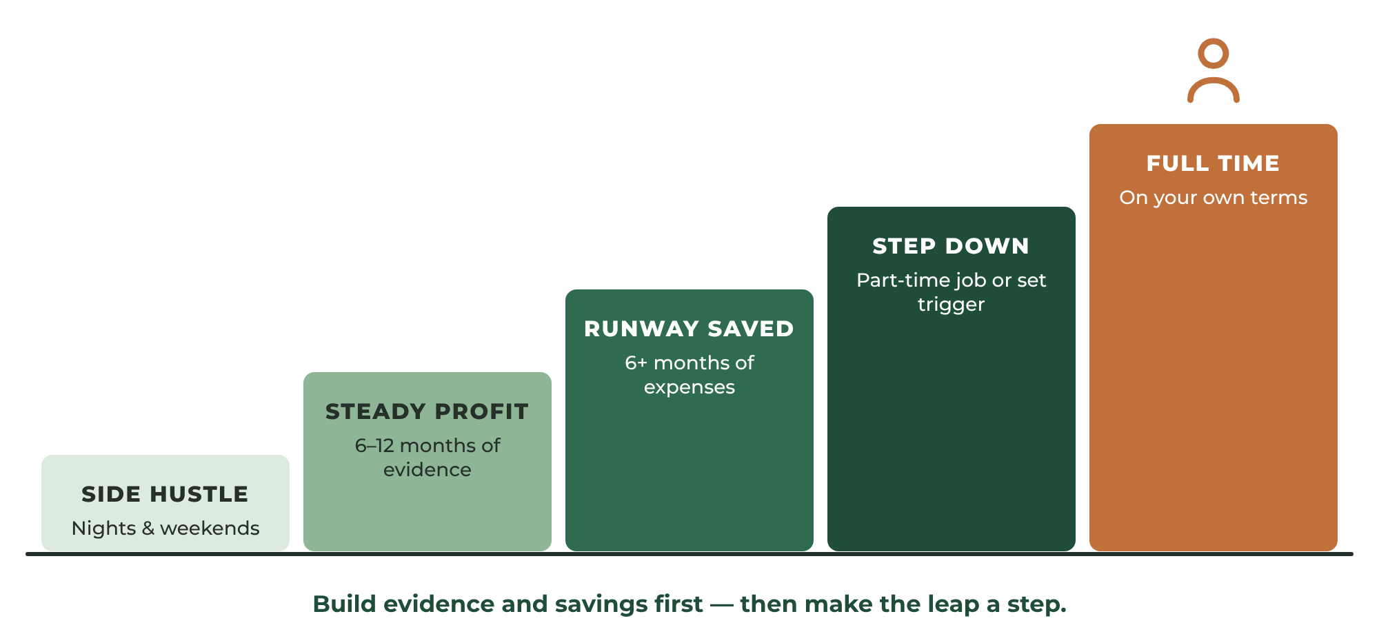
FIGURE 18.1 The transition path. Build a runway of savings and steady profit before you make the leap.

Build a Runway
Before leaving a job, build a financial cushion. Many advisors suggest having six months or more of personal living expenses saved, in addition to a separate business reserve. The larger your runway, the calmer your decisions will be.

Transition Gradually
The leap doesn't have to be a leap. Consider stepping down gradually: reduce your hours at your job, take a part-time position, or set a specific trigger, such as "When my business averages $4,000 in monthly profit for six consecutive months, I will give notice."
Patience is a competitive advantage. Those willing to build steadily often outperform those seeking quick results.
EXAMPLE
Marcus Makes the Move
Eighteen months after his first paid job, Marcus's business has produced steady profit for nine straight months, with a waiting list of customers and two referral partners. He has six months of personal expenses saved. He reduces his day job to three days a week, hires a part-time helper, and sets a date to go full time six months later — on his own terms.

YOUR ACTION STEPS
☐ Calculate the monthly profit you need to replace your income.
☐ Track six to twelve months of real performance.
☐ Build a personal runway and a business reserve.
☐ Write your transition trigger.

WORKSHEET
Chapter 18: Full-Time Readiness Assessment
Answer honestly, using real numbers.

READINESS MEASURE | CURRENT STATUS | READY? (Y/N)
Months of stable sales
Average monthly profit (last 6 months)
Profit needed to replace my income
Repeat customer percentage
Months of personal expenses saved
Business cash reserve
Health insurance plan
Capacity to meet demand
Support from family

INCOME REPLACEMENT CALCULATION
Personal monthly expenses: $
Health insurance (monthly): $
Retirement savings (monthly): $
Taxes (estimated monthly): $
Buffer: $
Required monthly profit: $
My transition trigger:

PART SIX

THE ENTREPRENEUR'S TOOLKIT
━━━━
Your 30-day launch plan, first-year plan, scorecards, and ready-to-use templates.
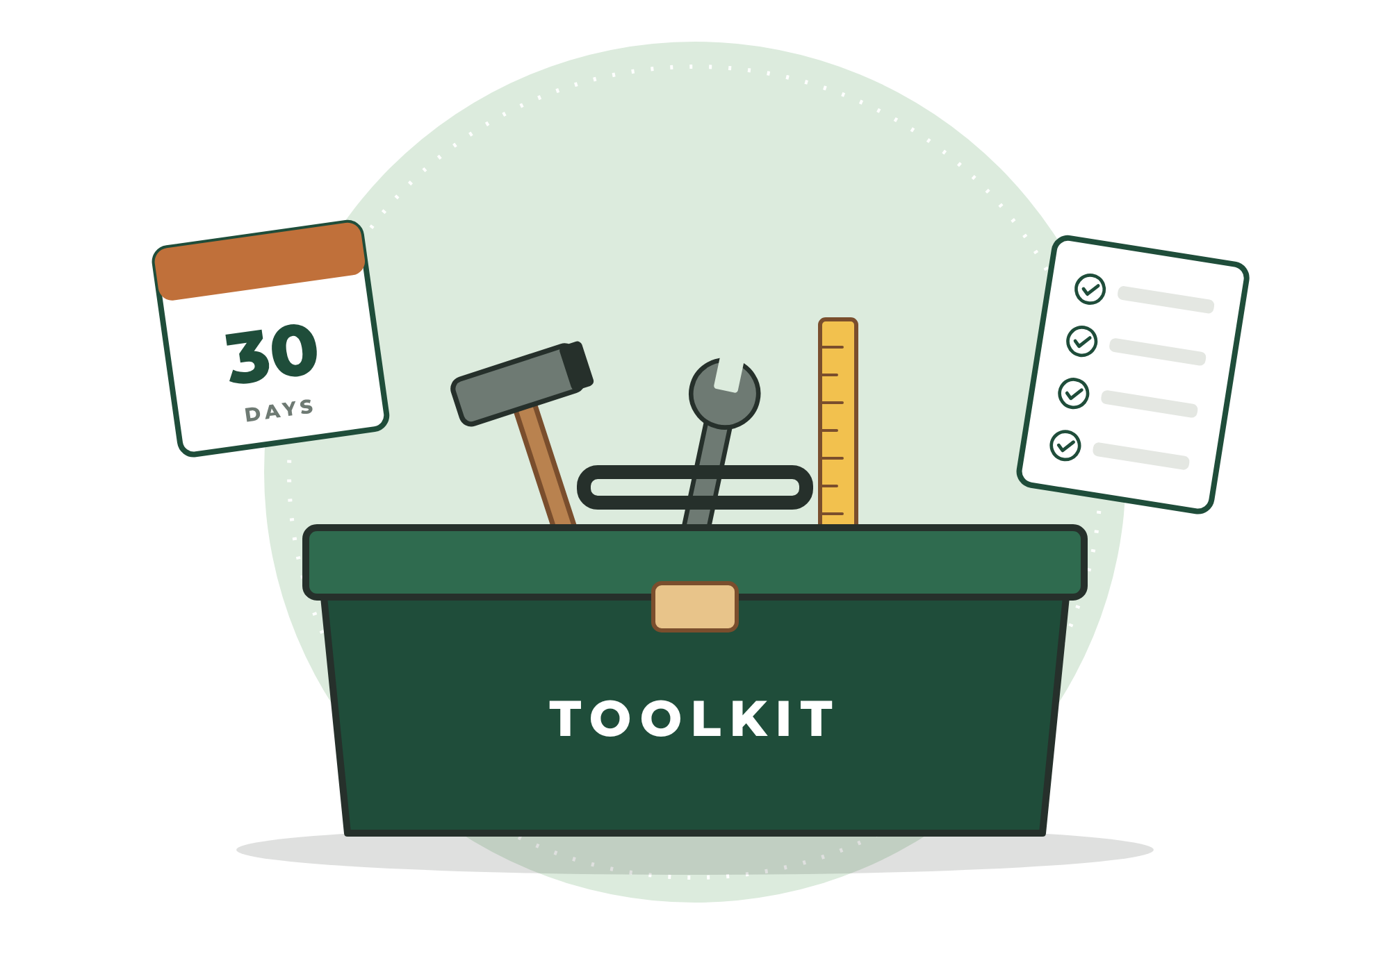

19
CHAPTER

The 30-Day Launch Plan
━━━
Thirty days from now, you can have a real business with a real offer, a real store or booking page, and real customers — or at least real conversations with them.
This plan turns everything in this book into daily actions. Each day has a single clear task and a measurable goal. Most tasks take one to two hours. If a day takes longer, keep going the next day. The point is momentum.
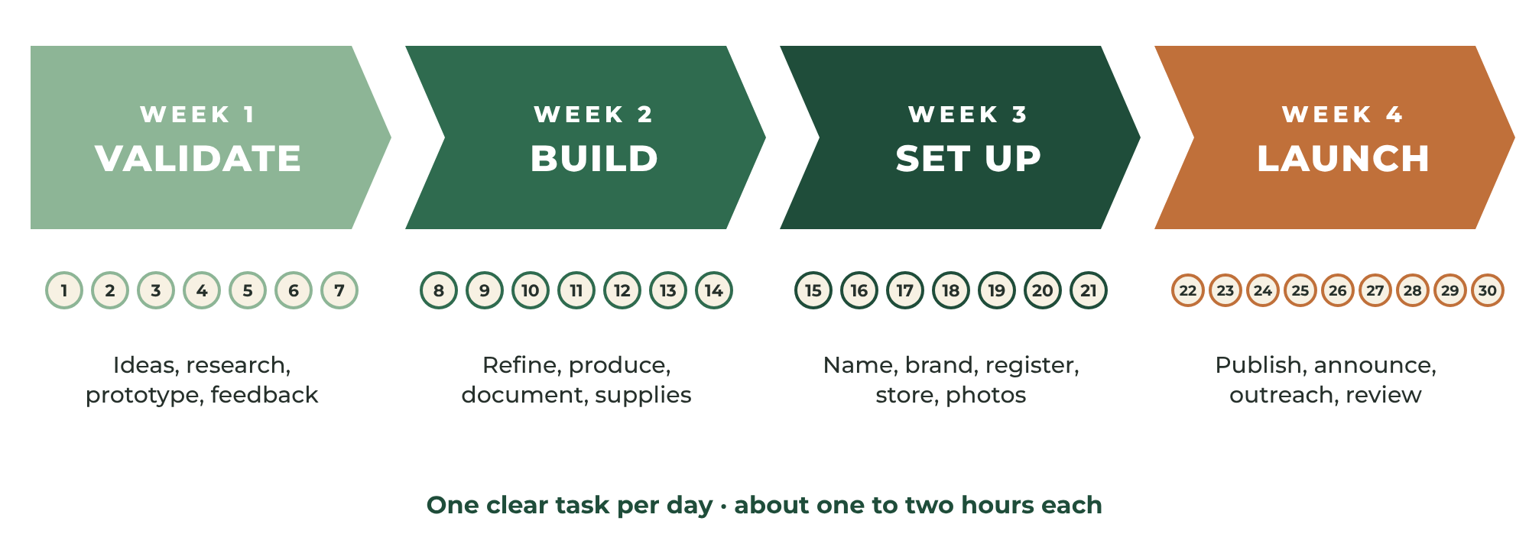
FIGURE 19.1 Four weeks, four stages: validate, build, set up, and launch.
PRO TIP
Makers and Service Providers
Where the plan differs for products and services, both versions are shown. Follow the one that fits your business — or both, if you are building a hybrid.

Week 1 — Validate the Opportunity
DAY  1 | Write down 20 product or service ideas.  Goal: 20 ideas completed. · Chapter 1

DAY  2 | Research every idea on marketplaces, Google, and local platforms. Record price, reviews, and competition.  Goal: Research completed. · Chapter 1

DAY  3 | Score your ideas and select your top five opportunities.  Goal: Five finalists selected. · Chapter 1

DAY  4 | Calculate profitability for all five using the pricing calculators.  Goal: Understand real margins. · Chapter 3

DAY  5 | Choose your launch offer and describe your ideal customer.  Goal: One clear winner. · Chapters 1–2

DAY  6 | Products: build Prototype Version One. Services: plan your service steps and perform a practice job.  Goal: Offer exists in real life. · Chapter 6

DAY  7 | Collect honest feedback from five people who match your ideal customer.  Goal: Improvements identified. · Chapter 2

Week 2 — Build a Real Offer
DAY  8 | Improve your prototype or service process based on feedback.  Goal: Version Two complete. · Chapter 2

DAY  9 | Products: create Product #1 and time every step. Services: write your service menu and packages.  Goal: Time study started. · Chapters 3, 6

DAY  10 | Products: create Product #2. Services: write your quote and booking process.  Goal: Process documented. · Chapter 6

DAY  11 | Products: create Product #3. Services: write your service agreement and policies.  Goal: Policies drafted. · Chapter 4

DAY  12 | Products: create Product #4. Services: offer two introductory jobs to real customers.  Goal: Real-world test underway. · Chapter 2

DAY  13 | Products: create Product #5. Services: complete introductory jobs and take before-and-after photos.  Goal: Proof collected. · Chapter 8

DAY  14 | Purchase packaging or service supplies. Write your quality checklist.  Goal: Five sale-ready products or a proven service. · Chapter 6

Week 3 — Build the Business
DAY  15 | Choose your business name and check availability.  Goal: Name selected. · Chapter 5

DAY  16 | Write your mission statement and tagline; choose colors and fonts.  Goal: Brand guide complete. · Chapter 5

DAY  17 | Register your business, get your EIN, and open a business bank account.  Goal: Business is official. · Chapter 4

DAY  18 | Products: open your Etsy shop or online store. Services: create your Google Business Profile and booking page.  Goal: Storefront created. · Chapter 7

DAY  19 | Set up your main social media profile and email signup.  Goal: Marketing channels ready. · Chapter 12

DAY  20 | Photograph your products or portfolio using the full shot list.  Goal: Professional photos complete. · Chapter 8

DAY  21 | Write your listings or service page using the templates.  Goal: Store infrastructure complete. · Chapter 9

Week 4 — Launch and Sell
DAY  22 | Publish your listings or service page. Test your checkout or booking process.  Goal: You are open for business. · Chapter 10

DAY  23 | Publish your first social media posts announcing your launch.  Goal: Launch announced. · Chapter 12

DAY  24 | Personally contact your list of family, friends, and supporters.  Goal: 25+ personal messages sent. · Chapter 11

DAY  25 | Join local community groups and introduce your business helpfully.  Goal: Three groups joined. · Chapter 11

DAY  26 | Post a behind-the-scenes or process video.  Goal: Process content published. · Chapter 12

DAY  27 | Contact five potential customers or referral partners directly.  Goal: Five outreach conversations. · Chapter 11

DAY  28 | Run a launch promotion with a clear end date.  Goal: Promotion live. · Chapter 10

DAY  29 | Review traffic, messages, sales, and feedback. Ask early customers for reviews.  Goal: Data reviewed and lessons recorded. · Chapter 14

DAY  30 | Celebrate, then set next month's goals.  Goal: First sale completed or active leads generated. · Chapter 18

WORKSHEET
30-Day Launch Tracker
Check off each day as you complete it.

DAY | TASK COMPLETED? | NOTES / RESULTS
1
2
3
4
5
6
7
8
9
10
11
12
13
14
15
16
17
18
19
20
21
22
23
24
25
26
27
28
29
30

20
CHAPTER

The First-Year Success Plan
━━━
A launch is a beginning, not a finish line. The first year is where a business learns to stand on its own.
This plan gives you a focus for each month. Focus is powerful. It is far better to do one important thing well each month than to do twelve things poorly.
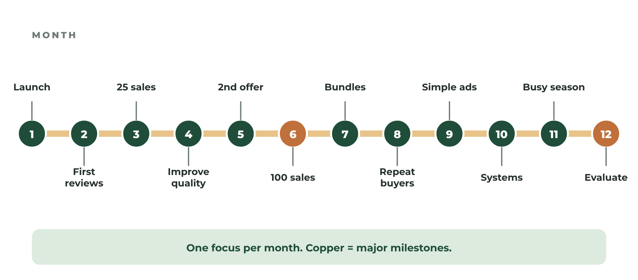
FIGURE 20.1 Twelve months, twelve focused milestones.
MONTH  1 | Launch.  Complete the 30-Day Launch Plan and make your first sales.

MONTH  2 | Collect your first reviews.  Over-deliver for early customers and ask every one of them for an honest review.

MONTH  3 | Reach 25 sales or jobs.  Market consistently using your weekly rhythm and content calendar.

MONTH  4 | Improve quality and efficiency.  Use feedback and time studies to refine your offer and your process.

MONTH  5 | Add a second product or service.  Validate it first with a small test or pilot.

MONTH  6 | Reach 100 sales or jobs.  Review your mid-year numbers and adjust your prices.

MONTH  7 | Introduce bundles or packages.  Increase your average order value.

MONTH  8 | Create repeat customers.  Start an email list routine and a follow-up system; launch a recurring plan if you offer services.

MONTH  9 | Begin simple advertising.  Test a small budget on your best-performing offer and track the results.

MONTH  10 | Improve systems and automation.  Write SOPs, save templates, and adopt tools that save time.

MONTH  11 | Prepare for your busy season.  Plan holiday or seasonal offers, inventory, and scheduling.

MONTH  12 | Evaluate your year.  Review your numbers, celebrate progress, and decide whether to pursue full-time business.

WORKSHEET
First-Year Milestone Tracker
Record your progress every month.

MONTH | FOCUS | REVENUE | PROFIT | SALES / JOBS | MILESTONE MET?
1
2
3
4
5
6
7
8
9
10
11
12

21
CHAPTER

Scorecards and Templates
━━━
Use these tools every day, every week, and every month. Make copies as often as you need.

Scorecards
Businesses are built through small actions repeated consistently. The Daily Scorecard asks five simple questions at the end of every day. If you can answer "yes" to most of them most days, your business is moving forward — even when sales are slow. The Weekly Review takes thirty minutes and helps you look back honestly, learn from what happened, and choose your top priorities for the week ahead. Use the Monthly Financial Scorecard in Chapter 14 at the end of every month.
PRO TIP
Make Copies
Photocopy the scorecards on the following pages or recreate them in a notebook or spreadsheet. The habit matters far more than the format.

WORKSHEET
The Entrepreneur's Daily Scorecard
Answer these five questions at the end of every day.

QUESTION | MON | TUE | WED | THU | FRI | SAT | SUN
Did I create or deliver something today?
Did I market today?
Did I improve my business today?
Did I learn something new today?
Did I move one step closer to my goal?

This week's biggest win:
Next week's top priority:

WORKSHEET
The Weekly Review
Spend 30 minutes every week looking back and planning ahead.

Week of: Sales / jobs this week:
Revenue this week: Profit this week:
What worked well:

What didn't work:

Customer feedback I received:

My top three priorities for next week:

Customer Communication Templates
Copy these templates into your phone, email, or store's saved replies. Personalize them, but keep the structure. Replace the words in brackets with your own information.
TEMPLATE
Order Confirmation (Products)
Hello [Name],
Thank you for your order! I've received it and will begin production right away.
Your estimated completion date is [date], and I'll send tracking information as soon as your order ships.
If you have any questions, just reply to this message.
Thank you for supporting my small business.
Best regards,
[Your name]
[Business name]

TEMPLATE
Shipping Notification
Hello [Name],
Good news — your order has shipped!
Tracking number: [number]
Estimated delivery: [date]
Thank you again for supporting my business. I hope you enjoy your [product].
Best regards,
[Your name]

TEMPLATE
Delay Notice
Hello [Name],
I want to give you a quick update on your order. Because of [brief reason], your order will be ready by [new date] instead of [original date].
I'm sorry for the delay, and I appreciate your patience. I want to make sure your [product] meets my quality standards before it leaves my workshop. If this new timing doesn't work for you, please let me know and we'll find a solution.
Best regards,
[Your name]

TEMPLATE
Review Request
Hello [Name],
I hope you're enjoying your [product / completed project].
If you have a moment, I would greatly appreciate an honest review. Customer feedback helps small businesses grow and helps future customers make informed decisions.
[Link to review page]
Thank you again for your support.
Best regards,
[Your name]

TEMPLATE
Inquiry Response (Services)
Hello [Name],
Thank you for reaching out! I'd be glad to help with [service].
To give you an accurate quote, could you send me:
• A photo of [item or area]
• Your address or neighborhood
• A few days and times that work for you
My [service] typically starts at [price], and most appointments are scheduled within [timeframe].
I look forward to helping you.
Best regards,
[Your name]
[Business name] | [Phone]

TEMPLATE
Quote / Estimate (Services)
Hello [Name],
Thank you for the opportunity to quote your project. Here are the details:
Service: [description]
Includes: [what is included]
Not included: [exclusions]
Price: [amount]
Deposit: [amount, if applicable]
Estimated time: [duration]
To book, simply reply "Approved" and choose a date. This quote is valid for [number] days.
Best regards,
[Your name]

TEMPLATE
Appointment Confirmation and Reminder
Hello [Name],
You're confirmed for [service] on [day, date] between [time window] at [address].
Please [any preparation, e.g., "clear the area" or "have parts unboxed"]. I'll text you when I'm on my way.
Need to reschedule? Just reply at least [24/48] hours in advance.
See you soon!
[Your name]

TEMPLATE
Job Completion and Thank You
Hello [Name],
Thank you for choosing [Business name]! It was a pleasure helping you with [service].
Your receipt is attached. If anything isn't right, please let me know within [timeframe] and I'll make it right.
If you were happy with the work, I'd be grateful for a quick review: [link]. And if you know anyone who needs help with [service], I'd love to help them too.
Best regards,
[Your name]

TEMPLATE
Handling a Complaint
Hello [Name],
Thank you for letting me know, and I'm truly sorry about [issue]. That's not the experience I want any customer to have.
Here's what I'd like to do to make it right: [replacement / repair / refund / return visit].
Please let me know if that works for you, or if there is anything else I can do.
Sincerely,
[Your name]

TEMPLATE
Follow-Up (30 Days Later)
Hello [Name],
I hope you're doing well! It's been about a month since your [order / service], and I wanted to check in. How is your [product / project] holding up?
If you ever need anything else — or know someone who might — I'm always happy to help.
Best regards,
[Your name]

Recommended Resources
These organizations and tools can help you along the way. Services, fees, and features change over time, so always check current details on each provider's website.

Free Business Help (United States)
- U.S. Small Business Administration (SBA) — guides to planning, launching, and managing a business at sba.gov.
- Small Business Development Centers (SBDCs) — free one-on-one advising in every state.
- SCORE — free mentoring from experienced business owners.
- Internal Revenue Service (IRS) — free EIN applications and small-business tax information at irs.gov.
- Your state's Secretary of State and Department of Revenue — business registration and sales tax permits.
- Your local library — many libraries offer free business databases, workshops, and meeting rooms.

Tools by Category
- Marketplaces: Etsy, Amazon Handmade, eBay, Facebook Marketplace
- Website and store builders: Shopify, Squarespace, Wix, WooCommerce
- Local and service platforms: Google Business Profile, Nextdoor, Thumbtack, Angi, TaskRabbit
- Freelance platforms: Upwork, Fiverr
- Bookkeeping: QuickBooks, Xero, Wave, FreshBooks
- Payments and invoicing: Square, Stripe, PayPal
- Design and photo editing: Canva, Adobe Express, Snapseed
- Email marketing: Mailchimp, Kit, MailerLite
- Scheduling: Calendly, Square Appointments, Acuity Scheduling

Final Thoughts
━━━
Entrepreneurship is not a destination. It is a process of continual improvement.
You will make mistakes. You will learn lessons. You will face setbacks.
Every successful entrepreneur has.
The businesses that endure are not necessarily built by the most talented people.
They are built by the people who continue.
The people who learn.
The people who adapt.
The people who keep moving forward long after excitement fades.
Your future business is not hidden behind some secret strategy. It begins with a simple decision.
Create something valuable.
Offer it to the world.
Learn from the response.
Then do it again.
And again.
And again.
That is how workshops become companies.
That is how skills become careers.
That is how side projects become livelihoods.
That is how entrepreneurs are made.

A Final Note From the Author
━━━
The purpose of this book is not merely to help you sell products or services.
It is to help you build an asset.
Every product you design, every customer you serve, every review you earn, and every process you improve becomes part of something larger than a side hustle.
You are building a business.
Businesses are not built in a single day, a single month, or even a single year. They are built through thousands of small decisions made consistently over time.
The entrepreneur who succeeds is rarely the smartest person in the room. More often, it is the person who remains committed after the excitement wears off.
Create value.
Serve customers.
Improve continuously.
Do those three things long enough, and the workshop that once produced hobbies — or the skills that once earned only thanks — can become a company that changes your life.
I can't wait to see what you build.
— The Skill Junky

About the Author
━━━
The Skill Junky is a lifelong learner, maker, and entrepreneur who believes that the skills people already have — in their hands, their heads, and their hearts — are the foundation of meaningful, independent work. Driven by an insatiable curiosity for learning how things are made, fixed, and sold, The Skill Junky writes practical, no-nonsense guides that help everyday people turn what they know and love into real income.
From Workshop to Worldwide is written for anyone who has ever been told, "You should sell these," or "You should charge for that" — and is finally ready to do it.

About Verdant Life LLC
━━━
Verdant Life LLC publishes practical books and resources that help people grow — in skill, in independence, and in livelihood. Our guides are designed to be used, not just read: clear steps, honest advice, and tools you can put to work today.

Notes
━━━

