PUBLIC GITHUB REPOSITORY URL: <https://github.com/Verdarin/JOSEF_MUSCAT_DGD_6.2A_DE>

PUBLIC API (VERCEL) URL:

TASK 1: SCREENSHOT OF YOUR DEVELOPMENT ENVIRONMENT SETUP:

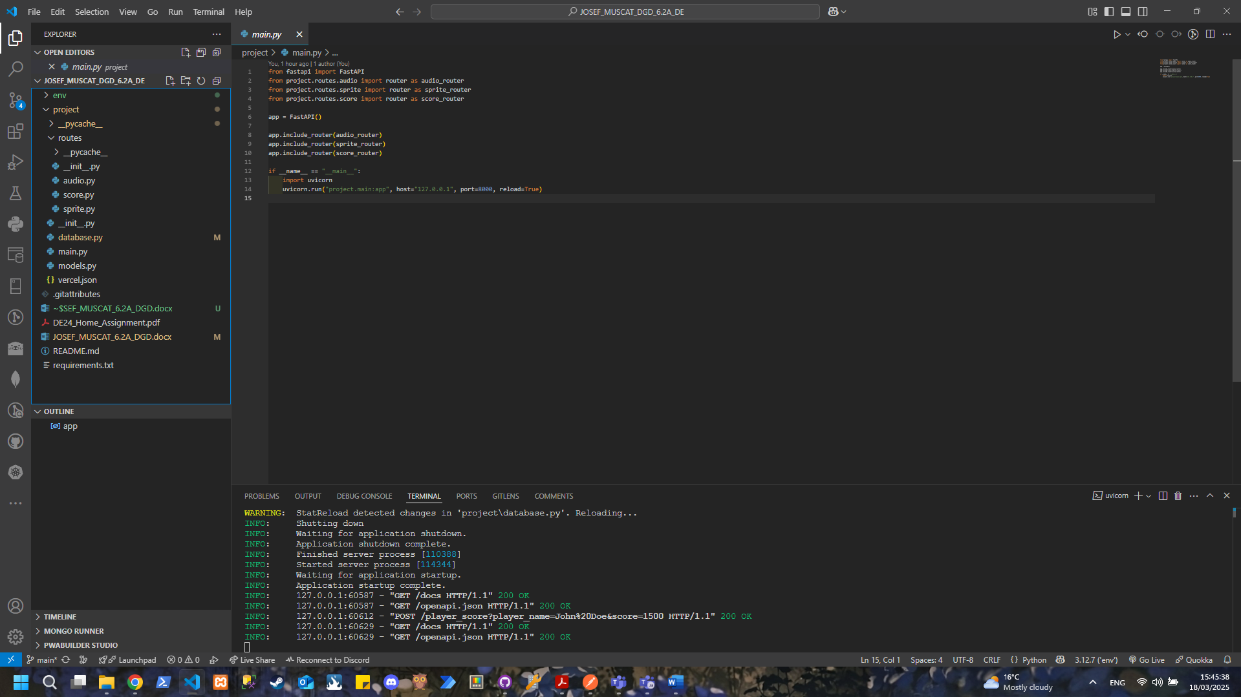

TASK 2: SCREENSHOT OF YOUR MONGO DATABASE ON MONGOATLAS:

TASK3A: SCREENSHOT OF THE API RUNNING ON LOCALHOST IN YOUR BROWSER:

POSTMAN IDE FOR [POST] PLAYER SCORE:

LOCALHOST API RESPONSE TO [POST]:

MONGO DB VALUES AFTER [POST]:

POST MAN IDE FOR [POST] UPLOAD AUDIO:

LOCALHOST API RESPONSE TO [POST] UPLOAD AUDIO

MONGODB DATABASE AFTER POST:

POSTMAN IDE FOR [POST] UPLOAD SPRITE

API LOCALHOST RESPONSE FOR [POST]:

MONGO DB VALUES AFTER [POST]: