GROUP D
Bacchus Winery Case Study
Milestone 2
Team Members | Verdis Moorer and Samuel Guizar
Case Study | Bacchus Winery

Revised Database Design
The Milestone 1 design was revised to add complete attributes, primary keys, foreign keys, junction tables, and constraints. The final schema separates repeating or many-to-many data so that the tables satisfy Third Normal Form (3NF).

3NF Design Notes
- Each table represents one subject, and each row has a primary key or a composite primary key.
- Supplier-to-item and order-to-product many-to-many relationships are resolved with junction tables.
- Employee time records store the work date and hours worked. Quarter and year are derived in reports instead of being stored redundantly.
- Distributor order headers are separated from distributor order line items.
- Purchase order headers are separated from purchase order line items.
- Sales reports reference the distributor and wine by foreign key rather than repeating distributor or wine descriptive data.
- Inventory references either a supply item or a wine product and stores only inventory-specific facts.

Revised Entity Relationship Diagram
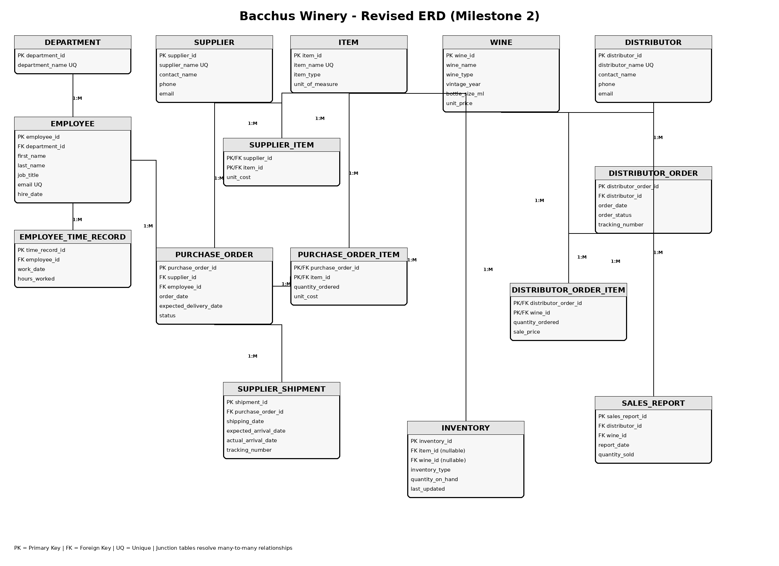

Final Table Summary
Table | Purpose
department | Winery departments.
employee | Employees and their assigned department.
employee_time_record | Dated hours worked for quarterly reporting.
supplier | The three Bacchus Winery suppliers.
item | Supply and production items.
supplier_item | Items offered by suppliers and their unit cost.
purchase_order | Supplier purchase-order header information.
purchase_order_item | Items and quantities on each purchase order.
supplier_shipment | Shipping and expected/actual arrival information.
wine | Wine products sold by Bacchus Winery.
distributor | Businesses that distribute Bacchus wines.
distributor_order | Distributor order header and tracking information.
distributor_order_item | Wines and quantities included in distributor orders.
inventory | Supply and distribution inventory counts.
sales_report | Distributor-reported wine sales.

MySQL and Python Files
The accompanying bacchus_winery.sql script creates the bacchus_winery database, creates all finalized tables, establishes keys and constraints, and inserts sample data. The bacchus_display.py script connects to MySQL and displays every table, followed by an employee-hours-by-quarter report.

Data Display Screenshots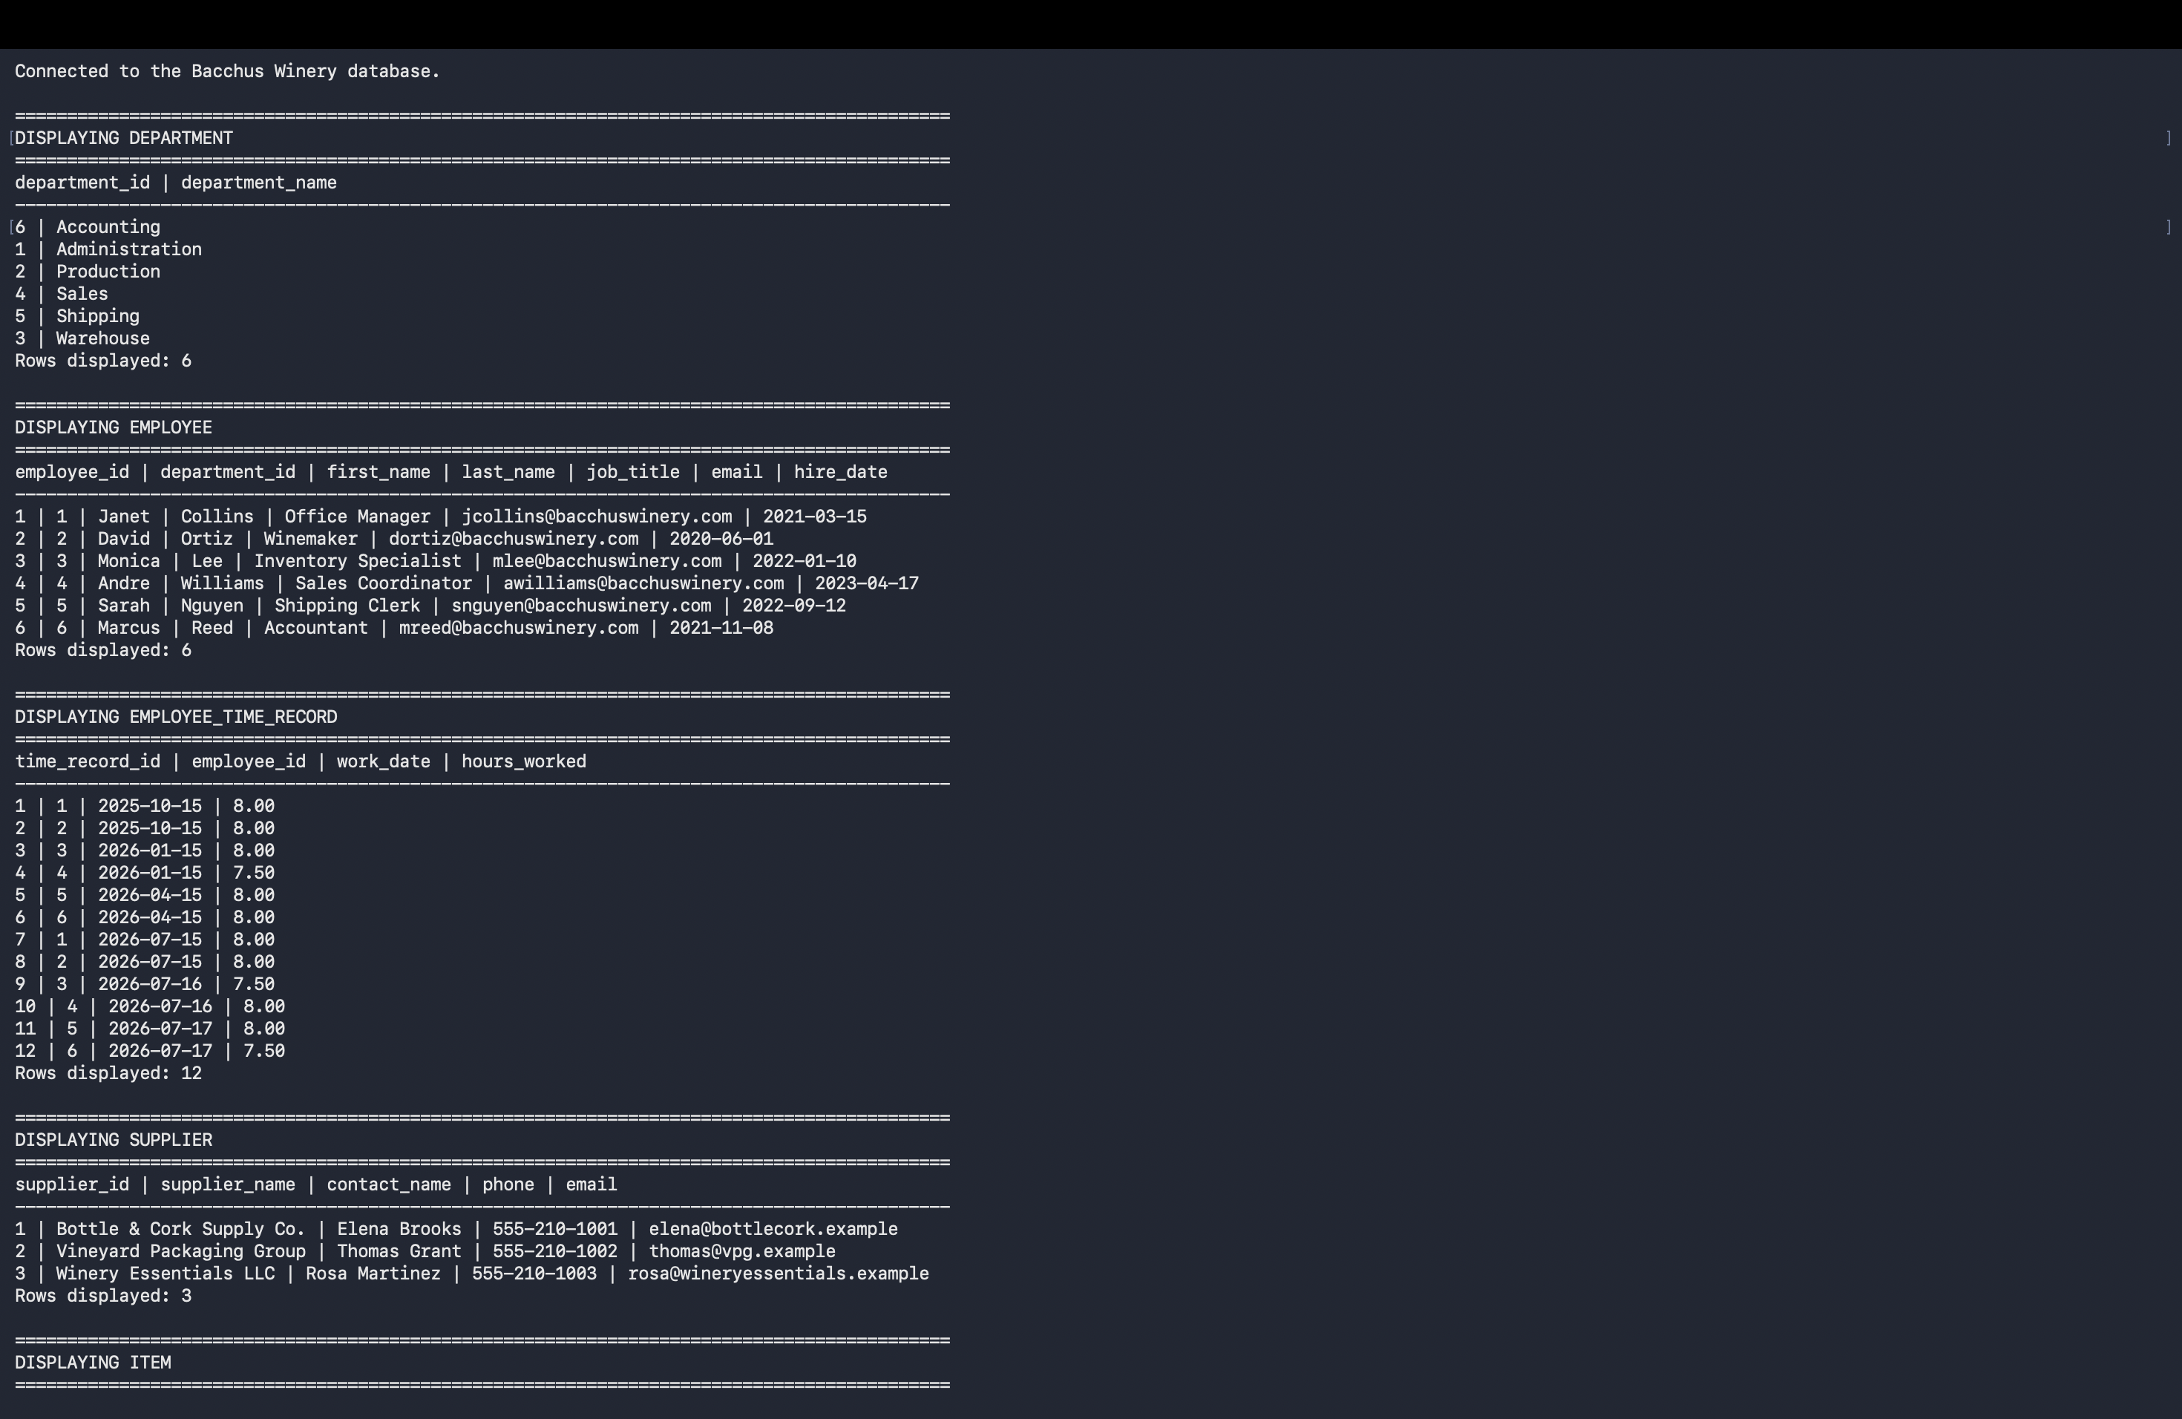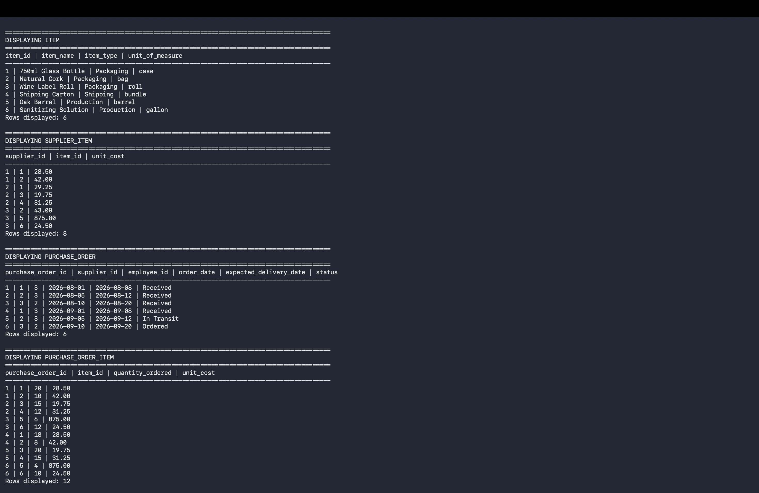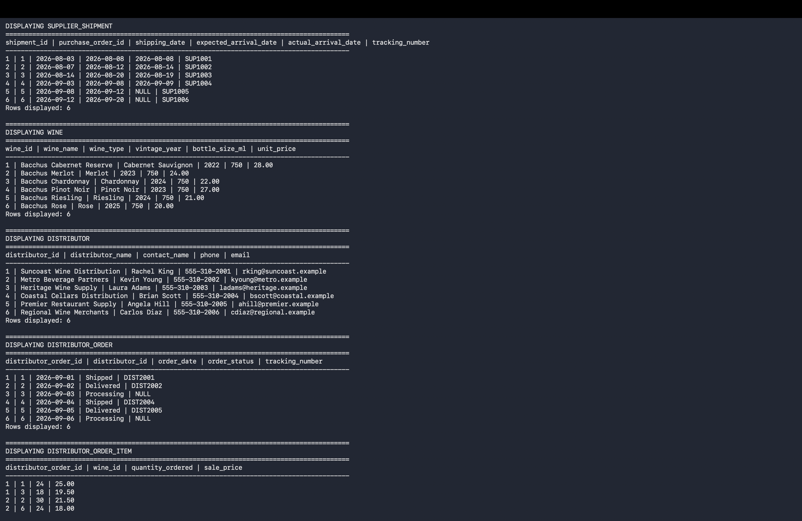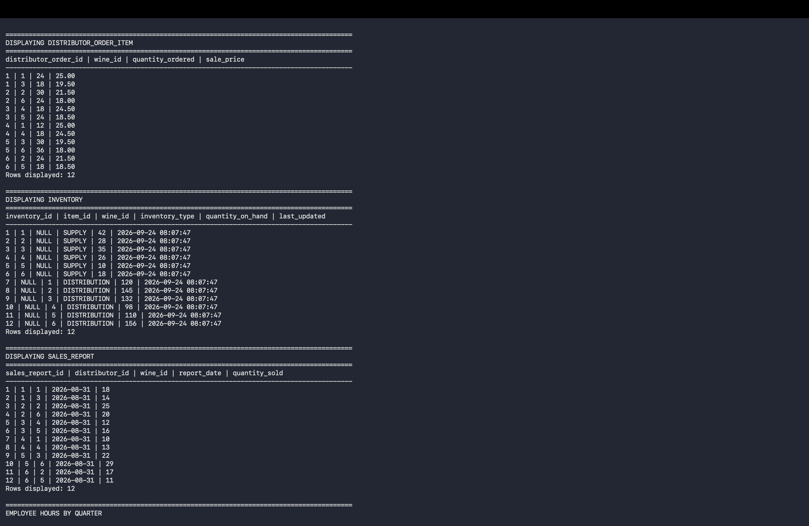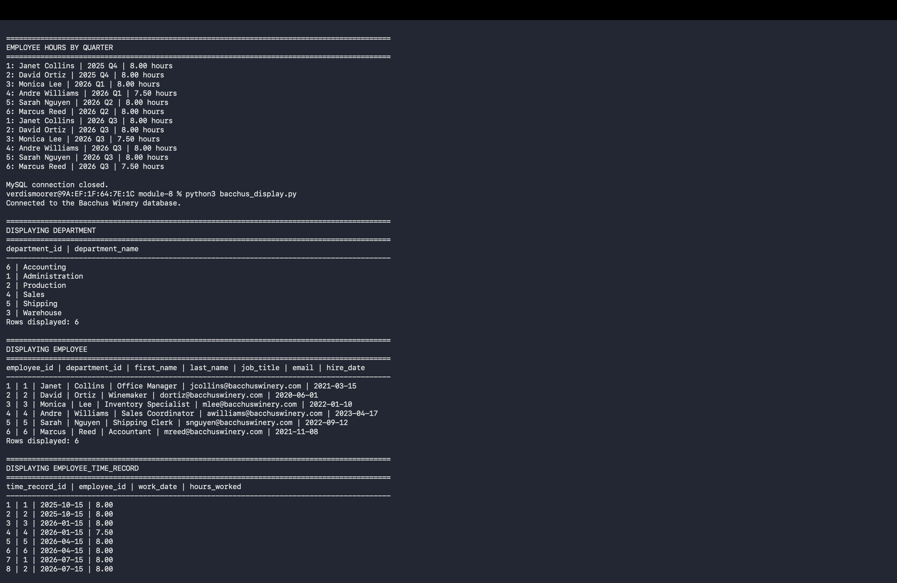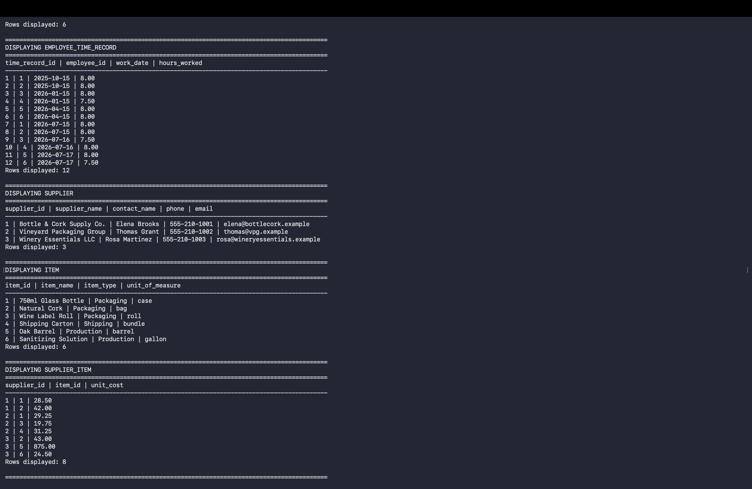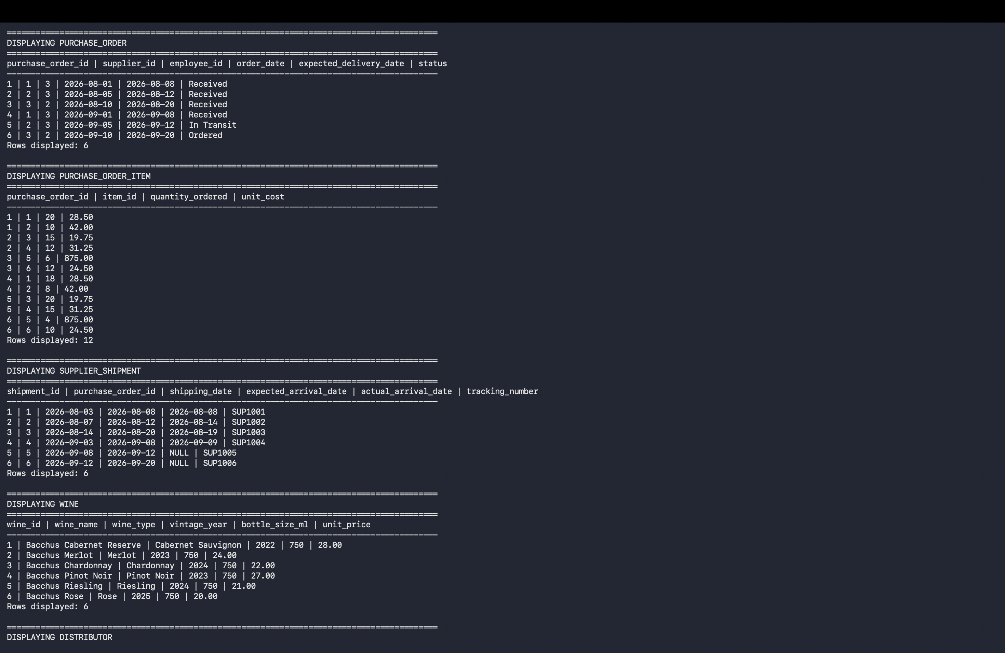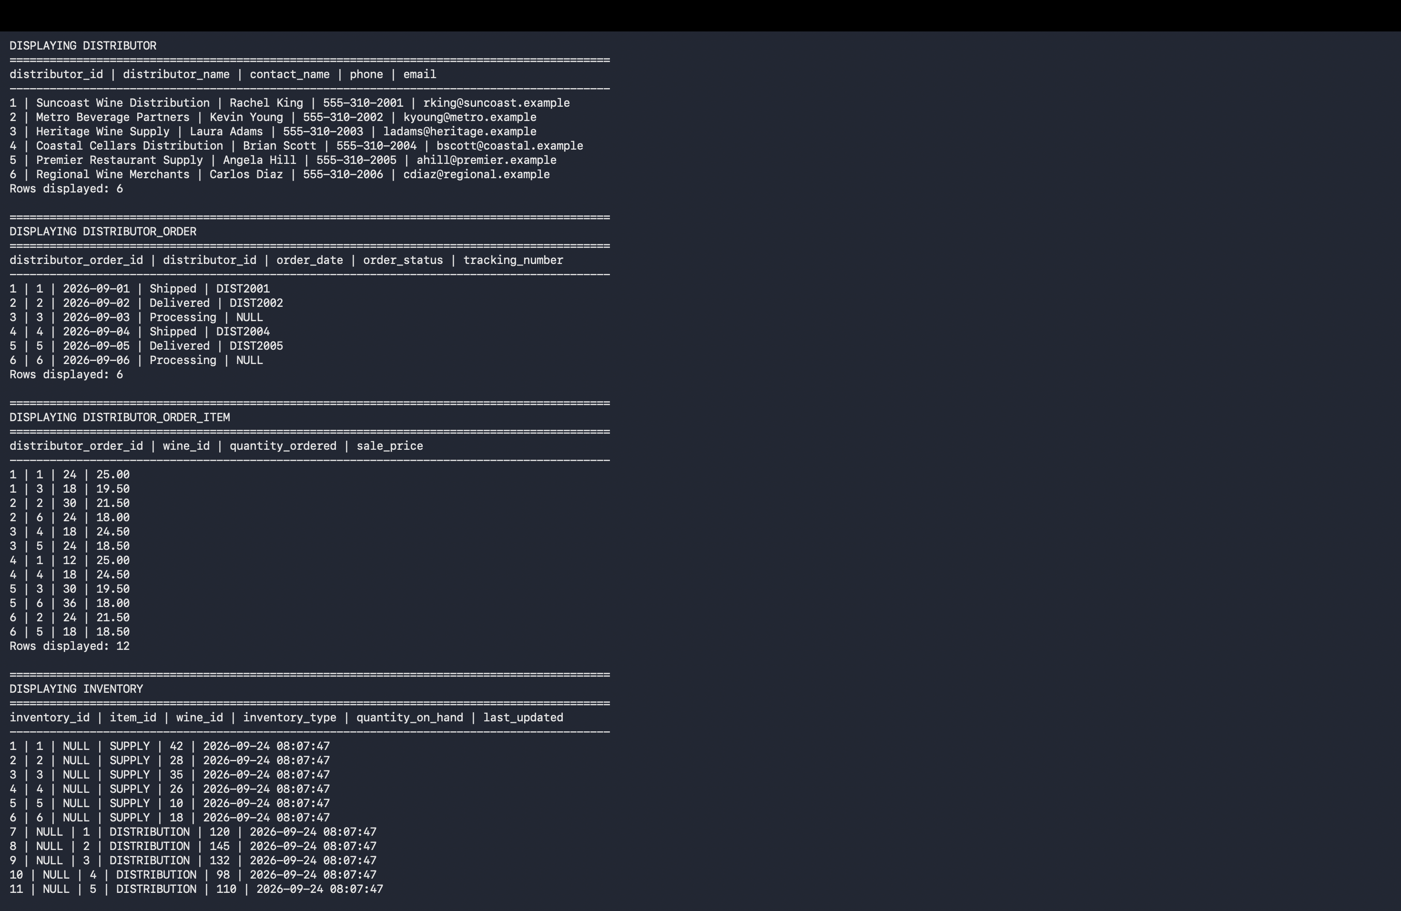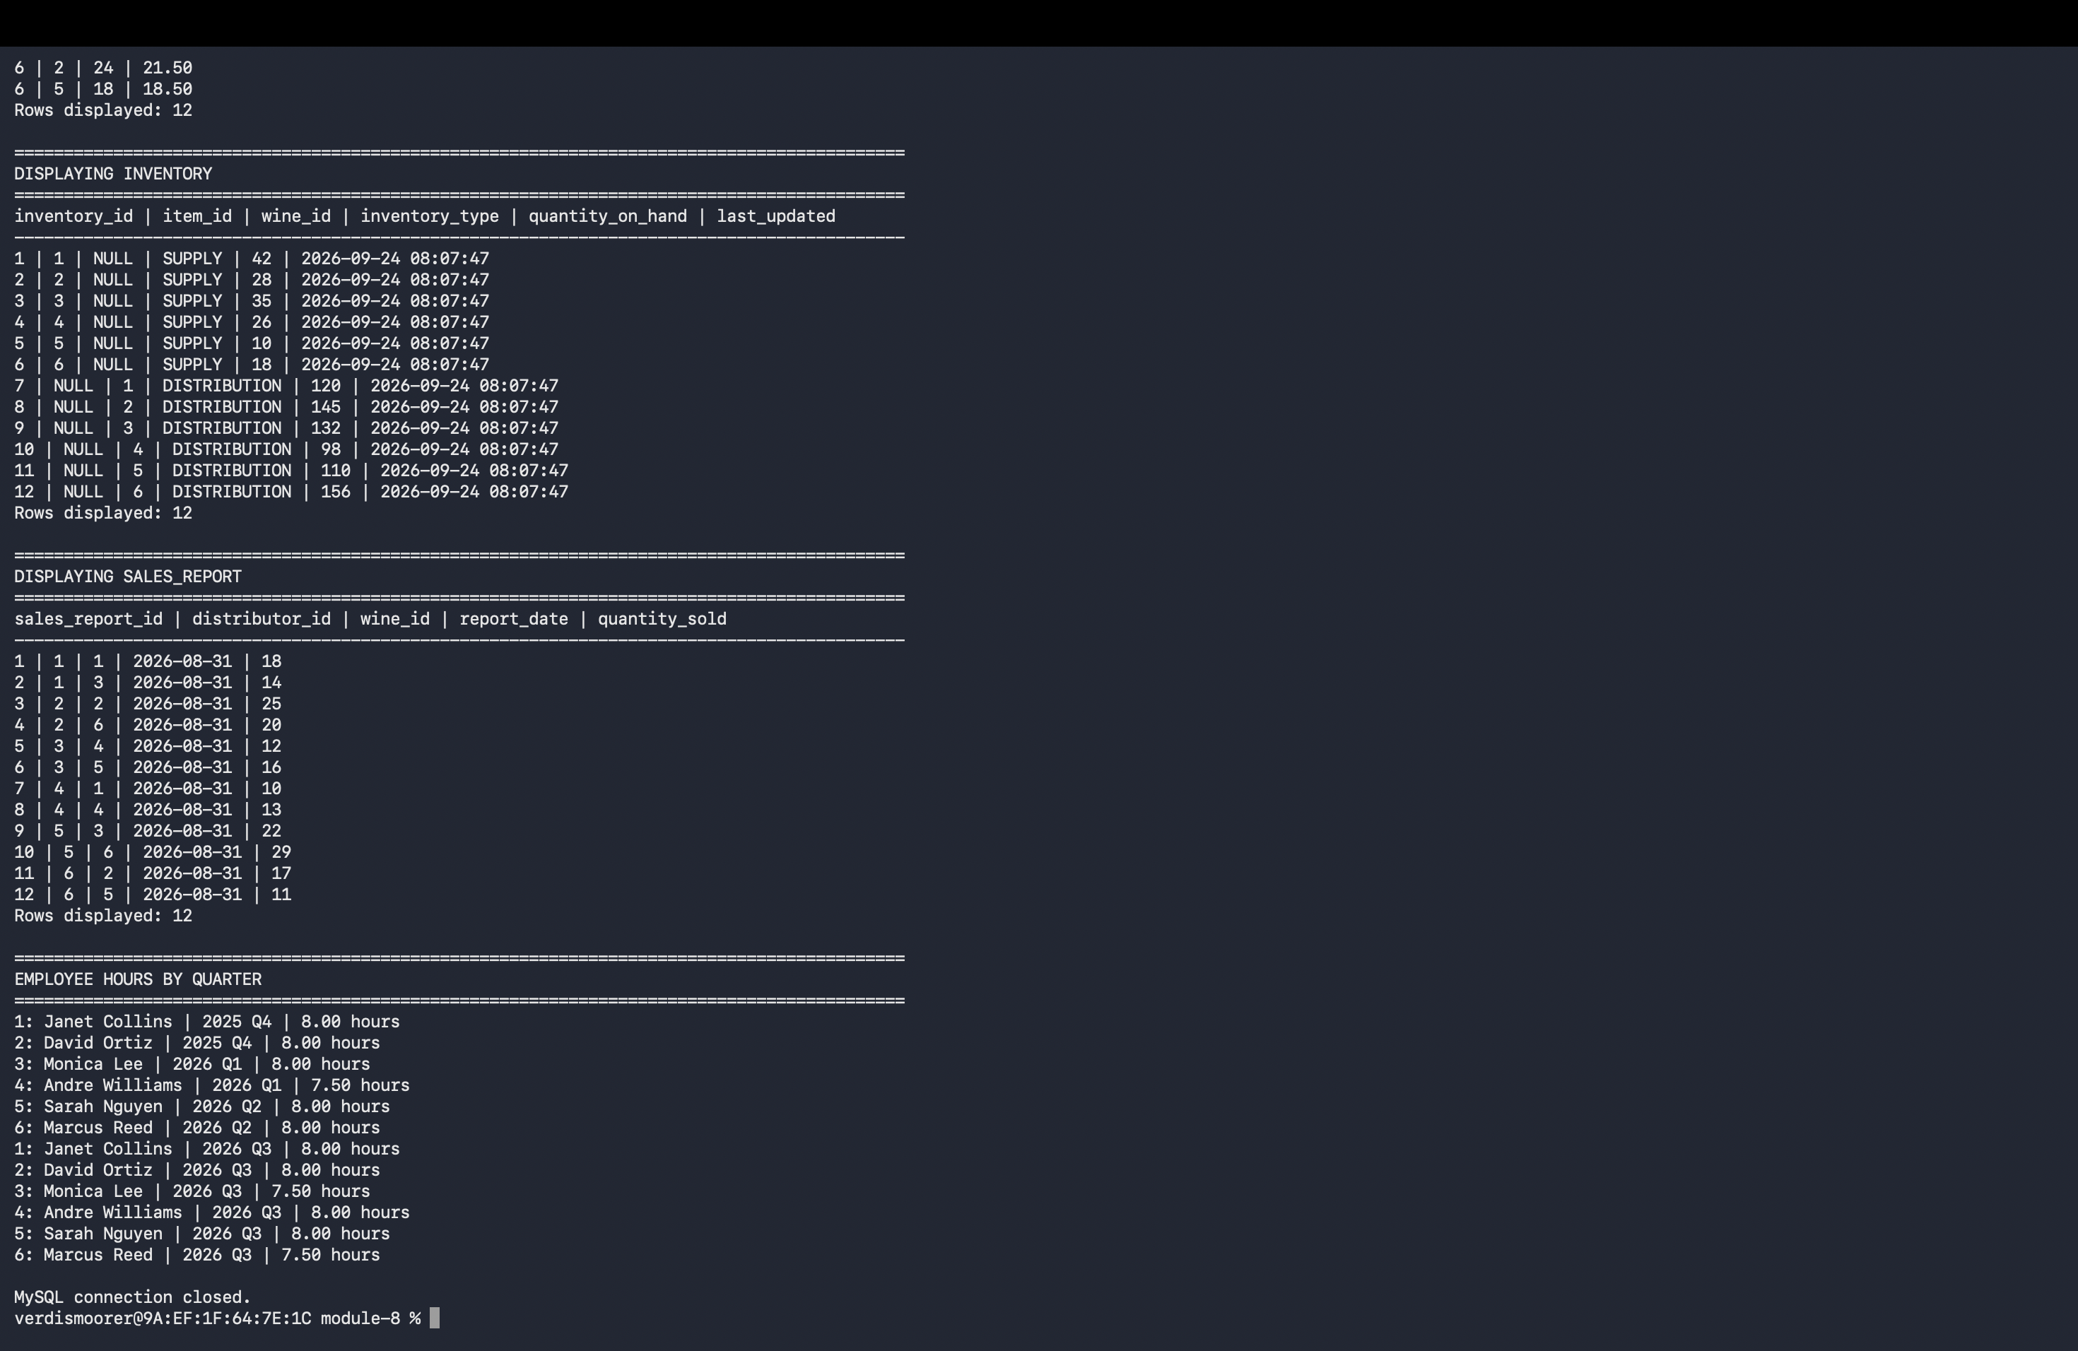

Files Included in Submission Package
- bacchus_winery.sql
- bacchus_display.py
- Group_D_Bacchus_Winery_Milestone_2.docx
- Bacchus_Winery_Revised_ERD.png

