CSD-402: JAVA PROGRAMMING
Module 4 Assignment- Method Overloading

Verdis Moorer

For this assignment, I created a java program that demonstrates method overloading by calculating the average of 4 different types of arrays. The program includes 4 methods name average( ), each accepting a different data type: short, int, long, and double.
I used arrays containing different numbers of elements to demonstrate that each method can calculate an average regardless of the array’s size. The program displays the original array elements along with the calculated average.
Program Testing
I tested the program using the following arrays:
- Short arrays: 3 elements, average of 20
- Integer array: 4 elements, average of 30
- Long array: 5 elements, average of 300
- Double array: 6 elements, average of 7.5

The program uses loops to add value in each array and divide the total by the numbers of elements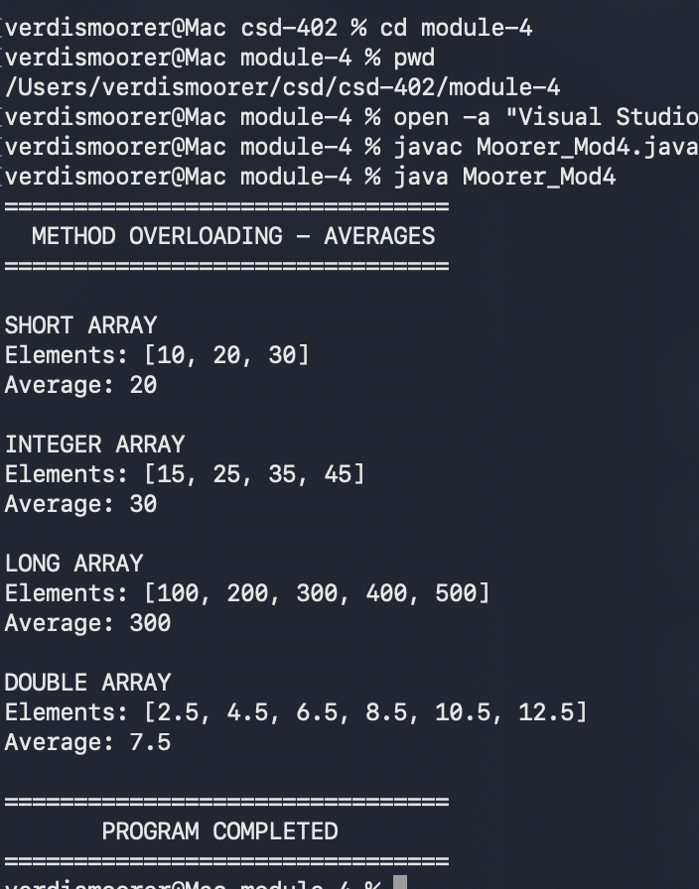
m

