**Spaceflight simulator possible user paths**

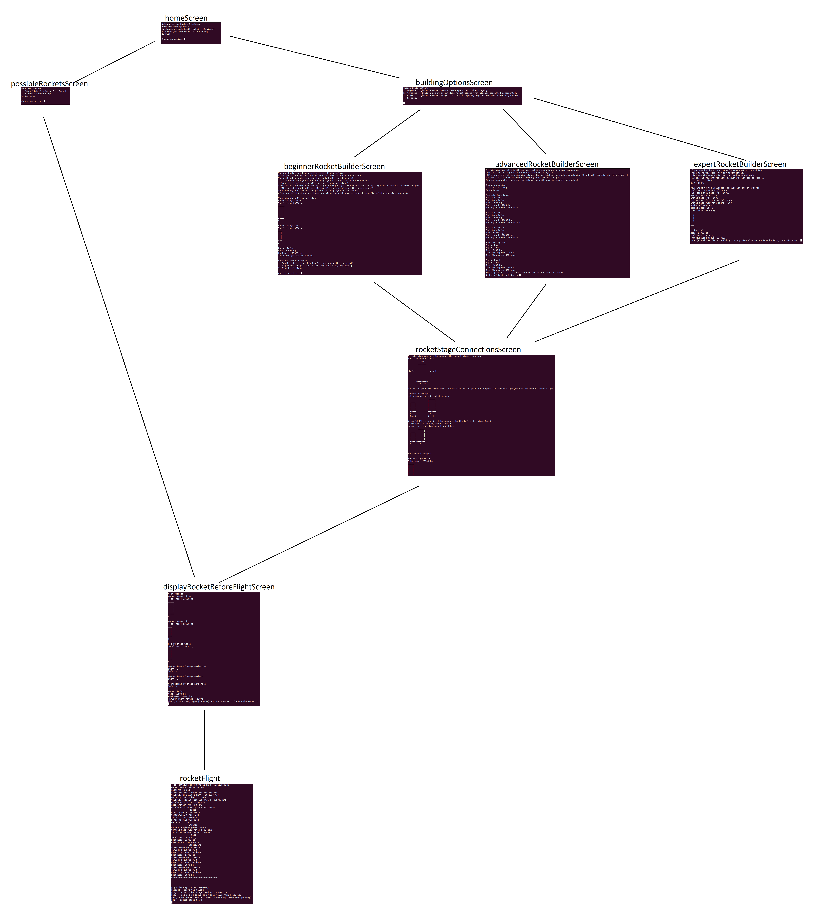

src: /documentation/pages/allScreensPathNames.jpg

**Flight physics**

During the flight we can control the rocket by:

* Changing rocket angle (α)
* Changing Power for all engines
* Detaching rocket stages.

All flight data is computed by interval time .

Gravity varies with altitude.

Rocket mass is decreasing while engines are on, because engines burn some fuel during . It is crucial in the simulation.

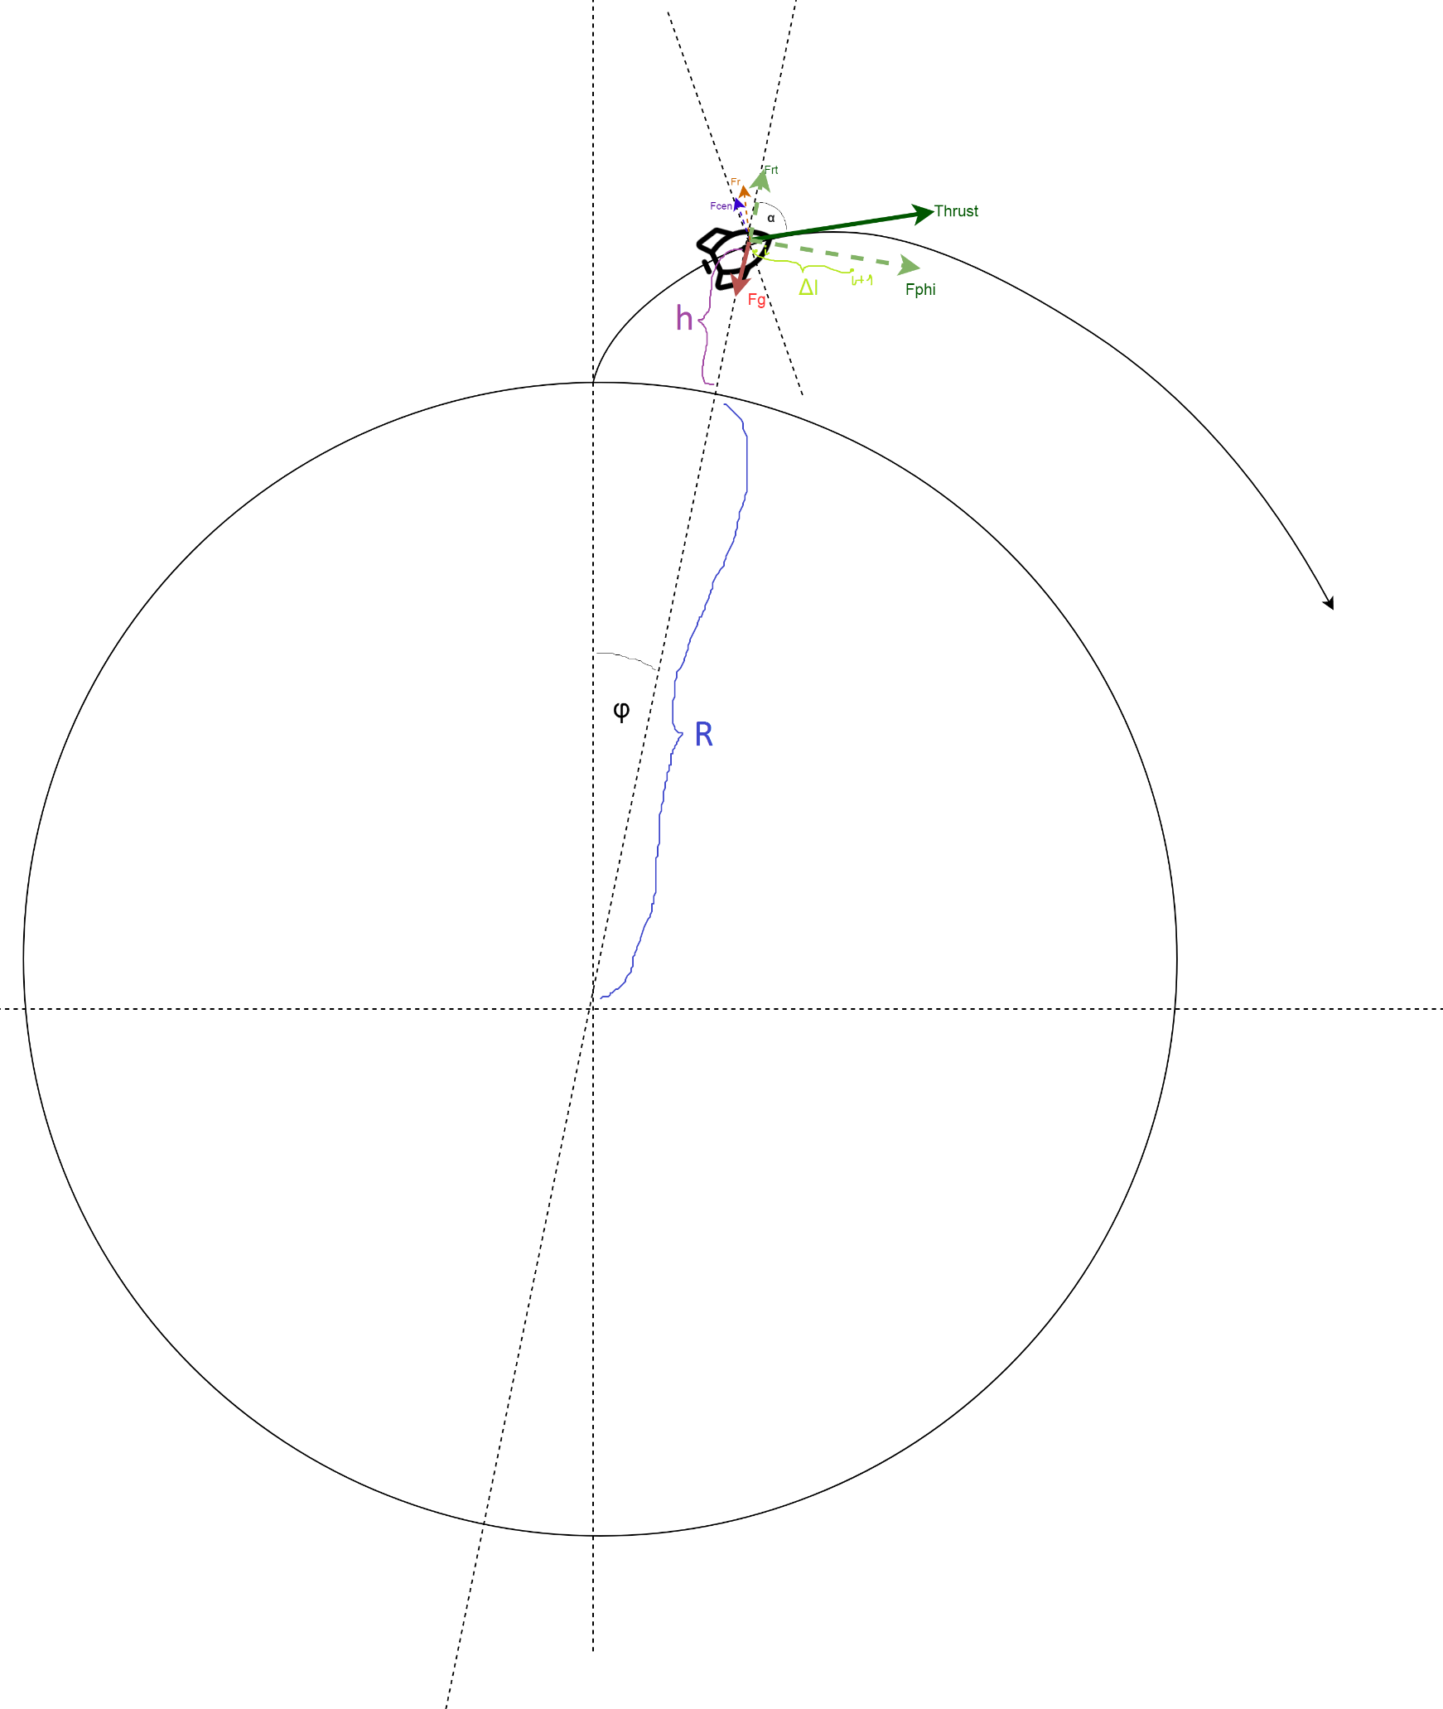

src: /documentation/physics/physics.jpg

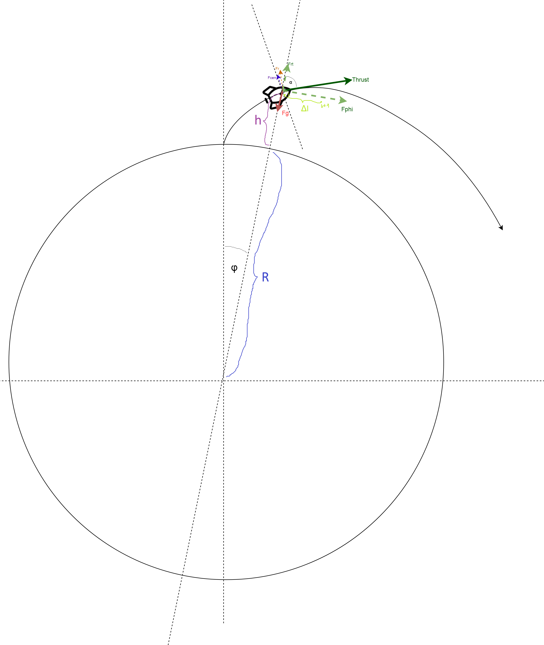

***Forces***

***Acceleration and velocity***

***Distance and angle***

*for small angles*

**Determining the position of the rocket in space**

All calculations are performed in the polar coordinate system (because it is much easier). So the rocket position is determined by some point O and rocket’s distance from point O (distance = R + altitude in our case), and the angle .

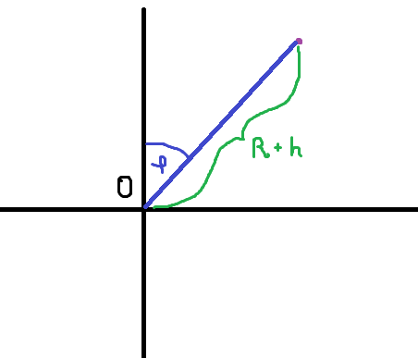

We can easily convert these values into Cartesian coordinates

**Flight simulator telemetry data**

After the flight, three files are generated:

1. rocketTelemetry_live.txt
   1. this file contains values for all variables during the flight in each time interval.
   2. 
2. rocketTrajectory.png
   1. this file show rocket trajectory zoomed into rocket it means that only a part of earth is visible.

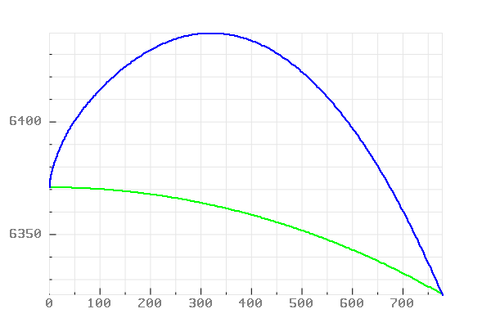

1. rocketTrajectoryFull.png
   1. this file show rocket trajectory in the view of full earth size.

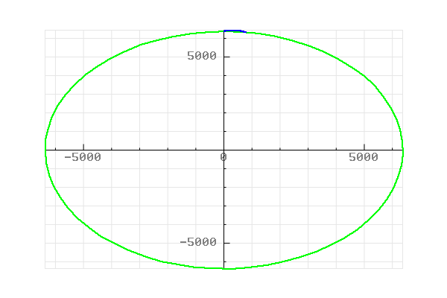

**Implementation**

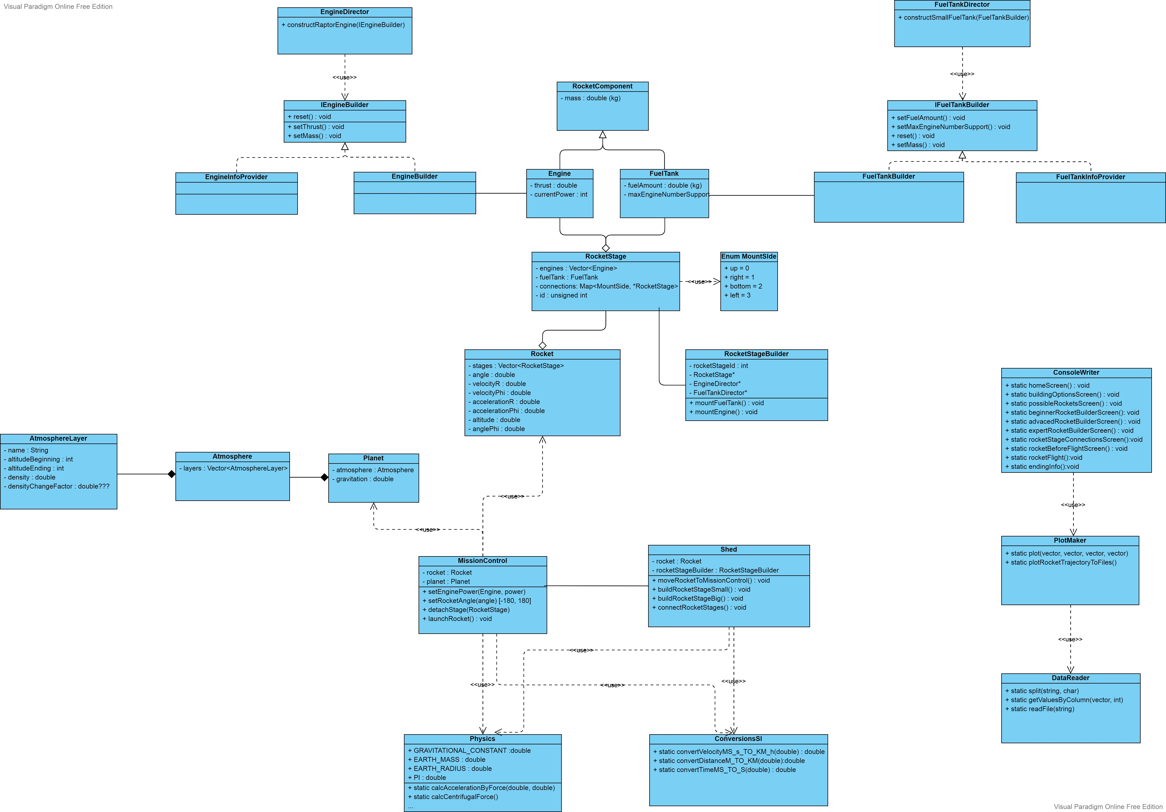

src: /documentation/impl/UML.jpg