FieldShore
User Manual

Rescue Strut Selection, Inventory Management
& Shoring Operations for USAR/FEMA

Version 3.7
May 2026
https://vergo402.github.io/paratech-struts/

Table of Contents
1. Getting Started
1.1 Installing the App
1.2 Connecting Your Department
2. Quick Find
2.1 Searching for Struts
2.2 Deductions
2.3 Inventory Quick View
3. Operations
3.1 Starting an Operation
3.2 Operation Layout
3.3 Ending an Operation
4. Shore Points
4.1 Adding a Shore Point
4.2 Shore Point Lifecycle
4.3 Grouped Shore Points
4.4 Drill-Down Navigation
5. ICS Command
5.1 Default Roles
5.2 Assigning Roles
5.3 Status Indicators
5.4 Custom Roles & Reparenting
6. Cut Table
7. Inventory
7.1 Adding Equipment
7.2 Excel Import/Export
8. Settings
8.1 Theme & Appearance
8.2 Feedback
9. Offline Use
10. Version History

1. Getting Started

1.1 Installing the App
FieldShore is a Progressive Web App (PWA). No app store download is required. Open the app URL in your phone's browser and install it to your home screen for a native app experience.
- To install:
- iOS: Tap the Share button, then "Add to Home Screen"
- Android: Tap the browser menu, then "Add to Home Screen" or accept the install prompt
TIP: Once installed, the app launches fullscreen and works offline, just like a native app.

1.2 Connecting Your Department
On first launch, you'll see the login screen. Enter your department's shared ID to connect to shared inventory and operations.
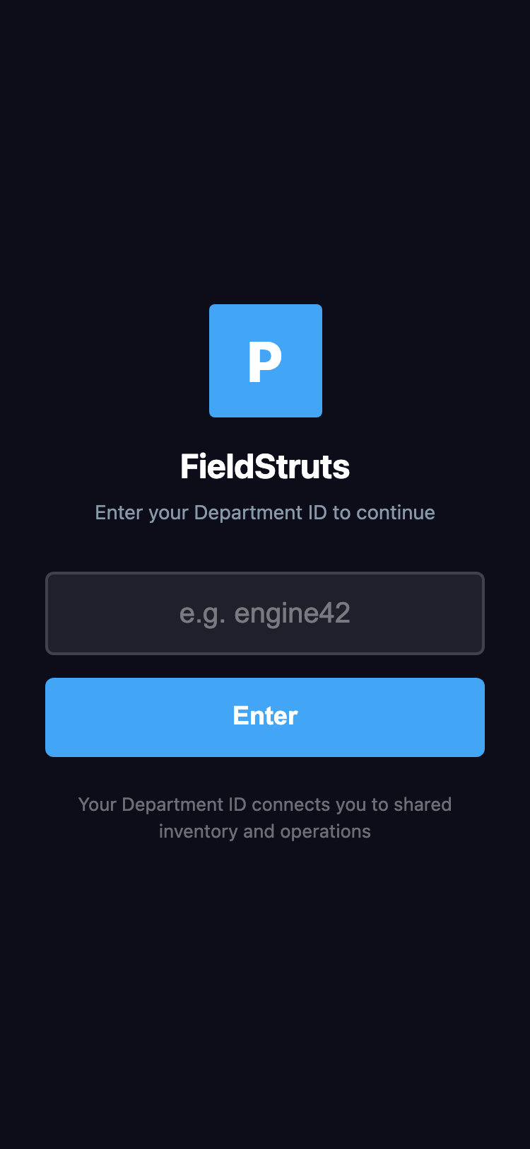
Login screen - Enter your Department ID to connect

Your Department ID connects all devices in your department. Everyone using the same ID sees the same inventory, operations, and shore points in real time. No password is required.
TIP: Share the same Department ID with your entire crew so all devices stay in sync.

2. Quick Find
The Quick Find tab is the fastest way to determine which Paratech struts fit a given opening measurement. Enter your measurement, optional load, and tap Find Struts.

2.1 Searching for Struts
To find matching struts:
- Enter the opening measurement in feet, inches, and fraction (down to 1/16")
- Optionally enter an estimated load in pounds
- Select which strut systems you have: Gold (LongShore), Grey (AcmeThread), and/or LockStroke
- Tap Find Struts
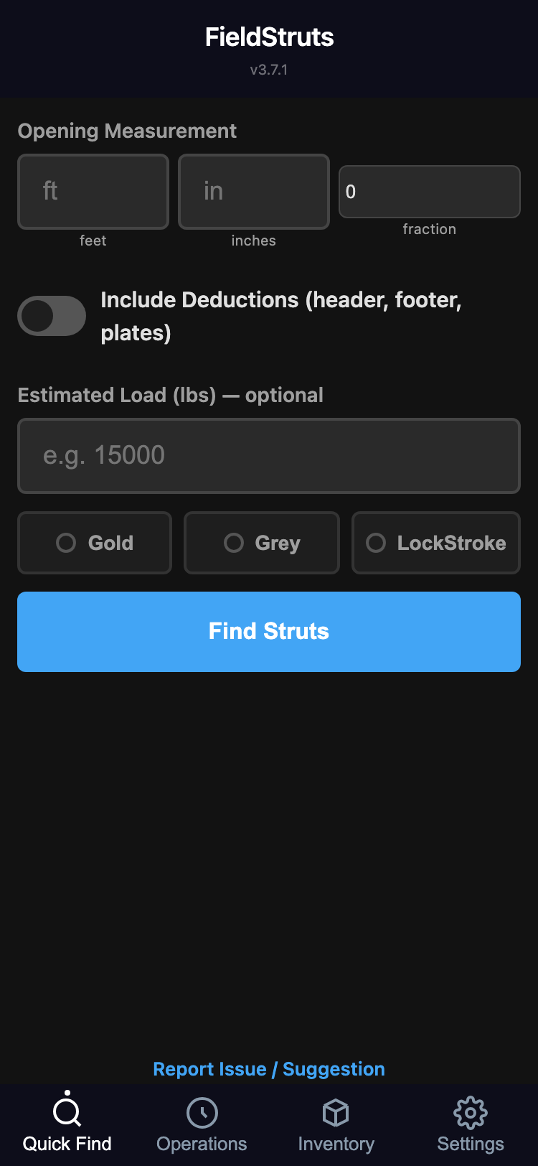
Quick Find - Enter measurement, load, and strut system

Results show all matching strut and extension combinations, ranked by safety factor. Each card displays the strut model, extension (if needed), combined length range, and load capacity at 4:1 safety factor.
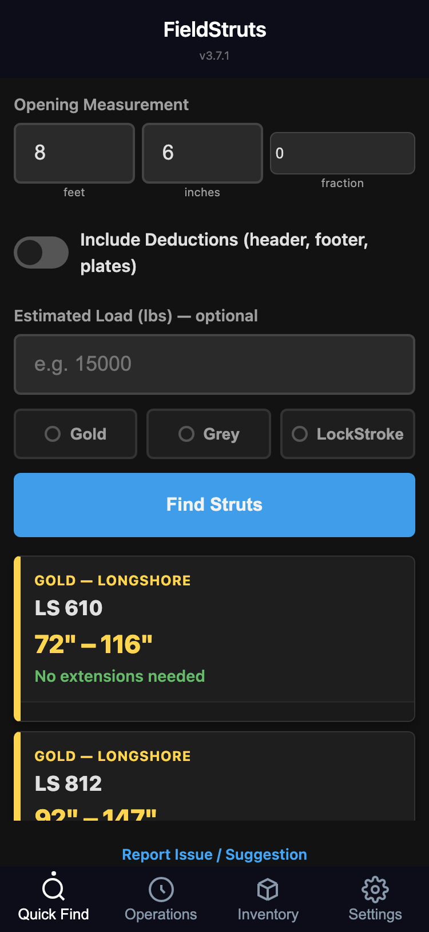
Search results showing matching struts ranked by safety factor

NOTE: If no strut systems are selected, all types are shown in results.

2.2 Deductions
Toggle Include Deductions to account for header wood, footer wood, and connector plates in your measurement. The app subtracts these heights from the opening before searching, so results reflect the actual strut length needed.
- Available deductions:
- Header/Footer wood: None, 4x4 (3.5"), or 6x6 (5.5")
- Top/Bottom plates: 14 Paratech connector types, each with a specific height

2.3 Inventory Quick View
Tap the cube icon (floating button, bottom-right corner) at any time to see your current available inventory without leaving the screen you're on.
TIP: Use Quick View during strut selection to see what's actually on your apparatus before deploying.

3. Operations
The Operations tab manages active shoring operations. This is where you create operations, assign apparatus, add shore points, and track deployment through the full lifecycle.

3.1 Starting an Operation
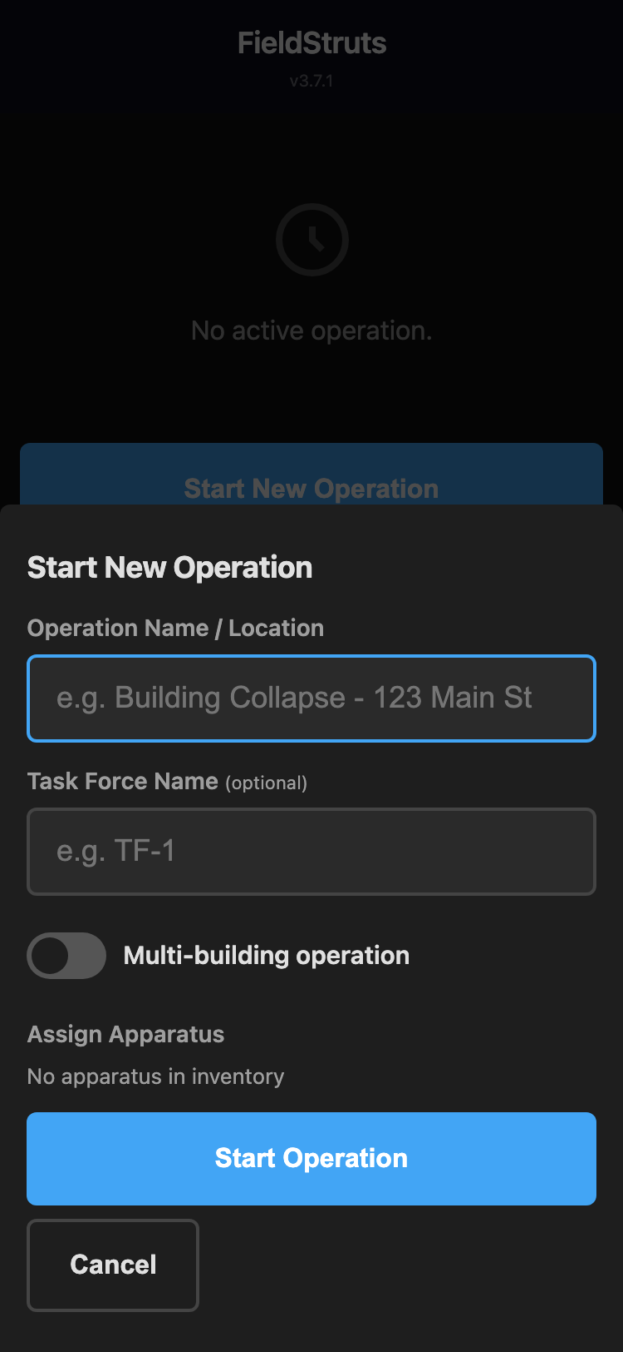
Start Operation - Name the operation and select apparatus

To start a new operation:
- Tap Start New Operation
- Enter an operation name (e.g., "123 Main St Collapse")
- Optionally enter a Task Force name
- Check Multi-Building if the operation spans more than one structure
- Select which apparatus to assign (all checked by default)
- Tap Start Operation

3.2 Operation Layout
Once an operation is active, the screen displays several sections:
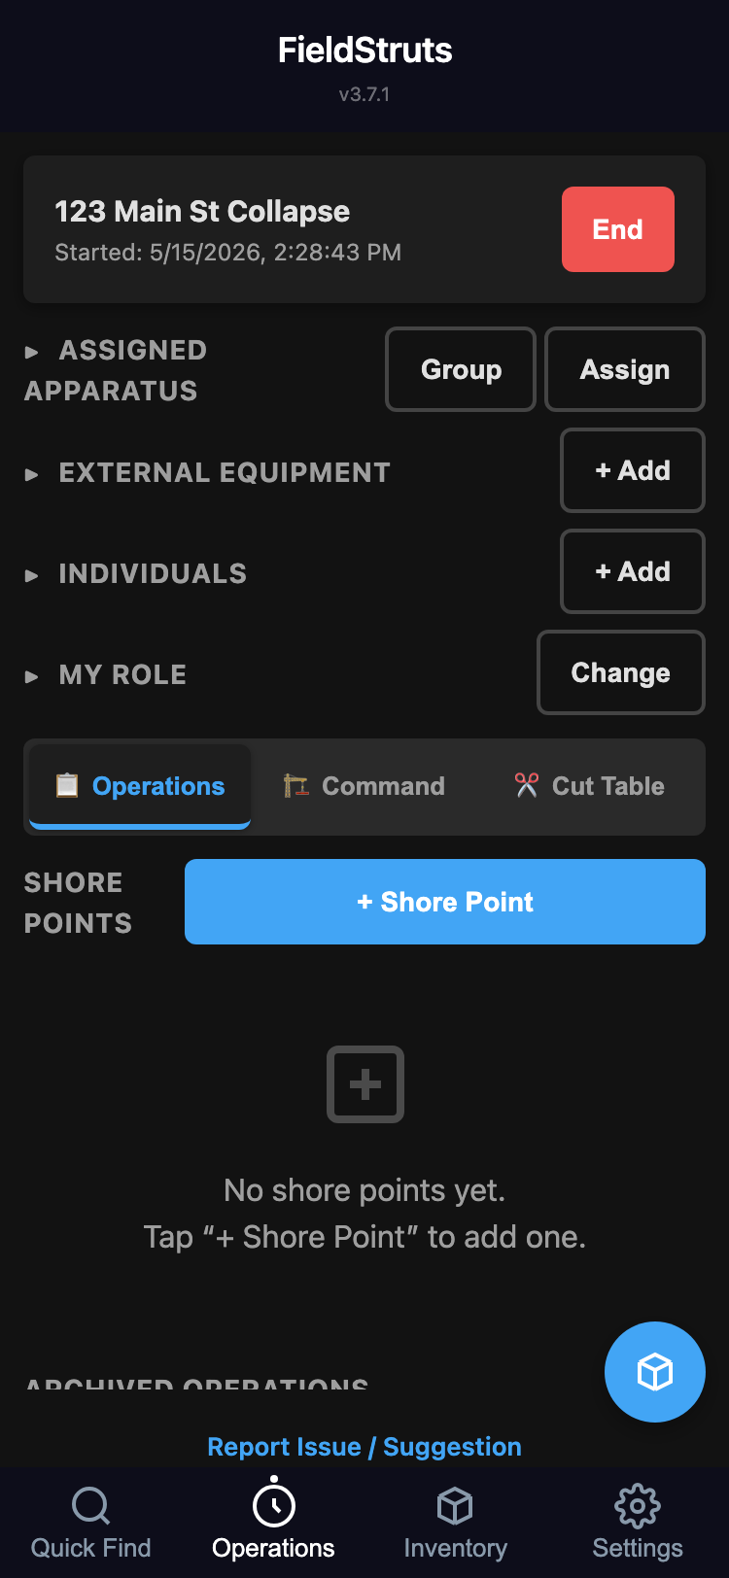
Active operation showing assigned apparatus and management sections

- Assigned Apparatus: Which units are part of this operation. Use Assign to add/remove, or Group to organize into named groups.
- External Equipment: Equipment borrowed from other departments. Tap + Add to log external struts.
- Individuals: Named personnel. Tap + Add to assign firefighters by name.
- My Role: Set your device's ICS role. This determines your default view.
TIP: Tap any section header to collapse it and keep the screen clean while working on shore points.

3.3 Ending an Operation
Tap End to archive the operation. It moves to the Archived Operations list at the bottom of the tab, where you can view details or permanently delete it.
IMPORTANT: Ending an operation archives all shore points and returns all equipment to inventory.

4. Shore Points
Shore points are the core of an operation. Each one represents a location that needs shoring with specific measurement requirements.

4.1 Adding a Shore Point
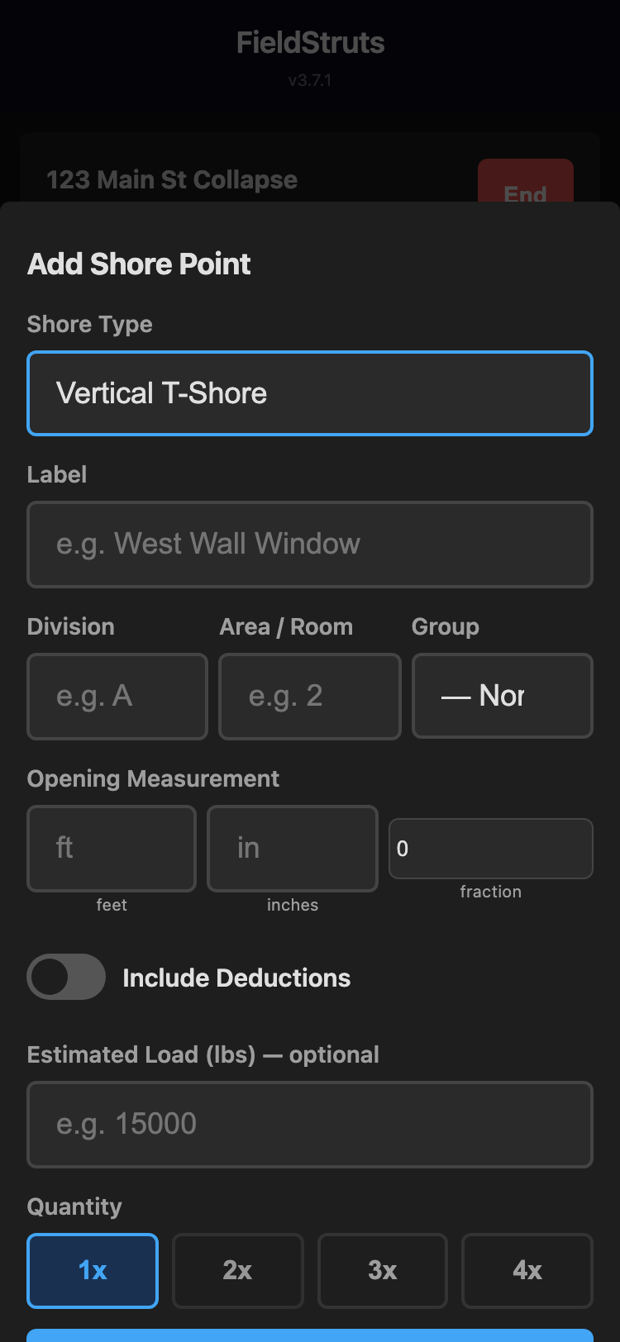
Add Shore Point - Enter location, measurement, and shore type

To add a shore point:
- Tap + Shore Point on the operations screen
- Enter a Label (e.g., "SP-1", "Kitchen Wall")
- Enter Division (geographic area) and Area (specific location)
- Select the Group (which apparatus is responsible)
- Choose a Shore Type:
- Vertical T-Shore — Single strut with header and footer
- Double-T Vertical Shore — Two struts with shared header
- 3-Post Vertical Shore — Three struts with 6x6 header and footer
- Enter the opening measurement and optional load
- Set quantity (1-4 struts) and tap Find & Deploy

4.2 Shore Point Lifecycle
Each shore point progresses through six statuses. Use the status buttons on each card to advance or send back through the workflow.
Status | Meaning
Pending | No equipment available — saved for later assignment
In Process | Equipment deployed, work beginning
Strut Placed | Strut is physically in position
Cutting | At the cut table for final sizing
Runner | Being transported to the shore location
Secured | In place and operational
Removed & Returned | Shore deconstructed, equipment returned to inventory

NOTE: Pending shore points automatically show a green indicator when matching equipment becomes available in inventory.

4.3 Grouped Shore Points
Shore types with quantity greater than 1 (e.g., a 3-strut T-shore) create grouped shore points. Status changes, cut marking, runner sends, and equipment returns apply to all members of the group at once.

4.4 Drill-Down Navigation
Shore points are organized hierarchically: Building > Division > Area > Group. Tap into each level to filter, with breadcrumb navigation and a back button at each step. The drill-down stops at the Area level — group assignments are shown on each card.

5. ICS Command
The Command sub-tab displays the ICS/NIMS organizational chart for the operation. It supports real-time role assignment, hierarchy restructuring, and operational status monitoring.

5.1 Default Roles
The default ICS hierarchy is:
Role | Abbreviation | Reports To
Incident Commander | IC | — (Root)
Safety Officer | Safety | IC
Operations | Ops | IC
Entry | Entry | Operations
Rescue | Rescue | Operations
Initial Shoring | Shoring | Operations
Runner | Run | Operations
Cutting Table | Cut | Operations
Wood Shoring | Wood | Operations

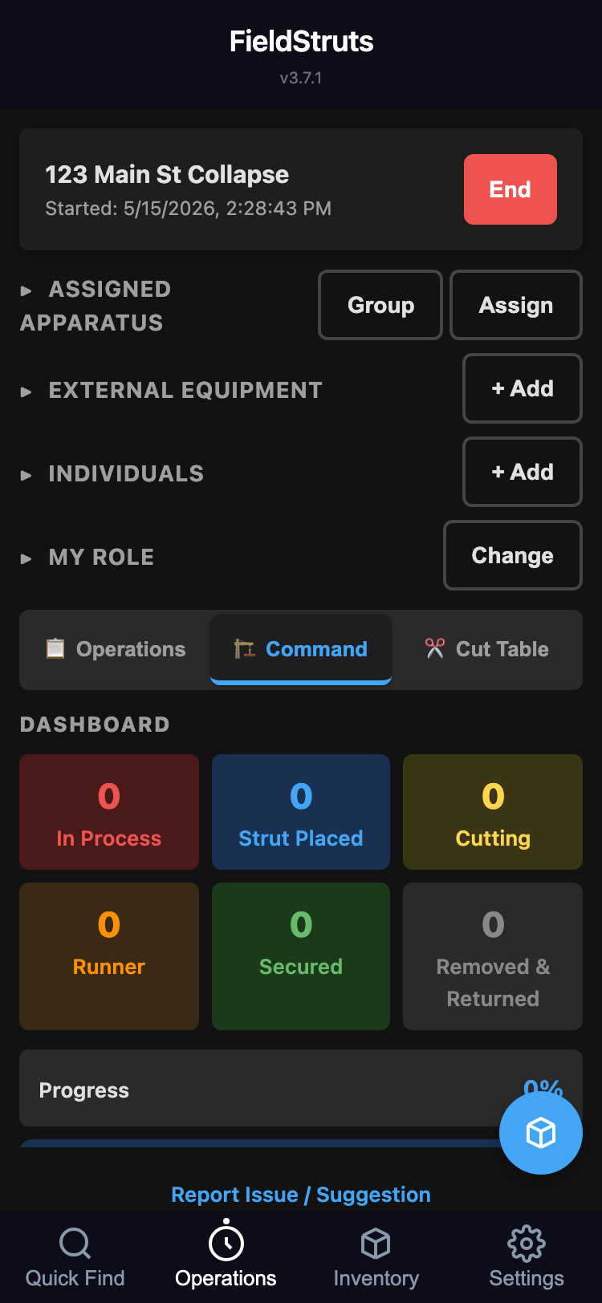
Command view with ICS org chart, status indicators, and headcount

5.2 Assigning Roles
Tap any node in the org chart to open the role management modal. From there you can:
- Assign available apparatus or individuals to the role
- Clear existing assignments
- View who is currently assigned and their status

5.3 Status Indicators
Filled roles display a colored status indicator:
- Green circle: Active — role has assignees AND active shore points in progress
- Amber square: Staged — role has assignees but no active shore points (crew waiting)
A legend below the org chart header explains the indicator meanings. The headcount badge (e.g., "3/5 resources assigned") shows overall staffing at a glance.
IMPORTANT: A warning badge appears on any role with more than 7 direct reports, per NIMS guidelines (optimal 3–7).

5.4 Custom Roles & Reparenting
You can customize the org chart structure:
- Add sub-roles: Tap any node → Sub-Role to add a child role underneath it
- Rename: Tap any node → Rename to change its display name
- Reparent (move): Long-press drag (mobile, 500ms hold) or tap → "Move to..." menu
- Swap personnel: Short drag between two roles swaps their crew assignments (not hierarchy)
NOTE: IC and Safety Officer cannot be moved. IC is always root; Safety always reports directly to IC (NIMS requirement). Only devices with IC or Safety role can reparent.

6. Cut Table
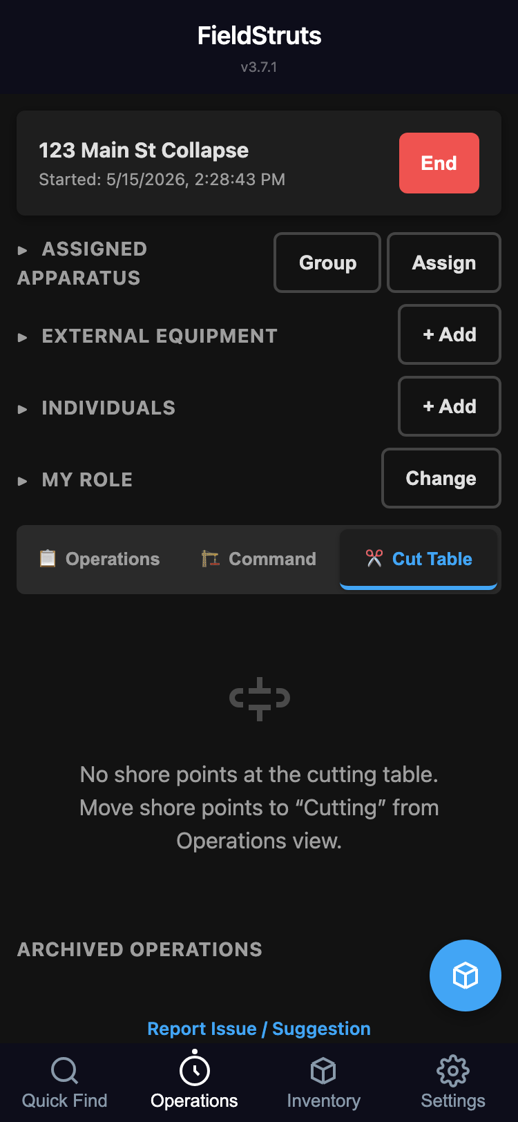
Cut Table view showing shore points currently in Cutting status

The Cut Table sub-tab provides a focused view for the cutting station. It shows all shore points currently in the Cutting status with their required measurements, so the cut team can see exactly what needs to be sized without scrolling through the full operations list.
TIP: Set your device's My Role to "Cutting Table" and the app will default to this view automatically.

7. Inventory
The Inventory tab manages your department's strut, extension, and connector plate inventory across all apparatus.
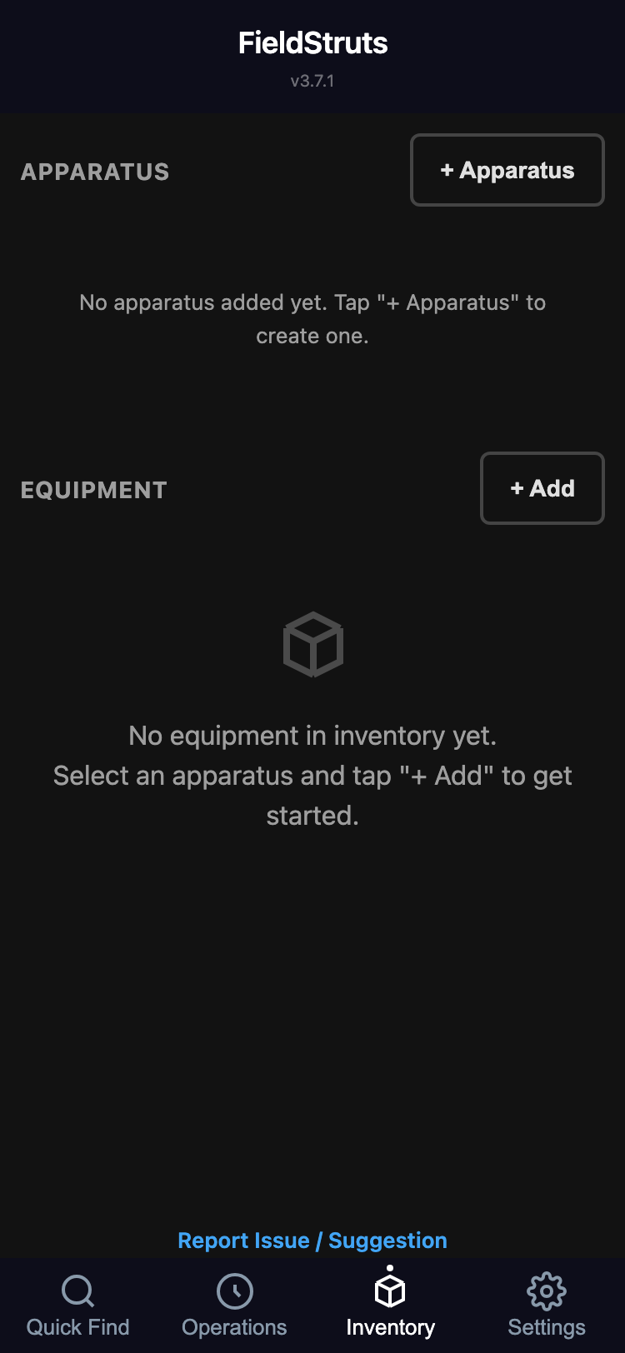
Inventory tab showing apparatus and equipment management

7.1 Adding Equipment
For each apparatus:
- Tap the apparatus name to expand it
- Tap + Add to open the equipment modal
- Use Quick Add for fast entry — a visual grid of all Paratech strut models, extensions, and connector plates with quantity badges
- Or use Manual Add for custom items
Use the + and - buttons on each item to adjust quantities. Items with deployed equipment cannot be reduced below the deployed count.

7.2 Excel Import/Export
Export your full inventory as an Excel (.xlsx) file using the export button. Import from Excel to bulk-load or update inventory. The app preserves item IDs across round-trips so deployed-strut references aren't broken.
TIP: Use Excel export before a deployment to have a paper backup of your inventory.

8. Settings
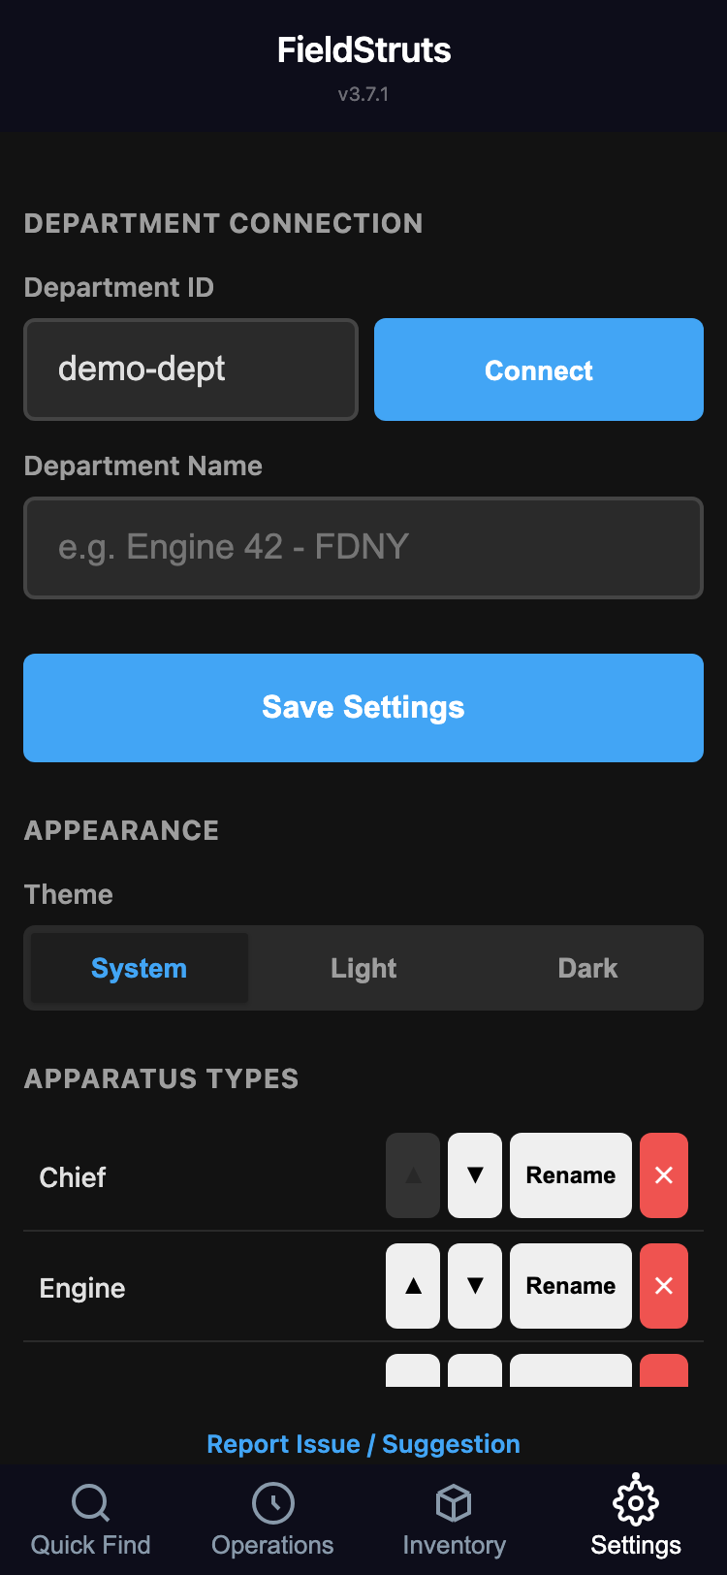
Settings tab with department info, appearance, and data options

The Settings tab includes:
- Department Name: Display name for your department
- Department ID: Your connection ID. Tap Log Out to switch departments.
- Apparatus Types: Customize the type list (add, rename, reorder, remove types)

8.1 Theme & Appearance
Choose between System (follows your device), Light, or Dark theme. The preference persists across sessions and applies immediately.
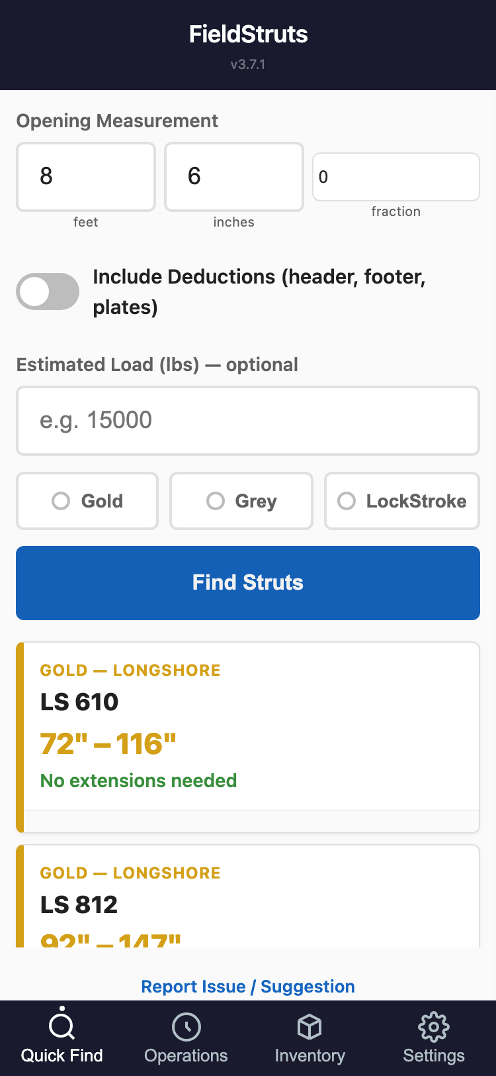
Light mode appearance

8.2 Feedback
Tap "Report Issue / Suggestion" at the bottom of any screen to open the feedback form. Select a category (Bug Report or Feature Request), describe the issue, and optionally attach a photo from your camera or gallery.
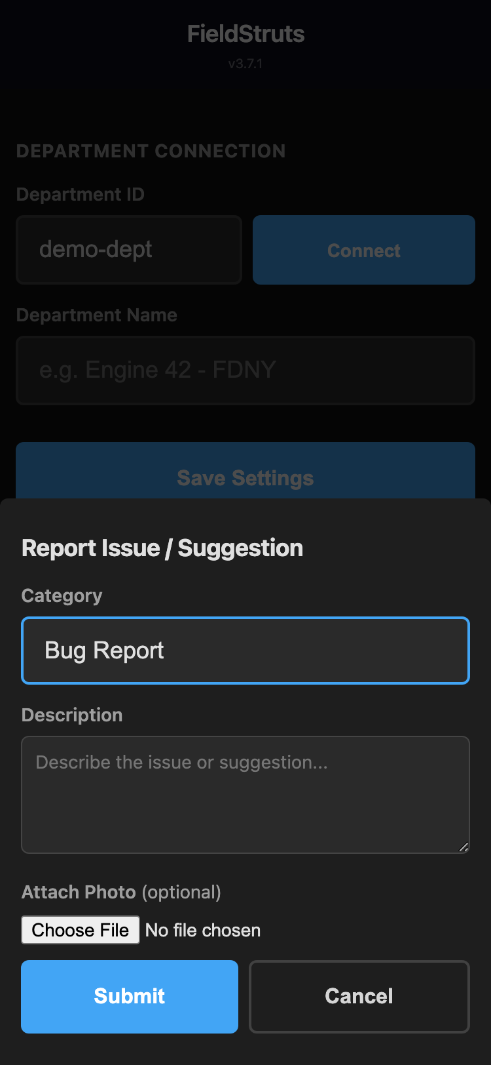
Feedback form with photo attachment option

TIP: Photos are automatically compressed before upload, so you can attach images even on slow connections.

9. Offline Use
FieldShore is designed for field use where connectivity is unreliable or unavailable.
- Fully offline capable: After the first load, all app assets are cached locally. The app works completely without an internet connection.
- Local-first data: All changes write to local storage first, then sync to Firebase when a connection is available.
- Automatic sync: When connectivity returns, queued changes sync automatically. No manual action needed.
- Connection indicator: A status bar in the header shows your current sync state.

Updating the App
When a new version is available, the service worker downloads it in the background. To activate the update:
- Close and reopen the app, or
- Refresh twice — the first refresh downloads, the second activates

10. Version History
Major and minor releases only. Patch releases (bug fixes) are omitted.
Version | Date | Highlights
3.7 | May 2026 | Firebase Anonymous Auth + security rules. Photo attachment in feedback. Status dot key/legend on ICS org chart.
3.6 | May 2026 | Firebase listener cleanup. Concurrent edit safety for org chart. Keyboard accessibility for all interactive elements. Performance optimization.
3.5 | May 2026 | Dark/light/system theme toggle. Shore point Group field changed to apparatus dropdown. Local-first write architecture.
3.4 | May 2026 | Command page overhaul: role reparenting, collapsible branches, status indicators, headcount badge, span-of-control warnings.
3.3 | May 2026 | 6-pass production audit. App renamed to FieldShore. Extension rule fixes, safety checks.
3.2 | May 2026 | Customizable apparatus types from Settings.
3.1 | May 2026 | Dynamic ICS org chart: custom sub-roles, rename, remove, tree rendering.
3.0 | May 2026 | Drag-and-drop ICS org chart repositioning.
2.4 | May 2026 | Apparatus type hierarchy. Apparatus groups for operations.
2.3 | May 2026 | NIMS/ICS terminology update (Team to Group). Collapsible sections.
2.2 | May 2026 | Interactive ICS org chart. Grouped shore points.
2.1 | May 2026 | Cut measurement persistence. Actual vs. expected cut display.
2.0 | May 2026 | Production hardening: Firebase error handling, XSS protection, offline write queue.
1.11 | May 2026 | Pending shore points. ICS/NIMS hierarchy chart.
1.10 | May 2026 | Individual personnel tracking with ICS role assignment.
1.9 | May 2026 | External equipment editing. Quick Add grid for externals.
1.8 | May 2026 | 6-status shore point workflow.
1.7 | May 2026 | ICS drill-down navigation. 3-tier view system.
1.4 | May 2026 | Live inventory count badges on Quick Add.
1.1 | May 2026 | Department login screen. Multi-strut deploy.
1.0 | May 2026 | First release. Quick Select, inventory, operations.

