VeriPay
AI-Powered Invoice Verification and Fraud Detection System
Project Report

Submitted by
Aryan Aryan
Aryan Sanghvi
Brandon Jillson
Hassan Sajid
Meet Solanki

19 April 2026
University Project Report

Abstract 1
Chapter 1: Introduction and Motivation 1
Chapter 2: Problem Statement and Project Objectives 1
2.1 Problem Statement 1
2.2 Goals for the Project 1
Chapter 3: Scope, Assumptions, and Stakeholders 1
3.1 Scope of the Project 1
3.2 Out of Scope or Optional Features 1
3.3 Assumptions 1
3.4 Stakeholders 1
Chapter 4: Technology Stack and Rationale 1
4.1 Backend Technology 1
4.2 Machine Learning and AI Stack 1
4.3 PDF, OCR, and Image Processing 1
4.4 Frontend Technology 1
4.5 Infrastructure and Deployment 1
Chapter 5: High-Level System Architecture 1
Chapter 6: Repository Structure and Major Artifacts 1
6.1 Backend Directory 1
6.2 Frontend Directory 1
6.3 AI Pipeline Directory 1
6.4 Other Supporting Assets 1
Chapter 7: Backend Design and Implementation 1
7.1 Application Bootstrap 1
7.2 Authentication Module 1
7.3 Vendor Management Module 1
7.4 Invoice Management Module 1
7.5 Cross-Cutting Service Modules 1
Chapter 8: Analysis Pipeline — End-to-End Workflow 1
Chapter 9: Machine Learning and Scoring Methodology 1
Chapter 10: Frontend — User Interface and User Journeys 1
Chapter 11: Data Model and Persistence 1
Chapter 12: REST API Surface Summary 1
12.1 Authentication Endpoints 1
12.2 Vendor Endpoints 1
12.3 Invoice Endpoints 1
12.4 Dashboard Endpoints 1
12.5 Supporting Endpoints 1
Chapter 13: Security, Privacy, and Operational Hardening 1
Chapter 14: Deployment and Environment Configuration 1
14.1 Docker Compose Services 1
14.2 Backend Container Responsibilities 1
14.3 Environment Variables 1
14.4 Docker Architecture 1
Chapter 15: Limitations, Risks, and Ethical Considerations 1
Chapter 16: Future Enhancements 1
Conclusion 1
Appendix A: Ensemble Fraud Score Logic 1
Appendix B: Invoice Lifecycle States 1
References 1

Abstract
VeriPay is a full-stack invoice verification system built to help organizations detect fraud before payments are approved. Instead of relying on OCR alone or a single fraud model, the platform evaluates invoices through several layers of analysis, including backend validation, machine learning, cryptographic checks, forensic inspection, semantic field extraction, and a web-based review interface.
The project was motivated by a practical gap: invoice fraud is becoming harder to catch through manual review alone. A fraudulent invoice may look visually convincing, redirect payment details, imitate a trusted vendor, or be altered in ways that are not immediately obvious. VeriPay does not treat invoice checking as a yes-or-no task. It approaches the document from multiple angles and combines those signals into one reviewable result.
The system accepts invoices in PDF and image formats, validates the uploaded file, computes a content hash, extracts text, checks digital signatures when available, identifies key financial fields, and compares banking details against trusted vendor records. These results are then combined into a weighted fraud score that is presented through a Next.js dashboard to support both automated analysis and human review.

Chapter 1: Introduction and Motivation
Invoices are routine business documents, but they carry real financial risk. They move through procurement, reimbursement, vendor payment, accounts payable, and audit workflows, and in many cases they directly trigger payment. That makes them a common target for fraud.
In many organizations, invoice validation still depends heavily on manual review. A staff member looks at the vendor name, checks the amount, scans the layout, and decides whether the document seems legitimate. That process can work for straightforward cases, but it is slow, inconsistent, and easy to get wrong when the volume is high or the fraud is subtle.
Basic OCR is not enough either. It may recover the text on the page, but it cannot answer more important questions: whether the bank account belongs to the right vendor, whether a PDF signature is valid, whether the layout has been manipulated, or whether the document contains suspicious visual changes. Static rules also have limits, because many fraudulent invoices do not fail simple arithmetic or formatting checks.
VeriPay was developed to address those gaps through a layered verification strategy. Rather than asking one model or one rule to make the entire decision, the system combines several independent signals, including cryptographic verification, vendor-bank matching, semantic extraction, document forensics, anomaly scoring, rule checks, and human review.

Chapter 2: Problem Statement and Project Objectives

2.1 Problem Statement
Organizations that process vendor invoices need a way to judge not only whether invoice data can be extracted, but whether the document can be trusted. Existing approaches often solve only part of the problem. Some systems extract text without assessing authenticity. Others depend on fixed rules that fail when fraud patterns change. Some assume access to large labeled fraud datasets, which are rarely available in practice. Many tools also provide weak explanations, making it difficult for reviewers to understand why an invoice was flagged. VeriPay addresses this by combining vendor identity checks, bank verification, document forensics, semantic extraction, and risk scoring in a single workflow.

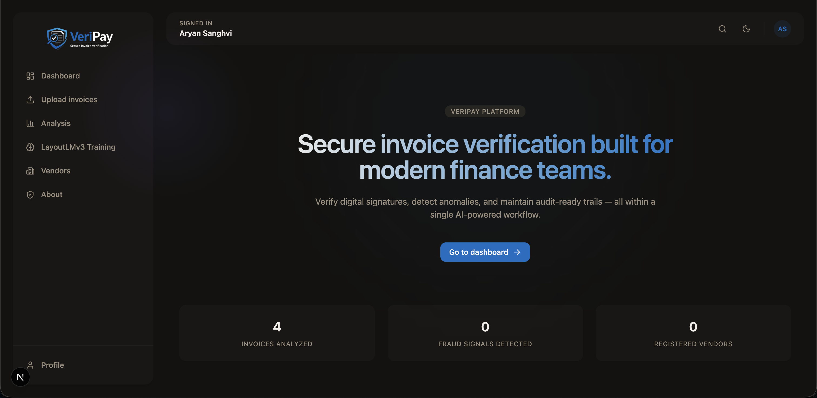
Figure 1: VeriPay Home Page — Platform landing interface
Traditional  System | → | Invoice  Upload | → | OCR  Extraction | → | Store  Data | ✗ Done  (Unverified)
VeriPay  System | → | Invoice  Upload | → | OCR &  Extraction | → | AI  Analysis | → Rules Check →
 | → | Crypto  Verify | → | Forensic  Analysis | → | Bank  Verify | ✓ Fraud Score  Verified

2.2 Goals for the Project
The verification gaps mentioned above helped determine VeriPay's build goals. The team wanted to cover the whole chain — from safe file intake to explainable risk output — rather than build around a narrow use case. The main goals were:
- Implement a secure authentication system covering registration, login, session management, and password recovery.
- Accept invoice uploads in PDF and image formats with content-type checks, magic-byte validation, file-size limits, and page-count caps.
- Compute SHA-256 hashes on upload to detect duplicates and establish a stable content fingerprint.
- Extract invoice text from native PDFs and scanned images, using OCR where the document requires it.
- Use a local LLM to pull structured fields from raw text — vendor name, invoice number, date, line totals, and banking details.
- Run rule-based arithmetic checks to catch inconsistencies between subtotals, tax, and totals.
- Verify cryptographic signatures on signed PDFs and match signer identity against registered vendor certificates.
- Cross-reference extracted bank details against trusted vendor payment records to detect possible payment redirection.
- Use machine learning and forensic analysis to detect documents that appear unusual or have been manipulated.
- Combine all signals into one weighted fraud score with a risk band and an explanation of what contributed to it.
- Support human review — approve, reject, comment — and use those decisions to feed back into supervised model training.

Chapter 3: Scope, Assumptions, and Stakeholders

3.1 Scope of the Project
VeriPay is scoped as a single-user platform where each authenticated account owns its own invoices, vendors, and bank bindings. The implemented feature set covers invoice upload with preview generation, analysis, and status tracking; a FastAPI backend with session-based auth and protected routes; PostgreSQL storage for all business objects including analysis results, reviews, and audit records; manual vendor and bank-binding registration with optional Plaid integration; and a frontend dashboard that ties upload, review, and result inspection into one workflow.

3.2 Out of Scope or Optional Features
Plaid-based bank verification requires valid API credentials and external connectivity, so it is treated as an optional integration rather than a core dependency. IBAN verification through external registries is also optional. Landing-page aggregate statistics require an authenticated session to populate. Model weights for LayoutLMv3 need to either be pre-cached or downloaded at startup, which means internet access is assumed during initial deployment.

3.3 Assumptions
The system assumes a working PostgreSQL instance whose connection details are passed through environment variables. It also assumes that secrets for session signing and bank-identifier hashing are properly configured before deployment. On the infrastructure side, Poppler and Tesseract must be installed for PDF rendering and OCR to work, and LayoutLM model weights must be available either through a local cache or a download-enabled network connection. The platform is intended for use inside a trusted, organization-controlled environment rather than as a public-facing consumer service.

3.4 Stakeholders
The primary users are accounts payable staff who upload invoices and read the analysis output. Financial reviewers make the actual approval or rejection decisions. Administrators handle deployment, configuration, and model management. Vendors are indirect participants whose registered certificates and bank details the system checks against. Finally, researchers or engineers who want to study fraud detection or improve the underlying models are a secondary audience that the training and audit interfaces are designed to support.

Chapter 4: Technology Stack and Rationale

4.1 Backend Technology
The backend is built with Python 3.11 and FastAPI. FastAPI was selected because it supports fast API development, clear request validation through Pydantic, and a structure that fits both synchronous and asynchronous workflows. SQLAlchemy is used for database interaction, PostgreSQL serves as the primary data store, and Alembic handles schema migrations. Session handling is implemented through Starlette middleware with cookie-backed sessions.

4.2 Machine Learning and AI Stack
The machine learning layer uses PyTorch and Hugging Face Transformers to support LayoutLMv3-based document embeddings. This model was chosen because invoice analysis depends not only on text, but also on layout and visual structure. Scikit-learn is used for anomaly detection and optional supervised classification, while Ollama provides local LLM inference for deployments where privacy matters.

4.3 PDF, OCR, and Image Processing
VeriPay uses a combination of document and image-processing libraries to analyze uploaded invoices. PyMuPDF, pdfplumber, and PyPDF2 are used for PDF handling. pdf2image and Pillow support conversion and image validation, pytesseract handles OCR for scanned files, and OpenCV supports forensic image analysis.

4.4 Frontend Technology
The frontend is built with Next.js, React, and TypeScript. Tailwind CSS is used for styling, while Radix UI components help provide accessible interface elements such as dialogs and dropdown menus.

4.5 Infrastructure and Deployment
The system is designed to run through Docker Compose, which coordinates the backend, frontend, and Ollama services. Named volumes are used for persistent data, and environment variables control runtime behavior across services.

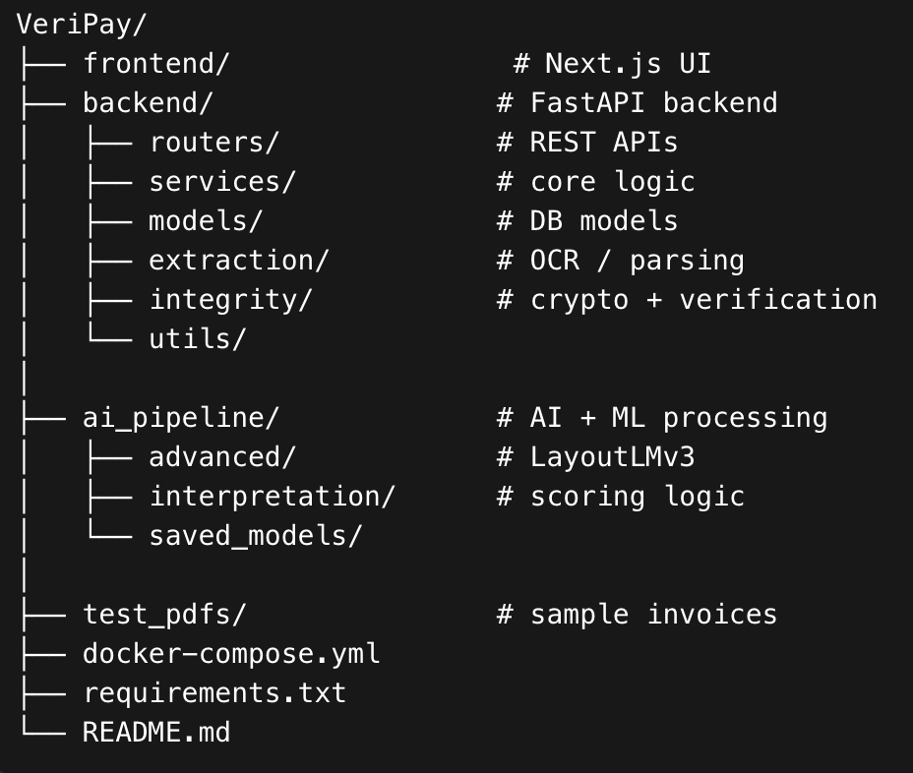
Figure 2: VeriPay Repository Structure by Layer
Frontend | Next.js  React + TypeScript |  | Tailwind CSS  Radix UI
Backend | FastAPI  Python 3.11 |  | SQLAlchemy  Alembic |  | SlowAPI  Rate Limit
Persistence | PostgreSQL  Database |  | File Storage  Disk
AI Layer | LayoutLMv3  HuggingFace |  | Ollama  Local LLM |  | Scikit-learn  PyTorch
Infra | Docker Compose  Orchestration |  | Named Volumes  Env Variables

Chapter 5: High-Level System Architecture
VeriPay follows a layered architecture in which the browser-based frontend communicates with a FastAPI backend through authenticated HTTP requests. The backend manages document processing, vendor verification, database persistence, and model execution. Structured results are stored in PostgreSQL, while raw invoice files and generated previews are stored on disk.
The frontend is responsible for user-facing workflows such as login, invoice upload, dashboard monitoring, vendor registration, result review, and training access. The API layer receives requests, applies authentication and rate limiting, validates input, and forwards work to the service layer. The service layer contains the main business logic, including semantic extraction, rule evaluation, forensic inspection, bank verification, audit logging, and fraud scoring. Beneath that, the persistence layer stores users, vendors, invoices, analysis results, reviews, and audit records. The AI layer supports embedding extraction, anomaly detection, optional supervised inference, artifact checks, and LLM-assisted field extraction.

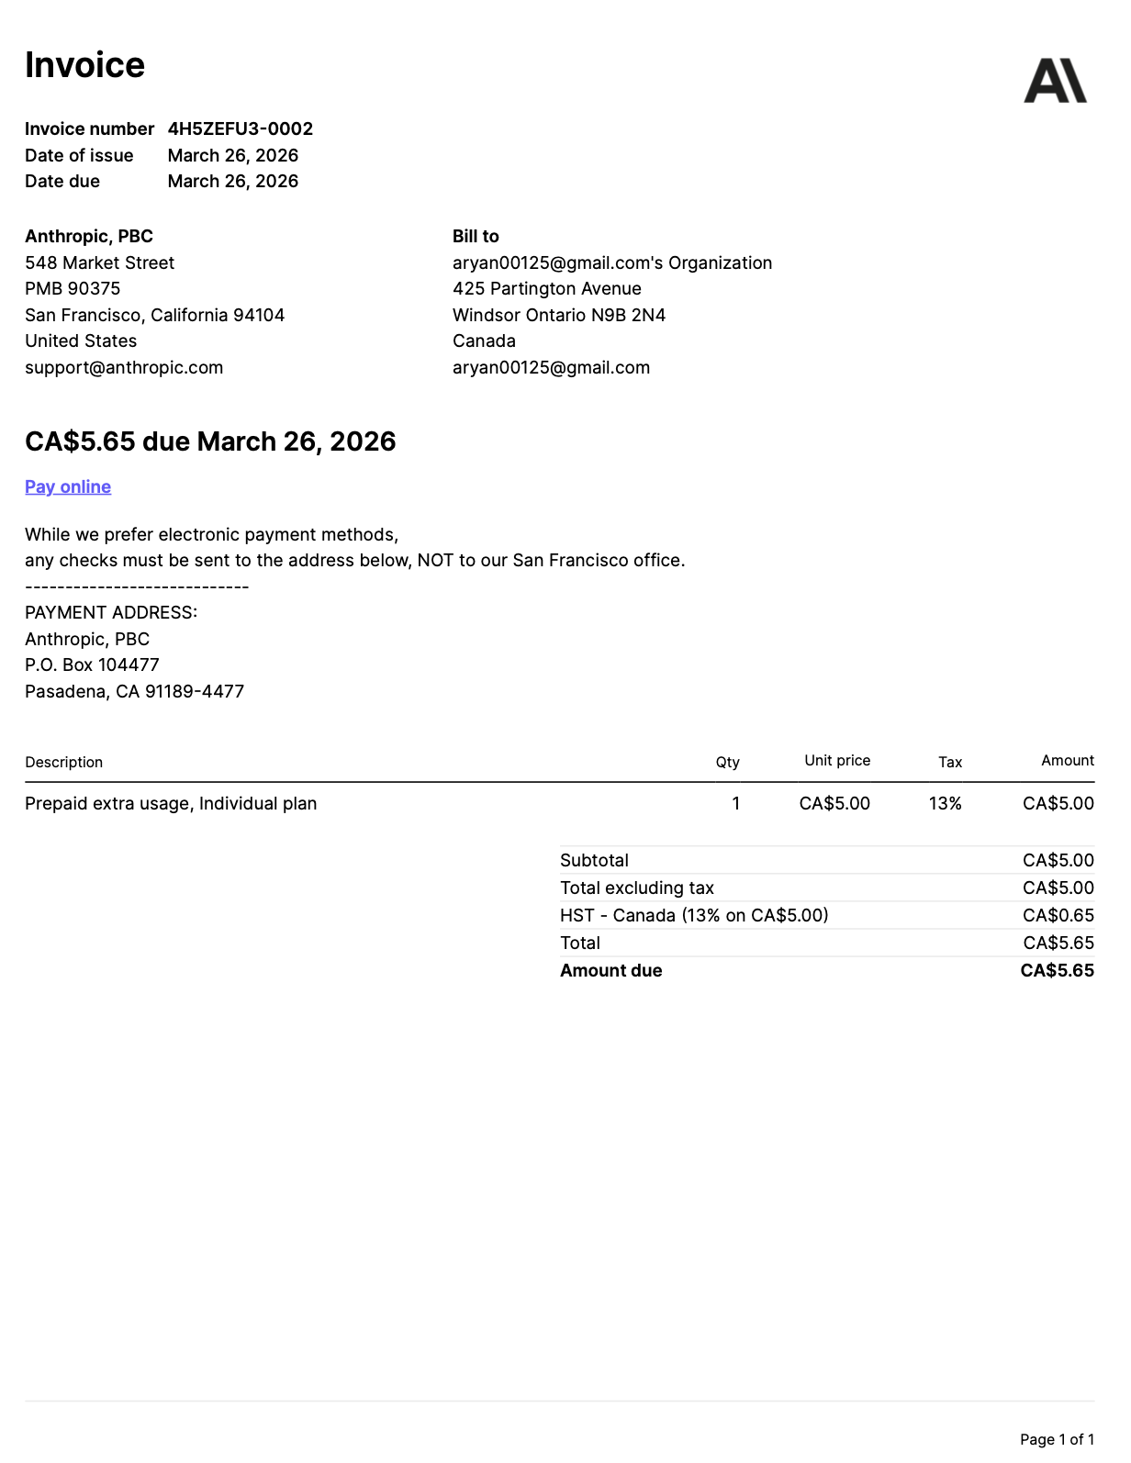
Figure 3: Full VeriPay System Architecture — All Components and Data Flows
Client |  | Application Layer |  | Persistence |  | AI Layer
Browser  Next.js | ⟷ | FastAPI  Backend | Auth & Session | → | PostgreSQL  Database | → | Ollama  Local LLM
 | ↕ |  | Invoice Service | → | File Storage  (Disk) | → | AI Pipeline  LayoutLMv3
 |  |  | Vendor Service |  |  | ↓ | Forensics Module
 |  |  | Audit Service

Chapter 6: Repository Structure and Major Artifacts

6.1 Backend Directory
The backend is organized around a central entry point, main.py, which bootstraps FastAPI, loads middleware, checks that required secrets are present, runs any pending Alembic migrations, and optionally warms up models before accepting traffic. Database connectivity lives in conn_db.py and shared dependency helpers such as session injection and current-user lookup live in dependencies.py.
Route logic is split across a routers directory covering authentication, invoices, vendors, dashboard aggregation, file serving, reviews, audit logs, and model training. Database models are defined under models, request and response shapes under schemas, and the main business logic — semantic extraction, rule checking, forensics, ensemble scoring, and image rendering — under services. Cryptographic verification and bank-matching orchestration sit in a separate integrity module. Schema migrations are managed by Alembic and live under alembic.

6.2 Frontend Directory
The Next.js application is organized under src/app, with one subfolder per route: login, upload, dashboard, invoice detail, vendor management, analysis, training, and profile. Shared UI components — result cards, review dialogs, vendor forms — live under src/components. Static files such as logos and brand assets are in the public directory.

6.3 AI Pipeline Directory
The AI pipeline has its own directory with dedicated modules for feature extraction and orchestration. advanced/layoutlm_features.py handles LayoutLMv3 embedding extraction, while advanced/pipeline_layoutlm.py coordinates the full embedding and analysis flow. Trained model files are stored under saved_models, and score interpretation helpers live under interpretation.

6.4 Other Supporting Assets
The root of the repository contains docker-compose.yml for service orchestration, requirements.txt listing Python dependencies, and a test_pdfs directory with sample invoices and certificates used during development and manual validation.

Chapter 7: Backend Design and Implementation

7.1 Application Bootstrap
When the application starts, it validates its environment before accepting any traffic. Session and bank-hashing secrets are checked for presence and strength, and weak or missing values cause the application to refuse to start in production mode. Middleware is layered deliberately: security headers go on first, then rate limiting, then session handling, and finally CORS to allow the frontend origin through. After that, the app verifies database connectivity and runs any pending Alembic migrations to bring the schema up to date. An optional model warm-up step can be enabled to pre-load LayoutLMv3 weights, which avoids slow cold starts on the first analysis request.

7.2 Authentication Module
Authentication is handled by a dedicated router that covers the full account lifecycle. New users can register with an email and password; returning users log in and get a signed session cookie back. The same router handles profile reads and updates, password changes, account deletion, and email availability checks. Password recovery flows are also included. All passwords are hashed before storage, so the database never holds plaintext credentials. Sensitive routes such as login and registration are rate limited to slow down brute-force attempts.

7.3 Vendor Management Module
Vendors are registered per user. An account holder can create a vendor record, optionally upload a certificate file, and attach one or more trusted bank bindings. When a certificate is present, the system extracts and stores a public-key fingerprint that can later be matched against the signer identity in a signed PDF. Bank bindings can be created manually or, when Plaid is configured, through a link-and-exchange flow that pulls real account data from a connected institution.

7.4 Invoice Management Module
The invoice router manages the full document lifecycle from first upload through to review. On upload, the file goes through a multi-step validation: MIME type is checked, magic bytes are inspected to confirm the declared type matches actual file content, size and page count are capped, and images are verified through Pillow. Once the file passes, its SHA-256 hash is computed and checked against existing records — duplicates are rejected immediately. The validated file is written to disk, its metadata is stored in the database, and text extraction may run immediately to warm the cache.

7.5 Cross-Cutting Service Modules
Several services are shared across the backend and called by multiple routers. The semantic extraction service manages LLM prompting and parses the structured JSON response. The rules service checks arithmetic consistency across invoice fields. The forensics service inspects document metadata, compression, fonts, and image layers for signs of tampering. The ensemble scorer takes signals from all the other services and produces a single weighted fraud score. Supporting services handle preview image rendering, suspicious-region highlight generation, and audit-log recording.

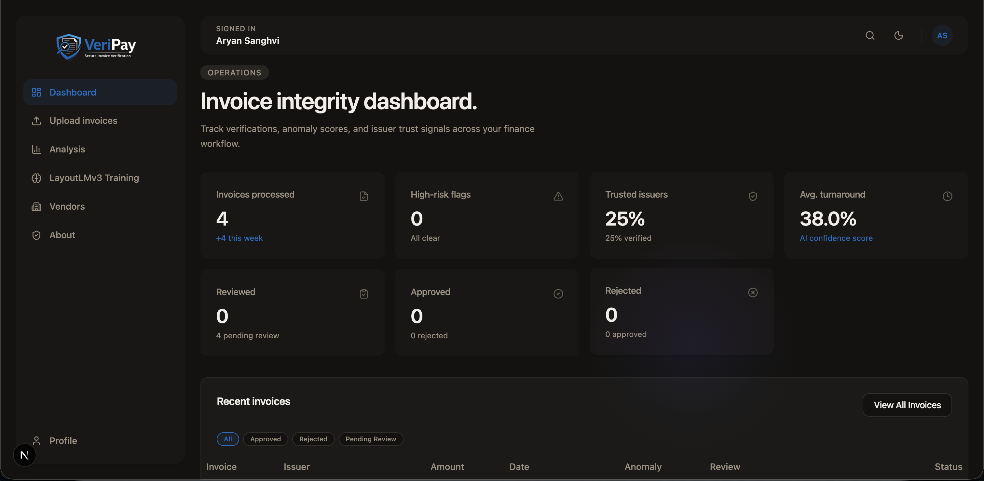
Figure 4: VeriPay Dashboard — Invoice integrity overview with stats and recent invoices
 |  | Middleware:  Auth + Rate Limit |  | ↓ AI Pipeline  LayoutLMv3 |  |  |  | JSON +  Status Code
HTTP  Request | → | Router  Layer | → | Service  Layer | → | PostgreSQL  Database | → | HTTP  Response

Chapter 8: Analysis Pipeline — End-to-End Workflow
After an invoice is uploaded, VeriPay starts an asynchronous analysis routine and marks the document as being processed. The frontend can then poll for updates while the backend moves through the analysis stages.
The pipeline begins by loading the invoice, identifying the file type, and extracting text either from cached content or fresh OCR or PDF parsing. If the document contains a digital signature, the system evaluates its cryptographic validity and compares signer information against trusted records when available.
Next, the system performs semantic extraction to recover structured invoice fields such as vendor details, dates, totals, and payment information. Bank details are normalized into standard identifiers and compared with trusted vendor bindings to detect possible payment redirection.
A preview image is then rendered for both display and forensic analysis. The forensics module inspects metadata, fonts, compression patterns, and other indicators of possible tampering. In parallel, the AI layer generates LayoutLMv3-based embeddings and applies anomaly detection. Rule-based checks verify arithmetic consistency, and the artifact-detection layer looks for suspicious generated or manipulated content.
Finally, the system converts relevant findings into visual highlights, combines all signals into a weighted fraud score, assigns a risk level, and stores the result in the database. If the pipeline fails at any point, the invoice is marked as analysis_failed and the error is recorded for debugging.

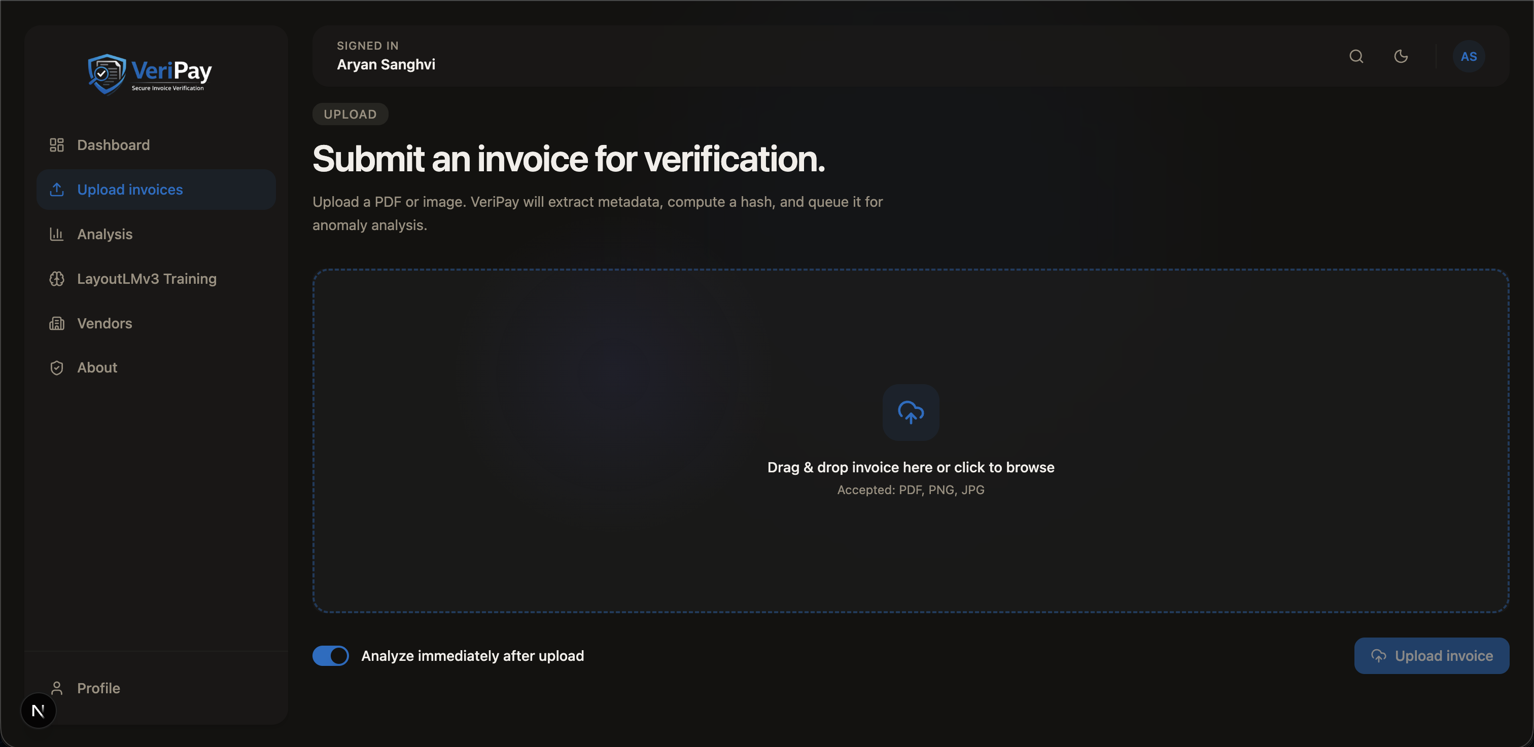
Figure 5: Invoice Upload Page — PDF submission and analysis trigger
Stage 1: Upload → Verification |  | Stage 2: Analysis → Score
Invoice Upload | ↓ |  | Forensic Analysis
File Validation + Hash | ↓ |  | AI Anomaly Analysis
Text Extraction (OCR/PDF) | ↓ |  | Rule-Based Validation
Cryptographic Evaluation | ↓ |  | AI Artifact Detection
Semantic Extraction (LLM) | ↓ |  | Highlight Construction
Bank Detail Normalization | ↓ |  | Ensemble Fraud Score
Vendor Bank Verification | ↓ |  | Persist Result + Notify UI
Preview Rendering
⚠ Invalid file at Step 2 → Analysis Failed (error stored)

Chapter 9: Machine Learning and Scoring Methodology
LayoutLMv3 is used because invoice analysis depends on more than plain text. The model captures both textual content and layout structure, which makes it more suitable for documents where placement and formatting matter. VeriPay uses the microsoft/layoutlmv3-base model through Hugging Face, processing each invoice up to a configurable page limit before extracting embeddings for downstream analysis.
For baseline anomaly detection, the system applies an unsupervised Isolation Forest over the document embeddings. This approach is useful because real fraud labels are often scarce, and many organizations do not have large, clean, labeled datasets for supervised training.
The system also supports supervised, user-scoped models based on historical approval and rejection decisions. These models are trained on reviewed invoices so that the platform can adapt to organization-specific patterns over time.
Semantic extraction is handled by a local LLM, which reads raw invoice text and returns structured JSON fields for downstream use. This makes the system more resilient when invoices differ in layout or contain noisy OCR output.
The final fraud score is not produced by a single model. Instead, VeriPay combines cryptographic verification, bank verification, forensic analysis, anomaly detection, rule checks, artifact detection, and extraction quality into a weighted ensemble. The score is then mapped into qualitative bands such as low, medium, high, and critical. The system can also increase the score when several high-risk signals appear together, such as a strong forensic alert combined with a bank mismatch.

Signal Group | Weight
Cryptographic Verification | 0.15
Bank Verification | 0.20
Forensic Analysis | 0.25
AI Anomaly Analysis | 0.15
Rule-Based Validation | 0.10
AI Artifact Detection | 0.10
Extraction Penalty | 0.05

Chapter 10: Frontend — User Interface and User Journeys
The frontend translates a technically complex backend into a practical review workflow. A user uploads an invoice, waits for the analysis to complete, inspects the returned results, and then decides whether the document should be approved or rejected.
The main user journeys include account registration and login, invoice upload, dashboard browsing, vendor registration, bank-binding management, invoice review, and access to audit or training features. The design aims to reduce friction for non-technical users who need to make financial decisions based on the system's output.
Instead of exposing raw JSON, the interface separates findings into focused result cards. Users can review cryptographic status, vendor payment verification, anomaly and risk scores, rule-check output, semantic extraction results, and human review controls without having to interpret internal system data directly.

Figure 10: About VeriPay — Platform overview and feature highlights

Chapter 11: Data Model and Persistence
Every meaningful object in VeriPay is scoped to an authenticated user, which means the database design starts with the Users table as the root. From there, each user can own Vendors, and each Vendor can have one or more VendorBankBindings — the trusted payment records that the system checks extracted bank details against.
Invoices are also user-owned. Each Invoice record holds the file path, the SHA-256 hash, the original filename, the current processing status, a cached copy of extracted text, any cryptographic status flags, and the signer fingerprint when one was detected. Once analysis completes, an AnalysisResults row is linked to the invoice containing the full output: confidence, prediction, fraud score, risk level, and the JSON payloads from each analysis subsystem.
Human decisions are stored separately in InvoiceReviews, where a reviewer can record an approval or rejection along with a confidence rating and comments. These rows are what feed the supervised training pipeline. Finally, AuditLogs capture significant system events — uploads, analysis triggers, vendor registrations, reviews — to support traceability and governance.

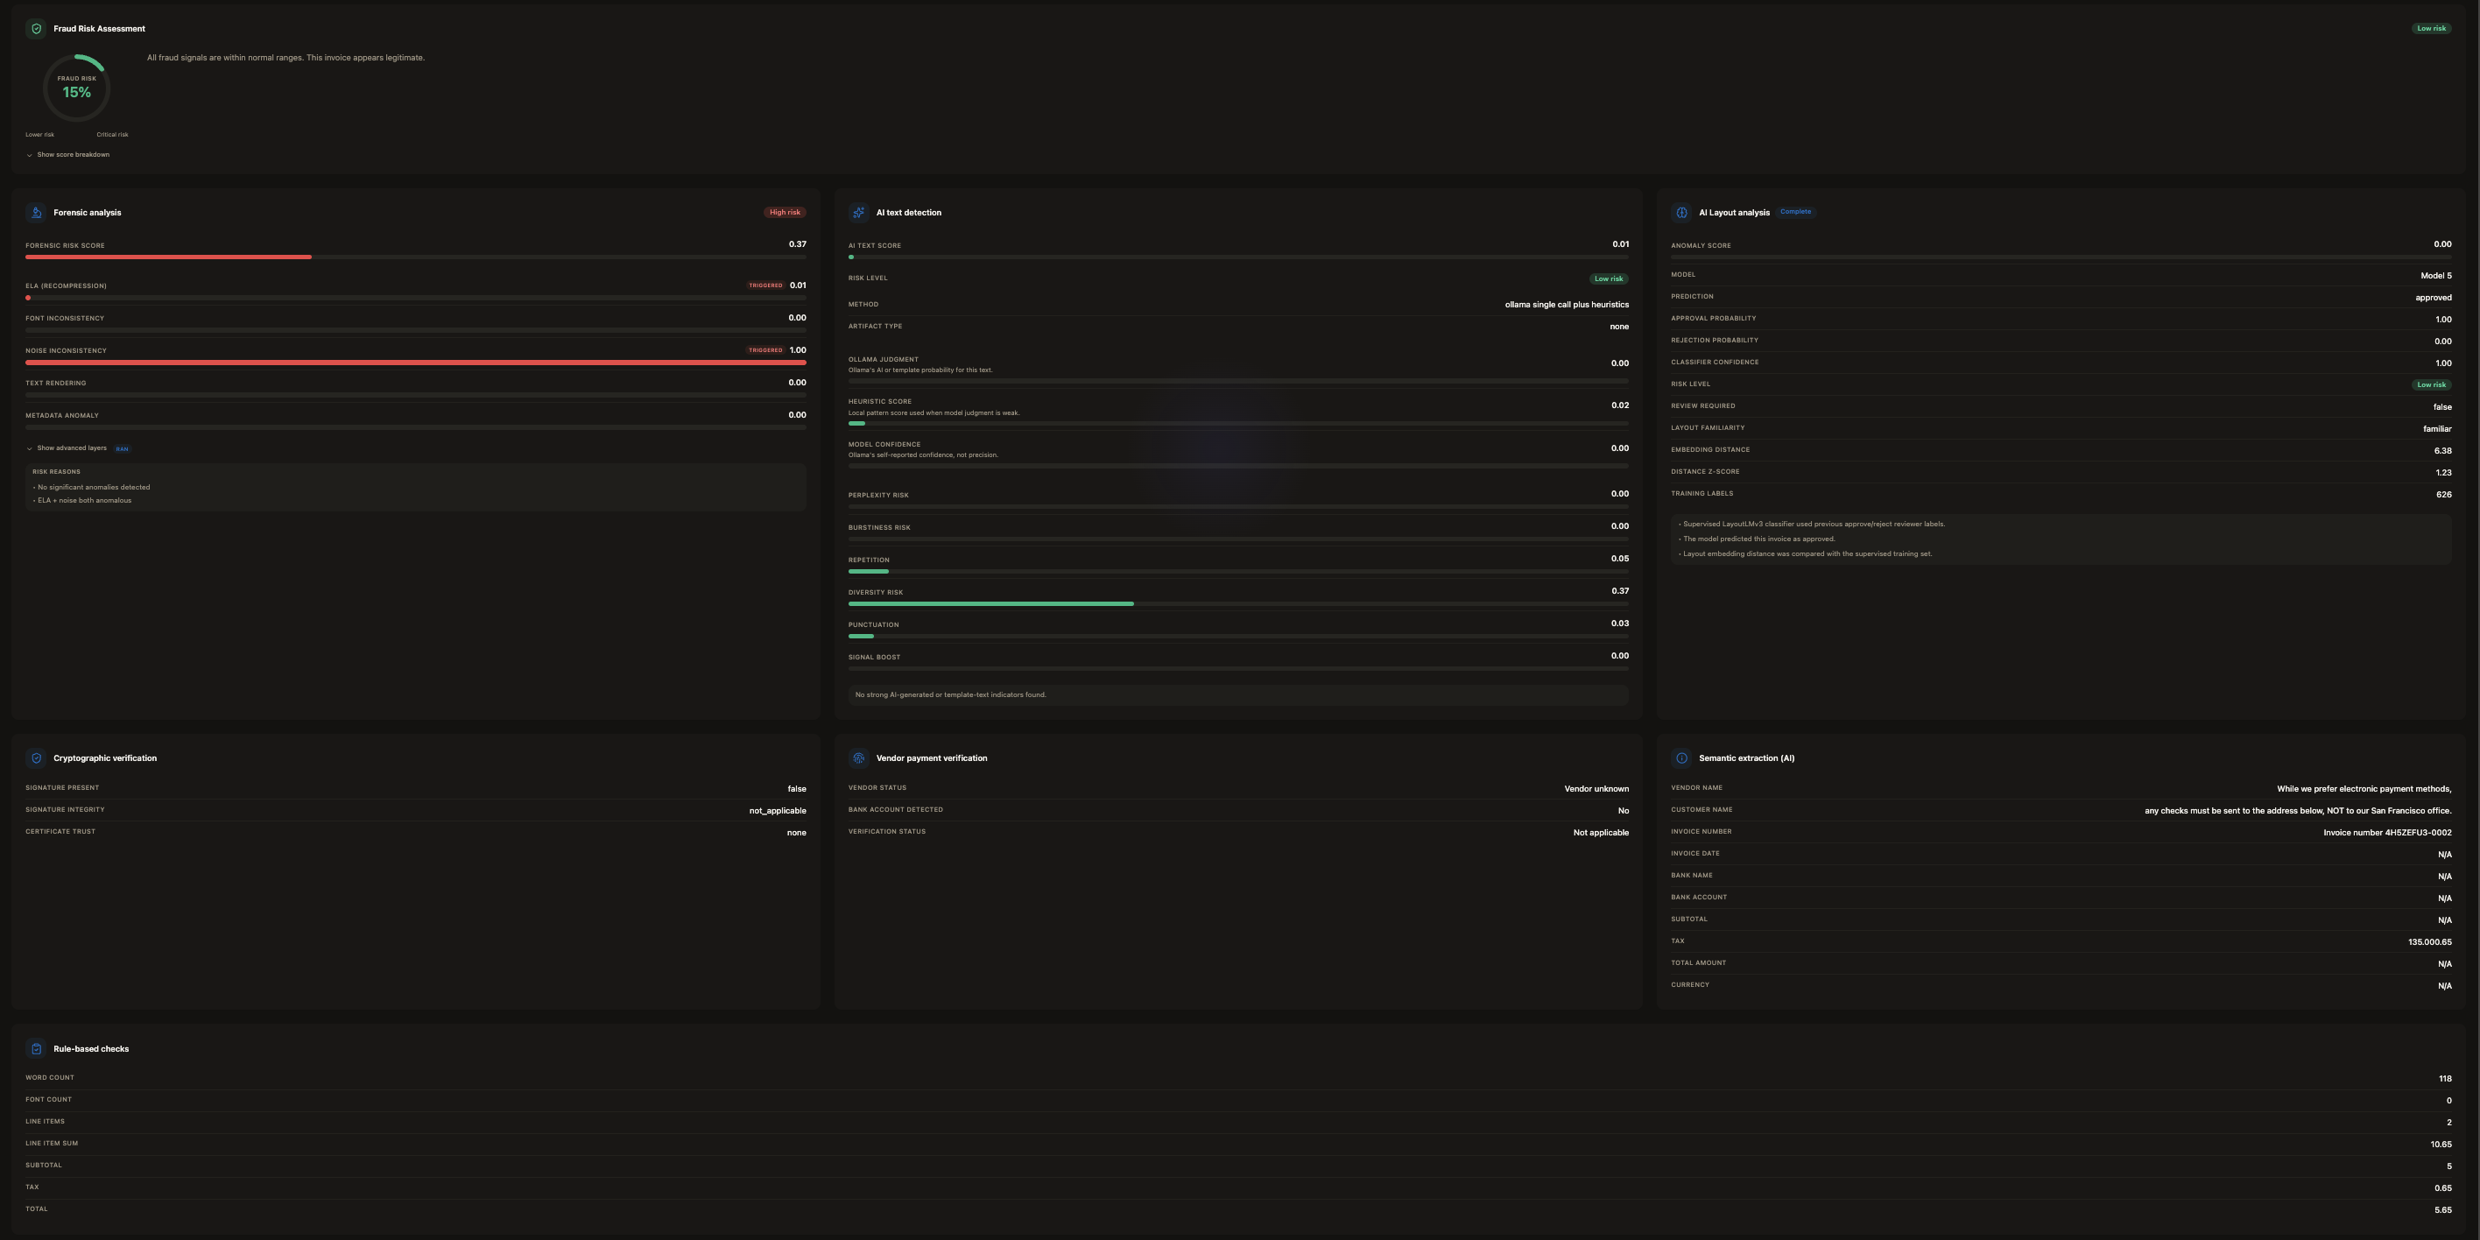
Figure 6: VeriPay Entity-Relationship Diagram
Users  id, email, name  password_hash  created_at | 1:N → | Vendors  id, user_id (FK)  name, status  cert_fingerprint | 1:N → | BankBindings  id, vendor_id (FK)  hashed_account  masked_account  source, status
1:N ↓
Invoices  id, user_id (FK)  file_path, file_hash  status, text_cache  signer_fp | 1:1 → | AnalysisResults  id, invoice_id (FK)  fraud_score, risk_level  semantic_json  rules_json, ai_json | 1:N → | InvoiceReviews  id, invoice_id (FK)  decision  confidence  comments
1:N ↓
AuditLogs
id, user_id (FK)
action, details
created_at

Chapter 12: REST API Surface Summary

12.1 Authentication Endpoints
The auth routes cover everything from first registration through to account deletion. Users can create an account, log in, log out, read or update their profile, change their password, check whether an email address is already taken, and go through a password recovery flow. These endpoints are rate limited and are the primary security boundary of the application.

12.2 Vendor Endpoints
Vendor routes let authenticated users create vendor records, list or retrieve them, update vendor details, and register bank bindings against a vendor. When Plaid is configured, two additional endpoints support the link-token and public-token exchange flow needed to pull bank account data from a connected institution.

12.3 Invoice Endpoints
The invoice API handles the full document lifecycle. Users can upload a new invoice, list their existing ones, trigger analysis on a specific document, poll for analysis status, attempt automatic vendor matching, and submit a human review decision. Deletion is also supported. The analysis and upload endpoints are among the most computationally expensive in the system and carry their own rate limits.

12.4 Dashboard Endpoints
Dashboard routes return aggregated views rather than raw records. They power the summary statistics cards, the recent-invoices feed, paginated browsable lists, and the detailed invoice drill-down view that combines invoice metadata, analysis output, and review history in one response.

12.5 Supporting Endpoints
The remaining route groups serve operational needs: a landing-page statistics endpoint that works without authentication, file-serving endpoints for invoice previews and rendered page images, audit-log access for administrators, and a training endpoint that triggers supervised model building from reviewed invoice history.

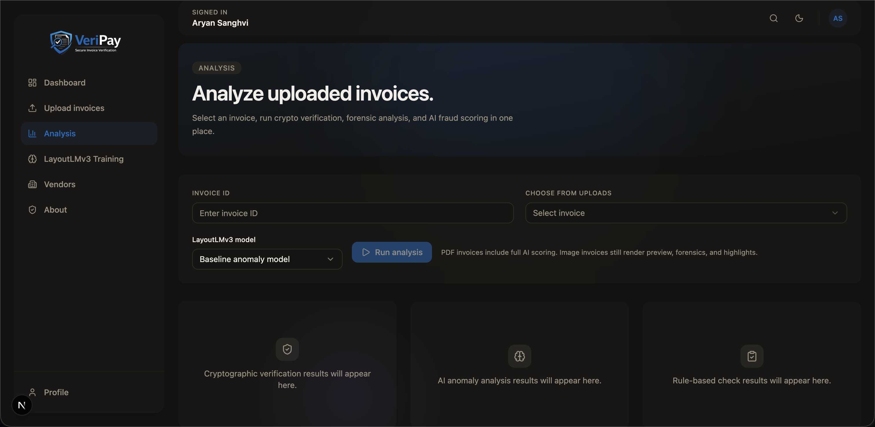
Figure 7: Analysis Page — Run cryptographic, forensic, and AI scoring
Frontend  (Next.js) | → | REST API  (FastAPI) | → | Service  Layer | → | Database  (PostgreSQL)
 |  | Route Groups:  /auth  /invoices  /vendors  /dashboard |  | ↓ also calls  AI Pipeline (LayoutLMv3)
← JSON Response returned to Frontend through the same chain

Chapter 13: Security, Privacy, and Operational Hardening
VeriPay uses signed session cookies to maintain authenticated state. In production deployments, HTTPS-only settings and HSTS expectations help protect session confidentiality.
Sensitive configuration is stored in environment variables rather than hardcoded in the codebase. This includes secrets related to session signing, bank hashing, database access, content-security policy, and model behavior.
Rate limiting is applied to sensitive and computationally expensive endpoints such as login, registration, upload, and analysis. This reduces brute-force risk and helps protect the system from operational abuse.
The upload pipeline includes several hardening steps. It checks MIME types, validates file signatures through magic bytes, enforces file-size limits, restricts PDF page counts, and verifies uploaded images before processing. These controls reduce the risk posed by malformed or malicious files.
Because invoices may contain sensitive financial and personal data, auditability and storage protection are also important. VeriPay records meaningful system actions in audit logs, and deployments are expected to protect stored files through secure permissions, backups, and general infrastructure hardening.

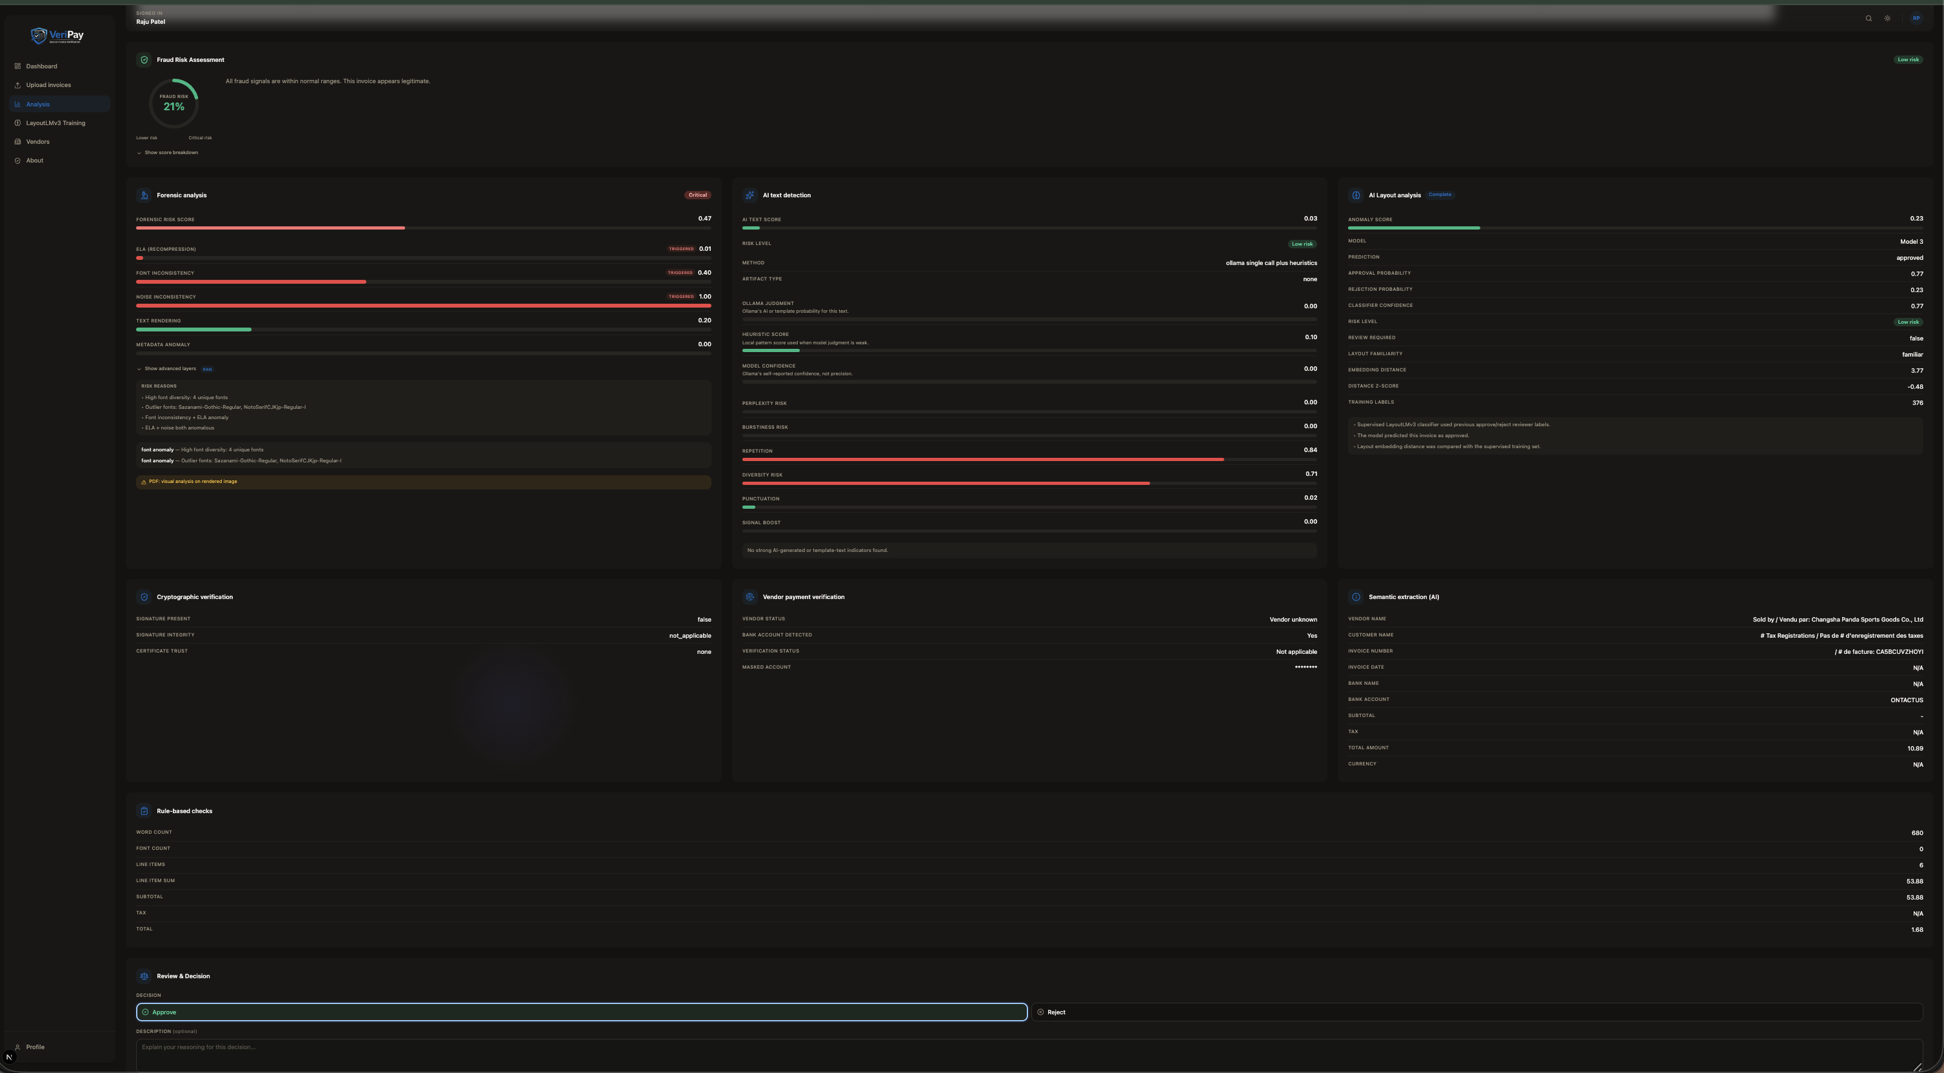
Figure 8: Full Invoice Analysis Result — All signals with reviewer decision panel
Incoming  Request | → | Rate Limiter  (SlowAPI) | → | Session Auth  Cookie Check | → | Upload Validation  MIME + Magic | → | SHA-256 Hash  Dedup Check
 |  | ✗ limit exceeded |  | ✗ unauthenticated |  | ✗ malformed file |  | ✗ duplicate found
✓ Application Logic (all gates passed)
Additional Hardening Measures
HTTPS + HSTS | Env Secrets (no hardcode) | Bank Hashing (HMAC) | Audit Logs | CSP Headers

Chapter 14: Deployment and Environment Configuration

14.1 Docker Compose Services
The system runs as four coordinated containers. The backend container hosts FastAPI through Uvicorn and is responsible for all analysis logic, database access, and file handling. The frontend container runs the Next.js application and serves the user-facing interface. The Ollama container hosts the local LLM and handles all inference requests from the backend. An optional initialization container can be included to pull the required LLM model on first run, which avoids a long wait during the backend's own startup sequence.

14.2 Backend Container Responsibilities
The backend container installs Python dependencies and the system-level tools that document processing depends on. Poppler is required for PDF page rendering, and Tesseract is required for OCR. Both must be present in the container image for invoice analysis to work end-to-end.

14.3 Environment Variables

Variable | Purpose
VERIPAY_ENV | Controls development or production behavior
SESSION_SECRET | Secret used for session-cookie signing
SESSION_MAX_AGE | Session lifetime in seconds
BANK_HASH_SECRET | Salt or secret used in bank-identifier hashing
DATABASE_URL | Full database URL if provided directly
DB_USER / DB_PASSWORD / DB_HOST / DB_PORT / DB_NAME / DB_SSLMODE | Database connection parts
CONTENT_SECURITY_POLICY | CSP override configuration
MODEL_WARMUP_ENABLED | Enables or disables startup warm-up
OLLAMA_URL | Endpoint for local Ollama inference
OLLAMA_MODEL | Selected local LLM model
OLLAMA_TIMEOUT | Request timeout for Ollama calls
OLLAMA_NUM_CTX | Context length for LLM inference
OLLAMA_MAX_TEXT_CHARS | Limit on invoice text sent to the LLM
MAX_ANALYSIS_PAGES | Maximum PDF pages used during embedding analysis
HF_HOME / TRANSFORMERS_CACHE | Cache directories for Hugging Face models

14.4 Docker Architecture

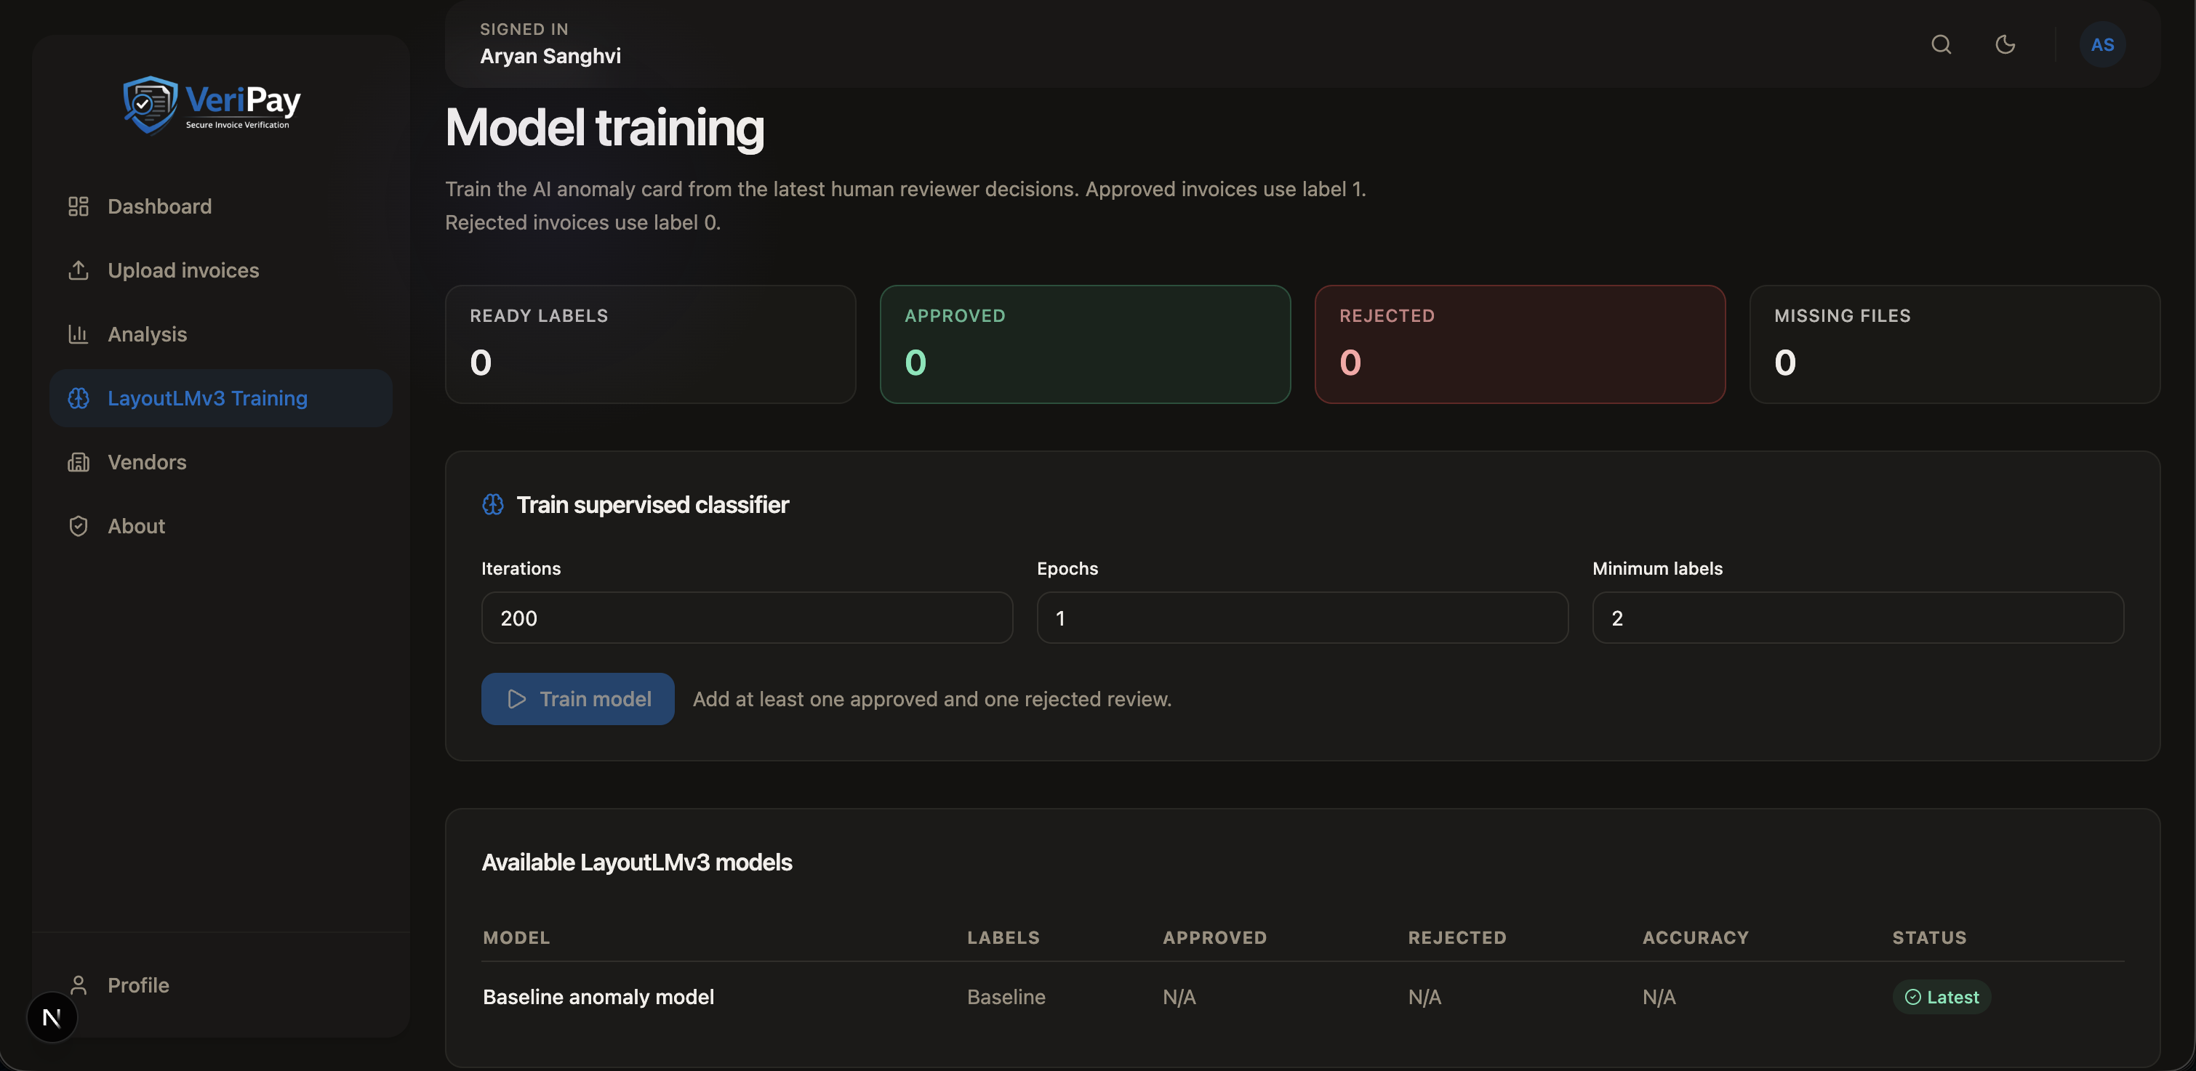
Figure 9: LayoutLMv3 Model Training Interface
Docker Compose Network — all containers share the same internal bridge
Frontend Container  Next.js  Port 3000  node_modules volume | REST :8000 | Backend Container  FastAPI + Uvicorn  Port 8000  Poppler + Tesseract  File Storage | HTTP :11434 | Ollama Container  Local LLM  Port 11434  ollama_data volume
 |  | ↓ SQL :5432
Database Container
PostgreSQL
Port 5432
pg_data volume

Chapter 15: Limitations, Risks, and Ethical Considerations
VeriPay improves invoice review, but it does not eliminate uncertainty. Unsupervised anomaly models can flag legitimate invoices that are simply unusual. Supervised models can reflect patterns in historical human decisions, including bias. LLM-based extraction can also miss fields or return incorrect values when the source text is noisy.
The system has operational limits as well. Not every invoice includes a digital signature, so cryptographic verification is not always available. Some optional verification features depend on third-party services, and offline environments must ensure that required models are already cached.
For that reason, VeriPay should be treated as a decision-support system rather than an autonomous payment engine. Fraud scores are probabilistic, not absolute. Human review remains important, especially when invoices involve high value, unusual vendors, or conflicting signals.
There is also an ethical dimension to automated fraud scoring. The platform processes sensitive financial information, and its output can affect payment decisions. That makes transparency, human override, and clear explanation essential parts of the design.

Chapter 16: Future Enhancements
A future version of VeriPay could support multi-tenant deployments with stronger role-based access control, allowing one installation to serve multiple teams or departments more securely.
Key management could also be improved through centralized secret-management systems and stronger encryption for stored files and backups.
Testing is another clear area for growth. More comprehensive backend integration tests and frontend end-to-end tests would increase confidence in production deployments.
On the modeling side, domain-specific fine-tuning could improve extraction quality, and more advanced detection methods could strengthen both image-forensics and vendor-specific anomaly analysis.
From a usability perspective, features such as streaming progress updates, WebSocket-based notifications, and richer explanations of risk signals would make the system easier to use during longer analysis sessions.

Conclusion
VeriPay shows how invoice verification can be approached as a trust-assessment problem rather than a simple text-extraction task. Instead of depending on one OCR engine, one ruleset, or one machine learning model, the platform combines multiple sources of evidence, including secure upload validation, file hashing, semantic extraction, cryptographic checks, vendor and bank verification, document forensics, anomaly scoring, and human review.
What makes the project useful is its layered design. It connects frontend workflows, backend orchestration, database persistence, local AI support, and weighted scoring into a system that is more practical than a basic document-parsing demo. In that sense, VeriPay is not just extracting invoice data; it is helping users decide whether an invoice should be trusted.
At the same time, the project does not overstate what automation can do. It recognizes uncertainty, preserves human oversight, and stores evidence in a way that supports review and auditability. That balance makes VeriPay a stronger academic project and a more believable example of applied software engineering for fraud-aware document analysis.

Appendix A: Ensemble Fraud Score Logic
The ensemble score is built from seven weighted signal groups: cryptographic verification, bank verification, forensic analysis, AI anomaly analysis, rule-based validation, AI artifact detection, and an extraction quality penalty. Each group contributes a normalized component score, and those are summed according to the weights shown in Chapter 9.
On top of the base weighted sum, the system applies amplifiers when multiple serious signals appear together. A strong forensic hit combined with a bank mismatch, for example, is treated as more alarming than either finding on its own. The same logic applies when cryptographic invalidity combines with forensic evidence, or when both AI anomaly and AI artifact scores are simultaneously elevated. If three or more high-severity signals are active at once, an additional amplifier is applied regardless of which specific combination they form.
The final score is clamped to a 0-to-1 range and then mapped to four risk bands: low, medium, high, and critical. The band determines how the result is displayed in the dashboard and whether a review is flagged as urgent.

Appendix B: Invoice Lifecycle States
An invoice moves through four processing states after upload. It starts as uploaded, meaning the file is stored and basic metadata has been recorded. Once analysis is triggered, the status changes to analyzing while the backend works through the pipeline asynchronously. When the pipeline completes without error, the status becomes analyzed and the result is available for review. If an exception occurs at any stage, the status is set to analysis_failed and the error message is stored against the record for debugging.
Human review operates independently of these processing states. An invoice can receive an approval, rejection, or comment at any point after it reaches the analyzed state, and those review records are stored separately so they do not overwrite the analysis output.

References
- FastAPI Documentation — https://fastapi.tiangolo.com
- SQLAlchemy Documentation — https://docs.sqlalchemy.org
- PostgreSQL Documentation — https://www.postgresql.org/docs
- Hugging Face Transformers Documentation — https://huggingface.co/docs/transformers
- LayoutLMv3 Research and Model Documentation — microsoft/layoutlmv3-base on HuggingFace
- PyTorch Documentation — https://pytorch.org/docs
- PyMuPDF Documentation — https://pymupdf.readthedocs.io
- pdfplumber Documentation — https://github.com/jsvine/pdfplumber
- PyPDF2 Documentation — https://pypdf2.readthedocs.io
- Pillow Documentation — https://pillow.readthedocs.io
- Tesseract OCR Documentation — https://tesseract-ocr.github.io
- OpenCV Documentation — https://docs.opencv.org
- Ollama Documentation — https://ollama.com/docs
- Next.js Documentation — https://nextjs.org/docs
- Tailwind CSS Documentation — https://tailwindcss.com/docs

