Учреждение образования

«Белорусский государственный университет
информатики и радиоэлектроники»

Кафедра ПОИТ

Отчет
по ра:
«Методы защиты проектных HDL-описания от несанкционированного использования. Применение водяных знаков и отпечатков пальцев (watermarking & fingerprint)»

Выполнил: Верховцов Павел Андреевич
магистрант кафедры ПОИТ
группа № 7М2221

Проверил: Иванюк Александр Александрович
доктор технических наук

Минск 2018

Stack
- Описание ISA

Мнемоника | Код операции (3 бита) | Операнд (5 бит)
ADD | 000 | xxxxx
SUBT | 001 | xxxxx
SHIFT | 010 | xxxxx
JNZ | 011 | aaaaa
PUSH | 100 | aaaaa
POP | 101 | aaaaa
POPIN | 110 | aaaaa
HALT | 111 | xxxxx

ADD – сложение значений TOS и TOS+1, результат записывается на вершину стека
SUBT – вычитание значений TOS+1 из TOS, результат записывается на вершину стека
SHIFT – логический сдвиг вправо значения TOS, результат записывается на вершину стека
JNZ addr – переход на операции по адресу addr, при сброшенном флаге нуля
PUSH addr – пересылка значения хранящегося по адресу addr на вершину стека TOS
POP addr – пересылка значения с вершины стека по адресу addr
POPIN addr – пересылка значения с вершины стека по адресу хранящемуся по адресу addr.
HALT - останова

- Микропрограмма

constant STUB: mem_addr := "00000";
constant LENGTH: mem_addr := "10000";
constant COUNTER: mem_addr := "10001";
constant CURRENT_VALUE: mem_addr := "10010";
constant DATA_START: mem_addr := "00000";
constant INIT_VALUE: mem_addr := "10011";
constant ZERO: mem_addr := "10100";
constant ONE: mem_addr := "10101";
constant EMPTY_SPACE: mem_addr := "10110";
constant LOADDR: mem_addr := "01010";
PUSH & ZERO,
POP & COUNTER,
PUSH & INIT_VALUE,
POP & CURRENT_VALUE,
PUSH & INIT_VALUE,
POP & DATA_START,
PUSH & ONE,
PUSH & LENGTH,
SUBT & STUB,
POP & LENGTH,
PUSH & COUNTER,
PUSH & ONE,
ADD & STUB,
POP & COUNTER,
PUSH & CURRENT_VALUE,
SHIFT & STUB,
POP & CURRENT_VALUE,
PUSH & CURRENT_VALUE,
POPIN & COUNTER,
PUSH & LENGTH,
PUSH & COUNTER,
SUBT & STUB,
JNZ & LOADDR

- Общая структурная схема
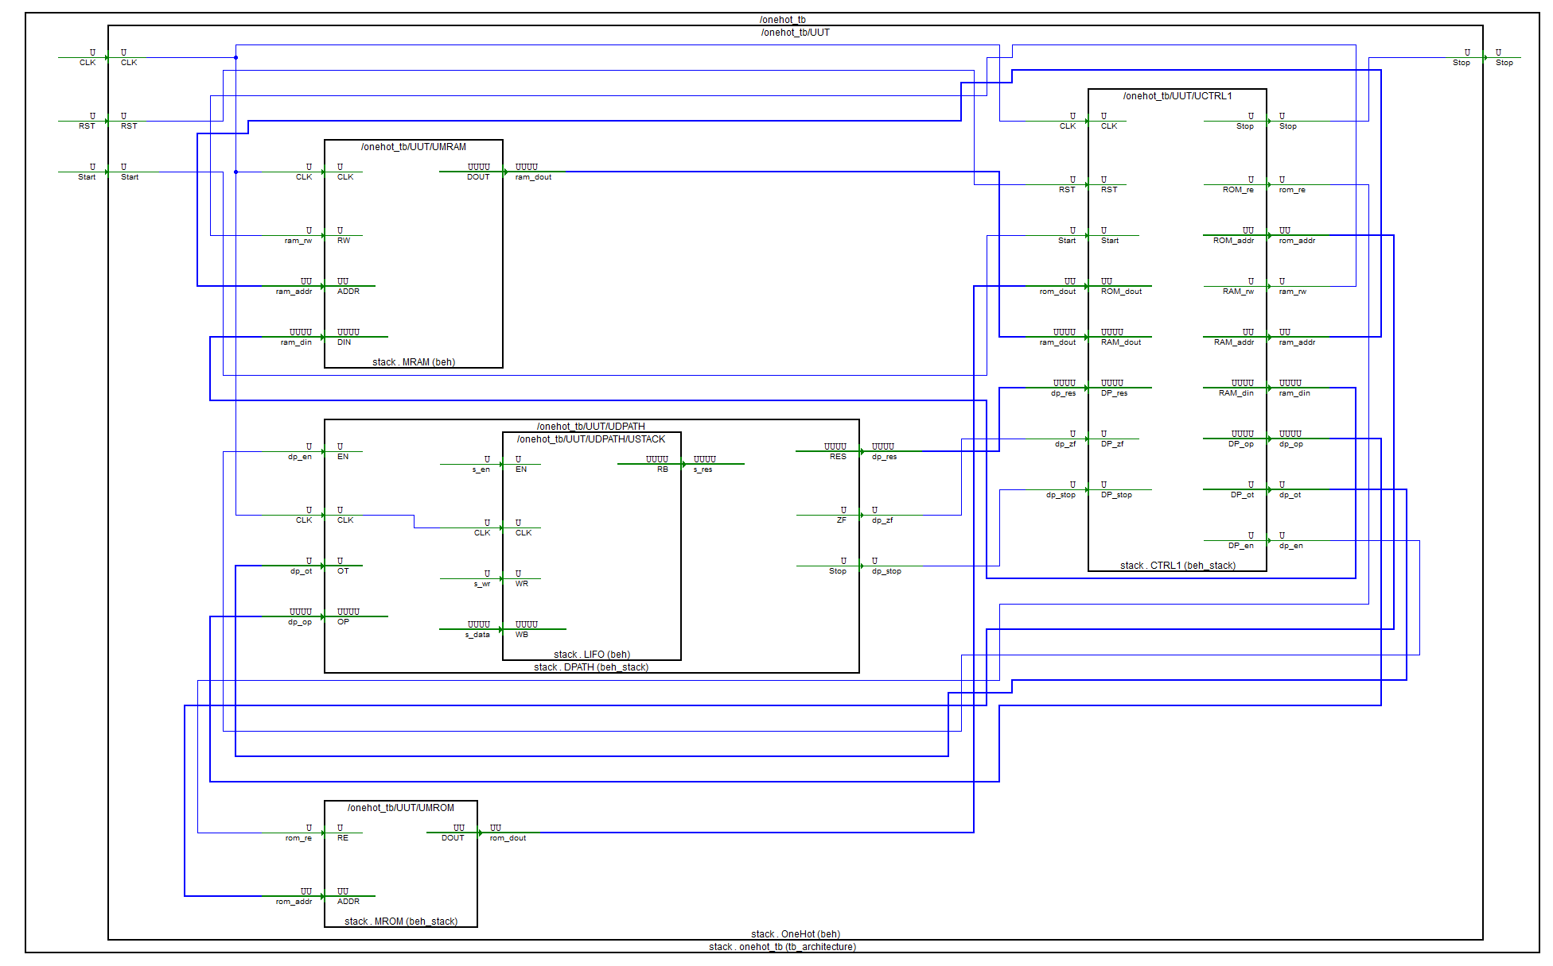
- Описание микроархитектуры

- Block Level
  - Блок MROM
    - HDL
library IEEE;
use IEEE.STD_LOGIC_1164.all;
use IEEE.STD_LOGIC_UNSIGNED.all;
use OneHotStack.all;

entity MROM is
port (
RE: in std_logic;
ADDR: in mem_addr;
DOUT: out command
);
end MROM;

architecture Beh_Stack of MROM is
type tROM is array (0 to 31) of command;

constant STUB: mem_addr := "00000";
constant LENGTH: mem_addr := "10000";
constant COUNTER: mem_addr := "10001";
constant CURRENT_VALUE: mem_addr := "10010";
constant DATA_START: mem_addr := "00000";
constant INIT_VALUE: mem_addr := "10011";
constant ZERO: mem_addr := "10100";
constant ONE: mem_addr := "10101";
constant EMPTY_SPACE: mem_addr := "10110";

constant LOADDR: mem_addr := "01010";

constant ROM: tROM :=(
-- OP CODE | RAM ADDR
-- Init
PUSH & ZERO,
POP & COUNTER,
PUSH & INIT_VALUE,
POP & CURRENT_VALUE,
PUSH & INIT_VALUE,
POP & DATA_START,
PUSH & ONE,
PUSH & LENGTH,
SUBT & STUB,
POP & LENGTH,
-- Loop
PUSH & COUNTER,
PUSH & ONE,
ADD & STUB,
POP & COUNTER,
PUSH & CURRENT_VALUE,
SHIFT & STUB,
POP & CURRENT_VALUE,
PUSH & CURRENT_VALUE,
POPIN & COUNTER,
PUSH & LENGTH,
PUSH & COUNTER,
SUBT & STUB,
JNZ & LOADDR,
others => HALT & STUB );
signal data: command;
begin
data <= ROM(conv_integer(ADDR));

zbufs: process (RE, data)
begin
if (RE = '1') then
DOUT <= data;
else
DOUT <= (others => 'Z');
end if;
end process;
end Beh_Stack;

    - TestBench

library stack;
use stack.OneHotStack.all;
library ieee;
use ieee.STD_LOGIC_UNSIGNED.all;
use ieee.std_logic_1164.all;

entity mrom_tb is
end mrom_tb;

architecture TB_ARCHITECTURE of mrom_tb is
component mrom
port(
RE : in STD_LOGIC;
ADDR : in mem_addr;
DOUT : out command );
end component;

signal RE : STD_LOGIC;
signal ADDR : mem_addr;
signal DOUT : command;

constant WAIT_period: time := 10 ns;

begin

UUT : mrom
port map (
RE => RE,
ADDR => ADDR,
DOUT => DOUT
);
main: process
begin
re <= '0';
addr <= "00010";
wait for 1 * WAIT_period;
re <= '1';
wait for 1 * WAIT_period;
addr <= "00000";
re <= '1';
wait for 1 * WAIT_period;
re <= '0';
wait for 100 * WAIT_period;
wait;
end process;

end TB_ARCHITECTURE;

configuration TESTBENCH_FOR_mrom of mrom_tb is
for TB_ARCHITECTURE
for UUT : mrom
use entity work.mrom(beh_stack);
end for;
end for;
end TESTBENCH_FOR_mrom;

    - Временные диаграммы функционирования
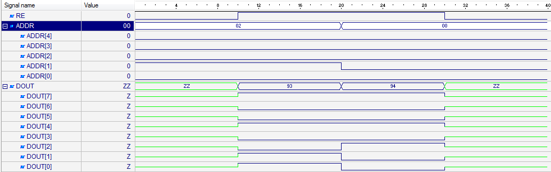

  - Блок MRAM
    - HDL
library IEEE;
use IEEE.STD_LOGIC_1164.all;
use IEEE.STD_LOGIC_UNSIGNED.all;
use OneHotStack.all;

entity MRAM is
port (
CLK: in std_logic;
RW: in std_logic;
ADDR: in mem_addr;
DIN: in operand;
DOUT: out operand
);
end MRAM;

architecture Beh of MRAM is
type tRAM is array (0 to 31) of operand;
signal RAM: tRAM:= (
-- | BIN | ADR BIN
"0000000000000000", -- | 00000 |
"0000000000000000", -- | 00001 |
"0000000000000000", -- | 00010 |
"0000000000000000", -- | 00011 |
"0000000000000000", -- | 00100 |
"0000000000000000", -- | 00101 |
"0000000000000000", -- | 00110 |
"0000000000000000", -- | 00111 |
"0000000000000000", -- | 01000 |
"0000000000000000", -- | 01001 |
"0000000000000000", -- | 01010 |
"0000000000000000", -- | 01011 |
"0000000000000000", -- | 01100 |
"0000000000000000", -- | 01101 |
"0000000000000000", -- | 01110 |
"0000000000000000", -- | 01111 |
"0000000000001000", -- | 10000 |
"0000000000000000", -- | 10001 |
"0000000000000000", -- | 10010 |
"0000000000000001", -- | 10011 |
"0000000000000000", -- | 10100 |
"0000000000000001", -- | 10101 |
others => "0000000000000000"
);
signal data_in: operand;
signal data_out: operand;
Begin
data_in <= Din;

WRITE: process (CLK, RW, ADDR, data_in)
begin
if (RW = '0') then
if (rising_edge(CLK)) then
RAM(conv_integer(ADDR)) <= data_in;
end if;
end if;
end process;

data_out <= RAM (conv_integer(ADDR));

RDP: process (RW, RAM, data_out)
begin
if (RW = '1') then
DOUT <= data_out;
else
DOUT <= (others => 'Z');
end if;
end process;
end Beh;

    - TestBench
library stack;
use stack.OneHotStack.all;
library ieee;
use ieee.STD_LOGIC_UNSIGNED.all;
use ieee.std_logic_1164.all;

entity mram_tb is
end mram_tb;

architecture TB_ARCHITECTURE of mram_tb is
component mram
port(
CLK : in STD_LOGIC;
RW : in STD_LOGIC;
ADDR : in mem_addr;
DIN : in operand;
DOUT : out operand );
end component;

signal CLK : STD_LOGIC;
signal RW : STD_LOGIC;
signal ADDR : mem_addr;
signal DIN : operand;
signal DOUT : operand;
constant CLK_period: time := 10 ns;

begin
UUT : mram
port map (

CLK => CLK,
RW => RW,
ADDR => ADDR,
DIN => DIN,
DOUT => DOUT
);

CLK_Process: process
begin

CLK <= '0';
wait for CLK_Period/2;

CLK <= '1';
wait for CLK_Period/2;
end process;
main: process
begin
wait for CLK_PERIOD;
addr <= "00010";
din <= "0000000000000100";
wait for CLK_PERIOD;
addr <= "00001";
rw <= '1';
wait for CLK_PERIOD;
addr <= "00000";
din <= "0000000000010000";
rw <= '0';
wait for CLK_PERIOD;
wait;
end process;
end TB_ARCHITECTURE;

configuration TESTBENCH_FOR_mram of mram_tb is
for TB_ARCHITECTURE
for UUT : mram
use entity work.mram(beh);
end for;
end for;
end TESTBENCH_FOR_mram;

    - Временные диаграммы функционирования
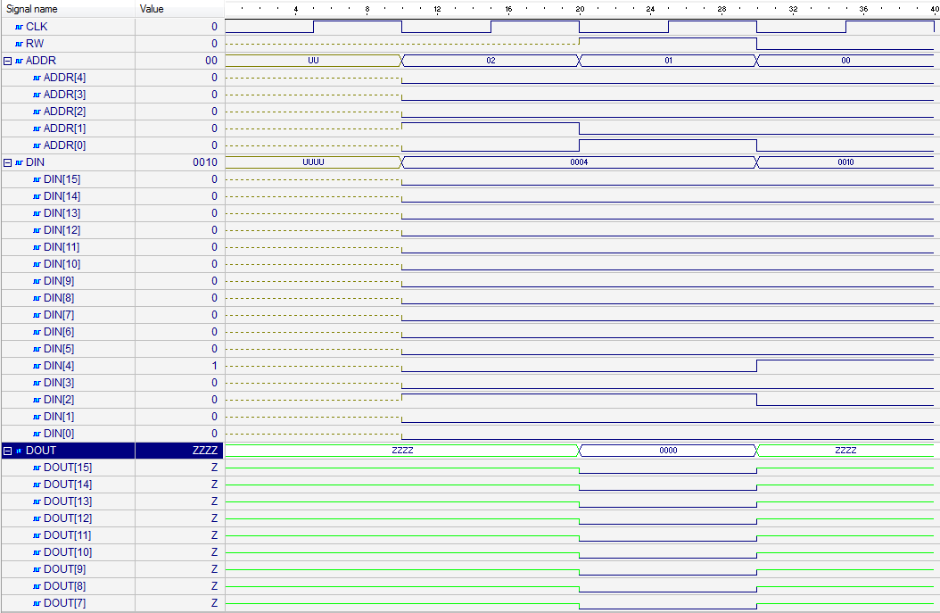

  - Блок CTRL
    - HDL
library IEEE;
use IEEE.STD_LOGIC_1164.all;
use IEEE.STD_LOGIC_UNSIGNED.all;
library stack;
use stack.OneHotStack.all;

entity CTRL1 is
port(
CLK, RST, Start: in std_logic;
Stop: out std_logic;
ROM_re: out std_logic;
ROM_addr: out mem_addr;
ROM_dout: in command;
RAM_rw: out std_logic;
RAM_addr: out mem_addr;
RAM_din: out operand;
RAM_dout: in operand;
DP_op: out operand;
DP_ot: out operation;
DP_en: out std_logic;
DP_res: in operand;
DP_zf: in std_logic;
DP_stop: in std_logic
);
end CTRL1;

architecture Beh_Stack of CTRL1 is
type states is (I, F, D, R, S, H, LIN, J, DP, DPW);
signal nxt_state, cur_state: states;
signal RI: command;
signal IC: mem_addr;
signal RO: operation;
signal RA: mem_addr;
signal RD: operand;
begin
FSM: process(CLK, RST, nxt_state)
begin
if (RST = '1') then
cur_state <= I;
elsif rising_edge(CLK) then
cur_state <= nxt_state;
end if;
end process;

COMB: process(cur_state, start, RO, DP_stop)
begin
case cur_state is
when I =>
if (start = '1') then
nxt_state <= F;
else
nxt_state <= I;
end if;
when F => nxt_state <= D;
when D =>
case RO is
when ADD | SUBT | SHIFT | POP => nxt_state <= DP;
when HALT => nxt_state <= H;
when JNZ => nxt_state <= J;
when others => nxt_state <= R;
end case;
when R =>
if (RO = PUSH) then
nxt_state <= DP;
elsif (RO = POPIN) then
nxt_state <= LIN;
else
nxt_state <= I;
end if;
when LIN => nxt_state <= DP;
when DP => nxt_state <= DPW;
when DPW =>
if (DP_stop = '0') then
nxt_state <= DPW;
else
if (RO = POP or RO = POPIN) then
nxt_state <= S;
else
nxt_state <= F;
end if;
end if;
when S | J => nxt_state <= F;
when H => nxt_state <= H;
when others => nxt_state <= I;
end case;
end process;

PSTOP: process (cur_state)
begin
if (cur_state = H) then
stop <= '1';
else
stop <= '0';
end if;
end process;

PMC: process (CLK, RST, cur_state)
begin
if (RST = '1') then

IC <= "00000";
elsif falling_edge(CLK) then
if (cur_state = D) then
IC <= IC + 1;
elsif (cur_state = J and DP_ZF = '0') then
IC <= RA;
end if;
end if;
end process;

ROM_addr <= IC;

PROMREAD: process (nxt_state, cur_state)
begin
if (nxt_state = F or cur_state = F) then
ROM_re <= '1';
else
ROM_re <= '0';
end if;
end process;

PROMDAT: process (RST, cur_state, ROM_dout)
begin
if (RST = '1') then
RI <= (others => '0');
elsif (cur_state = F) then
RI <= ROM_dout;
end if;
end process;

-- RO and RA control
PRORA: process (RST, nxt_state, RI)
begin
if (RST = '1') then
RO <= (others => '0');
RA <= (others => '0');
elsif (nxt_state = D) then
RO <= RI (7 downto 5);
RA <= RI (4 downto 0);
elsif (nxt_state = LIN) then
RA <= RD (4 downto 0);
end if;
end process;

PRAMST: process (RA)
begin
if (cur_state /= J) then
RAM_addr <= RA;
end if;
end process;

PRAMREAD: process (cur_state)
begin
if (cur_state = S) then
RAM_rw <= '0';
else
RAM_rw <= '1';
end if;
end process;

PRAMDAR: process (cur_state)
begin
if (cur_state = R) then
RD <= RAM_dout;
end if;
end process;

-- move the value from DPATH to RAM input bus
RAM_din <= DP_res;
-- move the value from RD to datapath
DP_op <= RD;
-- move RO value to DP operation bus
DP_ot <= RO;

pdpathen: process (cur_state)
begin
if (cur_state = DP) then
DP_en <= '1';
else
DP_en <= '0';
end if;
end process;
end Beh_Stack;
    - TestBench
library stack;
use stack.OneHotStack.all;
library ieee;
use ieee.STD_LOGIC_UNSIGNED.all;
use ieee.std_logic_1164.all;

entity ctrl1_tb is
end ctrl1_tb;

architecture TB_ARCHITECTURE of ctrl1_tb is

component MROM is
port (
RE: in std_logic;
ADDR: in mem_addr;
DOUT: out command
);
end component;

component MRAM is
port (
CLK: in std_logic;
RW: in std_logic;
ADDR: in mem_addr;
DIN: in operand;
DOUT: out operand
);
end component;

component DPATH is
port(
EN: in std_logic;
CLK: in std_logic;
OT: in operation;
OP: in operand;
RES: out operand;
ZF: out std_logic;
Stop: out std_logic
);
end component;

-- Component declaration of the tested unit
component ctrl1
port(
CLK : in STD_LOGIC;
RST : in STD_LOGIC;
Start : in STD_LOGIC;
Stop : out STD_LOGIC;
ROM_re : out STD_LOGIC;
ROM_addr : out mem_addr;
ROM_dout : in command;
RAM_rw : out STD_LOGIC;
RAM_addr : out mem_addr;
RAM_din : out operand;
RAM_dout : in operand;
DP_op : out operand;
DP_ot : out operation;
DP_en : out STD_LOGIC;
DP_res : in operand;
DP_zf : in STD_LOGIC;
DP_stop : in STD_LOGIC );
end component;

signal CLK : STD_LOGIC;
signal RST : STD_LOGIC;
signal Start : STD_LOGIC;
signal ROM_dout : command;
signal RAM_dout : operand;
signal DP_res : operand;
signal DP_zf : STD_LOGIC;
signal DP_stop : STD_LOGIC;
signal Stop : STD_LOGIC;
signal ROM_re : STD_LOGIC;
signal ROM_addr : mem_addr;
signal RAM_rw : STD_LOGIC;
signal RAM_addr : mem_addr;
signal RAM_din : operand;
signal DP_op : operand;
signal DP_ot : operation;
signal DP_en : STD_LOGIC;

constant CLK_period: time := 10 ns;

begin

-- Unit Under Test port map
UUT : ctrl1
port map (

CLK => CLK,
RST => RST,
Start => Start,
Stop => Stop,
ROM_re => ROM_re,
ROM_addr => ROM_addr,
ROM_dout => ROM_dout,
RAM_rw => RAM_rw,
RAM_addr => RAM_addr,
RAM_din => RAM_din,
RAM_dout => RAM_dout,
DP_op => DP_op,
DP_ot => DP_ot,
DP_en => DP_en,
DP_res => DP_res,
DP_zf => DP_zf,
DP_stop => DP_stop
);

UMRAM: MRAM
port map(

CLK => CLK,
RW => ram_rw,
ADDR => ram_addr,
DIN => ram_din,
DOUT => ram_dout
);
UMROM: entity MROM (Beh_Stack)
port map (
RE => rom_re,
ADDR => rom_addr,
DOUT => rom_dout
);

UDPATH: DPATH
port map(
EN => dp_en,
CLK => CLK,
OT => dp_ot,
OP => dp_op,
RES => dp_res,
ZF => dp_zf,
STOP => dp_stop
);

CLK_Process: process
begin

CLK <= '0';
wait for CLK_Period/2;

CLK <= '1';
wait for CLK_Period/2;
end process;
main: process
begin
rst <= '1';
wait for 1 * CLK_PERIOD;
rst <= '0';
start <= '1';
wait for 100 * CLK_PERIOD;
wait;
end process;
end TB_ARCHITECTURE;
configuration TESTBENCH_FOR_ctrl1 of ctrl1_tb is
for TB_ARCHITECTURE
for UUT : ctrl1
use entity work.ctrl1(beh_stack);
end for;
end for;
end TESTBENCH_FOR_ctrl1;

    - Временные диаграммы функционирования
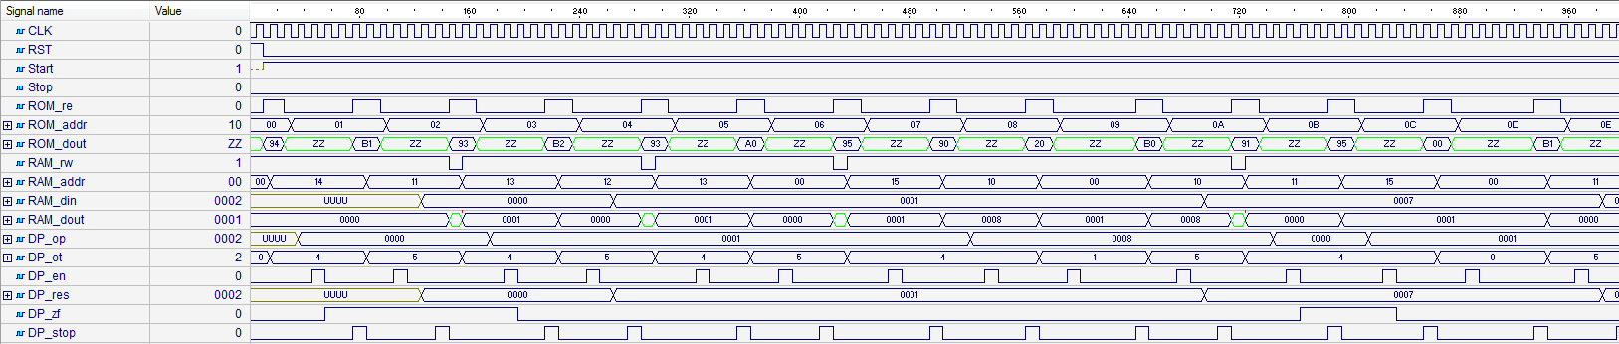

  - Блок DPATH
    - HDL
library IEEE;
use IEEE.STD_LOGIC_1164.all;
use IEEE.STD_LOGIC_ARITH.all;
use IEEE.STD_LOGIC_UNSIGNED.all;
library stack;
use stack.OneHotStack.all;
entity DPATH is
port(
EN: in std_logic;
CLK: in std_logic;
OT: in operation;
OP: in operand;
RES: out operand;
ZF: out std_logic;
Stop: out std_logic
);
end DPATH;

architecture Beh_Stack of DPATH is
component LIFO
generic(
m: integer := 2;
n: integer := 2
);
port (
EN: in std_logic;
CLK: in std_logic;
WR: in std_logic;
RB: out std_logic_vector(n-1 downto 0);
WB: in std_logic_vector(n-1 downto 0)
);
end component;
type states is (I, IPOP1, IPOP2, A, SB, SH, IPUSH, MOVERES, MOVERESOP, H);
signal nxt_state, cur_state: states;
signal res_op: operand;
signal i_op: operand;
signal i_op1: operand;
signal i_op2: operand;
signal i_res: operand;
signal s_en: std_logic;
signal s_wr: std_logic;
signal s_res: operand;
signal s_data: operand;
signal t_zf: std_logic;
Begin
USTACK: LIFO
generic map(
m => 5,
n => 16
)
port map(
CLK => CLK,
EN => s_en,
WR => s_wr,
RB => s_res,
WB => s_data
);

i_op <= OP;

FSM: process(CLK, nxt_state)
begin
if rising_edge(CLK) then
cur_state <= nxt_state;
end if;
end process;

COMB: process(cur_state, EN, OT)
begin
case cur_state is
when I =>
if (EN = '1') then
case OT is
when ADD | SUBT | SHIFT | POP | POPIN => nxt_state <= IPOP1;
when others => nxt_state <= MOVERESOP;
end case;
else
nxt_state <= I;
end if;
when IPOP1 =>
if (OT = POP or OT = POPIN) then
nxt_state <= MOVERES;
elsif (OT = SHIFT) then
nxt_state <= SH;
else
nxt_state <= IPOP2;
end if;
when IPOP2 =>
if (OT = ADD) then
nxt_state <= A;
else
nxt_state <= SB;
end if;
when A | SB | SH | MOVERESOP => nxt_state <= IPUSH;
when MOVERES => nxt_state <= H;
when IPUSH => nxt_state <= H;
when H => nxt_state <= I;
when others => nxt_state <= I;
end case;
end process;

-- stop signal handler
PSTOP: process (cur_state)
begin
if (cur_state = H) then
stop <= '1';
else
stop <= '0';
end if;
end process;
STACKCTRL: process (cur_state, nxt_state)
begin
if (nxt_state = IPOP1 or nxt_state = IPOP2) then
s_wr <= '1';
s_en <= '1';
elsif (cur_state = IPUSH) then
s_wr <= '0';
s_en <= '1';
else
s_wr <= '1';
s_en <= '0';
end if;
end process;

OP1CTRL: process (cur_state, s_res)
begin
if (cur_state = IPOP1) then
i_op1 <= s_res;
end if;
end process;

OP2CTRL: process (cur_state, s_res)
begin
if (cur_state = IPOP2) then
i_op2 <= s_res;
end if;
end process;

OPRESULTCTRL: process (cur_state, i_op1, i_op2, i_op)
begin
if (cur_state = A) then
res_op <= CONV_STD_LOGIC_VECTOR(CONV_INTEGER(i_op1) + CONV_INTEGER(i_op2), 16);
elsif (cur_state = SB) then
res_op <= CONV_STD_LOGIC_VECTOR(CONV_INTEGER(i_op1) - CONV_INTEGER(i_op2), 16);
elsif (cur_state = SH) then
res_op <= i_op1(14 downto 0) & '0';
elsif (cur_state = MOVERESOP) then
res_op <= i_op;
end if;
end process;

IRESCTRL: process (cur_state, i_op1)
begin
if (cur_state = MOVERES) then
i_res <= i_op1;
end if;
end process;

FLAGS: process(res_op)
begin
if res_op = (res_op'range => '0') then
t_zf <= '1';
else
t_zf <= '0';
end if;
end process;

s_data <= res_op;
RES <= i_res;
ZF <= t_zf;
End Beh_Stack;

    - TestBench
library stack;
use stack.OneHotStack.all;
library ieee;
use ieee.STD_LOGIC_UNSIGNED.all;
use ieee.std_logic_1164.all;
use ieee.std_logic_arith.all;

entity dpath_tb is
end dpath_tb;

architecture TB_ARCHITECTURE of dpath_tb is
component dpath
port(
EN : in STD_LOGIC;
CLK : in STD_LOGIC;
OT : in operation;
OP : in operand;
RES : out operand;
ZF : out STD_LOGIC;
Stop : out STD_LOGIC );
end component;

signal EN : STD_LOGIC;
signal CLK : STD_LOGIC;
signal OT : operation;
signal OP : operand;
signal RES : operand;
signal ZF : STD_LOGIC;
signal Stop : STD_LOGIC;

constant CLK_Period: time := 10 ns;
constant Stop_WAIT: time := 5 * CLK_Period;

begin

-- Unit Under Test port map
UUT : dpath
port map (

EN => EN,
CLK => CLK,
OT => OT,
OP => OP,
RES => RES,
ZF => ZF,
Stop => Stop
);

CLK_Process: process
begin

CLK <= '0';
wait for CLK_Period/2;

CLK <= '1';
wait for CLK_Period/2;
end process;

MAIN: process
begin
wait for clk_period;
en <= '0';
op <= "0000000000000010";
ot <= PUSH;
wait for clk_period;
en <= '1';
wait for clk_period;
en <= '0';
wait for Stop_WAIT;
en <= '1';
wait for clk_period;
en <= '0';
wait for Stop_WAIT;
ot <= ADD;
wait for clk_period;
en <= '1';
wait for clk_period;
en <= '0';
wait for Stop_WAIT;
ot <= POP;
wait for clk_period;
en <= '1';
wait for clk_period;
en <= '0';
wait for Stop_WAIT;
ot <= PUSH;
wait for clk_period;
en <= '1';
wait for clk_period;
en <= '0';
wait for Stop_WAIT;
en <= '1';
wait for clk_period;
en <= '0';
wait for Stop_WAIT;
ot <= SUBT;
wait for clk_period;
en <= '1';
wait for clk_period;
en <= '0';
wait for Stop_WAIT;
ot <= POP;
wait for clk_period;
en <= '1';
wait for clk_period;
en <= '0';
wait for Stop_WAIT;
ot <= PUSH;
wait for clk_period;
en <= '1';
wait for clk_period;
en <= '0';
wait for Stop_WAIT;
ot <= SHIFT;
wait for clk_period;
en <= '1';
wait for clk_period;
en <= '0';
wait for Stop_WAIT;
ot <= POP;
wait for clk_period;
en <= '1';
wait for clk_period;
en <= '0';
wait for Stop_WAIT;
wait;
end process;

end TB_ARCHITECTURE;

configuration TESTBENCH_FOR_dpath of dpath_tb is
for TB_ARCHITECTURE
for UUT : dpath
use entity work.dpath(beh_stack);
end for;
end for;
end TESTBENCH_FOR_dpath;

    - Временные диаграммы функционирования

- System Level
  - HDL
library IEEE;
use IEEE.STD_LOGIC_1164.all;
use IEEE.STD_LOGIC_UNSIGNED.all;
library stack;
use stack.OneHotStack.all;

entity OneHot is
port (
CLK, RST, Start: in std_logic;
Stop: out std_logic
);
end OneHot;

architecture Beh of OneHot is
component MROM is
port (
RE: in std_logic;
ADDR: in mem_addr;
DOUT: out command
);
end component;

component MRAM is
port (
CLK: in std_logic;
RW: in std_logic;
ADDR: in mem_addr;
DIN: in operand;
DOUT: out operand
);
end component;

component DPATH is
port(
EN: in std_logic;
CLK: in std_logic;
OT: in operation;
OP: in operand;
RES: out operand;
ZF: out std_logic;
Stop: out std_logic
);
end component;

component CTRL1 is
port(
CLK, RST, Start: in std_logic;
Stop: out std_logic;
ROM_re: out std_logic;
ROM_addr: out mem_addr;
ROM_dout: in command;
RAM_rw: out std_logic;
RAM_addr: out mem_addr;
RAM_din: out operand;
RAM_dout: in operand;
--datapath
DP_op: out operand;
DP_ot: out operation;
DP_en: out std_logic;
DP_res: in operand;
DP_zf: in std_logic;
DP_stop: in std_logic
);
end component;

signal rom_re: std_logic;
signal rom_addr: mem_addr;
signal rom_dout: command;
signal ram_rw: std_logic;
signal ram_addr: mem_addr;
signal ram_din: operand;
signal ram_dout: operand;
signal dp_op: operand;
signal dp_ot: operation;
signal dp_en: std_logic;
signal dp_res: operand;
signal dp_zf: std_logic;
signal dp_stop: std_logic;
begin
UMRAM: MRAM
port map(
CLK => CLK,
RW => ram_rw,
ADDR => ram_addr,
DIN => ram_din,
DOUT => ram_dout
);
UMROM: MROM
port map (
RE => rom_re,
ADDR => rom_addr,
DOUT => rom_dout
);
UDPATH: DPATH
port map(
EN => dp_en,
CLK => CLK,
OT => dp_ot,
OP => dp_op,
RES => dp_res,
ZF => dp_zf,
STOP => dp_stop
);
UCTRL1: CTRL1
port map(
CLK => CLK,
RST => RST,
START => Start,
STOP => STOP,
ROM_re => rom_re,
ROM_addr => rom_addr,
ROM_dout => rom_dout,
RAM_rw => ram_rw,
RAM_addr => ram_addr,
RAM_din => ram_din,
RAM_dout => ram_dout,
DP_en => dp_en,
DP_ot => dp_ot,
DP_op => dp_op,
DP_res => dp_res,
DP_zf => dp_zf,
DP_stop => dp_stop
);
end Beh;
  - Test Bench
library ieee;
use ieee.STD_LOGIC_UNSIGNED.all;
use ieee.std_logic_1164.all;
library stack;
use stack.OneHotStack.all;

entity onehot_tb is
end onehot_tb;

architecture TB_ARCHITECTURE of onehot_tb is
component onehot
port(
CLK : in STD_LOGIC;
RST : in STD_LOGIC;
Start : in STD_LOGIC;
Stop : out STD_LOGIC );
end component;

signal CLK : STD_LOGIC;
signal RST : STD_LOGIC;
signal Start : STD_LOGIC;
signal Stop : STD_LOGIC;

constant CLK_period: time := 10 ns;

begin

UUT : onehot
port map (
CLK => CLK,
RST => RST,
Start => Start,
Stop => Stop
);

CLK_Process: process
begin
CLK <= '0';
wait for CLK_Period/2;
CLK <= '1';
wait for CLK_Period/2;
end process;

main: process
begin
rst <= '1';
wait for 1 * CLK_PERIOD;
rst <= '0';
start <= '1';
wait for 100 * CLK_PERIOD;
wait;
end process;

end TB_ARCHITECTURE;

configuration TESTBENCH_FOR_onehot of onehot_tb is
for TB_ARCHITECTURE
for UUT : onehot
use entity work.onehot(beh);
end for;
end for;
end TESTBENCH_FOR_onehot;

  - Временные диаграммы функционирования
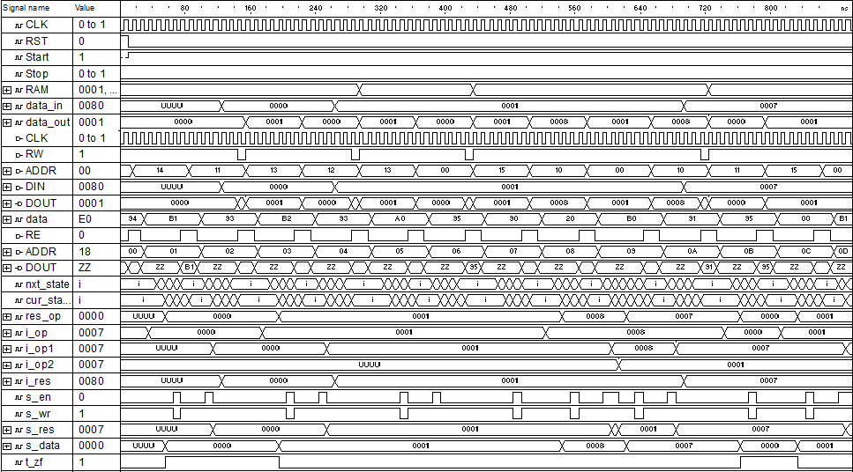
- Анализ аппаратурных и временные затрат
  - Аппаратные затраты (Cyclone 10CL006YU256I7G / Inter Quartus Prime 17.1 Lite)
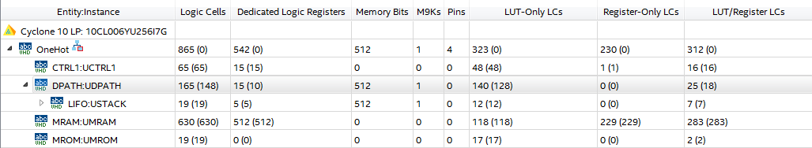

  - Временные затраты
Для генерации 8 элементов “One-Hot” последовательности требуется 710 тактов синхронизации.

- Выводы
Accumulator
- Описание ISA

Мнемоника | Код операции (3 бита) | Операнд (5 бит)
LOAD | 000 | aaaaa
STORE | 001 | aaaaa
ADD | 010 | aaaaa
SUBT | 011 | aaaaa
STOREIN | 100 | aaaaa
SHIFT | 101 | xxxxx
JNZ | 110 | aaaaa
HALT | 111 | xxxxx

ADD addr – сложение значений хранящегося в аккумуляторе с значением хранящемся по адресу addr, результат записывается в аккумулятор
SUBT addr – вычитание значения хранящегося по адресу addr значения хранящегося в аккумуляторе, результат записывается в аккумулятор
SHIFT – логический сдвиг вправо значения хранящегося в аккумуляторе, результат записывается в аккумулятор
JNZ addr – переход на операции по адресу addr, при сброшенном флаге нуля
LOAD addr – пересылка значения хранящегося по адресу addr в аккумулятор
STORE addr – пересылка значения хранящегося в аккумуляторе по адресу addr
STOREIN addr – пересылка значения хранящегося в аккумуляторе по адресу хранящемуся по адресу addr.
HALT - останова

- Микропрограмма

constant STUB: mem_addr := "00000";
constant DATA_START: mem_addr := "00000";
constant LENGTH :mem_addr := "10000";
constant COUNTER: mem_addr := "10001";
constant CURRENT_VALUE: mem_addr := "10010";
constant INIT_VALUE: mem_addr := "10011";
constant ZERO: mem_addr := "10100";
constant ONE: mem_addr := "10101";
constant LOOP_ADDR: mem_addr := "01000";
---------------------------
LOAD & ZERO,
STORE & COUNTER,
LOAD & INIT_VALUE,
STORE & DATA_START,
STORE & CURRENT_VALUE,
LOAD & LENGTH,
SUBT & ONE,
STORE & LENGTH,
LOAD & COUNTER,
ADD & ONE,
STORE & COUNTER,
LOAD & CURRENT_VALUE,
SHIFT & STUB,
STORE & CURRENT_VALUE,
STOREIN & COUNTER,
LOAD & LENGTH,
SUBT & COUNTER,
JNZ & LOOP_ADDR

- Общая структурная схема

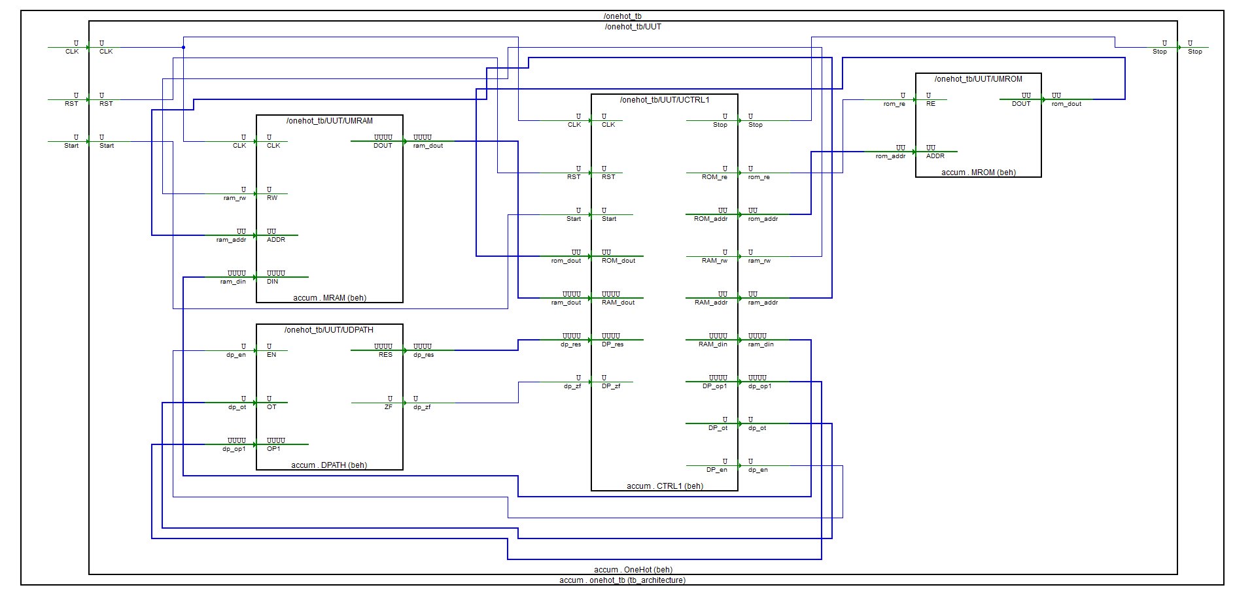

- Описание микроархитектуры

- Block Level
  - Блок MROM
    - HDL
library IEEE;
use IEEE.STD_LOGIC_1164.all;
use IEEE.STD_LOGIC_UNSIGNED.all;
library accum;
use accum.OneHotAccum.all;

entity MROM is
port (
RE: in std_logic;
ADDR: in mem_addr;
DOUT: out command
);
end MROM;

architecture Beh of MROM is
type tROM is array (0 to 31) of command;

constant STUB: mem_addr := "00000";
constant DATA_START: mem_addr := "00000";
constant LENGTH :mem_addr := "10000";
constant COUNTER: mem_addr := "10001";
constant CURRENT_VALUE: mem_addr := "10010";
constant INIT_VALUE: mem_addr := "10011";
constant ZERO: mem_addr := "10100";
constant ONE: mem_addr := "10101";

constant LOOP_ADDR: mem_addr := "01000";

constant ROM: tROM :=(
-- OP CODE | OP1
-- Init
LOAD & ZERO,
STORE & COUNTER,
LOAD & INIT_VALUE,
STORE & DATA_START,
STORE & CURRENT_VALUE,
LOAD & LENGTH,
SUBT & ONE,
STORE & LENGTH,
-- Loop
LOAD & COUNTER,
ADD & ONE,
STORE & COUNTER,
LOAD & CURRENT_VALUE,
SHIFT & STUB,
STORE & CURRENT_VALUE,
STOREIN & COUNTER,
LOAD & LENGTH,
SUBT & COUNTER,
JNZ & LOOP_ADDR,
others => HALT & STUB
);

signal data: command;
begin
data <= ROM(conv_integer(addr));

zbufs: process (RE, data)
begin
if (RE = '1') then
DOUT <= data;
else
DOUT <= (others => 'Z');
end if;
end process;
end Beh;
    - TestBench

library accum;
use accum.OneHotAccum.all;
library ieee;
use ieee.STD_LOGIC_UNSIGNED.all;
use ieee.std_logic_1164.all;

entity mrom_tb is
end mrom_tb;

architecture TB_ARCHITECTURE of mrom_tb is
component mrom
port(
RE : in STD_LOGIC;
ADDR : in mem_addr;
DOUT : out command );
end component;

signal RE : STD_LOGIC;
signal ADDR : mem_addr;
signal DOUT : command;

constant WAIT_period: time := 10 ns;

begin

UUT : mrom
port map (
RE => RE,
ADDR => ADDR,
DOUT => DOUT
);

main: process
begin
re <= '0';
addr <= "00010";
wait for 1 * WAIT_period;
re <= '1';
wait for 1 * WAIT_period;
addr <= "00000";
re <= '1';
wait for 1 * WAIT_period;
re <= '0';
wait for 100 * WAIT_period;
wait;
end process;
end TB_ARCHITECTURE;
configuration TESTBENCH_FOR_mrom of mrom_tb is
for TB_ARCHITECTURE
for UUT : mrom
use entity work.mrom(beh);
end for;
end for;
end TESTBENCH_FOR_mrom;

    - Временные диаграммы функционирования

  - Блок MRAM
    - HDL
library IEEE;
use IEEE.STD_LOGIC_1164.all;
use IEEE.STD_LOGIC_UNSIGNED.all;
library accum;
use accum.OneHotAccum.all;

entity MRAM is
port (
CLK: in std_logic;
RW: in std_logic;
ADDR: in mem_addr;
DIN: in operand;
DOUT: out operand
);
end MRAM;

architecture Beh of MRAM is
type tRAM is array (0 to 31) of operand;
signal RAM: tRAM:= (
-- | BIN | ADR BIN
"0000000000000000", -- | 00000 |
"0000000000000000", -- | 00001 |
"0000000000000000", -- | 00010 |
"0000000000000000", -- | 00011 |
"0000000000000000", -- | 00100 |
"0000000000000000", -- | 00101 |
"0000000000000000", -- | 00110 |
"0000000000000000", -- | 00111 |
"0000000000000000", -- | 01000 |
"0000000000000000", -- | 01001 |
"0000000000000000", -- | 01010 |
"0000000000000000", -- | 01011 |
"0000000000000000", -- | 01100 |
"0000000000000000", -- | 01101 |
"0000000000000000", -- | 01110 |
"0000000000000000", -- | 01111 |
"0000000000001000", -- | 10000 |
"0000000000000000", -- | 10001 |
"0000000000000000", -- | 10010 |
"0000000000000001", -- | 10011 |
"0000000000000000", -- | 10100 |
"0000000000000001", -- | 10101 |
others => "0000000000000000"
);
signal data_in: operand;
signal data_out: operand;
Begin
data_in <= Din;

WRITE: process (CLK, RW, ADDR, data_in)
begin
if (RW = '0') then
if (rising_edge(CLK)) then
RAM(conv_integer(ADDR)) <= data_in;
end if;
end if;
end process;

data_out <= RAM (conv_integer(ADDR));

RDP: process (RW, RAM, data_out)
begin
if (RW = '1') then
DOUT <= data_out;
else
DOUT <= (others => 'Z');
end if;
end process;
end Beh;

    - TestBench
library accum;
use accum.OneHotAccum.all;
library ieee;
use ieee.STD_LOGIC_UNSIGNED.all;
use ieee.std_logic_1164.all;

entity mram_tb is
end mram_tb;

architecture TB_ARCHITECTURE of mram_tb is
component mram
port(
CLK : in STD_LOGIC;
RW : in STD_LOGIC;
ADDR : in mem_addr;
DIN : in operand;
DOUT : out operand );
end component;
signal CLK : STD_LOGIC;
signal RW : STD_LOGIC;
signal ADDR : mem_addr;
signal DIN : operand;
signal DOUT : operand;
constant CLK_period: time := 10 ns;

begin
UUT : mram
port map (
CLK => CLK,
RW => RW,
ADDR => ADDR,
DIN => DIN,
DOUT => DOUT
);

CLK_Process: process
begin
CLK <= '0';
wait for CLK_Period/2;
CLK <= '1';
wait for CLK_Period/2;
end process;

main: process
begin
wait for CLK_PERIOD;
addr <= "00010";
din <= "0000000000000100";
wait for CLK_PERIOD;
addr <= "00001";
rw <= '1';
wait for CLK_PERIOD;
addr <= "00000";
din <= "0000000000010000";
rw <= '0';
wait for CLK_PERIOD;
wait;
end process;
end TB_ARCHITECTURE;
configuration TESTBENCH_FOR_mram of mram_tb is
for TB_ARCHITECTURE
for UUT : mram
use entity work.mram(beh);
end for;
end for;
end TESTBENCH_FOR_mram;

    - Временные диаграммы функционирования

  - Блок CTRL
    - HDL
library IEEE;
use IEEE.STD_LOGIC_1164.all;
use IEEE.STD_LOGIC_UNSIGNED.all;
library accum;
use accum.OneHotAccum.all;

entity CTRL1 is
port(
CLK, RST, Start: in std_logic;
Stop: out std_logic;

-- ROM
ROM_re: out std_logic;
ROM_addr: out mem_addr;
ROM_dout: in command;

-- RAM
RAM_rw: out std_logic;
RAM_addr: out mem_addr;
RAM_din: out operand;
RAM_dout: in operand;
--datapath
DP_op1: out operand;
DP_ot: out operation;
DP_en: out std_logic;
DP_res: in operand;
DP_zf: in std_logic
);
end CTRL1;

architecture Beh of CTRL1 is
type states is (I, F, D, R, L, SH, S, A, SB, H, JNOTZ, SIN);
signal nxt_state, cur_state: states;
signal RI: command;
signal IC: mem_addr;
signal RO: operation;
signal RA: mem_addr;
signal RD: operand;
begin
FSM: process(CLK, RST, nxt_state)
begin
if (RST = '1') then
cur_state <= I;
elsif rising_edge(CLK) then
cur_state <= nxt_state;
end if;
end process;

-- Next state
COMB: process(cur_state, start, RO)
begin
case cur_state is
when I =>
if (start = '1') then
nxt_state <= F;
else
nxt_state <= I;
end if;
when F => nxt_state <= D;
when D =>
if (RO = HALT) then
nxt_state <= H;
elsif (RO = STORE) then
nxt_state <= S;
elsif (RO = JNZ) then
nxt_state <= JNOTZ;
elsif (RO = SHIFT) then
nxt_state <= SH;
else
nxt_state <= R;
end if;
when R =>
if (RO = LOAD) then
nxt_state <= L;
elsif (RO = ADD) then
nxt_state <= A;
elsif (RO = SUBT) then
nxt_state <= SB;
elsif (RO = STOREIN) then
nxt_state <= SIN;
else
nxt_state <= I;
end if;
when SIN => nxt_state <= S;
when L | S | A | SB | SH | JNOTZ => nxt_state <= F;
when H => nxt_state <= H;
when others => nxt_state <= I;
end case;
end process;

-- stop signal
PSTOP: process (cur_state)
begin
if (cur_state = H) then
stop <= '1';
else
stop <= '0';
end if;
end process;

-- instruction counter
PMC: process (CLK, RST, cur_state)
begin
if (RST = '1') then
IC <= "00000";
elsif falling_edge(CLK) then
if (cur_state = D) then
IC <= IC + 1;
elsif (cur_state = JNOTZ and DP_ZF = '0') then
IC <= RA;
end if;
end if;
end process;

ROM_addr <= IC;

-- ROM read signal
PROMREAD: process (nxt_state, cur_state)
begin
if (nxt_state = F or cur_state = F) then
ROM_re <= '1';
else
ROM_re <= '0';
end if;
end process;

-- read ROM value and put it into RI
PROMDAT: process (RST, cur_state, ROM_dout)
begin
if (RST = '1') then
RI <= "00000000";
elsif (cur_state = F) then
RI <= ROM_dout;
end if;
end process;

-- RO and RA control
PRORA: process (RST, nxt_state, RI)
begin
if (RST = '1') then
RO <= "000";
RA <= "00000";
elsif (nxt_state = D) then
RO <= RI (7 downto 5);
RA <= RI (4 downto 0);
elsif (nxt_state = SIN) then
RA <= RD (4 downto 0);
end if;
end process;

PRAMST: process (RA)
begin
if (cur_state /= JNOTZ) then
RAM_addr <= RA;
end if;
end process;

-- RAM read/write control
PRAMREAD: process (cur_state)
begin
if (cur_state = S) then
RAM_rw <= '0';
else
RAM_rw <= '1';
end if;
end process;

-- read value from RAM and put it into RD
PRAMDAR: process (cur_state)
begin
if (cur_state = R) then
RD <= RAM_dout;
end if;
end process;

-- move the value from DPATH to RAM input bus
RAM_din <= DP_res;
-- move the value from RD to datapath
DP_op1 <= RD;
-- move RO value to DP operation bus
DP_ot <= RO;

paddsuben: process (cur_state)
begin
if (cur_state = A or cur_state = SB or cur_state = SH or cur_state = L) then
DP_en <= '1';
else
DP_en <= '0';
end if;
end process;
end Beh;

    - TestBench
library accum;
use accum.OneHotAccum.all;
library ieee;
use ieee.STD_LOGIC_UNSIGNED.all;
use ieee.std_logic_1164.all;

entity ctrl1_tb is
end ctrl1_tb;

architecture TB_ARCHITECTURE of ctrl1_tb is

component MROM is
port (
RE: in std_logic;
ADDR: in mem_addr;
DOUT: out command
);
end component;

component MRAM is
port (
CLK: in std_logic;
RW: in std_logic;
ADDR: in mem_addr;
DIN: in operand;
DOUT: out operand
);
end component;

component DPATH is
port(
EN: in std_logic;
OT: in operation;
OP1 : in operand;
RES: out operand;
ZF: out std_logic
);
end component;

component ctrl1
port(
CLK : in STD_LOGIC;
RST : in STD_LOGIC;
Start : in STD_LOGIC;
Stop : out STD_LOGIC;
ROM_re : out STD_LOGIC;
ROM_addr : out mem_addr;
ROM_dout : in command;
RAM_rw : out STD_LOGIC;
RAM_addr : out mem_addr;
RAM_din : out operand;
RAM_dout : in operand;
DP_op1 : out operand;
DP_ot : out operation;
DP_en : out STD_LOGIC;
DP_res : in operand;
DP_zf : in STD_LOGIC );
end component;

signal CLK : STD_LOGIC;
signal RST : STD_LOGIC;
signal Start : STD_LOGIC;
signal ROM_dout : command;
signal RAM_dout : operand;
signal DP_res : operand;
signal DP_zf : STD_LOGIC;
signal Stop : STD_LOGIC;
signal ROM_re : STD_LOGIC;
signal ROM_addr : mem_addr;
signal RAM_rw : STD_LOGIC;
signal RAM_addr : mem_addr;
signal RAM_din : operand;
signal DP_op1 : operand;
signal DP_ot : operation;
signal DP_en : STD_LOGIC;

constant CLK_period: time := 10 ns;

begin

UMRAM: MRAM
port map(
CLK => CLK,
RW => ram_rw,
ADDR => ram_addr,
DIN => ram_din,
DOUT => ram_dout
);
UMROM: MROM
port map (
RE => rom_re,
ADDR => rom_addr,
DOUT => rom_dout
);
UDPATH: DPATH
port map(
EN => dp_en,
OT => dp_ot,
OP1 => dp_op1,
RES => dp_res,
ZF => dp_zf
);
UCTRL1: CTRL1
port map(
CLK => CLK,
RST => RST,
START => Start,
STOP => STOP,
ROM_RE => rom_re,
ROM_ADDR => rom_addr,
ROM_DOUT => rom_dout,
RAM_RW => ram_rw,
RAM_ADDR => ram_addr,
RAM_DIN => ram_din,
RAM_DOUT => ram_dout,
DP_EN => dp_en,
DP_OT => dp_ot,
DP_OP1 => dp_op1,
DP_RES => dp_res,
DP_ZF => dp_zf
);

UUT : ctrl1
port map (
CLK => CLK,
RST => RST,
Start => Start,
Stop => Stop,
ROM_re => ROM_re,
ROM_addr => ROM_addr,
ROM_dout => ROM_dout,
RAM_rw => RAM_rw,
RAM_addr => RAM_addr,
RAM_din => RAM_din,
RAM_dout => RAM_dout,
DP_op1 => DP_op1,
DP_ot => DP_ot,
DP_en => DP_en,
DP_res => DP_res,
DP_zf => DP_zf
);

CLK_Process: process
begin
CLK <= '0';
wait for CLK_Period/2;
CLK <= '1';
wait for CLK_Period/2;
end process;

main: process
begin
rst <= '1';
wait for 1 * CLK_PERIOD;
rst <= '0';
start <= '1';
wait for 100 * CLK_PERIOD;
wait;
end process;

end TB_ARCHITECTURE;

configuration TESTBENCH_FOR_ctrl1 of ctrl1_tb is
for TB_ARCHITECTURE
for UUT : ctrl1
use entity work.ctrl1(beh);
end for;
end for;
end TESTBENCH_FOR_ctrl1;

    - Временные диаграммы функционирования
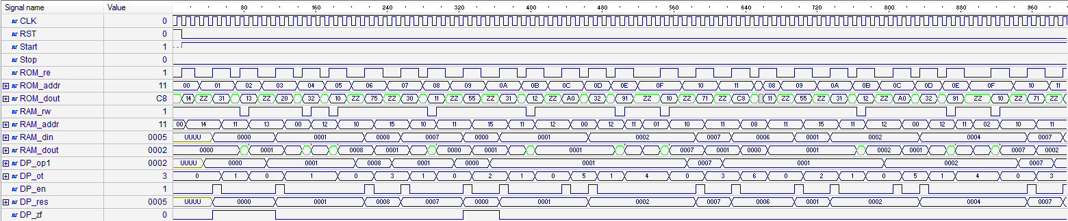

  - Блок DPATH
    - HDL
library IEEE;
use IEEE.STD_LOGIC_1164.all;
use IEEE.STD_LOGIC_ARITH.all;
use IEEE.STD_LOGIC_UNSIGNED.all;
library accum;
use accum.OneHotAccum.all;

entity DPATH is
port(
EN: in std_logic;
-- operation type
OT: in operation;
-- operand
OP1: in operand;
RES: out operand;
-- zero flag
ZF: out std_logic
);
end DPATH;

architecture Beh of DPATH is
signal ACCUM: operand;
signal res_add: operand;
signal res_sub: operand;
signal res_shift: operand;
signal t_zf: std_logic;
Begin
res_add <= CONV_STD_LOGIC_VECTOR(CONV_INTEGER(ACCUM) + CONV_INTEGER(OP1), 16);
res_sub <= CONV_STD_LOGIC_VECTOR(CONV_INTEGER(ACCUM) - CONV_INTEGER(OP1), 16);
res_shift <= ACCUM(14 downto 0) & '0';

REGA: process (EN, OT, OP1, res_add, res_sub, res_shift)
begin
if rising_edge(EN) then
case OT is
when LOAD => ACCUM <= OP1;
when ADD => ACCUM <= res_add;
when SUBT => ACCUM <= res_sub;
when SHIFT => ACCUM <= res_shift;
when others => null;
end case;
end if;
end process;

FLAGS: process(ACCUM)
begin
if ACCUM = (ACCUM'range => '0') then
t_zf <= '1';
else
t_zf <= '0';
end if;
end process;

RES <= ACCUM;
ZF <= t_zf;
End Beh;

    - TestBench
library accum;
use accum.OneHotAccum.all;
library ieee;
use ieee.STD_LOGIC_UNSIGNED.all;
use ieee.std_logic_1164.all;
use ieee.std_logic_arith.all;

-- Add your library and packages declaration here ...

entity dpath_tb is
end dpath_tb;

architecture TB_ARCHITECTURE of dpath_tb is
-- Component declaration of the tested unit
component dpath
port(
EN : in STD_LOGIC;
OT : in operation;
OP1 : in operand;
RES : out operand;
ZF : out STD_LOGIC );
end component;

-- Stimulus signals - signals mapped to the input and inout ports of tested entity
signal EN : STD_LOGIC;
signal OT : operation;
signal OP1 : operand;
-- Observed signals - signals mapped to the output ports of tested entity
signal RES : operand;
signal ZF : STD_LOGIC;

-- Add your code here ...
constant WAIT_period: time := 10 ns;
begin

-- Unit Under Test port map
UUT : dpath
port map (
EN => EN,
OT => OT,
OP1 => OP1,
RES => RES,
ZF => ZF
);

-- Add your stimulus here ...

MAIN: process
begin
wait for WAIT_period;
en <= '1';
wait for WAIT_period;
en <= '0';
wait for WAIT_period;
op1 <= "0000000000000010";
en <= '1';
ot <= LOAD;
wait for WAIT_period;
en <= '0';
op1 <= "0000000000100000";
wait for WAIT_period;
ot <= ADD;
en <= '1';
wait for WAIT_period;
en <= '0';
wait for WAIT_period;
ot <= SUBT;
en <= '1';
wait for WAIT_period;
en <= '0';
wait for WAIT_period;
wait;
end process;

end TB_ARCHITECTURE;

configuration TESTBENCH_FOR_dpath of dpath_tb is
for TB_ARCHITECTURE
for UUT : dpath
use entity work.dpath(beh);
end for;
end for;
end TESTBENCH_FOR_dpath;

    - Временные диаграммы функционирования

- System Level
  - HDL
library IEEE;
use IEEE.STD_LOGIC_1164.all;
use IEEE.STD_LOGIC_UNSIGNED.all;
library accum;
use accum.OneHotAccum.all;
entity OneHot is
port (
CLK, RST, Start: in std_logic;
Stop: out std_logic
);
end OneHot;

architecture Beh of OneHot is
component MROM is
port (
RE: in std_logic;
ADDR: in mem_addr;
DOUT: out command
);
end component;

component MRAM is
port (
CLK: in std_logic;
RW: in std_logic;
ADDR: in mem_addr;
DIN: in operand;
DOUT: out operand
);
end component;

component DPATH is
port(
EN: in std_logic;
OT: in operation;
OP1 : in operand;
RES: out operand;
ZF: out std_logic
);
end component;

component CTRL1 is
port(
CLK, RST, Start: in std_logic;
Stop: out std_logic;
-- ROM
ROM_re: out std_logic;
ROM_addr: out mem_addr;
ROM_dout: in command;
-- RAM
RAM_rw: out std_logic;
RAM_addr: out mem_addr;
RAM_din: out operand;
RAM_dout: in operand;
-- datapath
DP_op1: out operand;
DP_ot: out operation;
DP_en: out std_logic;
DP_res: in operand;
DP_zf: in std_logic
);
end component;

signal rom_re: std_logic;
signal rom_addr: mem_addr;
signal rom_dout: command;
signal ram_rw: std_logic;
signal ram_addr: mem_addr;
signal ram_din: operand;
signal ram_dout: operand;
signal dp_op1: operand;
signal dp_ot: operation;
signal dp_en: std_logic;
signal dp_res: operand;
signal dp_zf: std_logic;
begin
UMRAM: MRAM
port map(
CLK => CLK,
RW => ram_rw,
ADDR => ram_addr,
DIN => ram_din,
DOUT => ram_dout
);
UMROM: MROM
port map (
RE => rom_re,
ADDR => rom_addr,
DOUT => rom_dout
);
UDPATH: DPATH
port map(
EN => dp_en,
OT => dp_ot,
OP1 => dp_op1,
RES => dp_res,
ZF => dp_zf
);
UCTRL1: CTRL1
port map(
CLK => CLK,
RST => RST,
START => Start,
STOP => STOP,
ROM_RE => rom_re,
ROM_ADDR => rom_addr,
ROM_DOUT => rom_dout,
RAM_RW => ram_rw,
RAM_ADDR => ram_addr,
RAM_DIN => ram_din,
RAM_DOUT => ram_dout,
DP_EN => dp_en,
DP_OT => dp_ot,
DP_OP1 => dp_op1,
DP_RES => dp_res,
DP_ZF => dp_zf
);
end Beh;

  - Test Bench
library ieee;
use ieee.STD_LOGIC_UNSIGNED.all;
use ieee.std_logic_1164.all;

entity onehot_tb is
end onehot_tb;

architecture TB_ARCHITECTURE of onehot_tb is
component onehot
port(
CLK : in STD_LOGIC;
RST : in STD_LOGIC;
Start : in STD_LOGIC;
Stop : out STD_LOGIC );
end component;

signal CLK : STD_LOGIC;
signal RST : STD_LOGIC;
signal Start : STD_LOGIC;
signal Stop : STD_LOGIC;
constant CLK_period: time := 10 ns;
begin
UUT : onehot
port map (
CLK => CLK,
RST => RST,
Start => Start,
Stop => Stop
);
CLK_Process: process
begin
CLK <= '0';
wait for CLK_Period/2;
CLK <= '1';
wait for CLK_Period/2;
end process;

main: process
begin
rst <= '1';
wait for 1 * CLK_PERIOD;
rst <= '0';
start <= '1';
wait for 100 * CLK_PERIOD;
wait;
end process;
end TB_ARCHITECTURE;

configuration TESTBENCH_FOR_onehot of onehot_tb is
for TB_ARCHITECTURE
for UUT : onehot
use entity work.onehot(beh);
end for;
end for;
end TESTBENCH_FOR_onehot;

  - Временные диаграммы функционирования
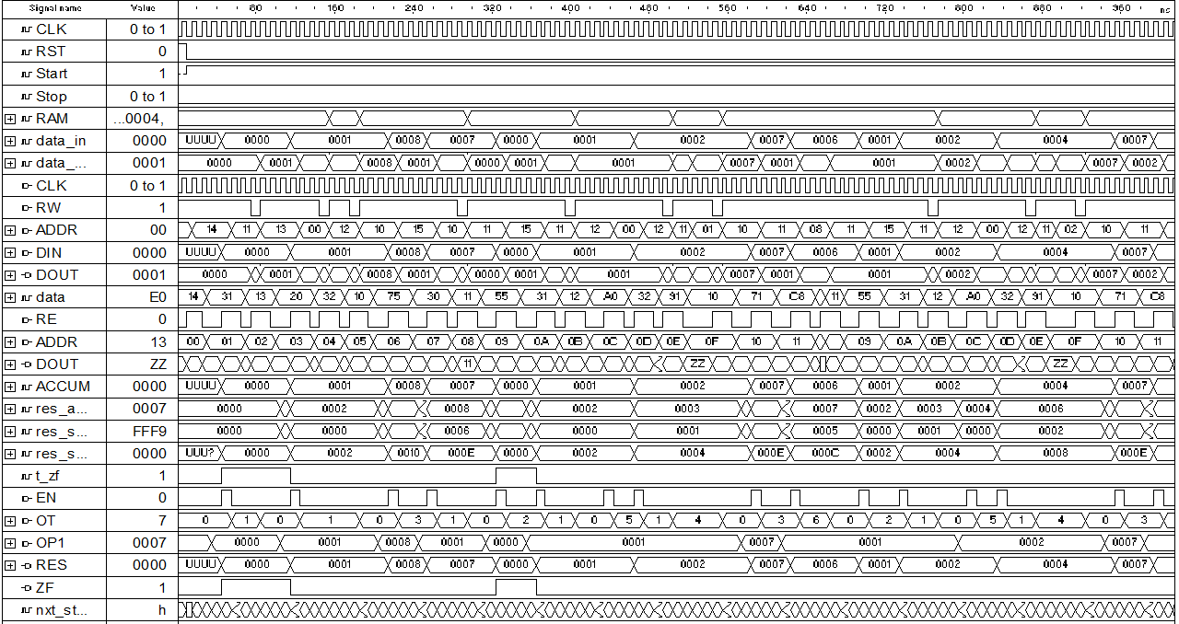
- Анализ аппаратурных и временные затрат
  - Аппаратные затраты (Cyclone 10CL006YU256I7G / Inter Quartus Prime 17.1 Lite)
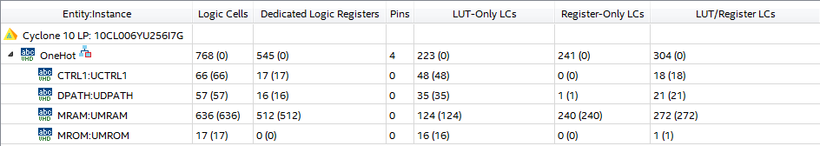
  - Временные затраты
Для генерации 8 элементов “One-Hot” последовательности требуется 290 тактов синхронизации.
- Выводы
GPR
- Описание ISA

Мнемоника | Код операции (3 бита) | Операнд #1 (5 бит) | Операнд #2 (5 бит) | Операнд #3 (5 бит)
ADD | 000 | aaaaa | aaaaa | aaaaa
SUBT | 010 | aaaaa | aaaaa | aaaaa
SHIFT | 011 | aaaaa | xxxxx | aaaaa
JNZ | 100 | aaaaa | xxxxx | xxxxxx
COPY | 101 | aaaaa | aaaaa | xxxxxx
HALT | 111 | xxxxx | xxxxx | xxxxx

ADD addr1, addr2, addr3 – сложение значений хранящегося по адресу addr1 и addr2, результат записывается по адресу addr3
SUBT addr1, addr2, addr3 – вычитание из значений хранящегося по адресу addr1 значение хранящееся по адресу addr2, результат записывается по адресу addr3
SHIFT addr1, addr3 – логический сдвиг вправо значения хранящегося по адресу addr1, результат записывается по адресу addr3
JNZ addr1 – переход на операции по адресу addr1, при сброшенном флаге нуля
COPY addr1, adde3 – пересылка значения хранящегося по адресу addr1 по адресу хранящемуся по адресу addr3.
HALT - останова

- Микропрограмма

constant STUB: mem_addr := "00000";
constant LENGTH: mem_addr := "10000";
constant COUNTER: mem_addr := "10001";
constant CURRENT_VALUE: mem_addr := "10010";
constant DATA_START: mem_addr := "00000";
constant INIT_VALUE: mem_addr := "10011";
constant ZERO: mem_addr := "10100";
constant ONE: mem_addr := "10101";
constant EMPTY_SPACE: mem_addr := "10110";
constant LOOP_ADDR: mem_addr := "00100";
--------------
ADD & ZERO & INIT_VALUE & DATA_START,
ADD & ZERO & INIT_VALUE & CURRENT_VALUE,
ADD & ZERO & ZERO & COUNTER,
SUBT & LENGTH & ONE & LENGTH,
ADD & COUNTER & ONE & COUNTER,
SHIFT & CURRENT_VALUE & STUB & CURRENT_VALUE,
COPY & CURRENT_VALUE & COUNTER & STUB,
SUBT & LENGTH & COUNTER & EMPTY_SPACE,
JNZ & LOOP_ADDR & STUB & STUB

- Общая структурная схема
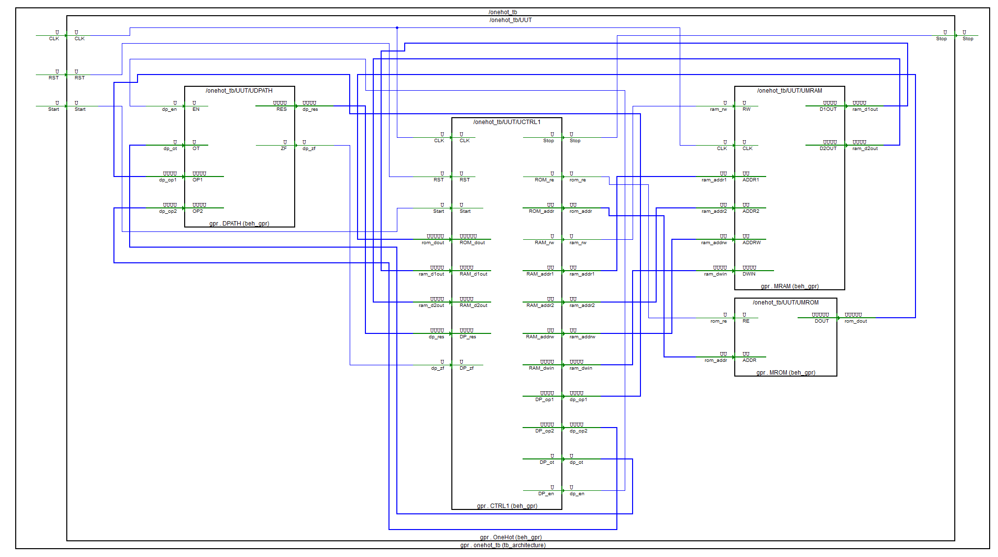

- Описание микроархитектуры

- Block Level
  - Блок MROM
    - HDL
library IEEE;
use IEEE.STD_LOGIC_1164.all;
use IEEE.STD_LOGIC_UNSIGNED.all;
library gpr;
use gpr.OneHotGPR.all;

entity MROM is
port (
RE: in std_logic;
ADDR: in mem_addr;
DOUT: out command
);
end MROM;

architecture Beh_GPR of MROM is
type tROM is array (0 to 31) of command;
constant STUB: mem_addr := "00000";
constant LENGTH: mem_addr := "10000";
constant COUNTER: mem_addr := "10001";
constant CURRENT_VALUE: mem_addr := "10010";
constant DATA_START: mem_addr := "00000";
constant INIT_VALUE: mem_addr := "10011";
constant ZERO: mem_addr := "10100";
constant ONE: mem_addr := "10101";
constant EMPTY_SPACE: mem_addr := "10110";
constant LOOP_ADDR: mem_addr := "00100";

constant ROM: tROM :=(
-- OP CODE | OP1 | OP2 | RESULT
-- Init
ADD & ZERO & INIT_VALUE & DATA_START,
ADD & ZERO & INIT_VALUE & CURRENT_VALUE,
ADD & ZERO & ZERO & COUNTER,
SUBT & LENGTH & ONE & LENGTH,
-- Loop
ADD & COUNTER & ONE & COUNTER,
SHIFT & CURRENT_VALUE & STUB & CURRENT_VALUE,
COPY & CURRENT_VALUE & COUNTER & STUB,
SUBT & LENGTH & COUNTER & EMPTY_SPACE,
JNZ & LOOP_ADDR & STUB & STUB,
others => HALT & STUB & STUB & STUB
);

signal data: command;
begin
data <= ROM(conv_integer(ADDR));

zbufs: process (RE, data)
begin
if (RE = '1') then
DOUT <= data;
else
DOUT <= (others => 'Z');
end if;
end process;
end Beh_GPR;

    - TestBench

library gpr;
use gpr.OneHotGPR.all;
library ieee;
use ieee.STD_LOGIC_UNSIGNED.all;
use ieee.std_logic_1164.all;

-- Add your library and packages declaration here ...

entity mrom_tb is
end mrom_tb;

architecture TB_ARCHITECTURE of mrom_tb is
-- Component declaration of the tested unit
component mrom
port(
RE : in STD_LOGIC;
ADDR : in mem_addr;
DOUT : out command );
end component;

signal RE : STD_LOGIC;
signal ADDR : mem_addr;
signal DOUT : command;
constant WAIT_period: time := 10 ns;

begin

-- Unit Under Test port map
UUT : mrom
port map (
RE => RE,
ADDR => ADDR,
DOUT => DOUT
);

-- Add your stimulus here ...

main: process
begin
re <= '0';
addr <= "00010";
wait for WAIT_period;
re <= '1';
wait for WAIT_period;
addr <= "00000";
re <= '1';
wait for WAIT_period;
re <= '0';
wait for WAIT_period;
wait;
end process;
end TB_ARCHITECTURE;

configuration TESTBENCH_FOR_mrom of mrom_tb is
for TB_ARCHITECTURE
for UUT : mrom
use entity work.mrom(beh_gpr);
end for;
end for;
end TESTBENCH_FOR_mrom;

    - Временные диаграммы функционирования

  - Блок MRAM
    - HDL
library IEEE;
use IEEE.STD_LOGIC_1164.all;
use IEEE.STD_LOGIC_UNSIGNED.all;
library gpr;
use gpr.OneHotGPR.all;

entity MRAM is
port(
-- 0 - write; 1 - read
RW: in std_logic;
CLK: in std_logic;
-- address for the first operand
ADDR1: in mem_addr;
-- address for the second operand
ADDR2: in mem_addr;
-- address to write
ADDRW: in mem_addr;
-- first operand
D1OUT: out operand;
-- second operand
D2OUT: out operand;
-- data to write
DWIN: in operand
);
end MRAM;

architecture Beh_GPR of MRAM is
type tRAM is array (0 to 31) of operand;
signal RAM: tRAM:= (
-- | VALUE BIN | ADR BIN | CONST NAME |
"0000000000000000", -- | 00000 | STUB, ADDR_DATA_START |
"0000000000000000", -- | 00001 | |
"0000000000000000", -- | 00010 | |
"0000000000000000", -- | 00011 | |
"0000000000000000", -- | 00100 | |
"0000000000000000", -- | 00101 | |
"0000000000000000", -- | 00110 | |
"0000000000000000", -- | 00111 | |
"0000000000000000", -- | 01000 | |
"0000000000000000", -- | 01001 | |
"0000000000000000", -- | 01010 | |
"0000000000000000", -- | 01011 | |
"0000000000000000", -- | 01100 | |
"0000000000000000", -- | 01101 | |
"0000000000000000", -- | 01110 | |
"0000000000000000", -- | 01111 | |
"0000000000001000", -- | 10000 | ADDR_LENGTH |
"0000000000000000", -- | 10001 | ADDR_COUNTER |
"0000000000000000", -- | 10010 | ADDR_CURRENT_VALUE |
"0000000000000001", -- | 10011 | ADDR_INIT_VALUE |
"0000000000000000", -- | 10100 | ADDR_ZERO |
"0000000000000001", -- | 10101 | ADDR_ONE |
"0000000000000000", -- | 10110 | EMPTY_SPACE |
others => "0000000000000000"
);

signal data_win: operand;
signal data_1out: operand;
signal data_2out: operand;
Begin
data_win <= DWIN;
WRITE: process(CLK)
begin
if (rising_edge(CLK)) then
if (RW = '0') then
RAM(conv_integer(ADDRW)) <= data_win;
end if;
end if;
end process;

data_1out <= RAM (conv_integer(ADDR1));
data_2out <= RAM (conv_integer(ADDR2));

READ: process(CLK)
begin
if (rising_edge(CLK)) then
if (RW = '1') then
D1OUT <= data_1out;
D2OUT <= data_2out;
else
D1OUT <= (others => 'Z');
D2OUT <= (others => 'Z');
end if;
end if;
end process;
End Beh_GPR;
    - TestBench
library gpr;
use gpr.OneHotGPR.all;
library ieee;
use ieee.STD_LOGIC_UNSIGNED.all;
use ieee.std_logic_1164.all;

entity mram_tb is
end mram_tb;

architecture TB_ARCHITECTURE of mram_tb is
component mram
port(
RW : in STD_LOGIC;
CLK : in STD_LOGIC;
ADDR1 : in mem_addr;
ADDR2 : in mem_addr;
ADDRW : in mem_addr;
D1OUT : out operand;
D2OUT : out operand;
DWIN : in operand );
end component;

signal RW : STD_LOGIC;
signal CLK : STD_LOGIC;
signal ADDR1 : mem_addr;
signal ADDR2 : mem_addr;
signal ADDRW : mem_addr;
signal DWIN : operand;
signal D1OUT : operand;
signal D2OUT : operand;
constant CLK_period: time := 10 ns;
begin

-- Unit Under Test port map
UUT : mram
port map (
RW => RW,
CLK => CLK,
ADDR1 => ADDR1,
ADDR2 => ADDR2,
ADDRW => ADDRW,
D1OUT => D1OUT,
D2OUT => D2OUT,
DWIN => DWIN
);

CLK_Process: process
begin
CLK <= '0';
wait for CLK_Period/2;
CLK <= '1';
wait for CLK_Period/2;
end process;

main: process
begin
wait for CLK_PERIOD;
addrw <= "00010";
dwin <= "0000000000000100";
wait for CLK_PERIOD;
addr1 <= "00001";
addr2 <= "00010";
rw <= '1';
wait for CLK_PERIOD;
addrw <= "00000";
dwin <= "0000000000010000";
rw <= '0';
wait for CLK_PERIOD;
wait;
end process;

end TB_ARCHITECTURE;

configuration TESTBENCH_FOR_mram of mram_tb is
for TB_ARCHITECTURE
for UUT : mram
use entity work.mram(beh_gpr);
end for;
end for;
end TESTBENCH_FOR_mram;

    - Временные диаграммы функционирования
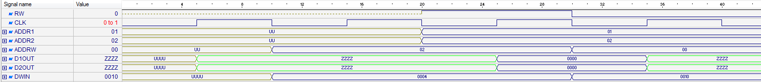

  - Блок CTRL
    - HDL
library IEEE;
use IEEE.STD_LOGIC_1164.all;
use IEEE.STD_LOGIC_UNSIGNED.all;
library gpr;
use gpr.OneHotGPR.all;

entity CTRL1 is
port(
CLK, RST, Start: in std_logic;
Stop: out std_logic;
ROM_re: out std_logic;
ROM_addr: out mem_addr;
ROM_dout: in command;
RAM_rw: out std_logic;
RAM_addr1: out mem_addr;
RAM_addr2: out mem_addr;
RAM_addrw: out mem_addr;
RAM_dwin: out operand;
RAM_d1out: in operand;
RAM_d2out: in operand;

--datapath
DP_op1: out operand;
DP_op2: out operand;
DP_ot: out operation;
DP_en: out std_logic;
DP_res: in operand;
DP_zf: in std_logic
);
end CTRL1;

architecture Beh_GPR of CTRL1 is
type states is (I, F, D, R, W, A, SB, SH, H, M, CP, CPR, JNOTZ);
signal nxt_state, cur_state: states;
-- instruction register
signal RI: std_logic_vector(17 downto 0);
-- instruction counter
signal IC: mem_addr;
-- operation type register
signal RO: std_logic_vector(2 downto 0);
-- memory address register for the first operand
signal RA_1: mem_addr;
-- memory address register for the second operand
signal RA_2: mem_addr;
-- memory address register for the result
signal RA_W: mem_addr;
-- data register for the first operand
signal RD_1: operand;
-- data register for the second operand
signal RD_2: operand;
-- data register for the result
signal RD_W: operand;
begin
-- synchronous memory
FSM: process(CLK, RST, nxt_state)
begin
if (RST = '1') then
cur_state <= I;
elsif rising_edge(CLK) then
cur_state <= nxt_state;
end if;
end process;

-- Next state
COMB: process(cur_state, start, RO)
begin
case cur_state is
when I =>
if (start = '1') then
nxt_state <= F;
else
nxt_state <= I;
end if;
when F => nxt_state <= D;
when D =>
if (RO = HALT) then
nxt_state <= H;
elsif (RO = JNZ) then
nxt_state <= JNOTZ;
else
nxt_state <= R;
end if;
when R =>
if (RO = ADD) then
nxt_state <= A;
elsif (RO = SUBT) then
nxt_state <= SB;
elsif (RO = SHIFT) then
nxt_state <= SH;
elsif (RO = COPY) then
nxt_state <= CP;
else
nxt_state <= I;
end if;
when CP => nxt_state <= CPR;
when CPR => nxt_state <= M;
when A | SB | SH | M => nxt_state <= W;
when W | JNOTZ => nxt_state <= F;
when H => nxt_state <= H;
when others => nxt_state <= I;
end case;
end process;

-- stop signal handler
PSTOP: process (cur_state)
begin
if (cur_state = H) then
stop <= '1';
else
stop <= '0';
end if;
end process;

-- instruction counter
PMC: process (CLK, RST, cur_state)
begin
if (RST = '1') then
IC <= (others => '0');
elsif falling_edge(CLK) then
if (cur_state = D) then
IC <= IC + 1;
elsif (cur_state = JNOTZ and DP_ZF = '0') then
IC <= RA_1;
end if;
end if;
end process;
ROM_addr <= IC;

-- reading from ROM
PROMREAD: process (nxt_state, cur_state)
begin
if (nxt_state = F or cur_state = F) then
ROM_re <= '1';
else
ROM_re <= '0';
end if;
end process;

-- reading the instruction from ROM and put it into RI
PROMDAT: process (RST, cur_state, ROM_dout)
begin
if (RST = '1') then
RI <= (others => '0');
elsif (cur_state = F) then
RI <= ROM_dout;
end if;
end process;

-- fill RO and RA_1, RA_2, RA_W registers
PRORA: process (RST, nxt_state, RI)
begin
if (RST = '1') then
RO <= (others => '0');
RA_1 <= (others => '0');
RA_2 <= (others => '0');
RA_W <= (others => '0');
elsif (nxt_state = D) then
RO <= RI (17 downto 15);
RA_1 <= RI (14 downto 10);
RA_2 <= RI (9 downto 5);
RA_W <= RI (4 downto 0);
elsif (nxt_state = CP) then
RA_2 <= RD_2 (4 downto 0);
elsif (nxt_state = CPR) then
RA_W <= RA_2;
end if;
end process;

PRAMST: process (RA_1, RA_2, RA_W)
begin
if (cur_state /= JNOTZ) then
RAM_addr1 <= RA_1;
RAM_addr2 <= RA_2;
RAM_addrw <= RA_W;
end if;
end process;

-- control read/write signal for RAM
PRAMREAD: process (cur_state)
begin
if (cur_state = W) then
RAM_rw <= '0';
else
RAM_rw <= '1';
end if;
end process;

-- read values from RAM and store them in RD_1 and RD_2 registers
PRAMDAR: process (cur_state)
begin
if (cur_state = R) then
RD_1 <= RAM_d1out;
RD_2 <= RAM_d2out;
end if;
end process;

-- pass the value from data path to RAM data bus
RAM_dwin <= DP_res;
-- pass the value from RD_1 register to the data path first operand
DP_op1 <= RD_1;
-- pass the value from RD_2 register to the data path second operand
DP_op2 <= RD_2;
-- pass the value from RO register to the data path operation type
DP_ot <= RO;

paddsuben: process (cur_state)
begin
if (cur_state = A or cur_state = SB or cur_state = SH or cur_state = M) then
DP_en <= '1';
else
DP_en <= '0';
end if;
end process;
end Beh_GPR;

    - TestBench
library accum;
use accum.OneHotAccum.all;
library ieee;
use ieee.STD_LOGIC_UNSIGNED.all;
use ieee.std_logic_1164.all;

entity ctrl1_tb is
end ctrl1_tb;

architecture TB_ARCHITECTURE of ctrl1_tb is

component MROM is
port (
RE: in std_logic;
ADDR: in mem_addr;
DOUT: out command
);
end component;

component MRAM is
port (
CLK: in std_logic;
RW: in std_logic;
ADDR: in mem_addr;
DIN: in operand;
DOUT: out operand
);
end component;

component DPATH is
port(
EN: in std_logic;
OT: in operation;
OP1 : in operand;
RES: out operand;
ZF: out std_logic
);
end component;

component ctrl1
port(
CLK : in STD_LOGIC;
RST : in STD_LOGIC;
Start : in STD_LOGIC;
Stop : out STD_LOGIC;
ROM_re : out STD_LOGIC;
ROM_addr : out mem_addr;
ROM_dout : in command;
RAM_rw : out STD_LOGIC;
RAM_addr : out mem_addr;
RAM_din : out operand;
RAM_dout : in operand;
DP_op1 : out operand;
DP_ot : out operation;
DP_en : out STD_LOGIC;
DP_res : in operand;
DP_zf : in STD_LOGIC );
end component;

signal CLK : STD_LOGIC;
signal RST : STD_LOGIC;
signal Start : STD_LOGIC;
signal ROM_dout : command;
signal RAM_dout : operand;
signal DP_res : operand;
signal DP_zf : STD_LOGIC;
signal Stop : STD_LOGIC;
signal ROM_re : STD_LOGIC;
signal ROM_addr : mem_addr;
signal RAM_rw : STD_LOGIC;
signal RAM_addr : mem_addr;
signal RAM_din : operand;
signal DP_op1 : operand;
signal DP_ot : operation;
signal DP_en : STD_LOGIC;
constant CLK_period: time := 10 ns;

begin

UMRAM: MRAM
port map(
CLK => CLK,
RW => ram_rw,
ADDR => ram_addr,
DIN => ram_din,
DOUT => ram_dout
);
UMROM: MROM
port map (
RE => rom_re,
ADDR => rom_addr,
DOUT => rom_dout
);
UDPATH: DPATH
port map(
EN => dp_en,
OT => dp_ot,
OP1 => dp_op1,
RES => dp_res,
ZF => dp_zf
);
UCTRL1: CTRL1
port map(
CLK => CLK,
RST => RST,
START => Start,
STOP => STOP,
ROM_RE => rom_re,
ROM_ADDR => rom_addr,
ROM_DOUT => rom_dout,
RAM_RW => ram_rw,
RAM_ADDR => ram_addr,
RAM_DIN => ram_din,
RAM_DOUT => ram_dout,
DP_EN => dp_en,
DP_OT => dp_ot,
DP_OP1 => dp_op1,
DP_RES => dp_res,
DP_ZF => dp_zf
);

UUT : ctrl1
port map (
CLK => CLK,
RST => RST,
Start => Start,
Stop => Stop,
ROM_re => ROM_re,
ROM_addr => ROM_addr,
ROM_dout => ROM_dout,
RAM_rw => RAM_rw,
RAM_addr => RAM_addr,
RAM_din => RAM_din,
RAM_dout => RAM_dout,
DP_op1 => DP_op1,
DP_ot => DP_ot,
DP_en => DP_en,
DP_res => DP_res,
DP_zf => DP_zf
);

CLK_Process: process
begin
CLK <= '0';
wait for CLK_Period/2;
CLK <= '1';
wait for CLK_Period/2;
end process;

main: process
begin
rst <= '1';
wait for CLK_PERIOD;
rst <= '0';
start <= '1';
wait for 100 * CLK_PERIOD;
wait;
end process;

end TB_ARCHITECTURE;

configuration TESTBENCH_FOR_ctrl1 of ctrl1_tb is
for TB_ARCHITECTURE
for UUT : ctrl1
use entity work.ctrl1(beh);
end for;
end for;
end TESTBENCH_FOR_ctrl1;

    - Временные диаграммы функционирования
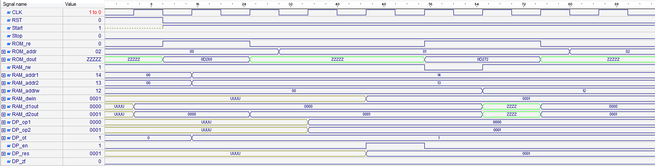

  - Блок DPATH
    - HDL
library IEEE;
use IEEE.STD_LOGIC_1164.all;
use IEEE.STD_LOGIC_ARITH.all;
use IEEE.STD_LOGIC_UNSIGNED.all;
library gpr;
use gpr.OneHotGPR.all;

entity DPATH is
port(
EN: in std_logic;
OT: in operation;
OP1: in operand;
OP2: in operand;
RES: out operand;
ZF: out std_logic
);
end DPATH;

architecture Beh_GPR of DPATH is
signal res_g: operand;
signal res_add: operand;
signal res_sub: operand;
signal res_shift: operand;
signal res_copy: operand;
signal t_zf: std_logic;
Begin
res_add <= CONV_STD_LOGIC_VECTOR(CONV_INTEGER(OP1) + CONV_INTEGER(OP2), 16);
res_sub <= CONV_STD_LOGIC_VECTOR(CONV_INTEGER(OP1) - CONV_INTEGER(OP2), 16);
res_shift <= OP1(14 downto 0) & '0';
res_copy <= OP1;

REGA: process (EN, OT, OP1, res_add, res_sub, res_shift, res_copy)
begin
if rising_edge(EN) then
case OT is
when ADD => res_g <= res_add;
when SUBT => res_g <= res_sub;
when SHIFT => res_g <= res_shift;
when COPY => res_g <= res_copy;
when others => null;
end case;
end if;
end process;

FLAGS: process(res_g)
begin
if res_g = (res_g'range => '0') then
t_zf <= '1';
else
t_zf <= '0';
end if;
end process;

RES <= res_g;
ZF <= t_zf;
End Beh_GPR;

    - TestBench
library gpr;
use gpr.OneHotGPR.all;
library ieee;
use ieee.STD_LOGIC_UNSIGNED.all;
use ieee.std_logic_1164.all;
use ieee.std_logic_arith.all;

entity dpath_tb is
end dpath_tb;

architecture TB_ARCHITECTURE of dpath_tb is
component dpath
port(
EN : in STD_LOGIC;
OT : in operation;
OP1 : in operand;
OP2 : in operand;
RES : out operand;
ZF : out STD_LOGIC );
end component;

signal EN : STD_LOGIC;
signal OT : operation;
signal OP1 : operand;
signal OP2 : operand;
signal RES : operand;
signal ZF : STD_LOGIC;
constant WAIT_period: time := 10 ns;
begin

UUT : dpath
port map (
EN => EN,
OT => OT,
OP1 => OP1,
OP2 => OP2,
RES => RES,
ZF => ZF
);

MAIN: process
begin
en <= '1';
wait for WAIT_period;
en <= '0';
op1 <= "0000000000000010";
op2 <= "0000000000000010";
ot <= ADD;
wait for WAIT_period;
en <= '1';
wait for WAIT_period;
en <= '0';
op1 <= "0000000000000010";
op2 <= "0000000000000010";
ot <= SUBT;
wait for WAIT_period;
en <= '1';
wait for WAIT_period;
en <= '0';
op1 <= "0000000000010010";
ot <= SHIFT;
wait for WAIT_period;
en <= '1';
wait for WAIT_period;
en <= '0';
op1 <= "0000000001010010";
ot <= COPY;
wait for WAIT_period;
en <= '1';
wait for WAIT_period;
en <= '0';
wait for WAIT_period;
wait;
end process;
end TB_ARCHITECTURE;
configuration TESTBENCH_FOR_dpath of dpath_tb is
for TB_ARCHITECTURE
for UUT : dpath
use entity work.dpath(beh_gpr);
end for;
end for;
end TESTBENCH_FOR_dpath;

    - Временные диаграммы функционирования

- System Level
  - HDL
library IEEE;
use IEEE.STD_LOGIC_1164.all;
use IEEE.STD_LOGIC_UNSIGNED.all;
library accum;
use accum.OneHotAccum.all;
entity OneHot is
port (
CLK, RST, Start: in std_logic;
Stop: out std_logic
);
end OneHot;

architecture Beh of OneHot is
component MROM is
port (
RE: in std_logic;
ADDR: in mem_addr;
DOUT: out command
);
end component;

component MRAM is
port (
CLK: in std_logic;
RW: in std_logic;
ADDR: in mem_addr;
DIN: in operand;
DOUT: out operand
);
end component;
component DPATH is
port(
EN: in std_logic;
OT: in operation;
OP1 : in operand;
RES: out operand;
ZF: out std_logic
);
end component;

component CTRL1 is
port(
CLK, RST, Start: in std_logic;
Stop: out std_logic;
ROM_re: out std_logic;
ROM_addr: out mem_addr;
ROM_dout: in command;
RAM_rw: out std_logic;
RAM_addr: out mem_addr;
RAM_din: out operand;
RAM_dout: in operand;
DP_op1: out operand;
DP_ot: out operation;
DP_en: out std_logic;
DP_res: in operand;
DP_zf: in std_logic
);
end component;

signal rom_re: std_logic;
signal rom_addr: mem_addr;
signal rom_dout: command;
signal ram_rw: std_logic;
signal ram_addr: mem_addr;
signal ram_din: operand;
signal ram_dout: operand;
signal dp_op1: operand;
signal dp_ot: operation;
signal dp_en: std_logic;
signal dp_res: operand;
signal dp_zf: std_logic;
begin
UMRAM: MRAM
port map(
CLK => CLK,
RW => ram_rw,
ADDR => ram_addr,
DIN => ram_din,
DOUT => ram_dout
);
UMROM: MROM
port map (
RE => rom_re,
ADDR => rom_addr,
DOUT => rom_dout
);
UDPATH: DPATH
port map(
EN => dp_en,
OT => dp_ot,
OP1 => dp_op1,
RES => dp_res,
ZF => dp_zf
);
UCTRL1: CTRL1
port map(
CLK => CLK,
RST => RST,
START => Start,
STOP => STOP,
ROM_RE => rom_re,
ROM_ADDR => rom_addr,
ROM_DOUT => rom_dout,
RAM_RW => ram_rw,
RAM_ADDR => ram_addr,
RAM_DIN => ram_din,
RAM_DOUT => ram_dout,
DP_EN => dp_en,
DP_OT => dp_ot,
DP_OP1 => dp_op1,
DP_RES => dp_res,
DP_ZF => dp_zf
);
end Beh;

  - Test Bench
library ieee;
use ieee.STD_LOGIC_UNSIGNED.all;
use ieee.std_logic_1164.all;

entity onehot_tb is
end onehot_tb;

architecture TB_ARCHITECTURE of onehot_tb is
component onehot
port(
CLK : in STD_LOGIC;
RST : in STD_LOGIC;
Start : in STD_LOGIC;
Stop : out STD_LOGIC );
end component;

signal CLK : STD_LOGIC;
signal RST : STD_LOGIC;
signal Start : STD_LOGIC;
signal Stop : STD_LOGIC;
constant CLK_period: time := 10 ns;
begin
UUT : onehot
port map (
CLK => CLK,
RST => RST,
Start => Start,
Stop => Stop
);
CLK_Process: process
begin
CLK <= '0';
wait for CLK_Period/2;
CLK <= '1';
wait for CLK_Period/2;
end process;

main: process
begin
rst <= '1';
wait for 1 * CLK_PERIOD;
rst <= '0';
start <= '1';
wait for 100 * CLK_PERIOD;
wait;
end process;
end TB_ARCHITECTURE;

configuration TESTBENCH_FOR_onehot of onehot_tb is
for TB_ARCHITECTURE
for UUT : onehot
use entity work.onehot(beh);
end for;
end for;
end TESTBENCH_FOR_onehot;

  - Временные диаграммы функционирования
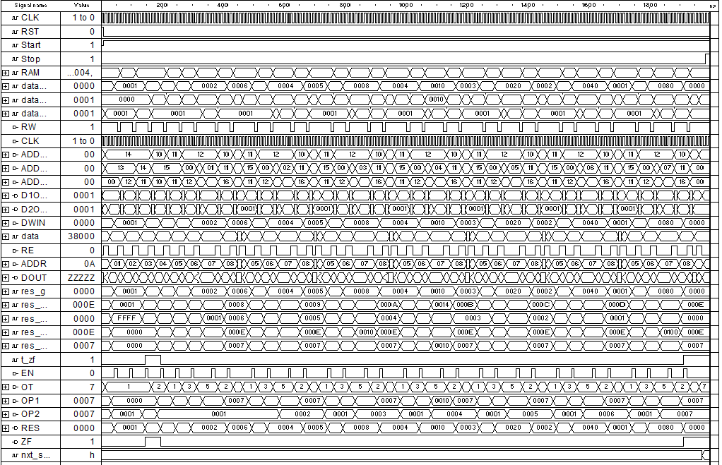
- Анализ аппаратурных и временные затрат
  - Аппаратные затраты (Cyclone 10CL006YU256I7G / Inter Quartus Prime 17.1 Lite)
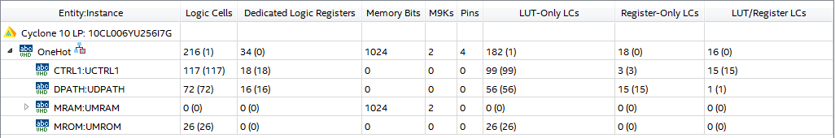
  - Временные затраты
Для генерации 8 элементов “One-Hot” последовательности требуется 198 тактов синхронизации.
- Выводы

