Manual Implementation:

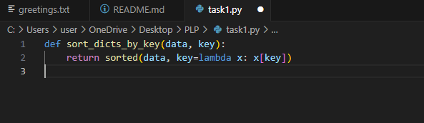

GitHub Copilot Version:

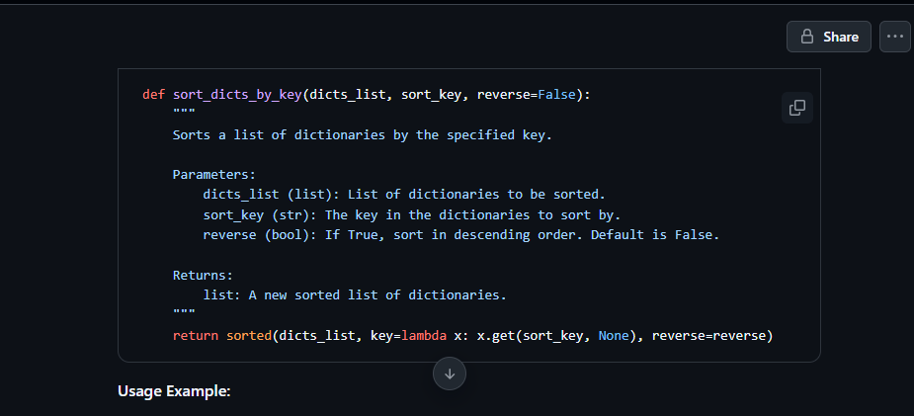

GitHub Copilot suggested an enhanced version of the dictionary sorting function by incorporating default-safe access using. get() and adding a detailed docstring. This version is more robust because it gracefully handles cases where the sort_key might be missing in some dictionaries, preventing potential runtime errors like KeyError that could occur in the manual version using direct indexing (x[sort_key]).

Additionally, the inclusion of the reverse parameter and its explanation in the docstring demonstrates Copilot’s capability to infer common usage patterns and add flexibility to the function. The use of .get(sort_key, None) allows the function to still work even when some dictionaries don’t contain the key, though this could introduce sorting inconsistencies if None values are present.

The Copilot version saved time by automatically generating boilerplate code, including documentation, which is a valuable benefit during rapid development. However, developers must review AI-suggested code to ensure it aligns with their intent—especially when silent handling of errors (e.g., missing keys) may introduce subtle bugs.

Overall, the Copilot-generated version is safer and more readable, especially in collaborative or production environments where error tolerance and clarity are essential.