**The Task is to write a program to extract and visualize course relations in the**

**Northeastern dynamic search site, i.e which course has which Prerequisites /Core requisites**

**The following is an example output, based on all courses for Computer Science Undergrad .". . .** 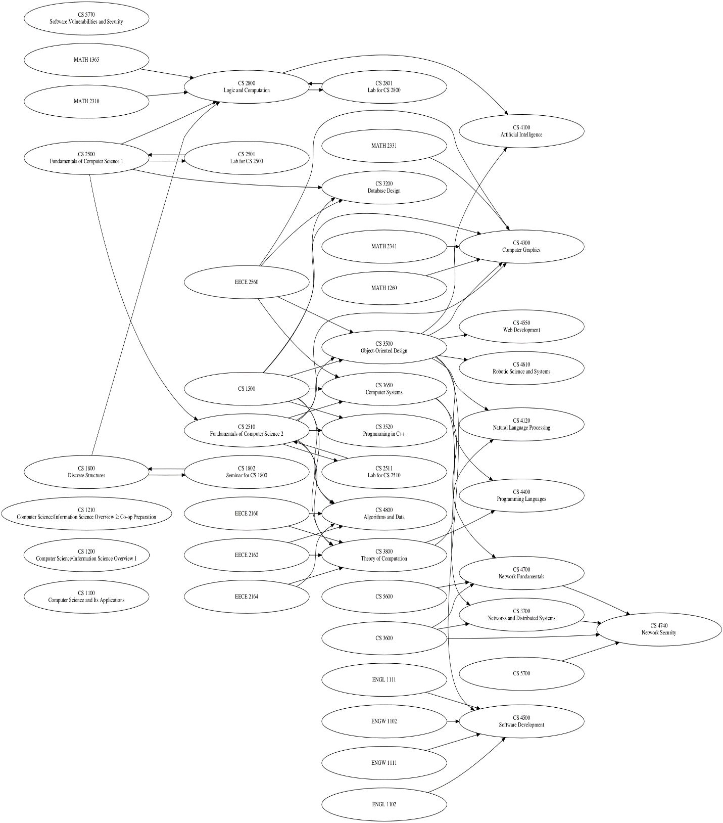

**How to Run the File:**

**courses (--level)* (--instructor)* (--subject)* [--course] <term code>**

Examples:

**courses.py --level "Graduate" "Undergraduate" --instructor "Rajaraman, Rajmohan" --subject "Computer Science - CS" "Fall 2017 Semester"  
  
  
courses.py --level "Graduate" --instructor "Rajaraman, Rajmohan" --subject "Computer Science - CS" "Fall 2017 Semester"  
  
courses.py --level "GR" --instructor "Rajaraman, Rajmohan" --subject "CS" "Fall 2017 Semester"**