

**Symbiosis Institute of Technology**

**A SE Project Report on**

Covid 19 database access website

Submitted by

**Aayushi Verma-18070124003**

**Isha Patil-18070124031**

**Tanvi Pathak-18070124072**

Under the Guidance of

**Prof. Preeti Mulay**

# Department of Information Technology

**SYMBIOSIS INSTITUTE OF TECHNOLOGY, PUNE**

**INDEX**

|  |  |  |
| --- | --- | --- |
|  | Topic | Page Number |
| 1. | **Introduction** |  |
| 1.1 | Purpose | 2 |
| 1.2 | Project Scope | 3 |
| 1.3 | References | 4 |
| 1.4 | Motivation | 5 |
| 1.5 | Timeline | 6 |
| 1.6 | Feasibility Study | 7 |
| 1.7 | SDLC Model | 8 |
| 2. | **Overall Description** |  |
| 2.1 | Product Perspective | 9 |
| 2.2 | Product Feature | 10 |
| 2.3 | Data flow diagrams | 11 |
| 2.4 | Use Case | 13 |
| 2.5 | Use Case Diagram | 14 |
| 2.6 | Context Diagram | 15 |
| 2.7 | Activity Diagram | 16 |
| 2.8 | Mind Map | 17 |
| 3. | **Features** |  |
| 3.1 | Functional Requirements | 18 |
| 3.2 | Non-Functional Requirements | 19 |
| 3.3 | Platform | 20 |

***1. INTRODUCTION***

**1.1 PURPOSE**

The purpose of this document is to build a covid-19 statistics database based website.

Using this website, the covid-19 statistics for active cases, deaths and recovered can be seen. This website will include a user friendly website for better access of the given data, in addition to the previously specified python based dash board. Our project will include a frontend, backend along with the dashboard using languages such as python, dash, node.js, CSS and HTML.

Instead of using a database, we will be making use of an open sourced API for accurate data retrieval.

**1.2 PROJECT SCOPE**

This covid 19 statistics website will be giving a comprehensive overview of the latest corona virus statistics with the greatest accuracy. The main use that this website will have is to give the corona virus statistics for active cases, recovered and deaths for all over the world.

This website will also give information regarding specific countries.

There also will be graphs signifying 10 top worst hit countries in general but also specific with respect to deaths, recovered and active cases.

**1.3 REFERENCES**

We took inspiration from the open source website <https://www.covid19india.org/>.

For technology related information to gain more knowledge, we did courses on Coursera and Udemy. We also referred to educational websites like geeksforgeeks, javapoint and tutorial point.

**1.4 MOTIVATION**

Motivation - This project is aimed at imparting information regarding the pandemic situation in the state of World in a user friendly and logical manner.

It is scientifically proven that human brain is better at retaining and processing visual information. This combined with user interactivity will quadruple the power of understanding the data and the scenario.

This project also enabled us to apply the knowledge we gained due to the pandemic given free time in a real time project. This has thus motivated us to learn new technologies and find better solutions to pre existing problems.

**1.5 TIMELINE**

Timeline of the project:

The estimated number of lines of code for this project is **5KLOC**. This figure is merely a ballpark mark of our project. We have chosen number in accordance to similar projects we found online and a rough estimate from our side. Since we haven’t started coding, this number is most likely an arbitrary value which will be modified as the project goes on.

**1.5 FEASIBILITY STUDY**

* Technical Feasibility - The project can be implemented using locally using Apache and Ngrok. Globally, it can be implemented for free using heruko web hosting.
* Economic Feasibility- As the project is very small scale, it is extremely economically feasible. The only cost that we may come across will be for web hosting.
* Operational Feasibility- We are aware of data analysis and data visualization basics and will follow a reverse engineering technique for gaining more skills as we go. We also have fair backend knowledge, using django.

**1.6 SDLC MODEL**

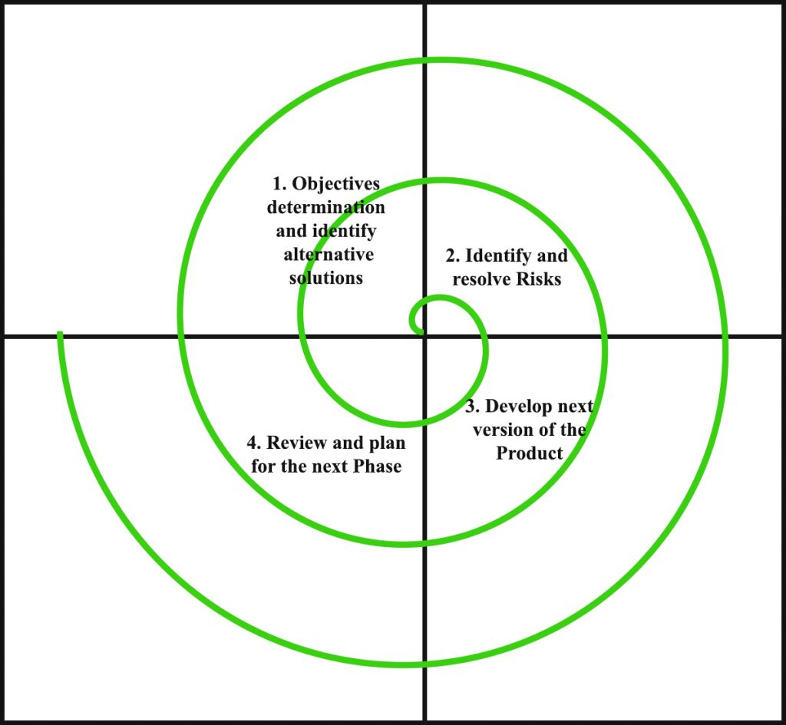

We have decided to implement the Spiral Model. We specifically chose this model for the dynamic nature of the programming it supports and the flexibility it provides. The Spiral Model has regular risk assessment which is an asset for our project given the fact that data analysis is dynamic in nature. Though the three of us took separate domains of the project to work on but to give the final resultant, it is very important for regular review and planning ahead as the three phases work on top of each other.

Spiral Model also gives us enough flexibility to go back and change something because it supports versions of projects. This aspect is important for the integration part of our project. The goal is to integrate the Jupiter notebook code to Django and then using HTML, CSS and JS, build a dynamic website.

***2. OVERALL DESCRIPTION***

**2.1 PRODUCT PERSPECTIVE**

Our website will have daily updated database of covid 19. This includes:

* Country wide statistics : Our website will have a map of the world, with circles showing the values namely:
  + Deaths
  + Recovered Cases
  + Active Cases
  + Total Cases
* Information pertaining to top 10 nations with the worst cases with regards to
  + Deaths
  + Recovered Cases
  + Active Cases
  + Total Cases
* We have also assembled the data to look as User friendly as possible with the use of tables as well as Graphs and Maps.

**2.2 PRODUCT FEATURE**

* User-friendly UI and UX to ensure best possible navigation of information for the user.
* The interface is designed keeping things as simple as possible and yet giving the information in a concise way.
* Smooth transitions between different countries using the Map feature which provides a pictorial representation which is more convenient as compared to Tables and Passages of information.
* Correct information to be displayed using tables, graphs and maps as and when needed.
* Careful usage of picture based representation for a much friendlier interface.

**2.3 DATA FLOW DIAGRAMS**

**Level 0 DFD Model:**

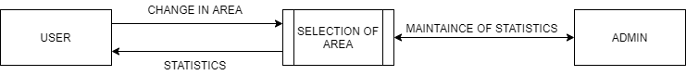

**Level 1 DFD Model:**

**Level 2 DFD Model:**

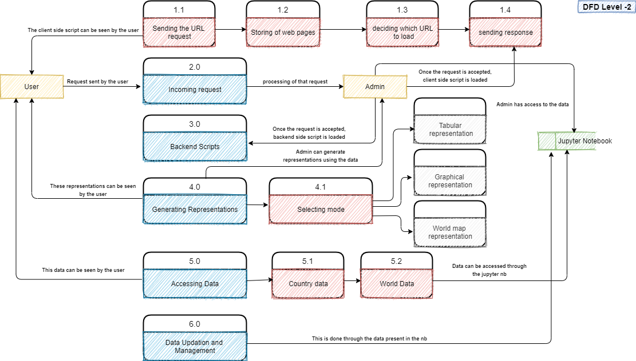

**Processes:**

* Retrieving State Statistics
* Retrieving City Statistics
* Tabular Representation or/and Graphical Representation
* Data Updating and Management.

**2.4 USE CASES**

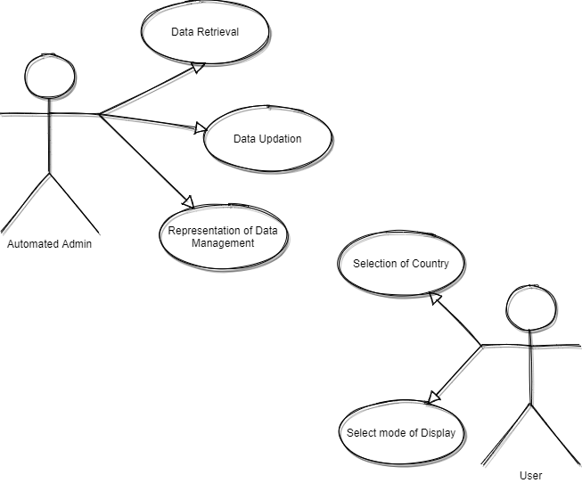

**2.5 USE CASE DIAGRAM**

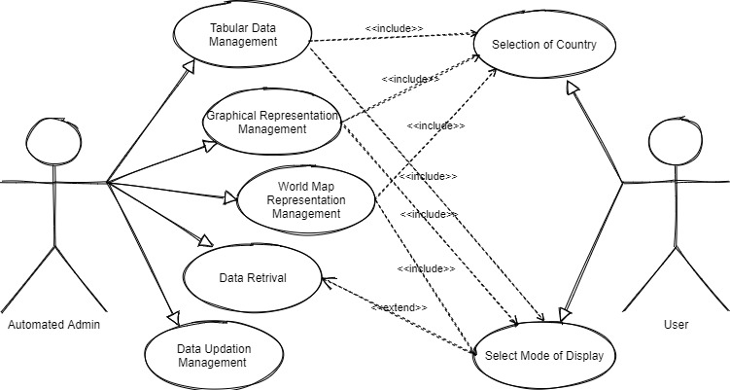

**2.6 CONTEXT DIAGRAM**

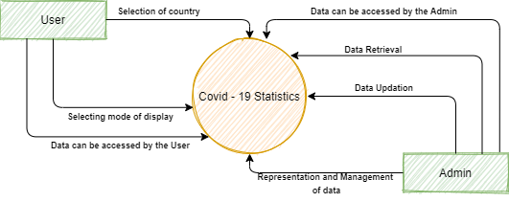

**2.6 ACTIVITY DIAGRAM**

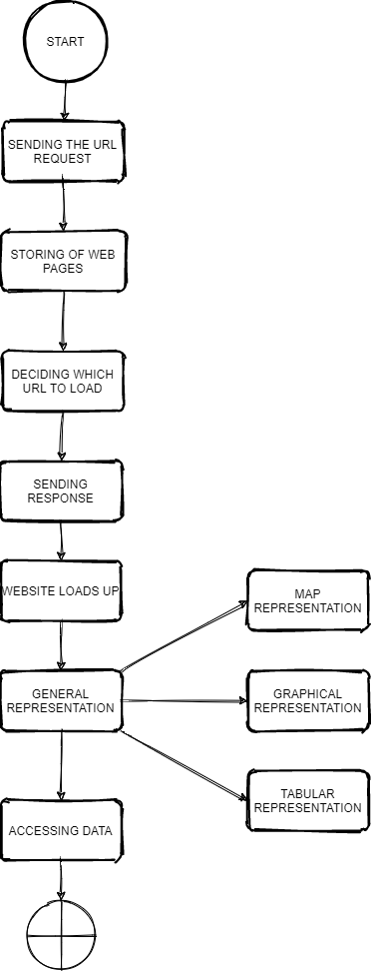

**2.7 MIND MAP**

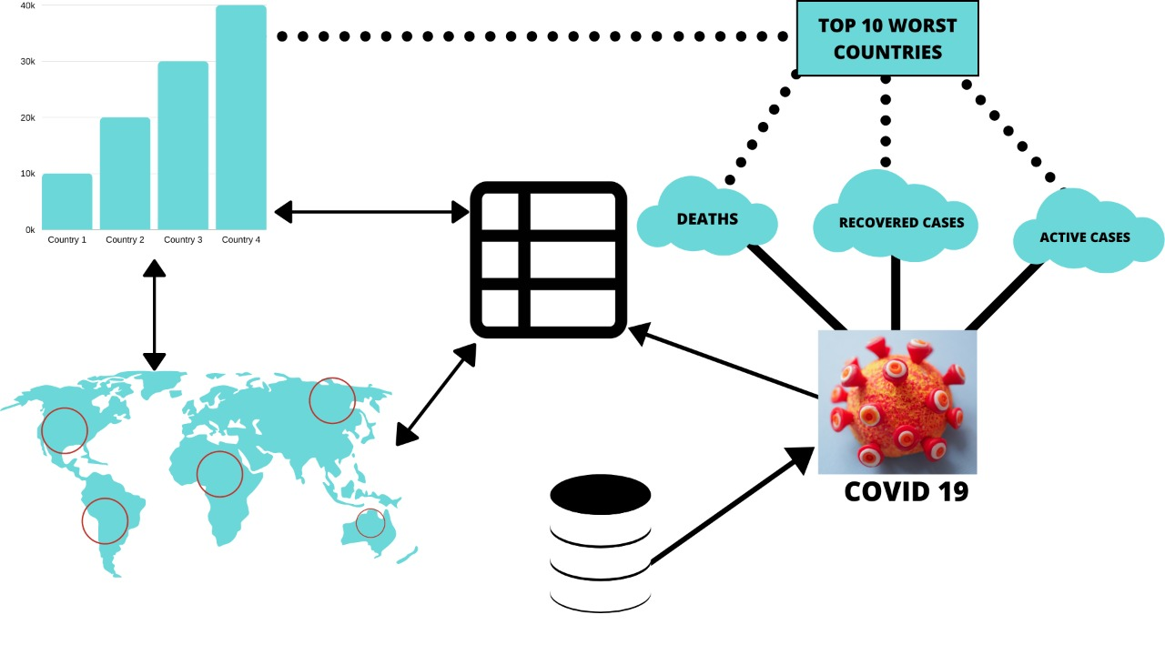

***3. FEATURES***

**3.1 Functional Requirements**

* <https://raw.githubusercontent.com/CSSEGISandData/COVID-19/master/csse_covid_19_data/csse_covid_19_time_series/> - The use of this link gives us access to the most relevant and accurate data related to covid 19 statistics like
  + Active Cases
  + Recovered Cases
  + Deaths
* Processes:
  + Retrieving State Statistics
  + Retrieving City Statistics
  + Tabular Representation or/and Graphical Representation
  + Data Updating and Management.
* Conversion of data to picture based representation like
  + Map
  + Graph
  + Table

**3.2 Non-Functional Requirements**

* This project is aimed at imparting information regarding the pandemic situation in the state of World in a user friendly and logical manner.
* Reduce misinformation by providing accurate information.
* Regular updating of the database ensures that we only have the most recent and therefore, the most accurate information.
* We aim to keep the website as user friendly as possible so that it can be used by anyone.
* The point of using pictorial representation is to keep the website very clear and not to over complicate the data.

**3.3 PLATFORMS**

* Python, Jupiter Notebook and Jupiter Notebook widgets for data analysis.
* Django, Python, Visual Studio Code for backend build.
* HTML, CSS, Bootstrap, ES6 JavaScript, Visual Studio Code for front end build.