HW3: UART

Asynchronous Serial Data Communication

Problem statement:

Connect two mbeds as show in Figure 7.13, and compile and download Program Example 7.9 into each.  You should find that the switches from one mbed control the LEDs from the other, and vice versa.

Group: Sandeep and VK

No of hours spent: 10 hrs

Set up:

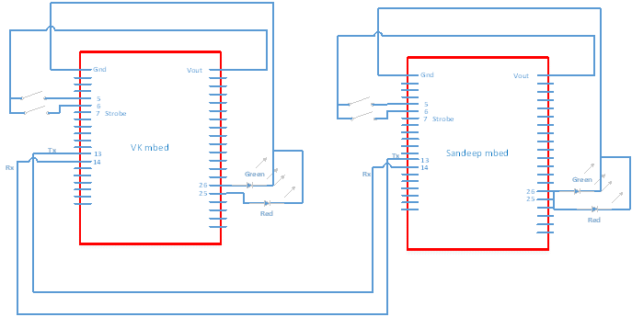

|  |  |  |
| --- | --- | --- |
| **Sandeep Board** | **Type** | **Signal Function** |
| 5 | Input | SW1 |
| 6 | Input | SW2 |
| 7 | Output | Strobe |
| 13 | Output | Tx (Transmit bits to other board) |
| 14 | Input | Rx (Recieves bits to other board) |
| 25 | Output | Drive RED LED |
| 26 | Output | Drive GREEN LED |

|  |  |  |
| --- | --- | --- |
| **VK Board** | **Type** | **Signal Function** |
| 5 | Input | SW1 |
| 6 | Input | SW2 |
| 7 | Output | Strobe |
| 13 | Output | Tx (Transmit bits to other board) |
| 14 | Input | Rx (Recieves bits to other board) |
| 25 | Output | Drive RED LED |
| 26 | Output | Drive GREEN LED |

|  |  |
| --- | --- |
| **State** | **Serial Transfer** |
| Both LED Off | A0 |
| RED | A1 |
| Green | A2 |
| Both Red and Green | A3 |

Baud rate: 9600 (104us/bit)

Scope scale: 200us

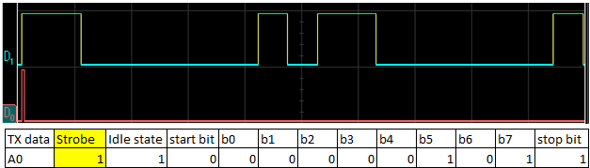

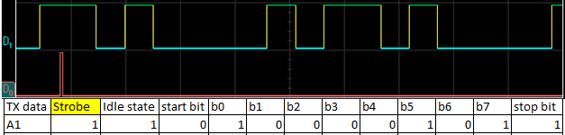

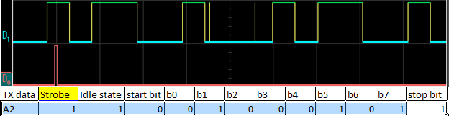

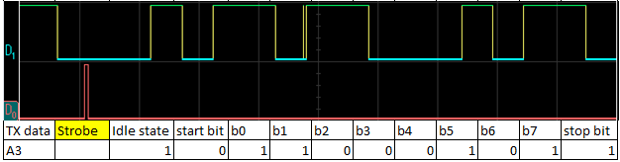

Red Only (serial data: A1)

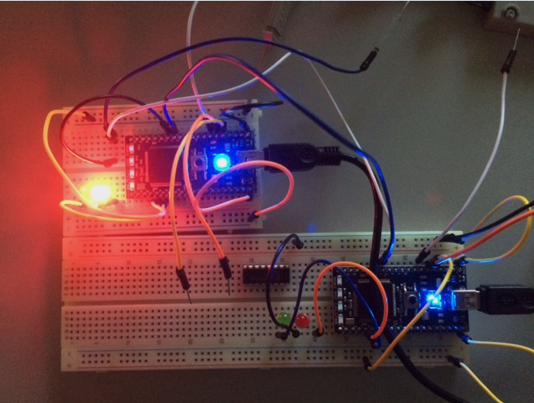

Green Only ( Serial data: A2)

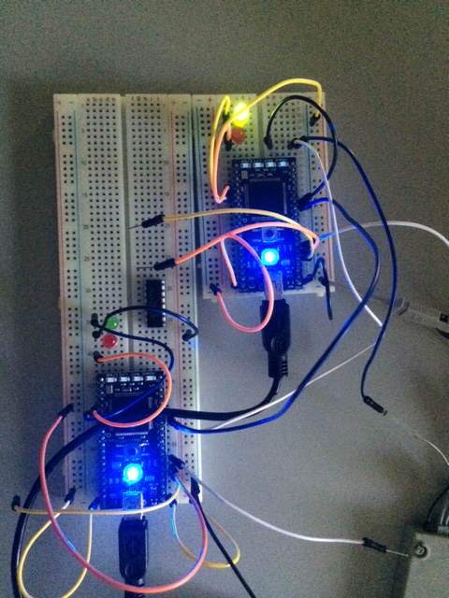

Both On ( Serial Data: A3)

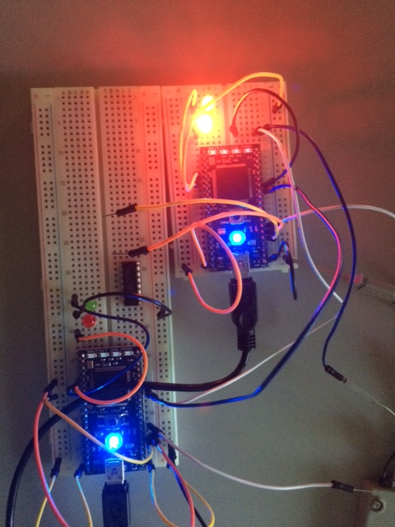

Both Board On ( Serial Data: A3 on each serial line)

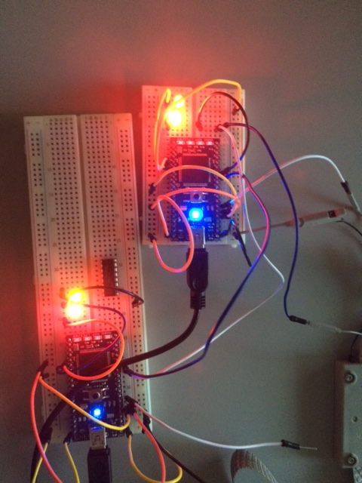

Code:

#include "mbed.h"

Serial async_port(p9, p10); //set up TX and Rx on pins 9 and 10

DigitalOut red_led(p25); //red led

DigitalOut green_led(p26); //green led

DigitalOut strobe(p7); // a strobe to trigger the scope

DigitalIn switch_ip1(p5);

DigitalIn switch_ip2(p6);

char switch_word; //word will be sent

char recd_val; //received value

int main() {

async_port.baud(9600); //setbaud rate to 9600

//accept default format of 8 bits,no parity

while (1){

// switch_word=0xA0;

switch_word=0xA0;

if (switch_ip1==1 & switch_ip2==0)

// if (switch_ip1==1)

switch_word=switch_word|0x01;

// if (switch_ip2==2)

if (switch_ip1==0 & switch_ip2==1)

switch_word=switch_word|0x02;

if (switch_ip1==1 & switch_ip2==1)

switch_word=switch_word|0x03;

strobe =1;

wait_us(10);

strobe =0;

async_port.putc(switch_word);

if (async_port.readable()==1)

recd_val=async_port.getc();

red_led=0;

green_led=0;

recd_val=recd_val&0x03;

if (recd_val==1)

red_led=1;

if (recd_val==2)

green_led=1;

if (recd_val==3){

red_led=1;

green_led=1;

}

}

}