

Heba Elsayed 2846

Ranim Dewaib 2864

Sally Dehis 2895

Social Network Website

Database

# Index:

ER Diagram …………………………………………………………………………………………………………

Relational Model ………………………………………………………………………………………………

DDL ………………………………………………………………………………………………………………………

Pseudo Code

Design

Website

ER Diagram

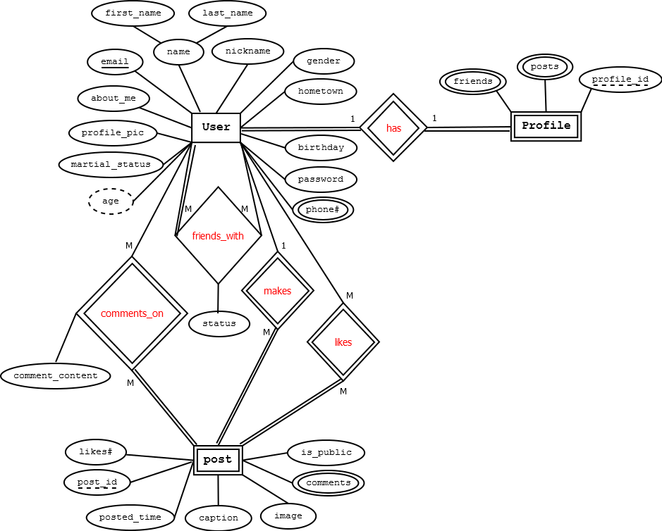

**Relational Model**

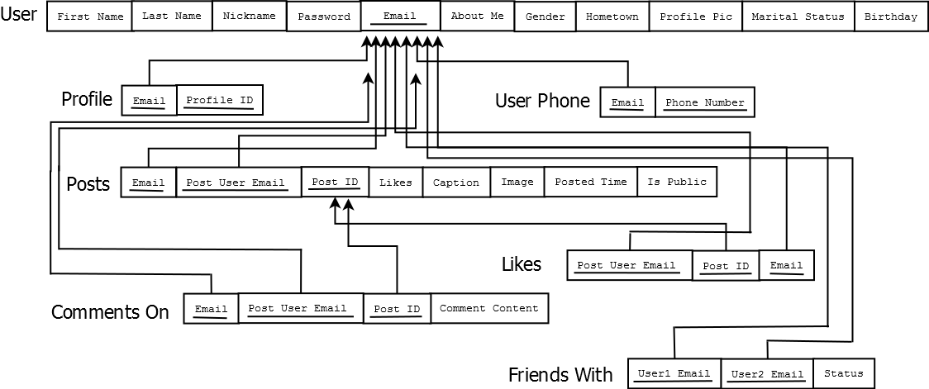

**Flow Chart**

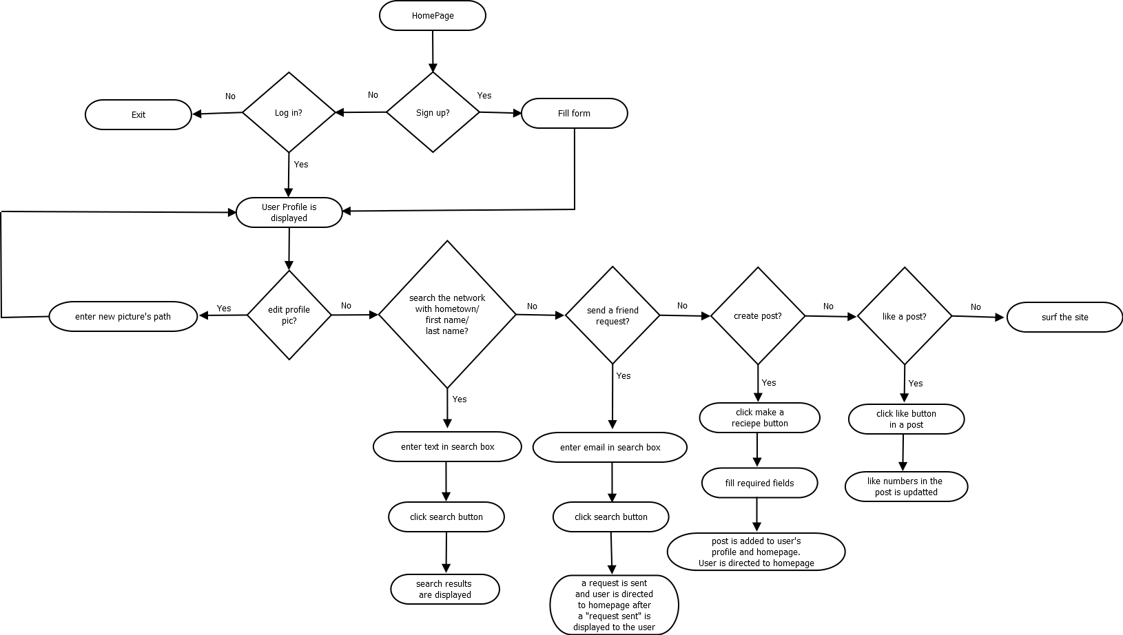

**DDL**

CREATE DATABASE SocialNetwork; //create database called "SocialNetwork" to use in the project

USE socialnetwork;

CREATE TABLE user_info(

email VARCHAR (50) NOT NULL,

password_user VARCHAR (10) NOT NULL,

about_me VARCHAR (500),

gender VARCHAR (1) NOT NULL,

hometown VARCHAR (50),

profile_pic VARCHAR (100) NOT NULL,

martial_status VARCHAR (1),

birthday date NOT NULL,

first_name VARCHAR (50) NOT NULL,

last_name VARCHAR (50) NOT NULL,

nickname VARCHAR (25),

PRIMARY KEY (email)

);

CREATE TABLE user_phonenumber(

email VARCHAR (50) NOT NULL,

phonenumber INT (15),

PRIMARY KEY (email,phonenumber)

);

CREATE TABLE user_profile(

email VARCHAR (50) NOT NULL,

profile_id INT (3) NOT NULL,

PRIMARY KEY (email,profile_id)

);

CREATE TABLE posts(

email VARCHAR (50) NOT NULL,

post_id INT (3) NOT NULL,

likes_number INT (3),

caption VARCHAR (300) NOT NULL,

image VARCHAR (100) NOT NULL,

posted_time timestamp NOT NULL,

is_public VARCHAR (1) NOT NULL,

PRIMARY KEY (email,post_id)

);

CREATE TABLE friends_with(

user1_email VARCHAR (50) NOT NULL,

user2_email VARCHAR (50) NOT NULL,

PRIMARY KEY (user1_email,user2_email)

);

CREATE TABLE comments_on(

user_email VARCHAR (50) NOT NULL,

poster_email VARCHAR (50) NOT NULL,

post_id INT (3) NOT NULL,

comment_content VARCHAR (500) NOT NULL,

nickname VARCHAR (25),

PRIMARY KEY (user_email,poster_email,post_id)

);

CREATE TABLE likes(

user_email VARCHAR (50) NOT NULL,

poster_email VARCHAR (50) NOT NULL,

post_id INT (3) NOT NULL,

PRIMARY KEY (user_email,poster_email,post_id)

);

Alter TABLE user_phonenumber ADD FOREIGN KEY (email) REFERENCES user_info (email) ON DELETE RESTRICT;

Alter TABLE user_profile ADD FOREIGN KEY (email) REFERENCES user_info (email) ON DELETE RESTRICT;

Alter TABLE posts ADD FOREIGN KEY (email) REFERENCES user_info (email) ON DELETE RESTRICT;

Alter TABLE friends_with ADD FOREIGN KEY (user1_email) REFERENCES user_info (email) ON DELETE RESTRICT;

Alter TABLE friends_with ADD FOREIGN KEY (user2_email) REFERENCES user_info (email) ON DELETE RESTRICT;

Alter TABLE comments_on ADD FOREIGN KEY (user_email) REFERENCES user_info (email) ON DELETE RESTRICT;

Alter TABLE comments_on ADD FOREIGN KEY (poster_email,post_id) REFERENCES posts (email,post_id) ON DELETE RESTRICT;

Alter TABLE likes ADD FOREIGN KEY (user_email) REFERENCES user_info (email) ON DELETE RESTRICT;

Alter TABLE likes ADD FOREIGN KEY (poster_email,post_id) REFERENCES posts (email,post_id) ON DELETE RESTRICT;

Sign Up

Sign In

Profile

Editing Profile

Image

Removing Image

Posting

Commenting on a Post

Liking a Post

Log out