## To link to a subtree in SourceTree:

***Disclaimer: These procedures worked at one point. However, this has not been maintained for new versions of SourceTree. For this reason, it is recommended that git bash be used for sub-tree merging.***

You need to follow these steps after an initial clone of the repository.

---1) Repository Add/Link Subtree

---2) In the URL field, enter the SSH address (given above)

---3) In the Branch / Commit field, select master

---4) In the Local Relative Path enter SourceCode/ForwardVSLibrary

--5) Check “Squash commits?”

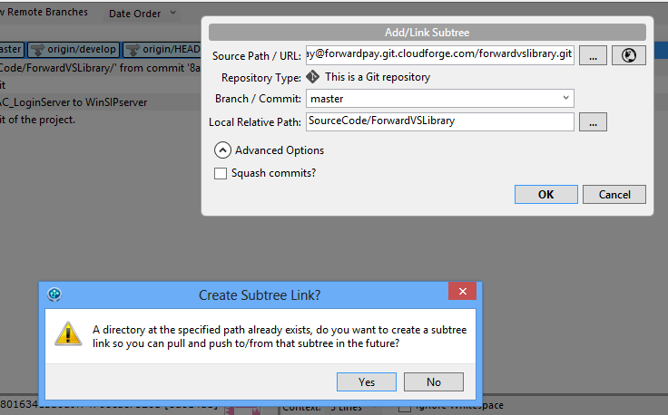

---5) After clicking Yes on “Create Subtree Link,” SourceTree should look like this:

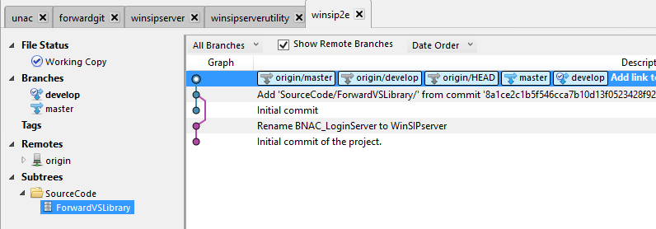

## To pull in changes made in the library outside of this project:

Follow these steps whenever you want to pull in the most recent ForwardVSLibrary.

---1) Right click on Subtrees->SourceCode->ForwardVSLibrary

---2) Click Pull ForwardVSLibrary (check "Squash commits?")

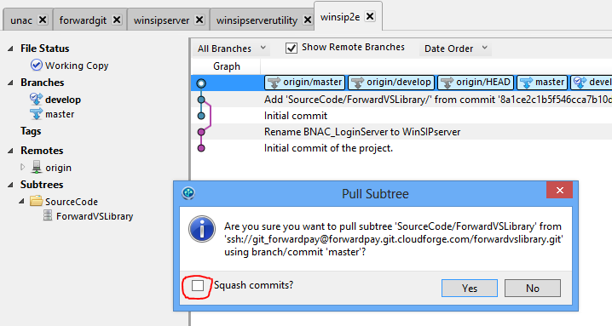

The resulting merge will look something like the image below, where the purple branch corresponds to the ForwardVSLibrary.

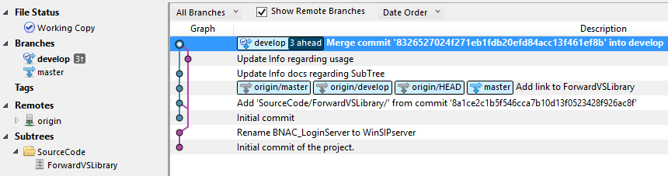

## To push in changes made to the library from inside this project:

**Note:** when editing the ForwardVSLibrary from within this project, use separate commits to the ForwardVSLibrary. For example, if you edit files in the FowardVSLibrary as well as in this project and you are ready to commit all of them, commit the ForwardVSLibrary files in one commit and the main project files in a separate commit.

Follow these steps whenever you made changes to the ForwardVSLibrary project and you want to push the changes back to the ForwardVSLibrary.

---1) Right click on Subtrees->SourceCode->ForwardVSLibrary

---2) Click Push ForwardVSLibrary (uncheck "Squash commits?")

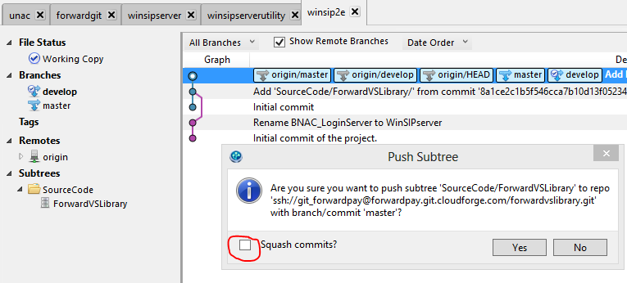

---3) Click Pull ForwardVSLibrary (check "Squash commits?")