ArchiveVox User Manual

Table of Contents
1. Getting Started
1.1 System Requirements
1.2 Accessing the Application
1.3 Login and Logout
1.4 User Interface Overview
2. Teacher Guide
2.1 Teacher Dashboard Overview
2.2 Managing Students
2.3 Reading Materials Library
2.4 Creating and Managing Assignments
2.5 Viewing Student Progress
2.6 Dashboard Analytics
3. Principal Guide
3.1 Principal Dashboard Overview
3.2 School-Wide Analytics
3.3 Managing Teachers
3.4 Class Performance Analysis
4. Student Guide
4.1 Student Dashboard Overview
4.2 Viewing Assignments
4.3 Completing Reading Assignments
4.4 Understanding the 3-Attempt System
4.5 Viewing Your Progress
4.6 Navigation and Logout
5. Reading Assessment Metrics Explained
6.1 WCPM (Words Correct Per Minute)
6.2 Accuracy Percentage
6.3 Miscue Types
5.4 Reading Levels (CRLA Profile)
5.5 Fluency Scores
6. Troubleshooting
Glossary

Section 1: Getting Started

1.1 System Requirements
To use ArchiveVox, you need:
- For Teachers, Principals, and Admins:
- A computer with internet access
- A modern web browser (Google Chrome, Mozilla Firefox, Microsoft Edge, or Safari)
- A valid username and password provided by your school administrator
- For Students:
- A computer, tablet, or smartphone with internet access
- A modern web browser
- A working microphone for recording reading assessments
- A valid username and password provided by your teacher
- Technical Requirements:
- The application is web-based and runs in the browser
- No software installation is required on your device
- The application works on Windows, Mac, and mobile devices

1.2 Accessing the Application
Step 1: Open your web browser
Step 2: Enter the ArchiveVox URL provided by your school administrator
Step 3: The login screen will appear
Note: If you do not know the URL, contact your school's IT administrator or teacher.

1.3 Login and Logout

Logging In
Step 1: On the login screen, enter your username in the "Username" field
Step 2: Enter your password in the "Password" field
Step 3: Click the "Sign In" button
Step 4: After successful login, you will be directed to your dashboard based on your user role:
- Teachers go to the Teacher Dashboard
- Principals go to the Principal Dashboard
- Admins go to the Admin Dashboard
- Students go to the Student Dashboard
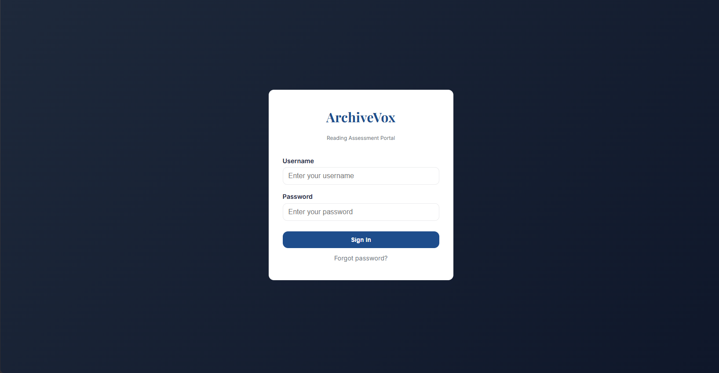
Figure 1.1: Login Screen

Logging Out
Step 1: Look for your user profile in the bottom-left corner of the sidebar
Step 2: Click the settings icon (gear icon) next to your name
Step 3: Select "Sign Out" from the menu
Note: For students, the logout button is located at the bottom of the sidebar.

1.4 User Interface Overview
The ArchiveVox interface consists of three main areas:
1. Sidebar (Left Side)
- Contains navigation menu items
- Shows your user name and role
- Provides quick access to logout
- Can be collapsed on smaller screens
2. Top Bar (Top)
- Shows the current page title
- Contains filter buttons (for teachers and principals)
- Includes notification bell
- Shows date range filters on dashboard
3. Main Content Area (Right)
- Displays the current page content
- Shows cards, charts, tables, and forms
- Changes based on your navigation selection

Section 2: Teacher Guide

2.1 Teacher Dashboard Overview
The Teacher Dashboard provides an overview of your class performance and recent activity.
Dashboard Components:
1. Statistics Cards (Top Row)
- My Students: Total number of students in your classes
- My Materials: Total number of reading materials you have uploaded
- Assessments: Total number of assessments completed
- Avg. Accuracy: Average accuracy percentage across all assessments
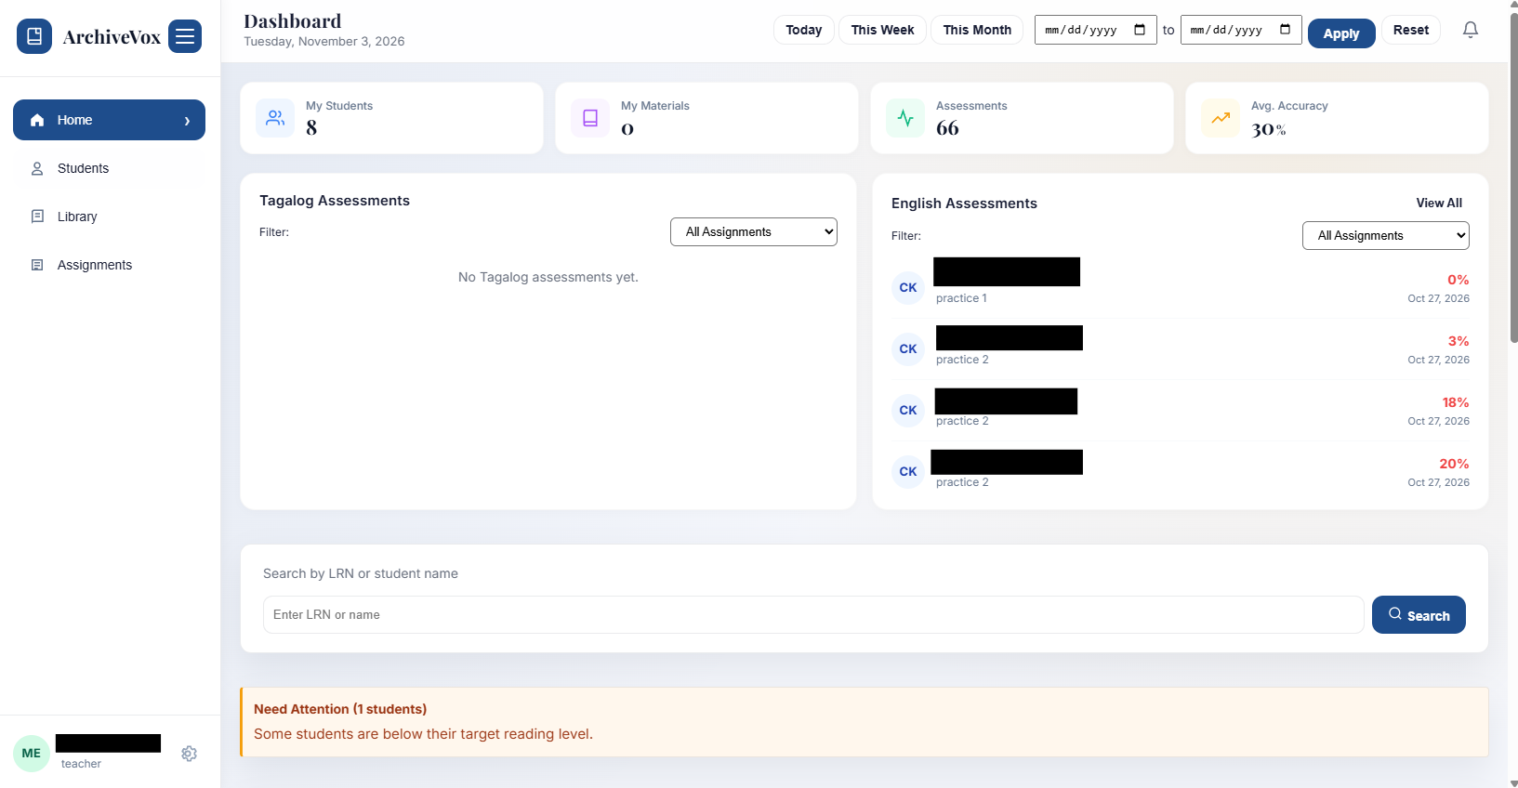
Figure 2.1: Teacher Dashboard with Statistics Cards
2. Recent Assessments Panels
- Tagalog Assessments: Shows recent assessments for Tagalog/Filipino materials
- English Assessments: Shows recent assessments for English materials
- Each panel shows the student's name, fluency score (WCPM), accuracy, and date
- "View All" button opens a modal with all assessments for that language
3. Assignment Filters
- Filter dropdown for Tagalog assignments by material title
- Filter dropdown for English assignments by material title
- Filters update the recent assessments lists in real-time
4. Date Filters (Top Bar)
- Quick filter buttons: Today, This Week, This Month
- Custom date range picker
- Apply button to filter dashboard data
- Reset button to clear filters

2.2 Managing Students

2.2.1 Viewing Student List
Step 1: Click "Students" in the sidebar navigation
Step 2: The student list displays in a spreadsheet-style view
- Students are automatically grouped by Grade and Section
- Each group shows all students in that class
- Each row shows: LRN, First Name, Last Name, Grade, Section, Actions
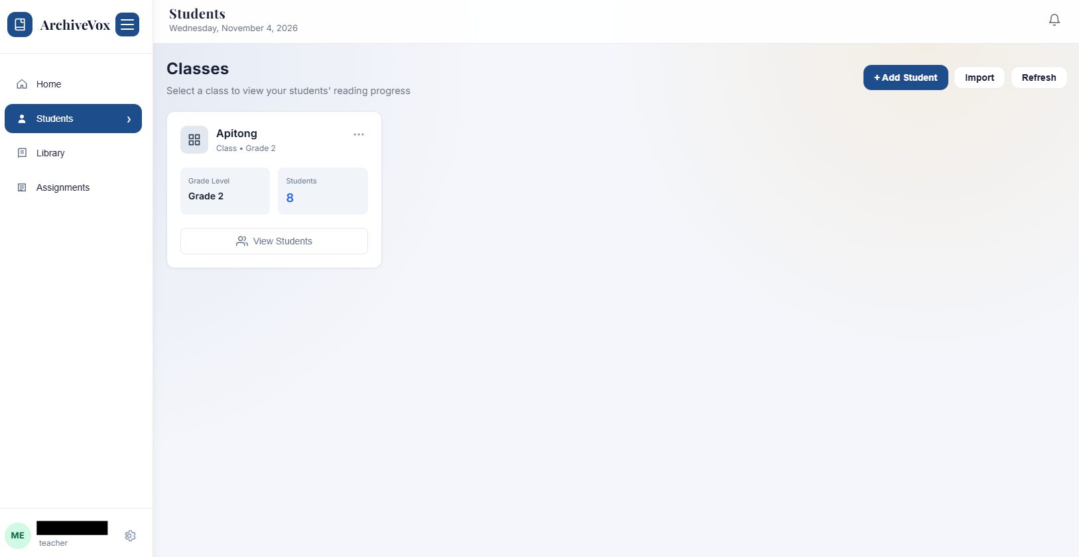
Figure 2.2: Student Management View
Step 3: Scroll to view all students in different classes

2.3 Reading Materials Library

2.3.1 Viewing Materials
Step 1: Click "Library" in the sidebar navigation
Step 2: Materials display in a card grid layout
- Each card shows: material title, grade level, word count, language, type
- Cards are color-coded by language (blue for English, purple for Filipino)
- OCR status is shown on each card (OCR Done, Processing, or Pending)
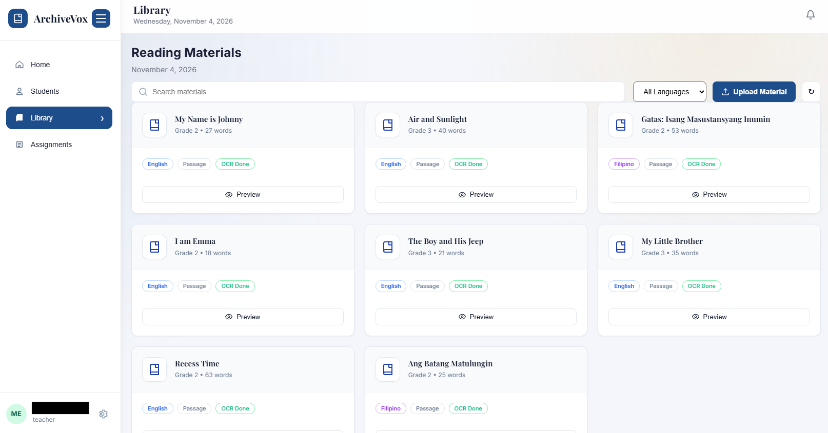
Figure 2.3: Reading Materials Library
Step 3: Click on any material card to view its details

2.3.2 Uploading New Materials
Step 1: In the Library view, click the "Upload Material" button
Step 2: The Upload Material modal appears
Step 3: Fill in the material information:
- Title (required)
- Description (optional)
- Grade Level (required)
- Language (English or Filipino)
- Material Type (Passage, Story, etc.)
- Difficulty (Easy, Average, Hard)
Step 4: Upload the reading material image
- Click the upload area or drag and drop an image file
- Supported formats: JPG, PNG, PDF
- The image should be a clear photo or scan of the reading passage
Step 5: Wait for OCR (Optical Character Recognition) to extract text
- OCR automatically extracts text from the image
- The extracted text appears in the "OCR Result" textarea
- This process may take a few seconds
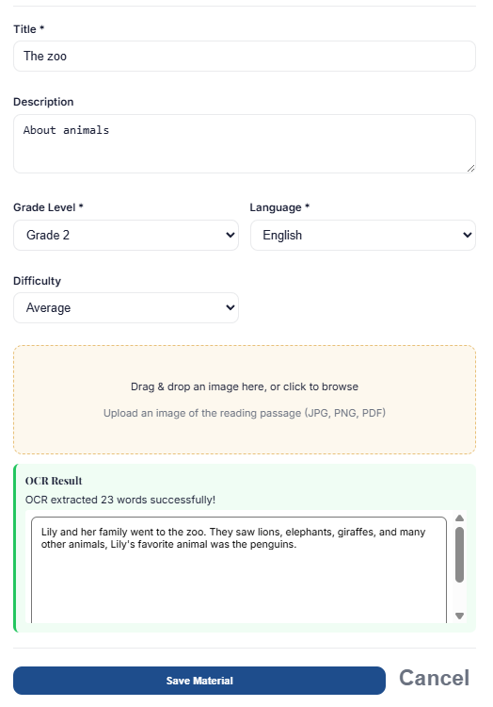
Figure 2.4: Upload Material Modal with OCR Preview

2.3.3 OCR Text Extraction and Editing
During Upload:
Step 1: After OCR extraction, review the extracted text in the textarea
Step 2: If the text is correct, proceed to save
Step 3: If the text has errors:
- Click inside the textarea
- Edit the text directly
- Correct any spelling or formatting issues
- The edited text will be saved instead of the OCR result
Step 4: Click "Save Material" to save the material with your edited text
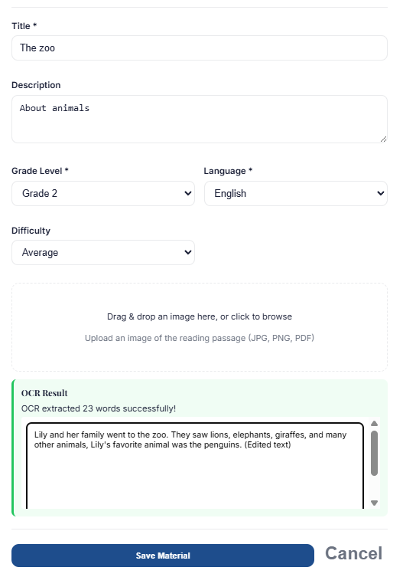
Figure 2.5: Upload Material with Edited OCR Text
Note: The OCR system attempts to extract text automatically, but manual editing is recommended to ensure accuracy.

2.3.4 Editing Material Details
Step 1: In the Library view, click on a material card
Step 2: The material details modal appears
Step 3: Click the "Edit Material" button
Step 4: The material information becomes editable:
- Title field becomes enabled
- Description field becomes enabled
- Grade Level dropdown becomes enabled
- Language dropdown becomes enabled
- Material Type dropdown becomes enabled
- Difficulty dropdown becomes enabled
- OCR text textarea becomes enabled
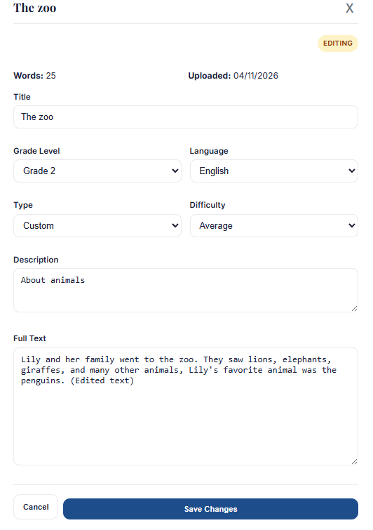
Figure 2.6: Edit Material Modal with Enabled Fields
Step 5: Make your changes
Step 6: Click "Save Changes" to update the material
Step 7: The modal closes and the material list refreshes

2.4 Creating and Managing Assignments

2.4.1 Creating New Assignments
Step 1: Click "Assignments" in the sidebar navigation
Step 2: Click the "+ New Assignment" button
Step 3: The Create Assignment modal appears
Step 4: Fill in the assignment details:
- Assignment Title (required)
- Instructions (optional)
- Class (required - select from your classes)
- Material (required - select from your library)
- Due Date (optional)
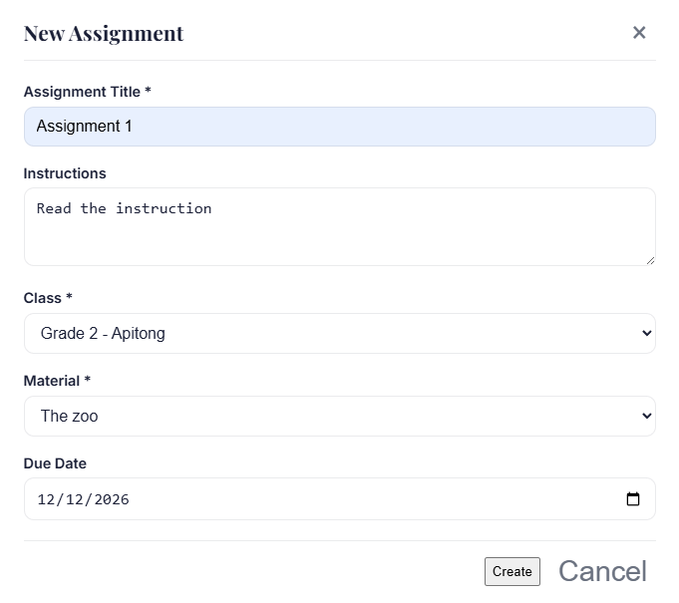
Figure 2.7: Create Assignment Modal
Step 5: Click "Create" to save the assignment
Step 6: The assignment appears in the assignments list

2.5 Viewing Student Progress
Teachers can view individual student progress through the Student Detail page.
How to Access Student Progress:
Step 1: Go to the Students section
Step 2: Search for a student by LRN or name
Step 3: Click on the student result card
Step 4: The Student Detail page shows:
- Student information (grade, section, birthdate)
- Aggregate statistics (completed readings, avg WCPM, avg accuracy)
- Assignments & Quizzes table with progress for each assignment
Step 5: Click on an assignment row to view detailed attempts

2.6 Dashboard Analytics

2.6.1 Class Performance Charts
Bar Chart:
- Shows average WCPM and accuracy per assignment
- Compares performance across different materials
- Helps identify which materials students struggle with
Pie Chart:
- Shows breakdown of miscue types
- Displays percentages for each miscue category
- Includes: Substitutions, Omissions, Insertions, Repetitions
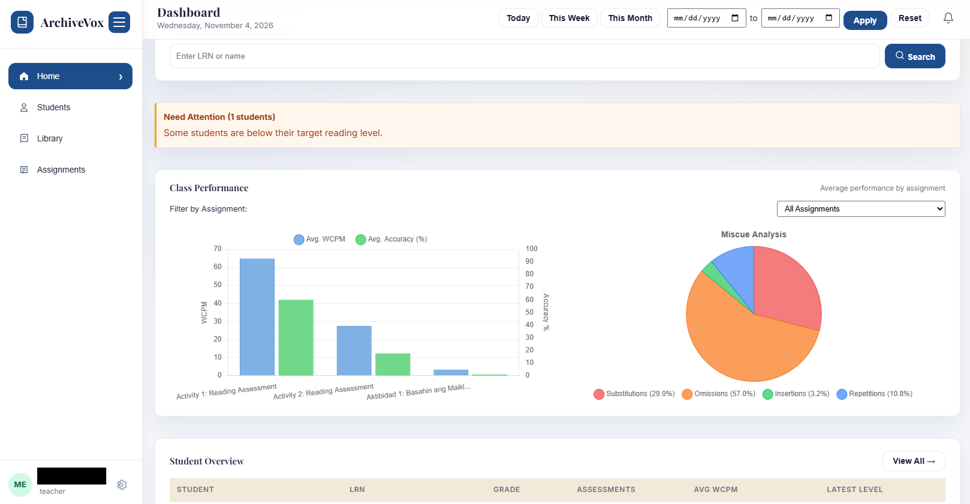
Figure 2.8: Teacher Dashboard Class Performance Charts

Section 3: Principal Guide

3.1 Principal Dashboard Overview
The Principal Dashboard provides school-wide analytics and performance data.
Dashboard Components:
1. Statistics Cards (Top Row)
- Total Students: Total number of students in the school
- Reading Materials: Total number of materials uploaded by all teachers
- Assessments Done: Total number of assessments completed school-wide
- Avg. Accuracy: School-wide average accuracy percentage
- Each card shows trend information (e.g., "+5 this week")
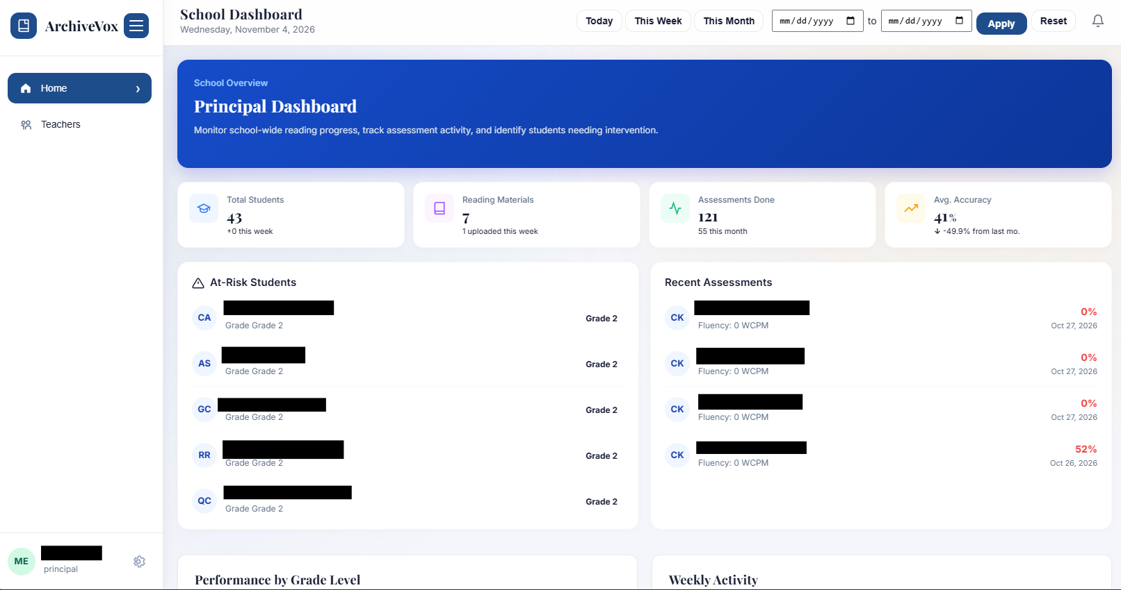
Figure 3.1: Principal Dashboard with School Statistics
2. At-Risk Students Panel
- Shows students who may need intervention
- Displays student name, grade, and reading level
- Red color highlights at-risk students
- Shows up to 5 most at-risk students

3.4 Class Performance Analysis

3.4.2 Cascading Filters (Grade → Section → Assignment)
The Class Performance section uses cascading filters:
Grade Filter:
- Select a grade to filter by
- Options: All Grades, Grade 1, Grade 2, Grade 3, etc.
- When you select a grade, the Section filter updates
Section Filter:
- Shows sections for the selected grade only
- Options: All Sections, plus specific sections (e.g., "Magnolia", "SSES")
- When you select a section, the Assignment filter updates
Assignment Filter:
- Shows assignments for the selected grade and section
- Options: All Assignments, plus specific assignments
- Selecting an assignment filters the charts
Reset Button:
- Clears all filters
- Shows data for all grades, sections, and assignments
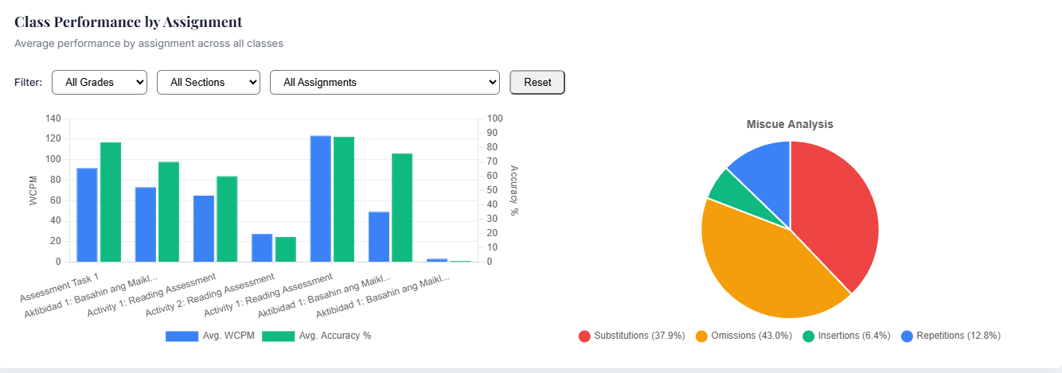
Figure 3.2: Principal Cascading Filters and Charts

Section 4: Student Guide

4.1 Student Dashboard Overview
The Student Dashboard is a separate interface designed for students.
Dashboard Components:
1. Welcome Section
- Personalized greeting with your name
- Encouraging message
2. Statistics Cards
- Assignments: Total number of assignments assigned to you
- Completed: Number of assignments you have finished
- Average Score: Your average quiz score across all assignments
3. My Assignments Section
- Shows your current assignments
- Each assignment card shows:
- Assignment title
- Status (Not Started, In Progress, Completed)
- Attempts used (X/3 attempts)
- Start button
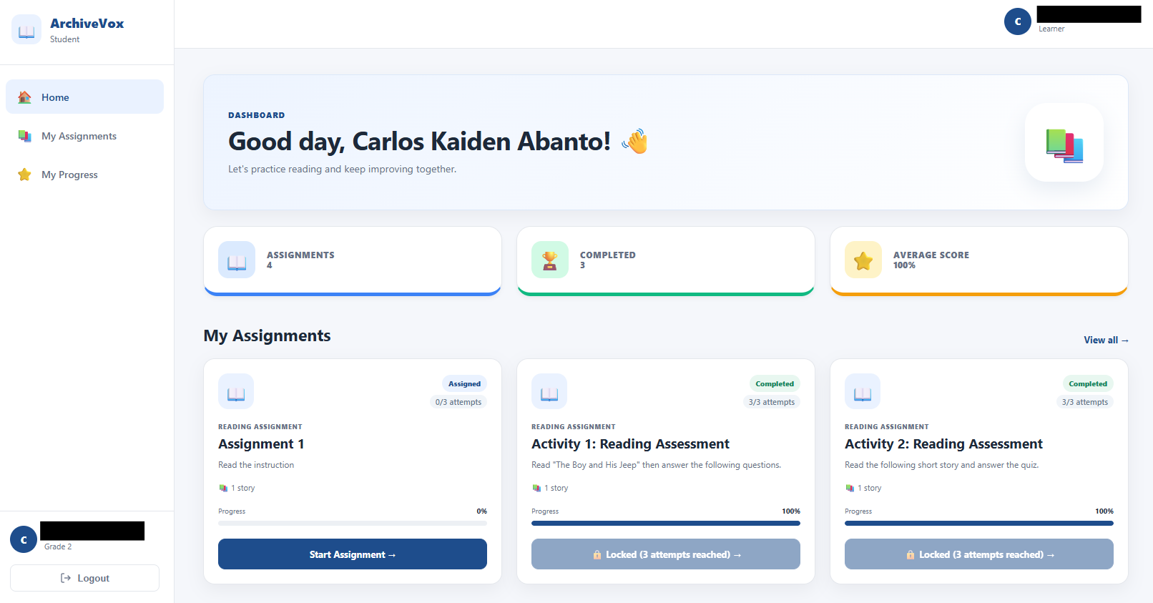
Figure 4.1: Student Dashboard

4.3 Completing Reading Assignments

4.3.1 Starting an Assignment
Step 1: Click on an assignment card
Step 2: The Assignment Details modal appears
- Shows assignment title and instructions
- Lists reading materials in the assignment
Step 3: Click "Start Assignment" to begin
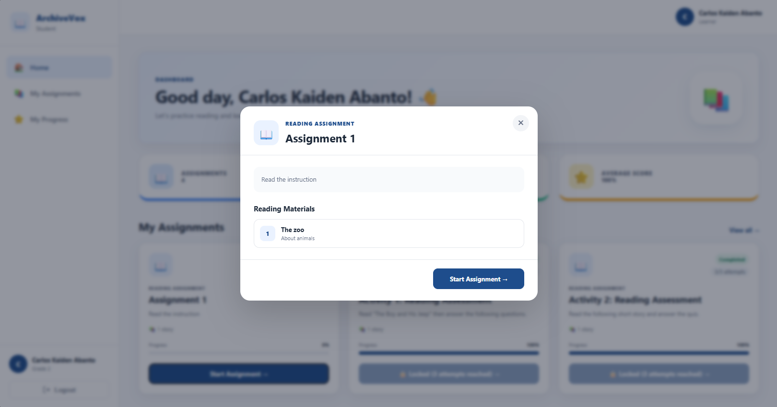
Figure 4.2: Student Assignment Card
Note: If you have used all 3 attempts, the button will be disabled and show "🔒 Locked (3 attempts reached)".

4.4 Understanding the 3-Attempt System
Each reading assignment allows a maximum of 3 attempts.

4.4.1 Maximum 3 Attempts
- Attempt 1: First time you read the material
- Attempt 2: Second time you read the material
- Attempt 3: Third and final time you read the material
- Attempt 4+: Not allowed - assignment locks
The assignment card shows how many attempts you have used (e.g., "1/3 attempts", "2/3 attempts").

4.4.2 Practice vs. Final Score Attempts
Practice Attempts (1 and 2):
- These are for practice
- Your score is not sent for final grading
- Labeled as "Practice Attempt"
- Helps you prepare without pressure
Final Score Attempt (3):
- This is your official attempt
- Your score is sent to your teacher for grading
- Labeled as "Final Assessment Recorded"
- Counts toward your final grade

4.4.3 Using "Try Again" for Re-recording
After completing a practice attempt (1 or 2), you can re-record without using another attempt:
Step 1: After submitting your reading, view your results
Step 2: If it was a practice attempt, you will see a "Try Again" button
- Button shows: "🔄 Try Again (X attempts left)"
Step 3: Click "Try Again"
Step 4: You return to the recording screen
- The attempt number does NOT increase
- You can re-record your reading
- This does not consume an additional attempt
Step 5: Record again and submit
Step 6: Your new recording replaces the previous one
- Still counts as the same attempt number
- Still a practice attempt (if attempt 1 or 2)
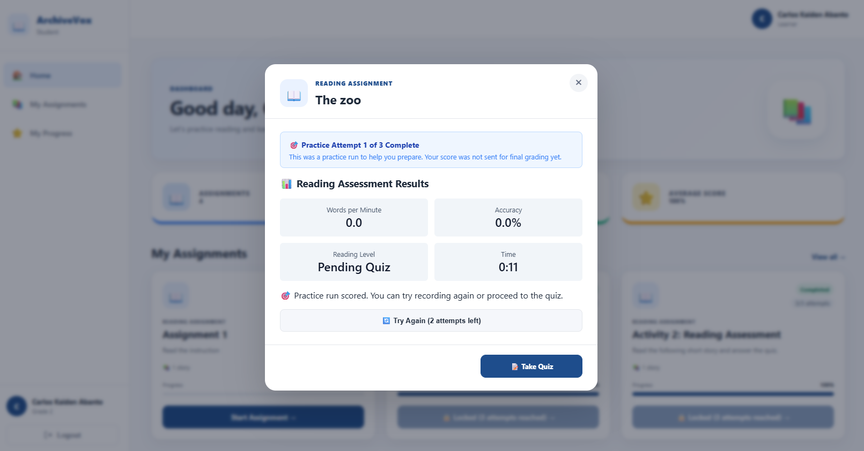
Figure 4.3: Student Reading Results with Try Again Button
Important: The "Try Again" feature is only available for practice attempts (1 and 2). After your final attempt (3), you cannot re-record.

Section 5: Reading Assessment Metrics Explained

5.1 WCPM (Words Correct Per Minute)
What it measures:
- How many words you read correctly in one minute
- Your reading speed
- Fluency
How it's calculated:
Total number of words read correctly ÷ time in minutes
What it means:
- Higher WCPM = faster, more fluent reading
- Lower WCPM = slower, less fluent reading
- Target WCPM varies by grade level
Example:
If you read 120 words correctly in 1 minute, your WCPM is 120

5.2 Accuracy Percentage
What it measures:
- How many words you read correctly
- Overall reading accuracy
- Precision
How it's calculated:
(Words read correctly ÷ Total words) × 100
What it means:
- 90-100% = Excellent accuracy
- 80-89% = Good accuracy
- 70-79% = Fair accuracy
- Below 70% = Needs improvement

5.3 Miscue Types
A miscue is a deviation from the exact text. Not all miscues are errors - some are natural parts of reading.

5.3.1 Substitutions
Definition: You say a different word than what is written
Example:
Text: "The cat sat on the mat"
You say: "The dog sat on the mat"
"Dog" is a substitution for "cat"
Impact: Can change meaning if the substituted word has a different meaning

5.3.2 Omissions
Definition: You skip or don't read a word
Example:
Text: "The cat sat on the mat"
You say: "The cat sat on mat"
"The" before "mat" is an omission
Impact: Can affect comprehension and fluency

5.3.3 Insertions
Definition: You add a word that is not in the text
Example:
Text: "The cat sat on the mat"
You say: "The big cat sat on the mat"
"Big" is an insertion
Impact: Can affect fluency and rhythm

5.3.4 Repetitions
Definition: You repeat a word or phrase
Example:
Text: "The cat sat on the mat"
You say: "The cat cat sat on the mat"
"Cat" is repeated
Impact: Can affect fluency and speed

5.4 Reading Levels (CRLA Profile)
The CRLA (Critical Reading Level Assessment) profile categorizes readers into three levels:
Independent Level:
- You can read and understand without help
- Accuracy: 95-100%
- Can read independently
Instructional Level:
- You can read with some guidance
- Accuracy: 90-94%
- Benefits from teacher support
Frustration Level:
- Reading is difficult and frustrating
- Accuracy: Below 90%
- Needs significant support and easier materials

Section 6: Troubleshooting

6.1 Login Issues
Problem: Cannot log in
Solutions:
- Check that your username and password are correct
- Make sure Caps Lock is not on
- Contact your teacher or administrator if you forgot your password
- Ensure you have internet connection

6.2 Audio Recording Problems
Problem: Microphone not working
Solutions:
- Check that your microphone is plugged in
- Allow microphone access in your browser
- Check browser settings for microphone permissions
- Try a different browser
- Test your microphone in other applications

6.3 OCR Extraction Errors
Problem: OCR does not extract text correctly
Solutions:
- Ensure the image is clear and high-quality
- Make sure the text is readable in the image
- Use the editing feature to correct the text manually
- Try uploading a different image

Glossary
Term | Definition
Accuracy Percentage | The percentage of words read correctly out of the total words in a passage.
Admin | A school administrator with full access to all features, including school-wide student and material management.
Assessment | A reading evaluation that measures a student's reading fluency, accuracy, and comprehension.
Assignment | A reading task assigned by a teacher to students, which may include one or more reading materials.
Attempt | One complete reading of a material, including recording and possibly a quiz. Students have a maximum of 3 attempts per assignment.
CRLA Profile | Critical Reading Level Assessment - a system for categorizing readers into Independent, Instructional, or Frustration levels.
Final Score Attempt | The third attempt in the 3-attempt system, which is officially graded and sent to the teacher.
Fluency | The ability to read text accurately, quickly, and with appropriate expression.
Insertion | A miscue where the reader adds a word that is not in the text.
LRN | Learner Reference Number - a unique identifier for each student.
Miscue | A deviation from the exact text while reading. Miscues include substitutions, omissions, insertions, and repetitions.
OCR | Optical Character Recognition - technology that converts images of text into machine-readable text.
Omission | A miscue where the reader skips or does not read a word.
Practice Attempt | The first or second attempt in the 3-attempt system, used for practice and not officially graded.
Principal | A school administrator who can view school-wide analytics and manage teachers, but has limited access to student and material management.
Reading Level | A categorization of a reader's ability (Independent, Instructional, or Frustration) based on accuracy and comprehension.
Repetition | A miscue where the reader repeats a word or phrase.
Substitution | A miscue where the reader says a different word than what is written.
Teacher | A classroom instructor who manages students, materials, assignments, and conducts assessments.
Try Again | A feature that allows students to re-record their reading without consuming an additional attempt (available only for practice attempts).
WCPM | Words Correct Per Minute - a measure of reading speed calculated by dividing the number of words read correctly by the time in minutes.

