Project

Zander Schoeman | 577496

Sean Botha | 577288

Ricardo De Wet | 577412

Vernon Engelbrecht | 578593

PRG281

Reason Sithole

Contents

What is the Goal of this App? 2

App rundown 2

# What is the Goal of this App?

The main goal of this Application is to create and track loans; whether it be a Personal Loan or a Business Loan. The Application determines the Total value of the Loan (At Due Date) by calculation using the Prime Interest Rate entered by the user, the Loan Amount, and the Term in which the loan will be held; entered by the user.

The app asks the user for information regarding the loan they want to take, and then saves the information and displays it in an organized manner. See the list below for the order in which the loan details are displayed:

1. Loan Number: The number of the Loan taken.
2. Last Name: The last name of the Customer taking the loan.
3. First Name: The first name of the Customer taking the loan.
4. Term: The term that the Customer chose to take the loan in (Short-Term, Medium-Term, or Long-Term).
5. Loan Amount: The amount of Money the Customer wants to loan.
6. Total Loan: The total amount of Money the Customer owes at the end of the Loaning Term, calculated with the method mentioned above.

# App rundown

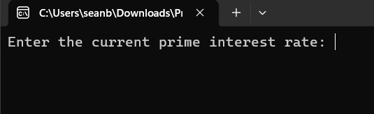

When the app runs, the user gets prompted to enter the current prime interest rate, this is a value you only enter once at the start of the program.

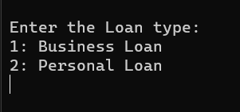

The user then gets prompted to enter the type of loan.

* A business loan applies an extra 1% on top of the prime interest rate.
* A personal loan applies and extra 2% on top of the prime interest rate.
* Not entering the loan type will not save your details.

The program then prompts the user to enter the length of the loan. If a value outside of the given range is entered, then the default loan term will be given (short term).

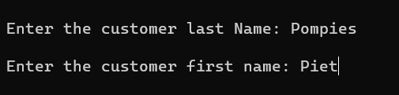

The program then prompts the user to enter the first and last name for the person who is responsible for the loan, in the case of individuals it is just the individuals name, but in the case of a company it is whoever oversees the company’s finance’s first and last name.

The program then prompts the user to enter an amount of loan.

* If the loan amount is above 100 000, the program will re-prompt the user to enter a valid amount (between 0 and 100 000).

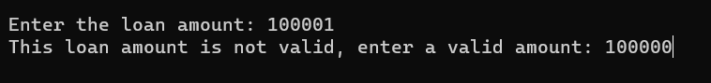

The program after it is looped 5 times as per instruction, displays the data that has been captured.

