# To Access Voicemail

When someone makes a Teams call and leaves a message it will show up on Teams under voicemail.

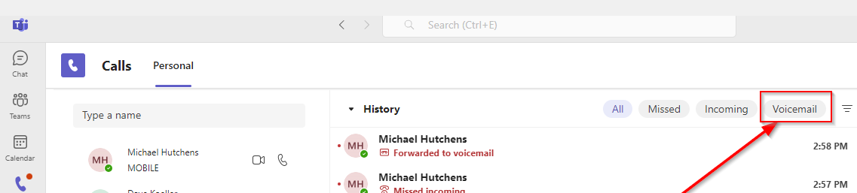

When someone calls your external number and leaves a message it will show up in an email if you are only using a softphone.

If you have a hard phone, you will get a notification light on that and then press the voicemail button on the phone and check your voicemail from the physical telephone.



The first time you log into voicemail from the physical telephone it will have you create a pass code and record your name.

**Voicemail Pass Code Rules**

(Numerical digits only 0-9)

Pass Code length must be 4-8 digits.

# Teams-Make a call from your call history, speed dial or contacts

## To make a call from your call history:

Go to **Calls** and review the **History**section in the center of the screen. Select any item from the list and then choose **Call from** the **Details** section on the right side of Teams.

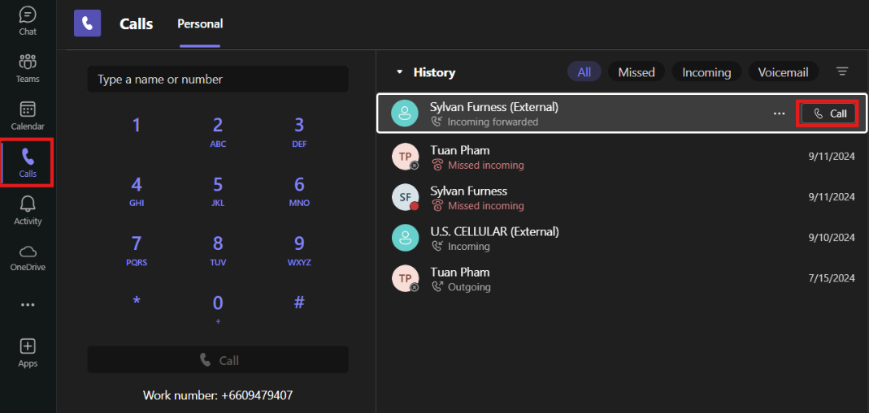

## To make a call from your speed dial:

To access your speed dial, go to **Calls** and then find the **Speed dial** section on the right side of Teams. Add people to **Speed dial** by selecting **Add.**

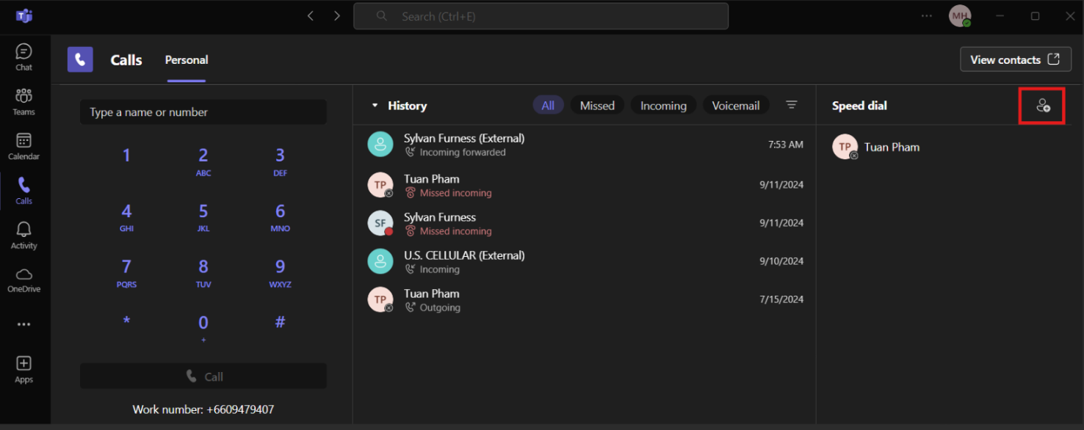

Then searching for their name or number.

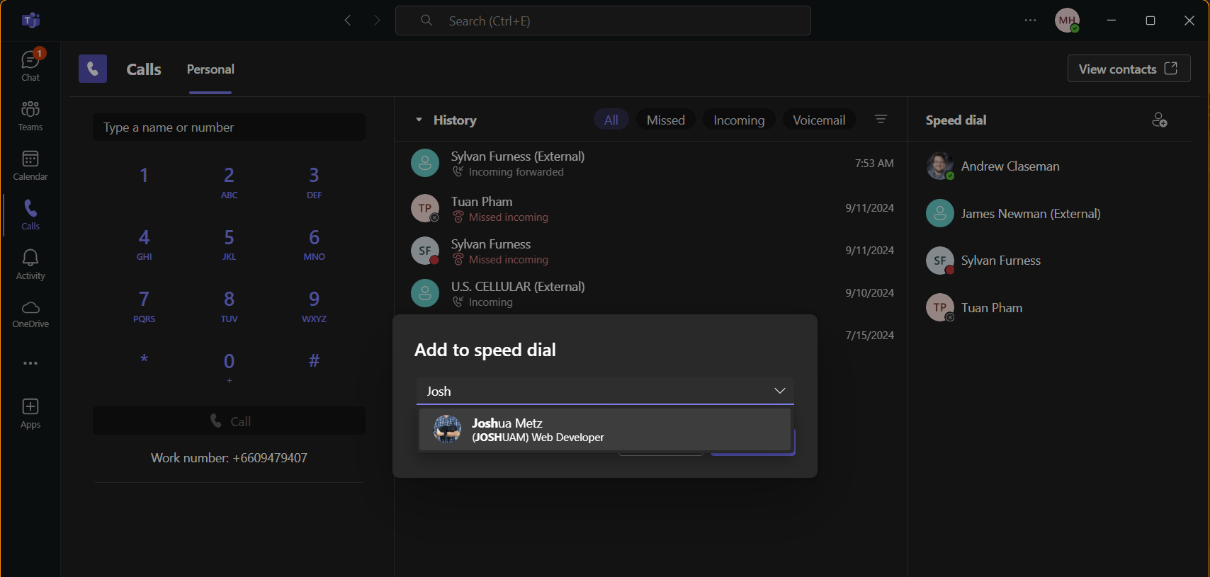

Then select the user and click the Add button.

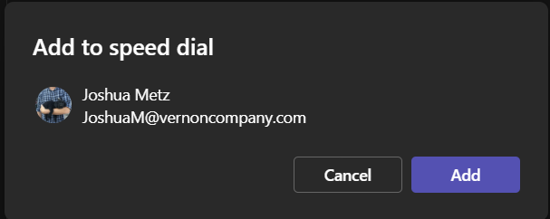

To call someone from speed dial mouse over the individual's name and click the phone icon.

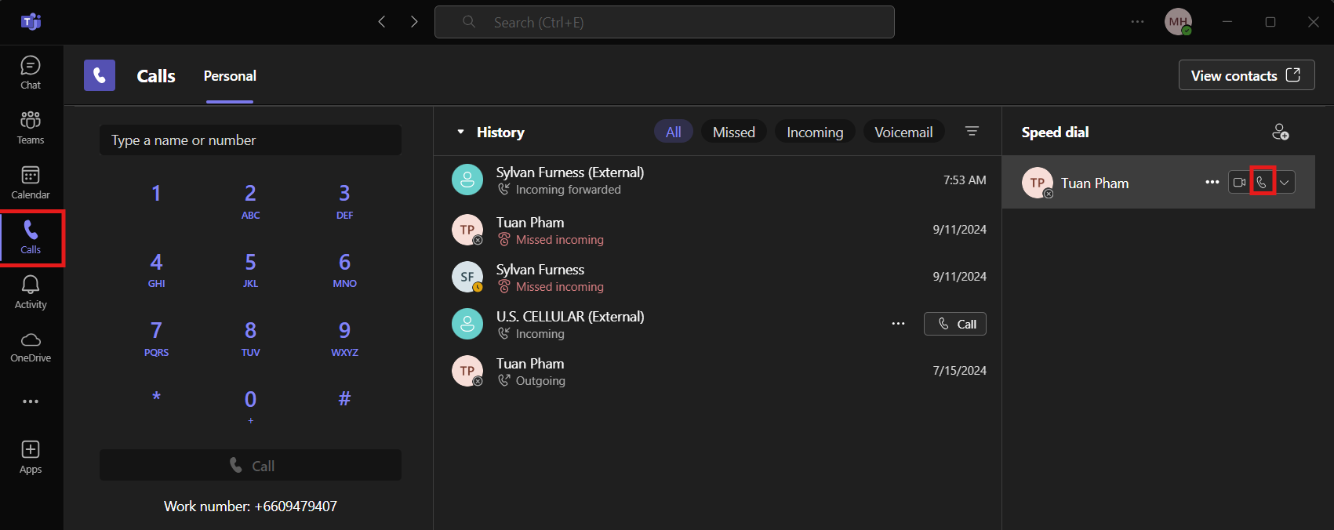

## To make a call from your contacts:

Select **Calls** > **Contacts** in the upper-right of Teams.

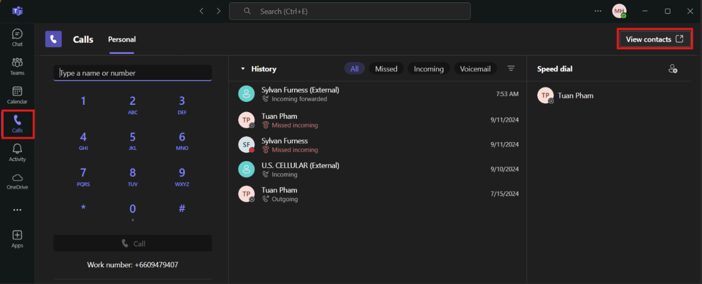

From here, call anyone by selecting **Call** to the right of their name. The call button will show up when you mouse over the contact.

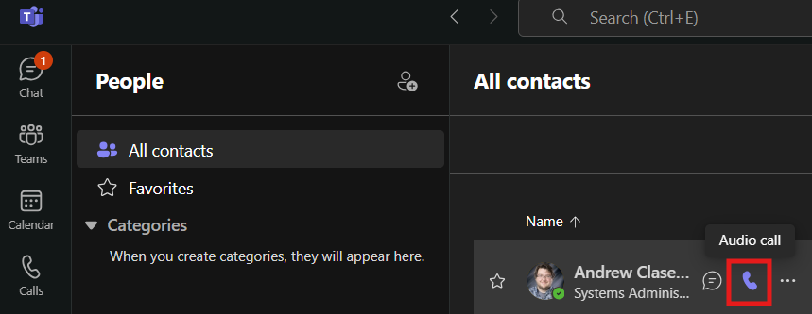

# Teams-Use the dial pad

To dial a number from Teams, go to **Calls.**

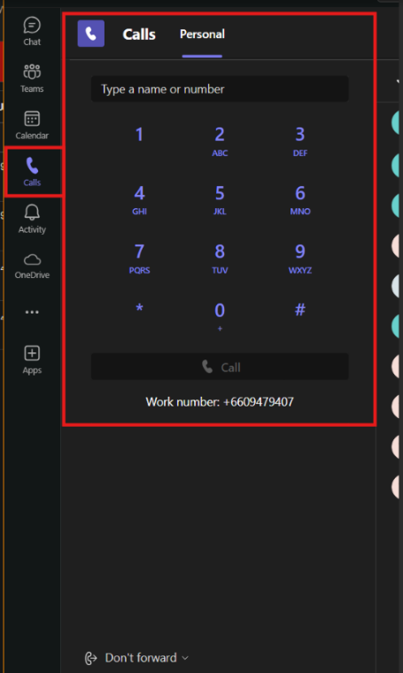

Then enter the number of the person you want to reach by using the dial pad. Then select **Call.**

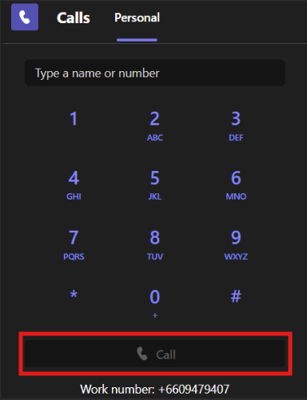

You can also type in the name of a person or call them from the dial pad.

# Teams-Hold, Transfer, Consult then transfer.

During a Teams call, you can take many actions. Here are a few common scenarios:

## Place a call on hold.

In your call window choose **Hold**. Everyone on the call will be notified that they've been put on hold. Continue your call by selecting **Resume**.

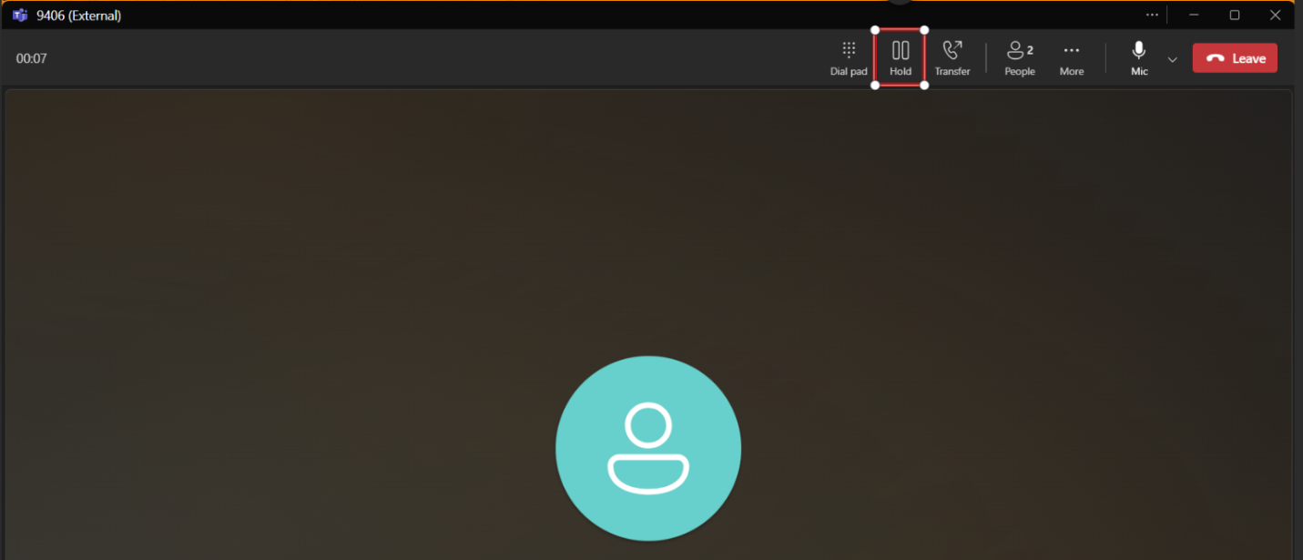

## To Transfer a call.

Select **Transfer**in your call controls. Then, type in the name of the person or phone number you want to transfer the call to and select them. To finish, select **Transfer**.

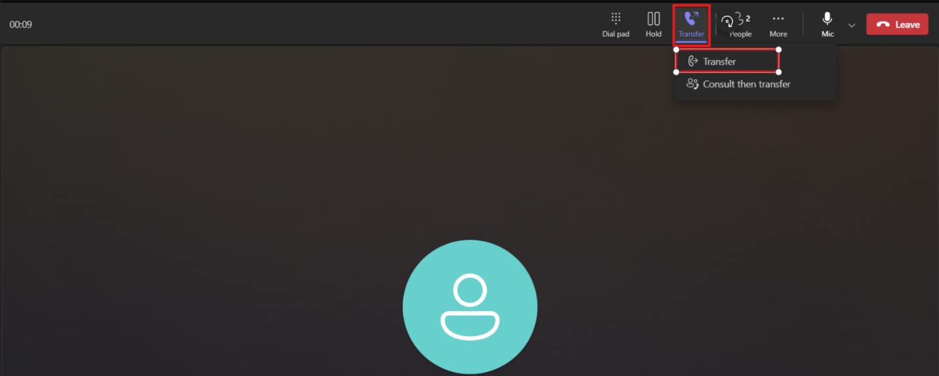

## Consult then transfer.

Select **Transfer** then **Consult then transfer**.

Under **Choose a person to consult**, start typing the name or number of the person you want to reach and select them when they appear. You can call them or consult with them over chat. When you're ready, select **Transfer**.

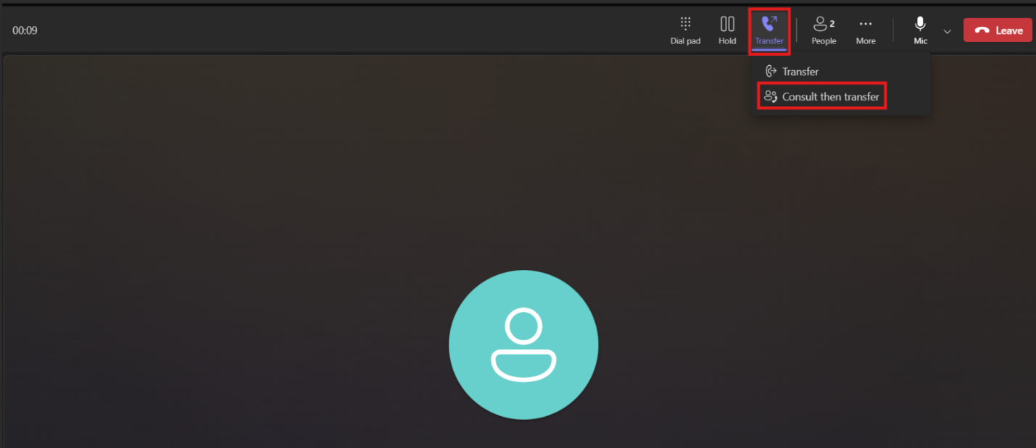

# Teams-Mobile app

On Teams mobile app you have the same functionality that you have in the desktop app.

If you are on the phone with someone in teams and then pull up the Teams mobile app you have an option to join the current call.

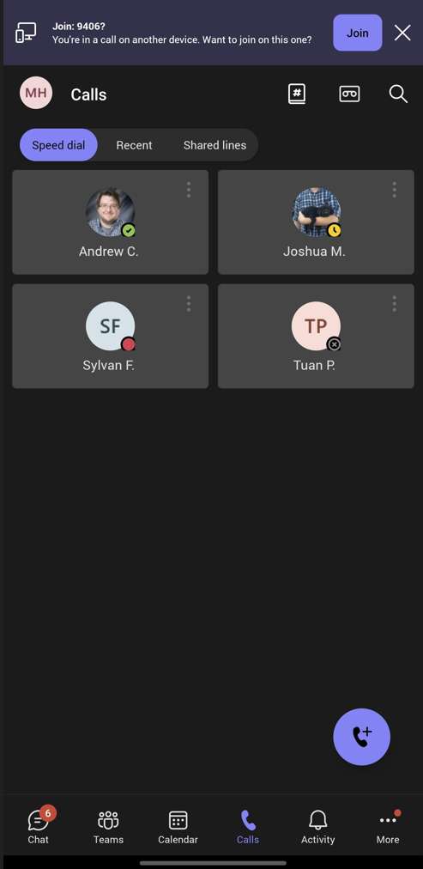

After clicking the join button, you will have another option. Add the mobile device to call joining it muted and keeping your desktop app connected. Or you can just transfer the call to your mobile device.

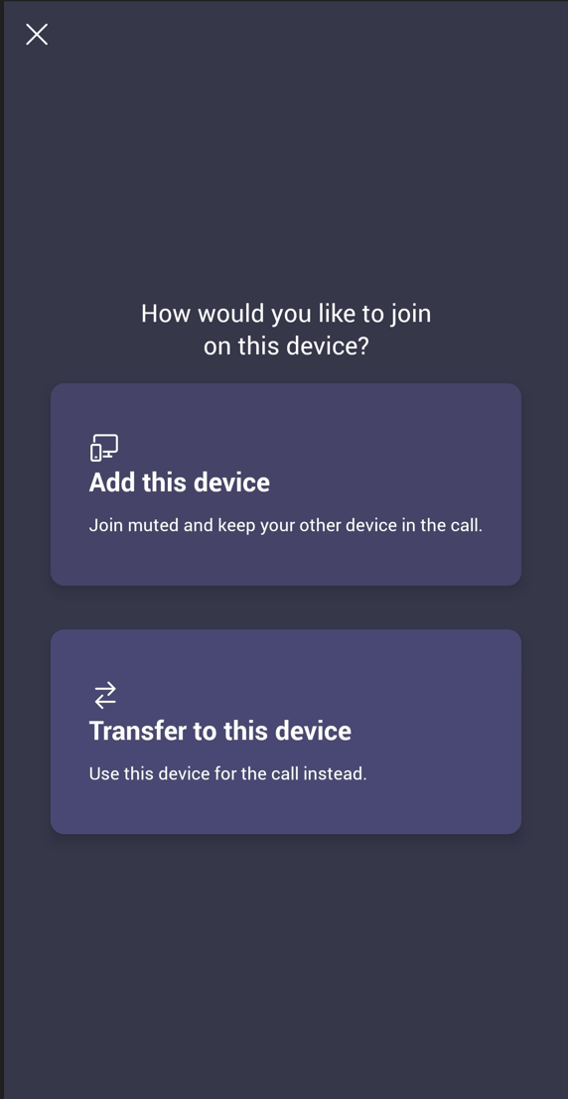

# Teams-Chat

## Start a chat with another person.

1. Start all chats the same way: by selecting **New chat** New chat iconat the top of your chat list.
2. Once you’ve selected **New chat** New chat icon in Teamsand entered a person’s name, compose your message in the box at the bottom of the chat.
3. To open formatting options, select **Format** Expand buttonbeneath the box where you type your message.
4. When your message is ready, select **Send** Send a message icon.or press **Enter**to start the chat.

You can also start a one-on-one chat from someone's profile card. Open it by choosing their picture in a channel or finding their name using the **Search box**.

## Start a chat with yourself.

When you first use Teams, you'll see your name pinned to the top of your chat list. Use this space for drafts, to send messages and files to yourself, or to get to know chat features a little better.

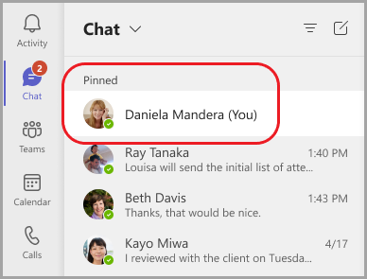

If you unpin the chat and want to find it again, select **New chat** New chat icon and enter your name where it says **To**. Compose your message just as you would in a regular one-on-one chat.

## Start and name a group chat.

A group chat includes multiple people in a conversation. Create a group chat the same way you start a one-on-one chat.

1. Select **New chat** New chat icon in Teamsat the top of your chat list.
2. Select the down arrow to the far right of the **To** field and then type a name for the chat in the **Group name** field.
3. Type in the names of the people you’d like to add in the **To**field.

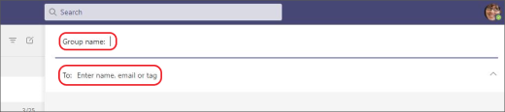

*Type a name for the group chat and add people.*

This starts a new conversation. Everyone who has access to the group chat can send messages.

You can include up to 250 people in a group chat.

## Add people to the conversation.

1. To add people to a group chat, select **View and add participants** Add participants icon**> Add people.**
2. Type in the names of the people you'd like to chat with. If it is already a group chat, you can also choose how much of the chat history to include.
3. Select **Add**to add them to the conversation.

**Notes:**

* You can only include chat history when adding someone to an existing group chat, not a one-on-one.
* Teams saves the entire chat history, all the way back to the first message. If someone leaves the group, their chat responses will remain in your chat history.

## See who's in a group chat.

To see who’s in a group chat, select **View and add participants** Add participants icon in the top right corner. This will show a list of everyone’s names.

# Create an instant meeting-conference call.

In Microsoft Teams, you can do one of the following:

## Create from Calander:

From  **Calendar**on the leftmost side of the screen, select  **Meet now**at the upper-right of the screen.

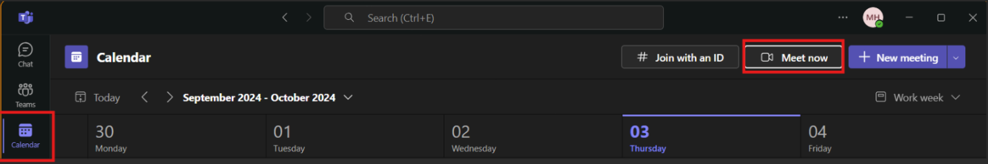

**Edit meeting name**: Give your meeting a descriptive title.

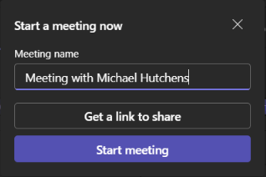

**Get a link**: Select **Get a link to**share to generate a link that you copy to your clipboard and share in any way you want.

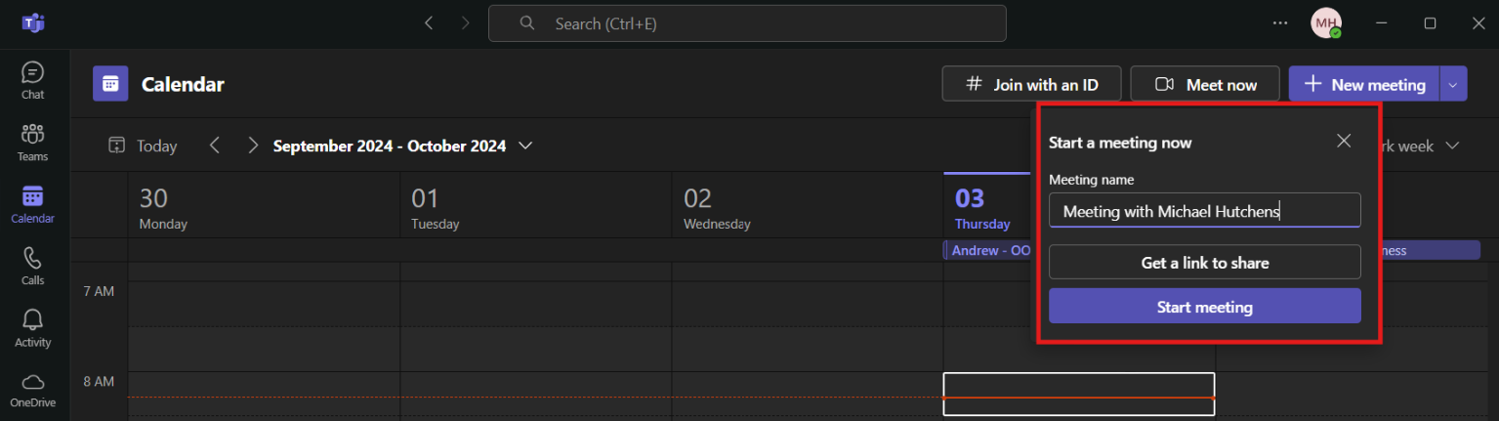

Select **Start meeting**to begin.

## Create from Chat:

Select Chat then click on an existing chat or create a new one. Then select Audio Call.

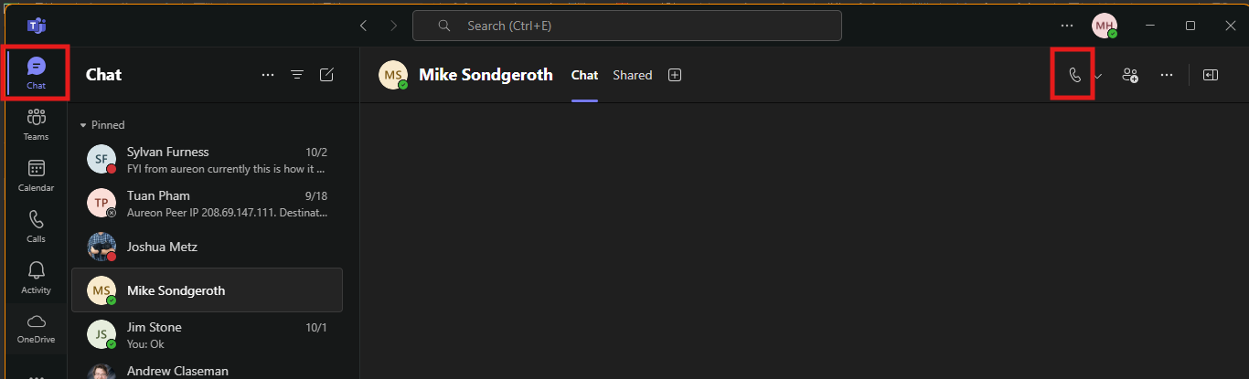

# Add another person to the meeting-conference call:

In the meeting-call click on people then type in the name or number of the person you are wanting to join the meeting-call.

