Users ↔ Projects — Data Model
From user_master you get the user's user_id. A user's project assignments are stored in user_role_mapping (one row per assignment). Join user_role_mapping on user_id to get that user's rows; each row's project_map_id points to project_mapping, and project_mapping.project_id points to project_master, which holds the project name.
So the path is:
user_master → (user_id) → user_role_mapping → (project_map_id) → project_mapping → (project_id) → project_master.

The tables
Table | What it is | Key columns
user_master | The people (one row per user) | user_id (PK), user_name, user_email, is_active
project_master | The projects | project_id (PK), project_name, region_id
user_role_master | The role catalog (role names) | user_role_id (PK), user_role
project_mapping | A project's org slot (ties a project to a BU / division) | project_map_id (PK), project_id (FK), bu_id, division_id
user_role_mapping | THE link — a user + a role + a project slot | user_id (FK), user_role_id (FK), project_map_id (FK), is_active

How the link works
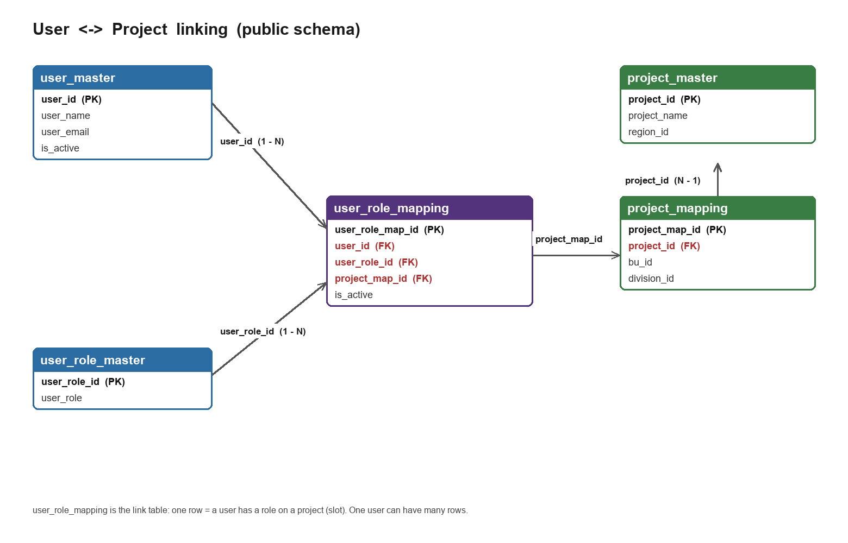
- A user connects to a project through user_role_mapping: user_id + user_role_id + project_map_id.
- project_map_id points (via project_mapping) to a real project_id in project_master.
- One user, many rows = multiple roles and/or multiple projects.
- No user_role_mapping row = no role and no project for that user (the app then treats them as having no access).

The join that ties it together
SELECT um.user_name, r.user_role, p.project_name
FROM public.user_master um
JOIN public.user_role_mapping urm ON urm.user_id = um.user_id
JOIN public.user_role_master r ON r.user_role_id = urm.user_role_id
JOIN public.project_mapping pm ON pm.project_map_id = urm.project_map_id
JOIN public.project_master p ON p.project_id = pm.project_id
WHERE um.user_email = 'someone@algihaz.com';

Example
User | Role | Project
Algihaz Digital | Digital Admin | Neom Mountain - Test
Algihaz Digital | Corporate HSE Manager | Replacement Power - Test
Samiullah Maqbool | Regional HSE Manager | HAIL Project
Each line above is one row in user_role_mapping, with names filled in by the joins.

