

College of Engineering and Technology
Mechanical Engineering
Robotic Arm
Presented By:
Veronica Abdelnour 221005499
Raneen Mohamed 241006862
Lojyn Tarek 221006272

Supervised By:
DR. Mostafa Fouz

Table of Contents
1. The DH Solved Problem.
2. Required Actuation for Square Drawing Task
3. Implementation Process
4. Circuit and Hardware Used
5. Project Summary

1.The DH solved problem:

DH forward-kinematics — problem statement and full solution

Dh params = [ a0 alpha0 d1 theta1
a1 alpha1 d2 theta2
a2 alpha2 d3 theta3
a3 alpha3 d4 theta4]

Dh params = [ 0 0 L0 0
Lb1 π/2 La1 0
L2 π 0 0
L3 0 0 0]

DH transform formula (standard DH)
i−1Ti​=​[cosθi​ −sinθi​cosαi.−1​ ​sinθi​sinαi-1. ai−1​cosθi
sinθi ​ ​cosθi​cosαi−1. ​−cosθi​sinαi−1. ai−1​sinθi
0 ​sinαi−1. Cosαi-1. Di
0​ 0 0 1 ]

Apply parameters and compute each link transform

Link 1: (a0 = 0, α0 = 0, d1 = L0, θ1 = 0)
With $θ_{1}=0, α_{0}=0$

0T1​=​[1 0 0 0
0 1 0 0
0 0 1 L0​
0 ​0 0 1]

Link 2: (a1 = Lb1, α1 = π/2, d2 = La1, θ2 = 0)
With θ2 ​= 0, α1​ = π/2 (so cos α1 = 0, sin α1 = 1):

1T2=[1 0 0 Lb1​
0 0 -1 0
0 1 0 La1
0 0 0 1]

Link 3: (a2 = L2, α2 = π, d3 = 0, θ3 = 0)
With θ3 = 0, α2 = π (so cos α2 = -1, sin α2 = 0):

2T3​=[1 0 0 L2
0 -1 0 0
0 0 -1 0
0 0 0 1]

Link 4: (a3 = L3, α3 = 0, d4 = 0, θ4 = 0)
With θ4 = 0, α3 = 0 :

3T4​=[1 0 0 L3
0 1 0 0
0 0 1 0
0 0 0 1]

Multiply to get base → end-effector transform
Compute
0T4​ = 0T1​ * 1T2 * ​2T3 * ​3T4
Doing the matrix multiplication (simplified) gives:

0T4​=[1 0 0 Lb1+L2+L3
0 0 1 0
0 -1 0 L0​+La1​1​
0 0 0 1]

Interpretation
End-effector position (origin of frame 4 in base frame coordinates) is the translation vector (first three entries of fourth column):

p04​=[ Lb1+L2+L3
0
L0​+La1​1​ ]
​.
End-effector orientation (rotation matrix R04 equals upper-left 3×3 block):

R04​=[1 0 0
0 0 1
0 -1 0]

This rotation matrix means the end-effector x-axis is aligned with base x, its y-axis is aligned with base z, and its z-axis is aligned with −base y (read columns as the frame-4 axes expressed in base coordinates, or rows depending on convention).

2.What the robot must do to draw the square

Your end-effector must follow the four edges of a square in 3D space
P1​→P2​→P3​→P4​→P1​

Each point has coordinates:

P1=[X, Ystart, Zstart]P1​=[X,Ystart​,Zstart​]

P2=[X+S, Ystart, Zstart]P2​=[X+S,Ystart​,Zstart​]

P3=[X+S, Ystart+S, Zstart]P3​=[X+S,Ystart​+S,Zstart​]

P4=[X, Ystart+S, Zstart]P4​=[X,Ystart​+S,Zstart​]

Where S = squareSide = 0.04 m.

The robot must move the end-effector along these lines using:

Servo 1 → Joint 1 (base rotation)

Servo 2 → Joint 2 (shoulder)

Servo 3 → Joint 3 (elbow).

What actuation is required?

For each small step along each line segment:

Step 1 — Compute IK for current target

Your code does

T = trvec2tform(segment(i,:));

[configSoln,info] = ik('endeffector', T, weights, initialguess);

This calculates the joint angles needed to make the end-effector reach the point.

Thus for every point on the square path, we get:

q=[q1q2q3]

where:

q1q1​ = base rotation

q2q2​ = shoulder angle

q3q3​ = elbow angle

Step 2 — Convert radians → degrees

writePosition(s1, mapS1(deg1));

writePosition(s2, mapS2(deg2));

writePosition(s3, mapS3(deg3));

Your map function:
mapS1 = @(deg) min(max(deg,0),180)/180;
meaning:

0° → PWM = 0.0

180° → PWM = 1.0

Thus your servos always stay within [0° , 180°].

So what is the required actuation?

The required actuation is:

A sequence of 3-servo coordinated rotations (q1, q2, q3)
computed by the IK solver for each of the ~40 points along the four edges of the square.

Let’s break it down by each joint:

joint 1 (Base servo)

Function:

Rotates the robot around the vertical axis to keep the end-effector aligned with the square path’s X/Y motion.

Expected motion:

Small side-to-side adjustments when moving between points

May rotate slightly from P1→P2 and P3→P4

Minimal rotation for P2→P3 (since motion is mainly along Y)

Joint 2 (Shoulder servo)

Function:

Raises/lowers the arm to set the correct distance from the base.

Expected motion:

Most significant movement during the square

As X increases, shoulder lifts/drops to maintain reach

Smooth continuous motion along each edge.

Joint 3 (Elbow servo)

Function:

Controls precise reach by adjusting forearm extension.

Expected motion:

Works opposite to the shoulder

Extends on P1→P2 and contracts on P3→P4

Follows a smooth curve in joint space for each edge

3. Implementation process
1. Hardware Setup
Selected Arduino Uno as the main controller.

Connected three servo motors:

Servo 1 → Base rotation (D3)

Servo 2 → Shoulder joint (D4)

Servo 3 → Elbow joint (D5)

Powered servos with an external 5V supply to avoid overloading Arduino.

Verified ground connection is common between Arduino and power source.

Connected the robot arm mechanical structure with link lengths:

L0,L1,L2,L3L0​,L1​,L2​,L3​

2. DH Parameter Definition

Defined the Denavit–Hartenberg table to describe the robot geometry.

Used MATLAB’s standard DH convention:

| a | α | d | θ |
| -- | --- | -- | - |
| 0 | 0 | L0 | 0 |
| 0 | π/2 | L1 | 0 |
| L2 | π | 0 | 0 |
| L3 | 0 | 0 | 0 |

3. Building the Robot Model in MATLAB

Created a rigidBodyTree using MATLAB Robotics Toolbox.

Added each joint and link sequentially:

Joint 1 → fixed

Joint 2 → revolute

Joint 3 → revolute

Joint 4 → revolute (end-effector)

Applied DH transforms using:

setFixedTransform(jntX, dhparams(i,:), 'dh');

Set joint limits using:
jnt.PositionLimits = deg2rad([0 180]);
Verified the 3D robot visualization using show(robot).

5. Inverse Kinematics (IK) Setup

Configured the IK solver using:

ik = inverseKinematics('RigidBodyTree', robot);

Defined a downward-facing end-effector orientation using Euler angles.

Selected IK weight vector to prioritize position accuracy over orientation:

weights = [0 0 0 1 1 1];

Tested IK with fixed points to validate solver performance.
6. User Interface and Mode Selection

Program allowed four operating modes:

A – Manual joint angle input

B – Move to a specific 3D point

C – Draw a square trajectory

D – Draw a circular trajectory

This was done with:

mode = input('Enter a character: ', 's');

7. Trajectory Generation

Square Mode (Mode C)

User provides:

X position

Y start

Z start

Computed square vertices:

P1 → P2 → P3 → P4 → P1

Used interpolation function to generate smooth steps:
segment = interpolate(Pk, Pk+1, 10);
Ensured the end-effector moves in straight-line segments.

Circle Mode

Generated circular path in XY plane using parametric equation:

x = Xc + r*cos(θ);

y = Yc + r*sin(θ);

z = Z_plane;

8. IK Execution for Each Trajectory Point

For each interpolated point:

Generated transformation matrix with trvec2tform.

Solved IK to obtain joint angles.

Verified the motion feasibility using ExitFlag.

Updated visualization and servo commands.

This allowed continuous, smooth drawing of the shapes.

9. Servo Actuation

Sent computed angles to physical servos using:

writePosition(sX, mapS(degX));

Used a delay (pause(0.03)) to ensure stable motion.

Real-time robot motion matched the simulated trajectory.

10. Validation and Testing

Observed system behavior in both simulation and hardware.

Checked trajectory accuracy and end-effector stability.

Adjusted IK weights and servo mappings to improve performance.

4.The circuit and hardware used:

1. Arduino UNO

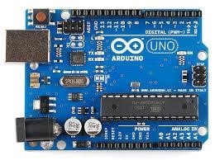
Figure 4: Arduino IDE

The Arduino Uno acts as the main microcontroller of the 3DOF robotic arm system.
It is based on the ATmega328P and is widely used due to its simplicity, stability, and compatibility with servo control.

Role in the 3DOF Robot:
- Generates precise PWM signals to control each servo motor.
- Runs the control code through the Arduino IDE.
- Interfaces with external modules such as Serial Monitor, sensors, or joysticks.
- Supports multiple PWM pins (sufficient for 3 servos).

Why it’s ideal:
- Easy programming
- Stable performance
- Reliable for precise robotic movements

2.Buck

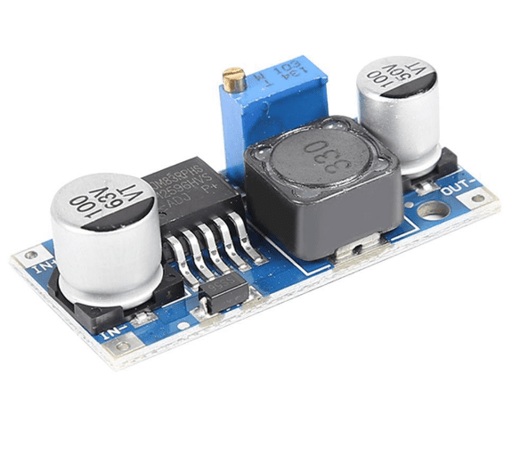

​
The Buck Converter reduces the 12V input down to 6V, which is the optimal voltage for powering the MG996R servo motors.
Why a Buck Converter?
- Provides a stable 6V output for servo operation
- High efficiency (85–95%)
- Supports high current draw without overheating
- Much better than linear regulators for powering multiple servos
Function in the System:
- Converts 12V → 6V for the 3 servos
- Shares a common ground with the Arduino to ensure proper signal reference
- Prevents power drops when servos draw large current.

3. 12V Power Supply
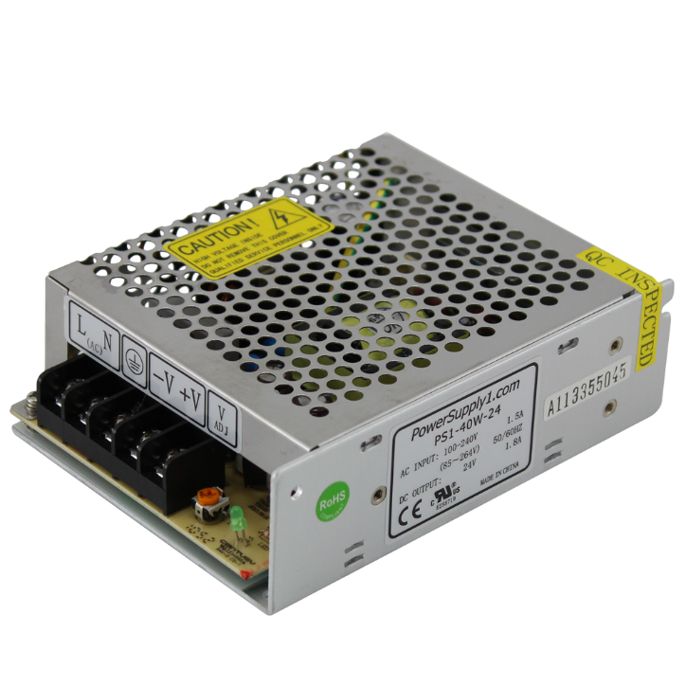

A 12V power supply is used as the main energy source for the robotic arm system.
It provides the required input voltage for the buck converter and ensures a stable power feed to the servos.
Why 12V?
- The servo motors need 6V, but with high current.
- The Arduino Uno can be powered safely through the Vin pin (7–12V).
- A 12V supply allows the buck converter to step down efficiently without overheating.
Advantages:
- Stable voltage
- High current capability
- Suitable for multi-servo robotics projects
4. MG996R Servo Motor (180°)

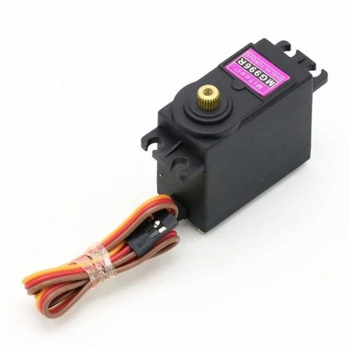

The MG996R is a high-torque metal gear servo used for the robotic arm joints.
It rotates between 0° and 180°, making it ideal for articulated robotic movements.
Specifications:
- Operating Voltage: 4.8V–7.2V (best at 6V)
Torque:
- ~9 kg·cm at 4.8V
- ~11 kg·cm at 6V
Current Draw:
- Normal: 500–900 mA
- Stall: up to 2A
- Rotation: 180°
- Gears: Metal gears for durability
Role in the 3DOF Arm:
- Servo 1: Base rotation
- Servo 2: Shoulder movement
- Servo 3: Elbow movement
Each servo receives an independent PWM signal for smooth and accurate motion.

5. project
