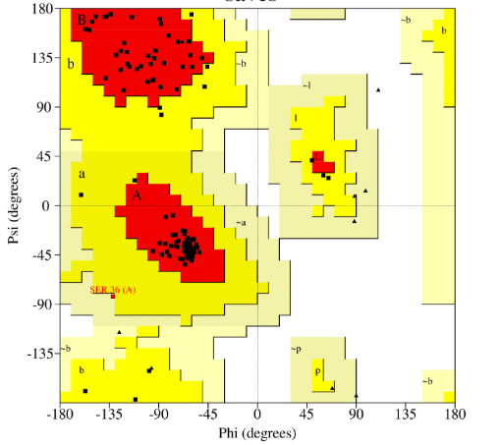
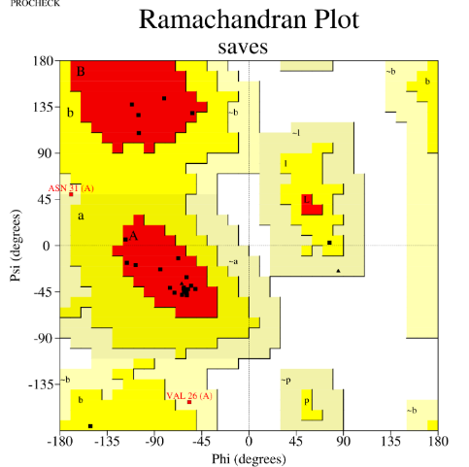
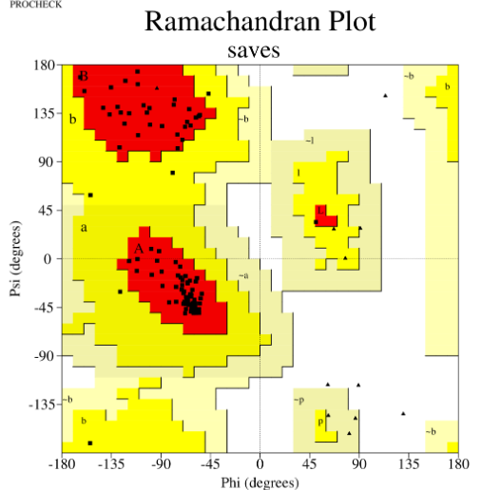
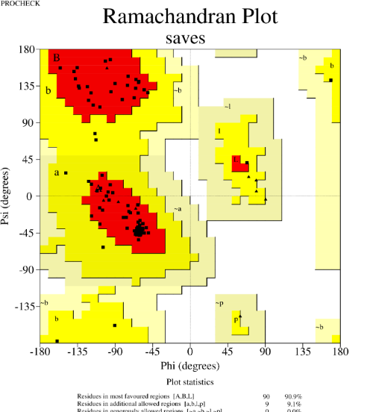
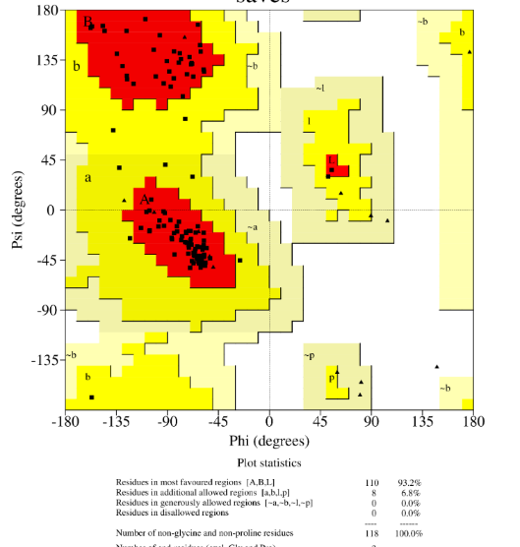

a b

c d

e

Figure 1: Ramachandran plots for models a P0DKT6, b Q4Q03, c P00620, d P21789, and e B5U6Z2.

Table 1: Residue names and numbers of surface binding pockets considered to guide docking.
Protein |  | Active residues used
Snake Venom PLA2s | P0DKT6 | Lue2, Ile3, Glu4, Phe5, Gly6, Lys7, Met8, Thr10, Glu11, Glu12, Pro16, Val17, Phe18, Pro19, Tyr20, Glu21, Ala22
 | Q4QT03 | Val18, Phe21, Ile25, Pro33, Tyr37, Tyr43, Cys44, Gly47, Gly48, Cys60, His63, Asp64, Tyr67, Lys76, Phe112
 | P00620 | Leu2, Phe5, Gly6, Ile9, Val16, Tyr19, Ile20, Tyr25, Cys26, Gly27, Cys42, His45, Asp46, Tyr49, Lys58, Phe93
 | P21789 | Lue2, Phe5, Gly6, Ile9, Pro17, Tyr21, Gly22, Tyr27, Cys28, Gly29, Cys44, His47, Asp48, Ala92, Phe96
 | B5U6Z2 | Val18, Phe21, Gly22, Ile25, Pro33, Phe34, Tyr37, Thr38, Tyr43, Cys44, Leu46, Cys60, His63, Asp64, Tyr67, Asp105, Phe112
Mtb membrane protein | 4QLP | Phe100, Gln101, Glu102, Leu105, Ile111, Thr113, Arg119, Gln120, Arg121, Asp122, Ala136, Ala137, Asp138, Val141, Trp798, Pro800, Glu801, Gly802, Trp803, Asp827, His828, Gln829, Arg841
 | 7WCJ | Pro40, Ala41, Thr42, Asp43, Gly44, Ala45, Thr46, Ala49, Arg53, Leu69, Arg71, Pro73, Asn74, Gln76, Arg77, Leu78, Ala95, Asp97, Val98, Val99, Trp100, Thr149, Thr150, Asn151, Gln153, Trp187, Ala189, Val190, Gln191, Ala192, Asn193, Gln194, Gly195, Glu196, Ala197, Leu198, Val200, trp201, asp250, ser252, ile253, thr256, glu257, glu258, gly259, ser260, ala261, arg262, leu263, ala264, glu266, gln267, val274, Asn275, Trp276, Pro277, Phe278, Phe280, Ala281, Ser282, Leu284, Glu285, Asn286, Gly291, Val292, Asn308, Ile310, Thr312, Phe313, Thr314, Pro315, Ser316, Asp317, Phe320, Tyr336, Gly350, Gly351, Leu352, His377, Asn380, Tyr381, Ser383, Leu384, Glu385, Gly386, Gly387, Leu388, Pro389, Gln400, Ala403, Lys404, Tyr405, Pro406, Met407, Arg421, Tyr427, Gln428, Ala431, Val432, Ala435, Ser439, Pro440, Ile441
 | 7NVH | Thr39, Gln40, Asp64, Ser66, Gly67, Val70, Ala164, Gly165, Leu166, Val169, Ala170, Leu173, Thr174, Ile177, His234, Tyr235, Phe236, Ile422, Ser423, Glu424, Gln437, Phe440, Tyr447, Thr448, Ser449, Leu693, Met695
 | 7UQ0 | Asp64, Pro65, Gly66, Pro67, Arg70, Pro71, Ala72, His73, Asn74, Ala75, Ala76, Gln161, Gly162, Val178, Phe179, Thr180, Ala181, Ala182, Asp186, Asn189, Asn190, Arg192, Gly193, Ala196, Ala199, Ile201, Asp205, Ile208, Thr209
 | 6DDN | Ser144, Asp163, Pro176, Ala182, Lys183, Leu186, Leu187, Ser233, Tyr240, Ala270, Trp332, Asp336, Leu339, Phe340, Asp341

Table 2: HADDOCK docking with P0DKT6. Showing scores for the top-ranked cluster when docked to each of the Mtb membrane proteins.
Parameters | Mtb membrane protein name
 | 4QLP | 7WCJ | 7NVH | 7UQ0 | 6DDN
HADDOCK score | -109.9±4.6 | -73.7±4.6 | -88.7±55 | -89.0±2.9 | -72.5±13.8
Cluster size | 32 | 16 | 44 | 78 | 7
RMSD from the overall lowest-energy structure | 0.3±0.0.2 | 0.3±0.2 | 0.9±0.7 | 0.9±0.6 | 0.7±0.4
vdW Energy | -61.0±8.1 | -62.5±6.8 | -50.7±5.9 | -61.6±4.2 | -43.8±4.0
Electrostatic Energy | -219.9±28.2 | -284.7±30.0 | -223.4±28.4 | -67.3±5.5 | -105.0±34.1
Desolvation Energy | -13.5±2.0 | -10.8±2.5 | -17.7±2.0 | -27.0±1.6 | -13.0±1.4
Restraints Violation Energy | 84.7±10.1 | 565.5±48.4 | 243.8±54.5 | 130.4±32.2 | 53.1±29.1
Buried Surface Area | 2071.4±71.8 | 2350.5±46.7 | 2000.5±82.8 | 1715.2±41.3 | 1420.7±59.9
Z-Score | -2.5 | -1.2 | -2.1 | -0.9 | -1.5
vdW-van der Waals Energy.

Table 3: HADDOCK docking with Q4QT03. Showing scores for the top-ranked cluster when docked to each of the Mtb membrane proteins.
Parameters | Mtb membrane protein name
 | 4QLP | 7WCJ | 7NVH | 7UQ0 | 6DDN
HADDOCK score | -99.2 ± 4.3 | -66.2±8.9 | -93.6±5.1 | -93.2±1.9 | -72.7±9.2
Cluster size | 30 | 26 | 21 | 46 | 9
RMSD from the overall lowest-energy structure | 0.7 ± 0.4 | 0.4±0.3 | 16.5±0.1 | 10.4±0.1 | 2.4±0.7
vdW Energy | -51.3 ± 3.7 | -65.6±4.9 | -77.5±4.2 | -58.4±3.6 | -37.8±4.6
Electrostatic Energy | -176.1 ± 7.2 | -465.7±57.2 | -210.3±24.0 | -160.7±23.9 | -147.8±36.0
Desolvation Energy | -22.9 ± 2.6 | 22.4±4.9 | -12.1±3.1 | -15.8±1.3 | -19.4±0.9
Restraints Violation Energy | 102.2 ± 14.2 | 701.9±97.0 | 380.4±32.4 | 131.3±21.5 | 140.0±22.6
Buried Surface Area | 1954.1 ± 39.1 | 2749.9±78.6 | 2691.1±56.5 | 1857.9±43.2 | 1631.7±200.1
Z-Score | -1.7 | -1.5 | -2.3 | -2.2 | -1.4

Table 4: HADDOCK docking with P00620. Showing scores for the top-ranked cluster when docked to each of the Mtb membrane proteins.
Parameters | Mtb membrane protein name
 | 4QLP | 7WCJ | 7NVH | 7UQ0 | 6DDN
HADDOCK score | -143.6±2.6 | -104.0±4.2 | -117.6±3.8 | -123.2±1.0 | -115.3±8.3
Cluster size | 127 | 39 | 4 | 132 | 7
RMSD from the overall lowest-energy structure | 11.3±0.0 | 10.9 ±0.3 | 7.8±0.1 | 7.0±0.3 | 0.6±0.4
vdW energy | 86.7±6.0 | -81.8±3.8 | -75.0±5.2 | -61.7±5.3 | -54.2±8.6
Electrostatic Energy | 253.5±24.9 | -228.1±28.3 | -182.5+/-20.9 | -172.8±16.7 | -191.5±38.6
Desolvation Energy | -18.3±2.3 | -35.5±4.2 | -33.5±4.0 | -35.2±2.9 | -30.2±3.2
Restraints Violation Energy | 121.2±48.9 | 589.8±52.9 | 273.5±83.6 | 82.4±49.6 | 74.1±16.0
Buried Surface Area | 2505.8±61.9 | 2501.4±149.6 | 2512.2±30.4 | 1834.9±45.2 | 1848.4±76.8
Z-Score | -1.0 | -1.4 | -2.1 | -1.3 | 2.4

Table 5: HADDOCK docking with P21789. Showing scores for the top-ranked clusters with each Mtb membrane protein.
Parameters | Mtb membrane protein name
 | 4QLP | 7WCJ | 7NVH | 7UQ0 | 6DDN
HADDOCK score | -121.9±5.5 | -81.7±7.8 | -120.9±6.5 | -134.1±3.2 | -125.3±10.7
Cluster size | 7 | 40 | 9 | 36 | 16
RMSD from the overall lowest-energy structure | 12.0±0.3 | 8.5±0.3 | 14.6±0.1 | 0.8±0.5 | 0.4±0.3
vdW Energy | -85.9±12.2 | -79.1±5.8 | -75.4±3.0 | -61.5±4.6 | -39.8±5.6
Electrostatic Energy | -201.0±45.8 | -386.5±18.2 | -229.2±29.3 | -213.1±13.4 | -500.6±38.5.6
Desolvation Energy | -32.4±6.8 | 8.8±2.7 | -28.7±2.3 | -39.2±4.4 | -4.5±0.9
Restraints Violation Energy | 366.6±55.1 | 659.0±74.5 | 291.4±39.1 | 91.9±19.0 | 192.2±27.6
Buried Surface Area | 2778.3±147.1 | 2991.8±151.2 | 2447.5±101.1 | 2069.1±30.4 | 1948.7±59.1
Z-Score | -1.8 | -1.9 | -1.8 | -1.4 | -2.1

Table 6: HADDOCK docking with B5U6Z2. Showing scores for the top-ranked clusters with each Mtb membrane protein.
Parameters | Mtb membrane protein name
 | 4QLP | 7WCJ | 7NVH | 7UQ0 | 6DDN
HADDOCK score | -100.3±3.4 | -60.1±6.9 | -81.9±1.6 | -130.2±2.5 | -75.2±7.0
Cluster size | 53 | 65 | 11 | 58 | 34
RMSD from the overall lowest-energy structure | 13.3±0.1 | 0.6±0.4 | 17.2±0.1 | 0.5±0.4 | 4.6±0.3
vdW Energy | -58.2±1.9 | -83.2±2.5 | -58.4±4.3 | -75.6±5.1 | -59.7±8.8
Electrostatic Energy | -154.9±10.4 | -222.5±25.1 | -317.0±17.6 | -180.6±35.5 | -190.7±44.2
Desolvation Energy | -23.2±2.0 | -8.4±4.1 | 3.6±3.0 | -30.3±2.7 | -5.9±3.3
Restraints Violation Energy | 119.7±23.5 | 759.8±31.7 | 364.3±40.6 | 117.0±17.5 | 285.1±54.0
Buried Surface Area | 1930±30.6 | 3023.5±137.9 | 2375.5±87.3 | 2402.7±43.5 | 2232.9±138.6
Z-Score | -1.9 | -1.9 | -1.9 | -1.9 | -1.8

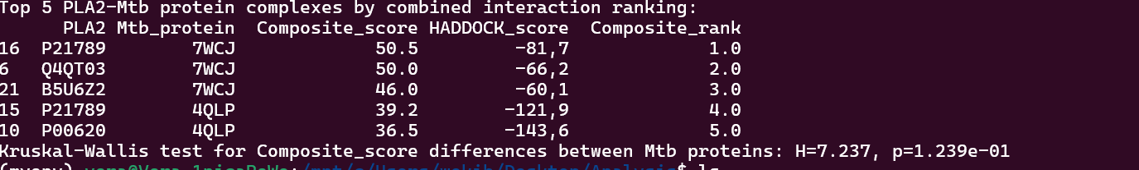

Figure 2: A screenshot of the top ranks of interaction analysis of HADDOCK generated svPLA2-Mtb membrane

The most suitable template identified for the svPLA2s, P00620 and P21789, was 1VIP (anticoagulant class II phospholipase A2 from the venom of Vipera russelli russelli). Although both templates had an E-value of 0.0, their sequence identities to the template differed substantially—59% for P00620 and 77% for P21789. A pairwise sequence alignment was performed and is shown in the figure below.

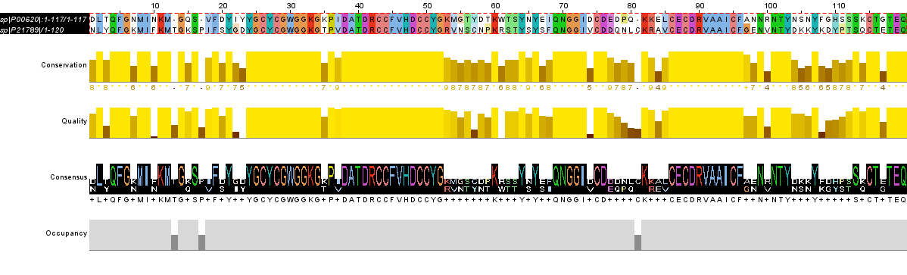
Pairwise sequence alignment of P21789 (PA2A_CERCE) and P00620 (PA2A_BITGA) using EMBOSS NEEDLE Pairwise Sequence Alignment (PSA) via EMBL-EBI webserver (https://www.ebi.ac.uk/jdispatcher/psa/emboss_needle). The matrix used is the EBLOSUM62. The alignment length was 121. The two sequences share a 59.5% identity, and 74.4% similarity. 3.3% (4/121) gaps were created. Corresponding amino acids are marked “|” (516). The Pairwise sequence alignment was visualized by Jalview (488).

