***How do you use your mobile phone?***

Dear participant,

Thank you for your contribution. Your data will be used confidentially and for scientific purposes only. Filling out this survey should take no more than 5 minutes.

1. **General profile**

Participant ID (As in **DS01**):

Gender: □ Male □ Female

Month and Year of birth:

What is your professional activity?

Since when?

You are: □ Left-hander □ Right-hander □ Ambidextrous

Do you practise a specific art requiring a particular or intensive use of the fingers (e.g. piano)?

If yes, what kind?

Since when? How often (hours per week) …………………………………..

Have you ever severely injured your hands, your fingers?

If yes, when and are you still impaired?

1. **Information about your mobile phone**

A. How long (in years) have /did you owned a standard mobile phone? a smartphone?.............................

B. Do you use the internet browser on your phone (for example Chrome or Opera) for checking Facebook or Twitter or Tinder or any other social networking site (choose *ONE*)?

□ Never

□ Less than 30% of the time on the browser

□ Between 30% and 80% of the time on the browser

□ More than 80% of the time on the browser

□ Always

C. Name/s of the internet browser you are referring to in ‘B’……………………..

D. For how many minutes per day do you use your phone ? ………………………… min per day

E. For how many minutes per day did you use your phone last week ? ……………… min per day

F. For how many minutes did you use your phone yesterday ? ……………………..…min

1. **If you are a smartphone user, how often do you use your phone in the following ways? Rank the situations from the most frequent (assign number 1) to the most rare (assign number 18).**

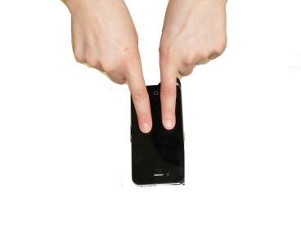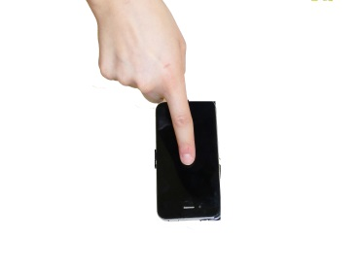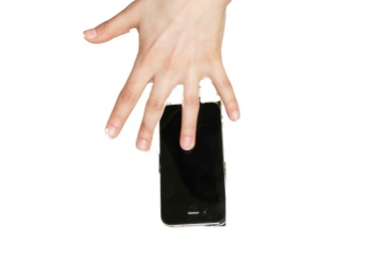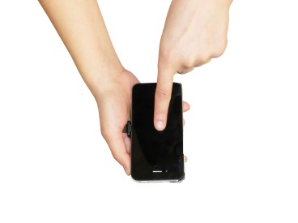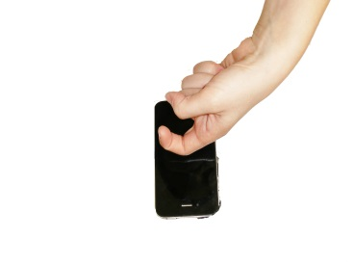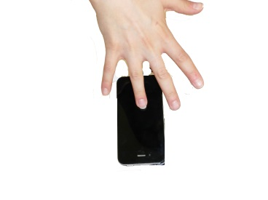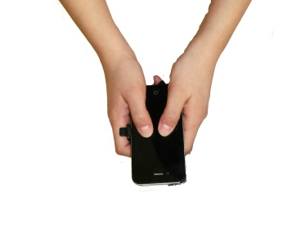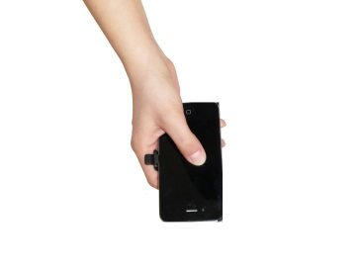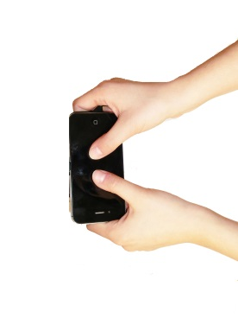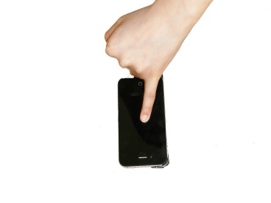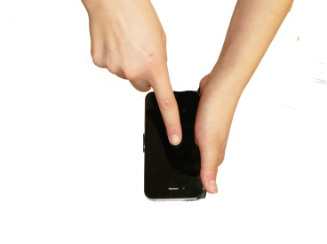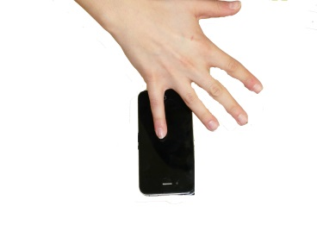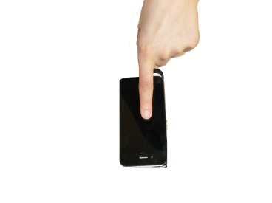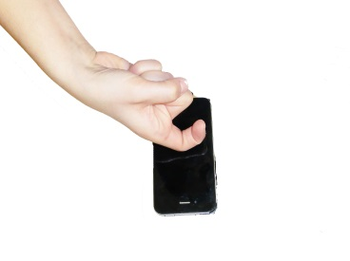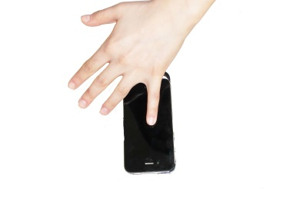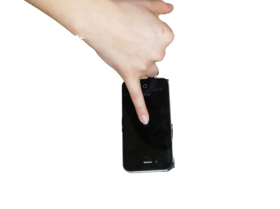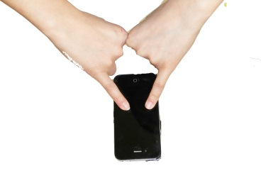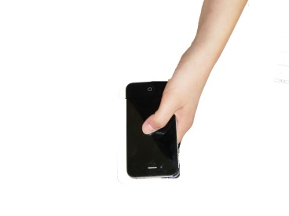

1. **Do you use any of these devices? If yes, with which hand usually?**

Track pad on the notebook/PC □ No □ Yes, □ with the right hand □ with the left hand

Mouse □ No □ Yes, □ with the right hand □ with the left hand

Wii □ No □ Yes, □ with the right hand □ with the left hand

Gamepad/joystick □ No □ Yes, □ with the right hand □ with the left hand

Tablet □ No □ Yes, □ with the right hand □ with the left hand

1. **Do you use a stylus on your phone?**

|  |  |  |  |
| --- | --- | --- | --- |
| □ never | □ rarely | □ often | □ always |

Date…………………………. Signature