This document refers to this task: “2---- Another thing is during the test itself, so on Psychtoolkit there are a few things to fill in, I will send a more detailed document on this in a bit with what it should look like.”

For every task AND survey

* Corsi
* N back
* Task switching
* Phone survey
* SF-36

Fill in the following forms.

Obviously it’s very related to task 1 (1---- First of all, descriptions of the tasks. There are 2 sides to this, a short description/pitch One sentence. The second is a longer description which explains what the user will be doing in the task.. Longer means up to 5 sentences max. This text should also be translated in dutch once approved.)

# 1 : about

# 2 (optional)

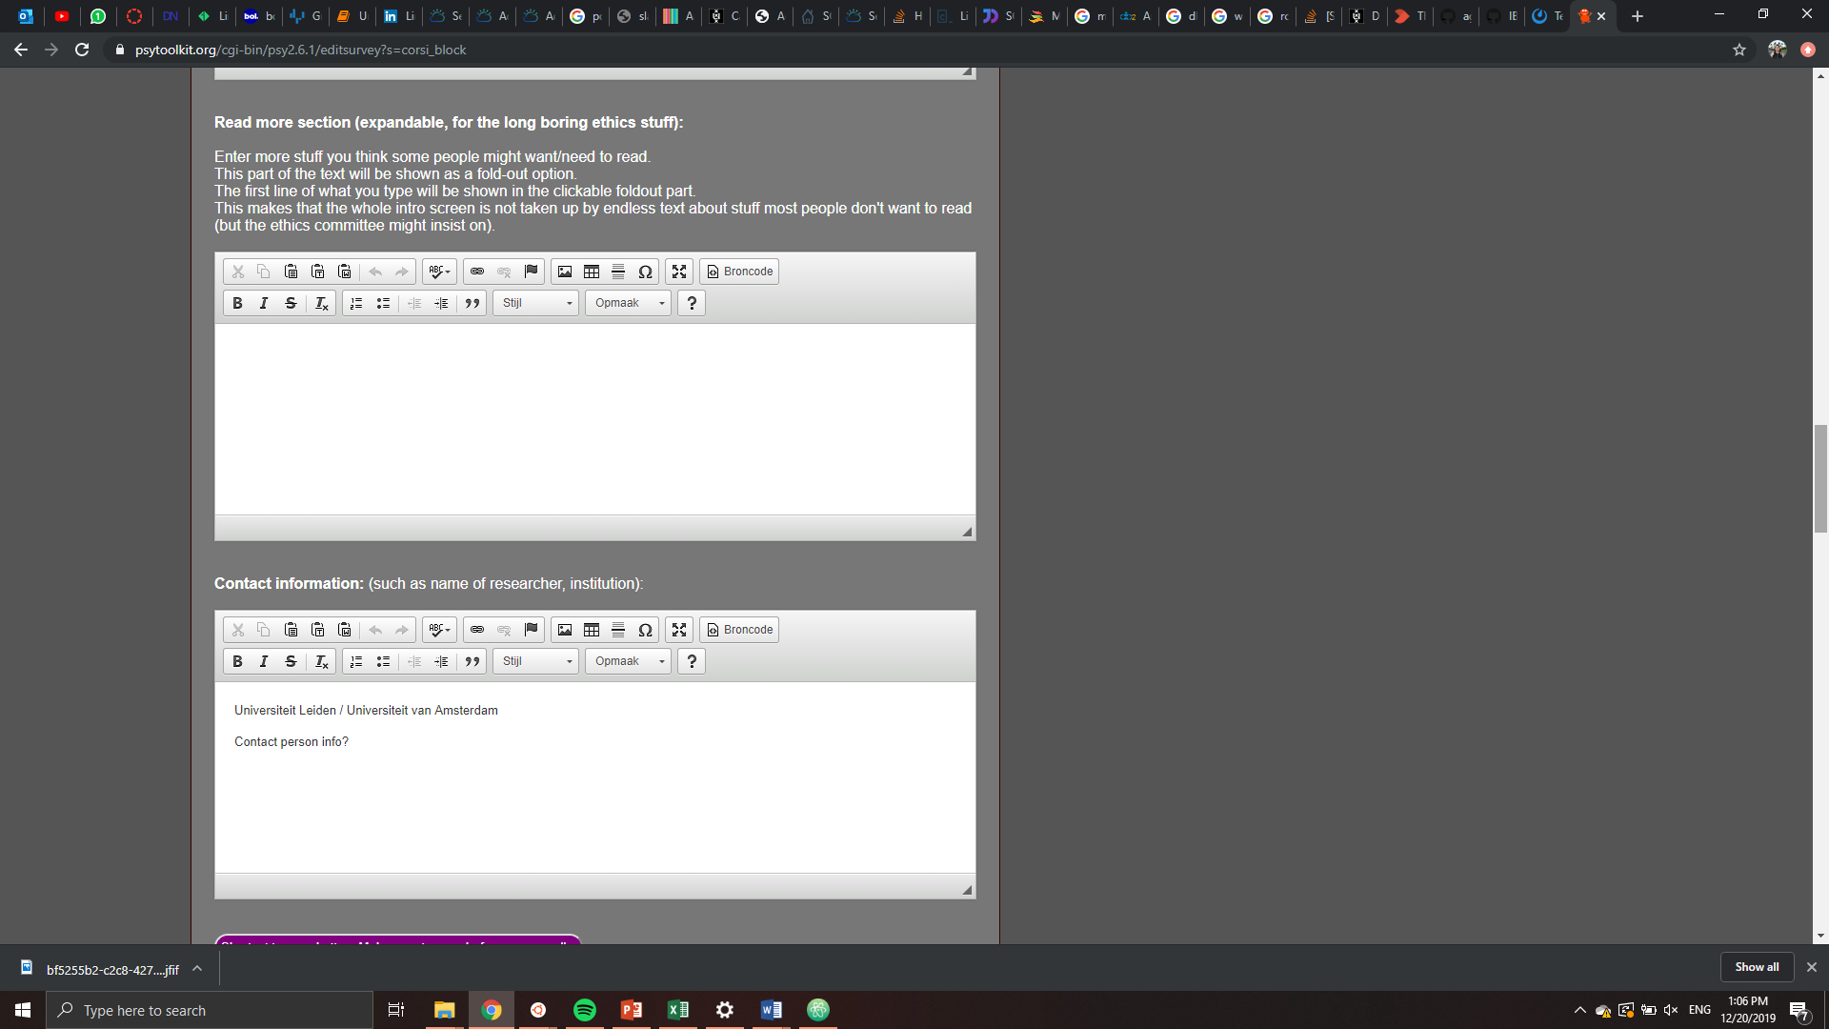

# 3: contact info



# 4: consent

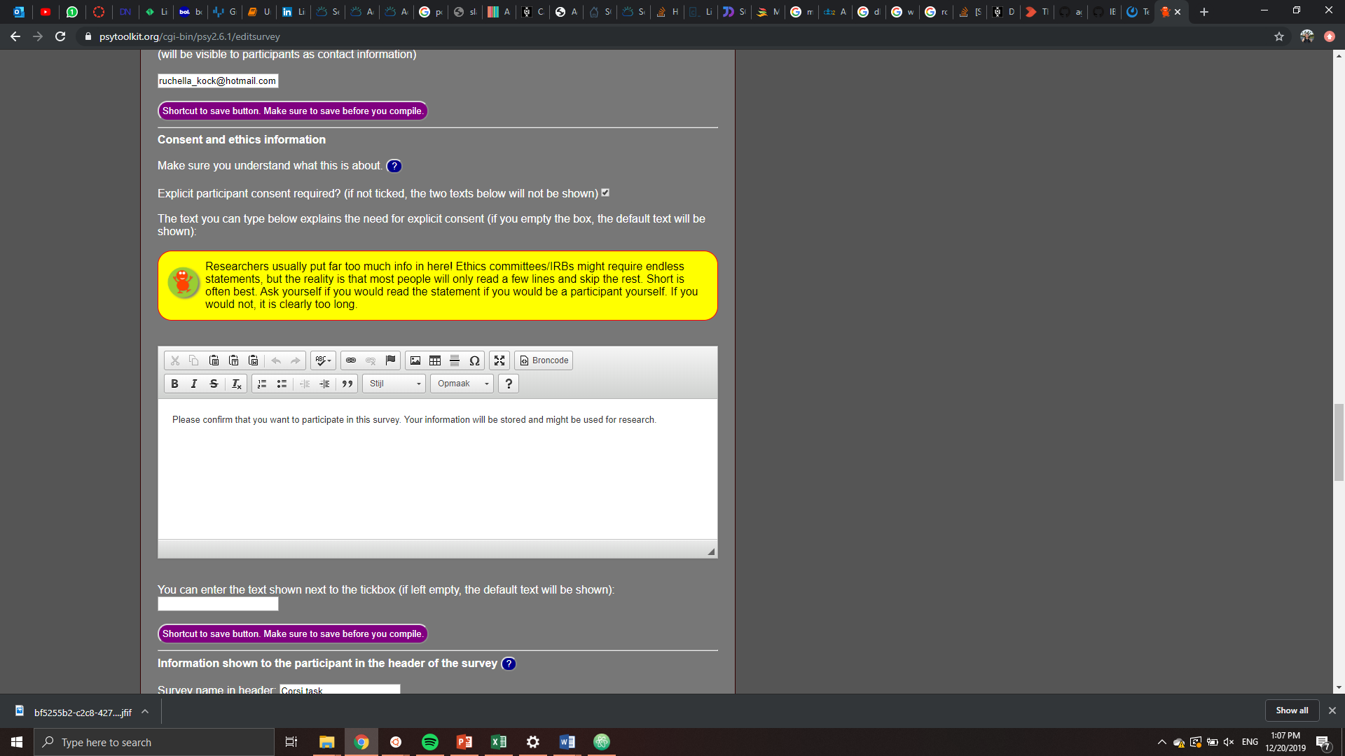

# 5: After task

# 