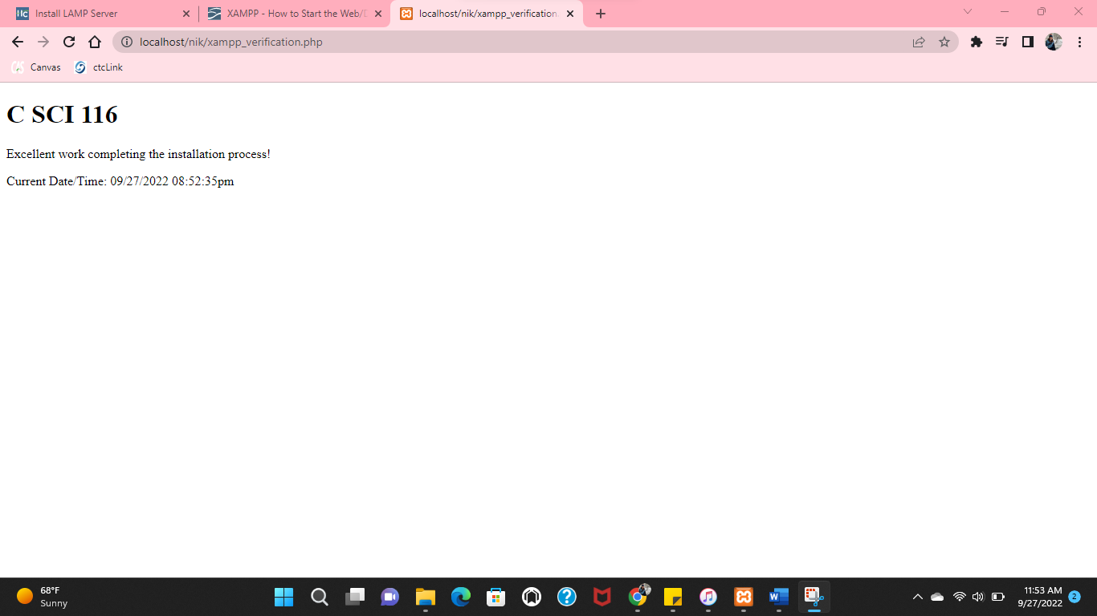

Followed your instructions step by step from the video tutorial on Xampp. I named a folder “nik” and pasted the xampp_vertification.php document inside the folder.