Git Guide (Veronika Sukhovii)

Git Init
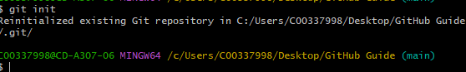
The Git init command creates a new, empty Git repository in your current folder.
Git add
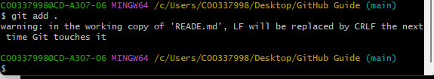
The git add command prepares your files before saving them. It moves changes from your folder to the staging area
Git commit
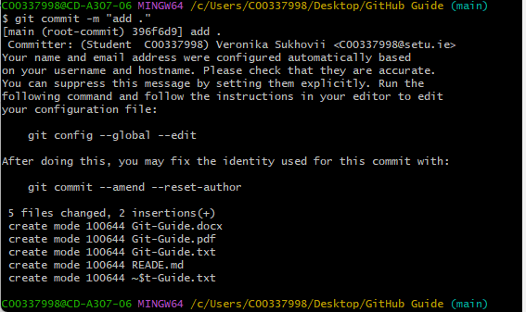
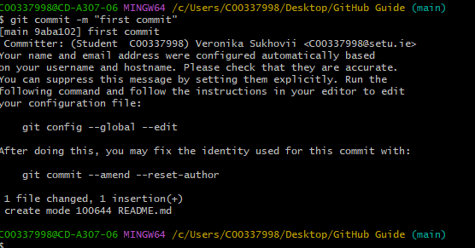
New revision point on local repository and will enter editor mode to enter multiline comment
Git status
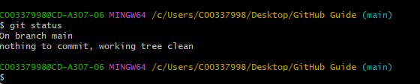
Shows the state of the working directory and staged files
Git remote
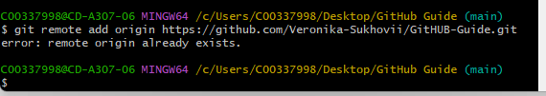
Connects the local repository on my computer to GitHub

Git push
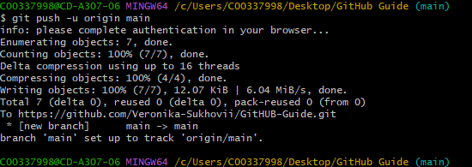
Uploads local commits to the remote repository on GitHub
Git branch
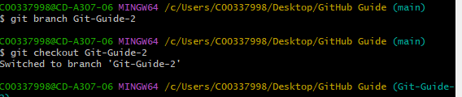
“it as a "parallel universe" for your code.”. Lists, creates, or renames branches in my repositiry
Git checkout
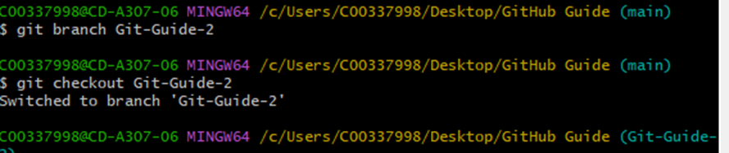
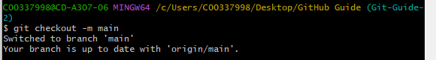
Switches to another branch or creates a new branch

Git pull
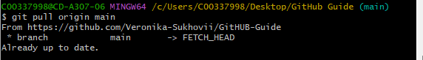
Downloands changes from GitHub and updates my local project
Git log
Displays the commit history for the current repository s

