**Test plan**

***“Wear Me”***

*Individual project*

**Version history**

|  |  |  |  |  |
| --- | --- | --- | --- | --- |
| **Version** | **Date** | **Author(s)** | **Changes** | **State** |
| 0.1 | 05.11.2021 | Veronika Valeva | Initial test plan with planning of Sprint 1 and 2, information about the problem, the group, way of working, reserch methods, finances | Sprint 3 deliverable |
| 0.2 | 22.11.2021 | Veronika Valeva | Refactor of code with sonarqube recomendations. Added sonarqube quality assurance metricsscreenshots | Sprint 4 deliverable |
| 0.3 | 08.01.2022 | Veronika Valeva | Update SonarQube | Sprint 6 deliverable |

# Testing strategy and configuration management

**Testing strategy**

A few testing methods will be applied:

* Unit testsing –used to test different parts/units of the code and will be implemented each sprint for the newly added features
* Regression tests – used to test if the whole program still works as it should when a new feature is added. This testing will also be done each sprint
* User tests - User testing refers to a technique used in the design process to evaluate a product, feature or prototype with real users
* System testing – used to test the whole system and will be done in the last sprint before release of the final product

The testing of some features that require to be tested often or are complicated and may be wrongly tested, will be automated. An example is the login in the application. For automated testing a software like Selenium will be used.

**Test environment and required resources**

Continuous integration and continuous delivery are used. For the test environment, we are going to use a CI/CD environment in this project.

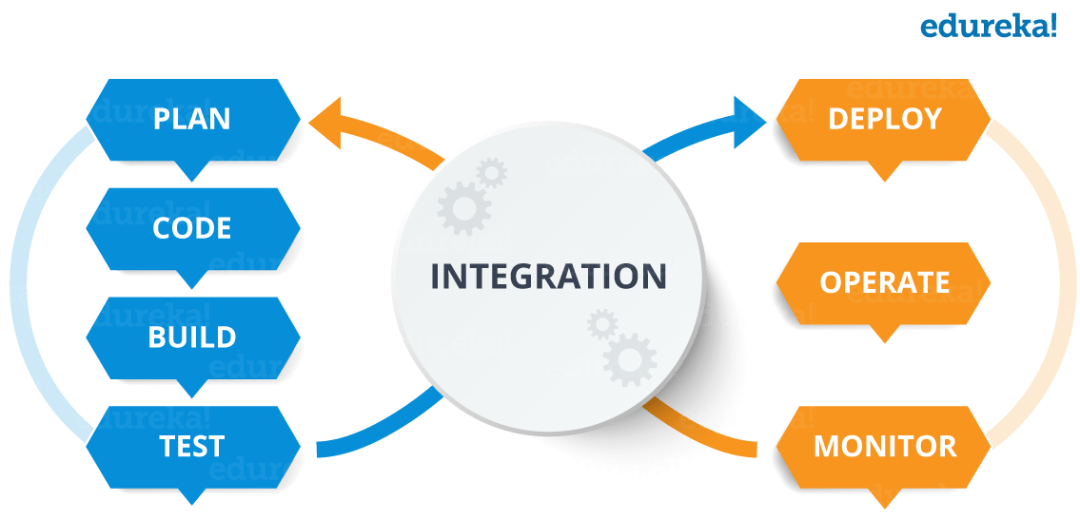

**Configuration management**

*A management tool for the project will be Git CI/CD.*

# Integration testing

Postman is used to automate integration tests. Automated testing prevents human error and streamlines testing. The tests and requests are aggregated and created into a single automated test sequence.

# SonarQube

SonarQube is a tool which aims to improve the quality of your code using static analysis techniques to report:

22.11.2021 – Update SonarQube screenshots

08.01.2022 – Update SonarQube screenshot

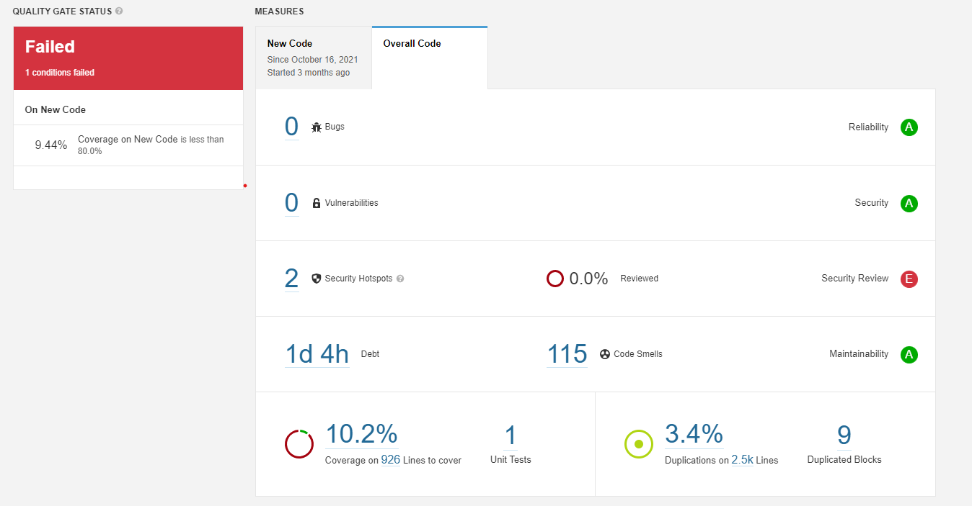

# User Acceptance Test Cases

|  |  |  |  |  |  |
| --- | --- | --- | --- | --- | --- |
| ID | User story | Name | Pre-condition | Test data | Expected result |
| TC-01 | US-01 | Register/create profile on the website | The log in/register page is displayed |  | The user can use the website |
| TC-02 | US-02 | The user can log in to her/his profile on the website | The log in/register page is displayed | **Customer account:** username: veronika  Password: veronika  **Community Manager:**  U: nikolay  P: nikolay  **Sales Manager:**  U: sales  P: sales | The user can use the website |
| TC-03 | US-03 | The user can view the website without creating or having an account | The main page of the website is displayed. |  | The user can use the website without an account. |
| TC-04 | US-04 | The user can view the main page of the website | The main page is displayed |  | The user can use the website |
| TC-05 | US-05 | The user can filter the products on the main page | The filter function on the main page is activated. The filter menu is displayed |  | The user can choose different items. |
| TC-06 | US-06 | The user can view his/her profile | The user viewing the site has already logged/registered on the website. |  | The user can view my personal information. |
| TC-07 | US-07 | The user can edit my personal information in his/her profile | The profile page has to be displayed. The edit profile functions should be activated. The edit profile page is displayed. |  | The user’s information on the website is up to date. |
| TC-08 | US-08 | The user can add/edit/delete his/her billing information | The profile page should be displayed. The edit billing information function should be activated. The edit billing information page is displayed. |  | The user’s billing information is up to date. |
| TC-09 | US-09 | The user can save an item presented on the website to a list of his/her favourite items | The save to favourites function should be activated. |  | The user can easily review those chosen items later. |
| TC-10 | US-10 | The user can add a certain item to his/her shopping bag | The add to shopping bag function should be activated. |  | The user can buy it later |
| TC-11 | US-11 | The user can remove items from the list with favourite items | The list of favourite items is displayed. |  | The user can review only items that I want. |
| TC-12 | US-12 | The user can remove items from his/her shopping bag | The shopping bag is displayed. The shopping bag should not be empty or no action is going to occur. |  | The user doesn’t have to buy items I do not want. |
| TC-13 | US-13 | The user can proceed to order the items in his/her shopping bag | The ordering page is displayed. |  | The user can buy the items. |
| TC-14 | US-14 | The user can choose his/her payment method | The data constrains about the ordering up till now should be completed. The payment methods are displayed on the page. |  | The user can proceed with my order |
| TC-15 | US-15 | The user can finish his/her order | The data constrains about the ordering up till now should be completed. An email is sent to the e-mail the customer has provided. |  | The user can receive the items I have ordered. |
| TC-16 | US-16 | The user can stop the ordering during the filling of information | The ordering process is stopped. |  | The user can add/remove items from his/her order. |
| TC-17 | US-17 | The user can reach to the Sales manager and cancel his/her order | An order has been made. The customer sends an email to the Sales manager with the information about the order. |  | The user does not have to pay and receive items the user doesn’t want. |
| TC-18 | US-18 | The user can log out of his/her profile |  |  | The user can end his/her visit on the website |
| TC-19 | US-19 | The community manager can change the status of a user’s profile. | The change status function is activated. The community manager chooses and saves the updated status of the chosen profile. |  | The manager can perform his/her job. |
| TC-20 | US-20 | The sales manager can view the products present in the database | The page with all products is displayed. The filter for the different products status is displayed. |  | The manager can perform his/her job. |
| TC-21 | US-21 | The sales manager can change the status of a product | The change status function is activated. The page for changing product status is displayed. |  | The manager can perform his/her job. |
| TC-22 | US-22 | The sales manager can edit the description of a product | The page showing the product is displayed. |  | The manager can perform his/her job. |