**What type of restaurant could we open in Denver and what area should we choose?**

**Introduction:** We would like to open a new restaurant in Denver for the city visitors. To define the business strategy, we had to:

1. explore distribution of restaurants and understand types of cuisine
2. identify areas where visitors usually stay and based on hotel category define type of visitors

Based on the analysis result we aimed to identify the best location (the place with a lot of hotels but few restaurants) and restaurant type (something unusual) to open.

**Data:**

(1) Denver Zip data was extracted from publicly available repository (<https://public.opendatasoft.com/explore/dataset/us-zip-code-latitude-and-longitude>). The data includes information about Zip codes for different US cities as well as latitude and longitude for each Zip; data for Denver will be extracted

(2) The data was requested from the forsquare database (<https://foursquare.com/>). The extracted data included information on various restaurants and hotel categories along with their geographical location

**Methodology:**

Analysis was conducted on python 3.6 available in IBM Watson Studio. The analysis is documented in Jupiter notebook, available in Github (<https://github.com/VeronikaVor/Coursera_Capstone/blob/master/py_denv.ipynb>). Denver Zip data was uploaded from the public repository and for each Zip code an API foresquare request was generated and processed.

The analysis consisted of 2 steps – exploratory data analysis and clustering. On the first step (1) total number of restaurant and hotel venues was counted and visualized, (2) the most common restaurant types were identified and (3) number of restaurants and hotels for each Zip location was calculated. On the second step, Kmean clustering algorithm was used to analyze the data, N of clusters was set 2. Number of venues for each cluster was explored.

**Results:**

Exploratory data analysis

Table 1 demonstrates total number of hotel venues in Denver for each of the considered categories, sorted by their count:

**Table 1.** Total N of hotel venues in Denver

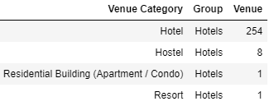

As can be seen from Table 1, hotels are the most preferable group.

**Table 2** demonstrates total number of restaurant venues in Denver for each of the considered categories, sorted by their count:

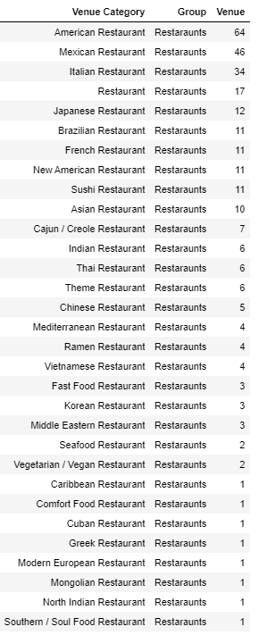

As can be seen from Table 2, American, Mexican and Italian restaurants are the most common in Denver.

Distribution of venues across different Zip is shown in figure 1.

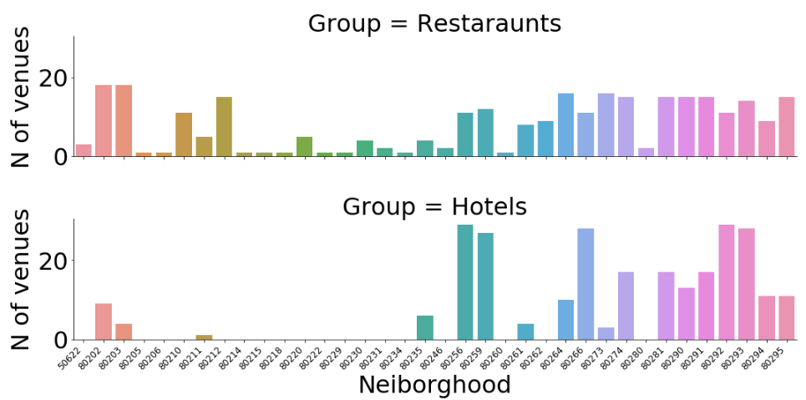

**Figure 1.** Distribution of (A) restaurants and (B) hotels across the Zip

A lot of hotels are located in Zip 80256, 80259, 80266, 80922, 80923, no hotels are identified in some areas. Restaurants are presented in areas with no hotels, so, these are possibly places for local people.

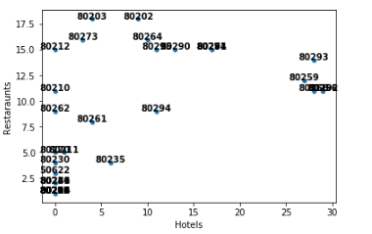

**Figure 2.** Scatterplot of hotel and restaurant count by Zip.

Based on Figure 2 we can conclude that in all areas with hotels at least 4 restaurants are opened.

**Clustering**

Kmean clustering was done using N=2 clusters and the results were visualized (Figure 3):

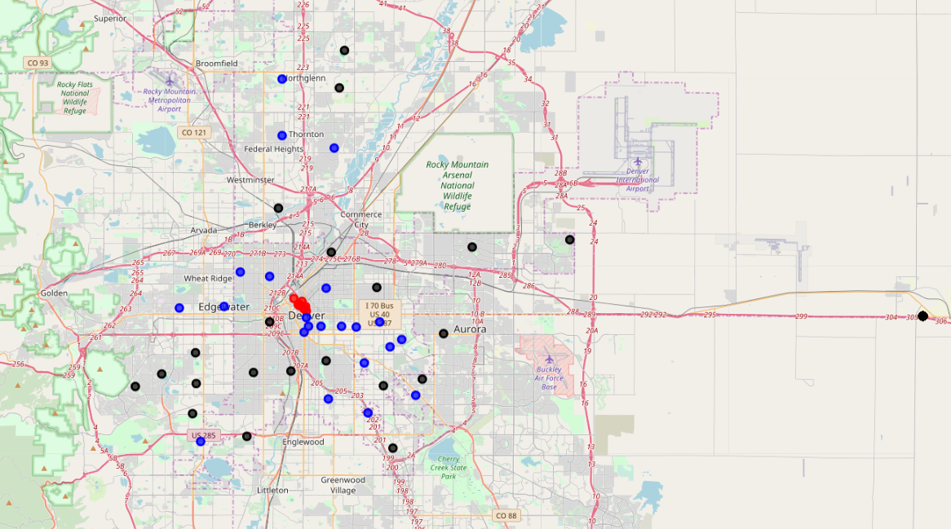

**Figure 3.** Denver map with defined clusters (blue=cluster#0, red=cluster#1), and zip areas without any venues (black).

From fig 3 we can conclude that Zip areas from cluster 1 are located in the center of the city, areas from cluster 0- in the periphery, whereas no venues can be found in remote regions.

Figure 4 provides characteristics of the clusters.

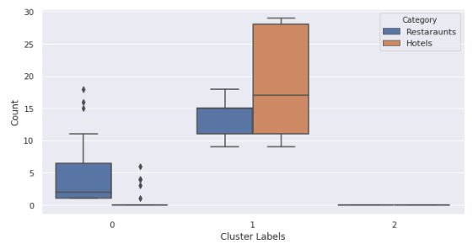

**Figure 4.** Boxplot of hotel and restaurant venues for each cluster/group.

Cluster #1 is characterized by high number of hotels and relatively high number of restaurants, whereas few hotels is presented in cluster #0 Zip locations

**Discussion:**

Here we performed a simplistic 2-step analysis aimed to identify best place and restaurant type to open in Denver.

Opening venues in touristic areas with a lot of hotels could be a good business strategy, so, we aimed to identify areas with high number of hotels. Based on the clustering we identified areas with high number of hotels, howbeit, these areas were characterized by relatively high numbers of restaurants. Highly competitive environment, we need to further optimize business strategy, so, we decided to explore the restaurant types; this allowed us to identify the most common types of restaurants, such as American or Mexican restaurants. We wouldn’t recommend to open places with similar cuisine; opening a vegetarian/vegan or seafood restaurant could be a good option, as very few venues are presented.

**Conclusion:**

Based on the analysis we could recommend opening a vegetarian/vegan, seafood restaurant in cluster#2 areas (e.g. Zip = 14199 or 3043).