# **R****equirements**

*Package in package 'Model'*

Requirements

Version Phase 1.0 Proposed

Veronika created on 14.02.2018. Last modified 28.02.2018

## **Requirements diagram**

*Custom diagram in package 'Requirements'*

Requirements

Version 1.0

Veronika created on 14.02.2018. Last modified 28.02.2018

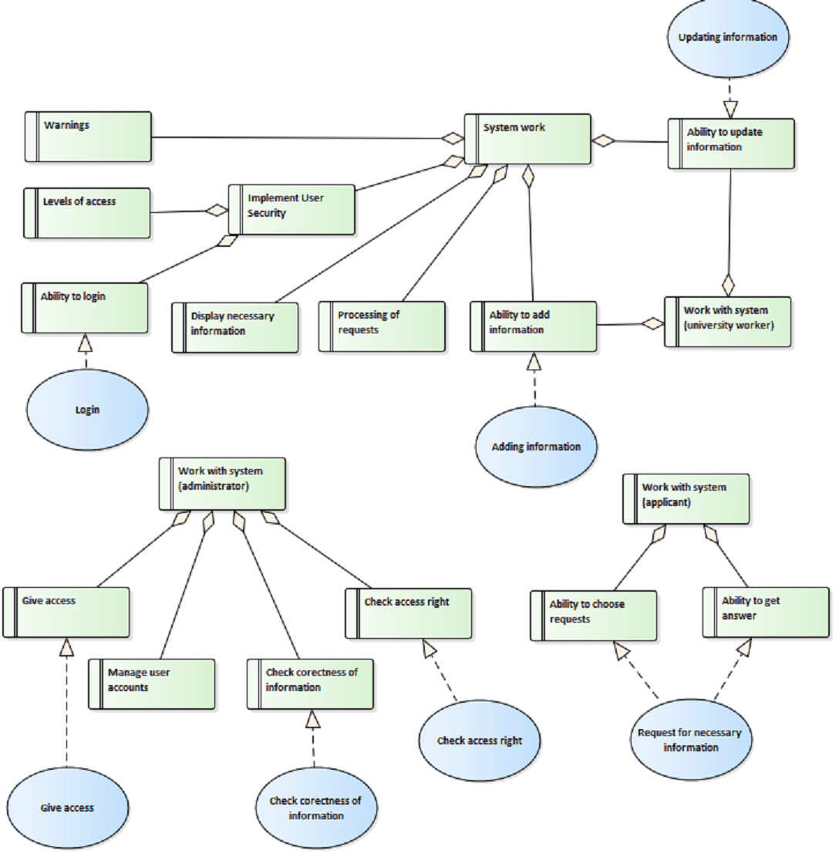

Requirements

## **System work**

*Requirement «Functional» in package 'Requirements'*

Требования к самой системе

System work

Version 1.0 Phase 1.0 Proposed

Veronika created on 27.02.2018. Last modified 27.02.2018

| **ELEMENTS OWNED BY System work** |
| --- |
| Display necessary information : Requirement «Functional»  Система должна отображать запрашиваемую информацию |

|  |
| --- |
| Implement User Security : SecurityRequirement «SecurityRequirement»  Система должна обеспечивать безопасное хранение данных пользователя |

|  |
| --- |
| Processing of requests : Requirement «Functional»  Система должна обеспечивать обработку запросов пользователей |

|  |
| --- |
| Warnings : Requirement «Functional»  Система должна выдавать сообщение об ошибке в случае некорректного ввода или выбора действия |

| **INCOMING STRUCTURAL RELATIONSHIPS** |
| --- |
| Aggregation from «Functional» Display necessary information to «Functional» System work  [ Direction is 'Source -> Destination'. ] |

|  |
| --- |
| Aggregation from «SecurityRequirement» Implement User Security to «Functional» System work  [ Direction is 'Source -> Destination'. ] |

|  |
| --- |
| Aggregation from «Functional» Processing of requests to «Functional» System work  [ Direction is 'Source -> Destination'. ] |

|  |
| --- |
| Aggregation from «Functional» Ability to update information to «Functional» System work  [ Direction is 'Source -> Destination'. ] |

|  |
| --- |
| Aggregation from «Functional» Warnings to «Functional» System work  [ Direction is 'Source -> Destination'. ] |

|  |
| --- |
| Aggregation from «Functional» Ability to add information to «Functional» System work  [ Direction is 'Source -> Destination'. ] |

### **Display necessary information**

*Requirement «Functional» owned by 'System work', in package 'Requirements'*

Система должна отображать запрашиваемую информацию

Display necessary information

Version 1.0 Phase 1.0 Proposed

Veronika created on 27.02.2018. Last modified 27.02.2018

| **OUTGOING STRUCTURAL RELATIONSHIPS** |
| --- |
| Aggregation from «Functional» Display necessary information to «Functional» System work  [ Direction is 'Source -> Destination'. ] |

### **Implement User Security**

*SecurityRequirement «SecurityRequirement» owned by 'System work', in package 'Requirements'*

Система должна обеспечивать безопасное хранение данных пользователя

Implement User Security

Version 1.0 Phase 1.0 Proposed

Veronika created on 27.02.2018. Last modified 27.02.2018

| **ELEMENTS OWNED BY Implement User Security** |
| --- |
| Ability to login : Requirement «Functional»  Пользователь должен иметь возможность авторизоваться на сайте |

|  |
| --- |
| Levels of access : Requirement «Functional»  Администратор должен предоставлять различные уровни доступа для пользователей |

| **OUTGOING STRUCTURAL RELATIONSHIPS** |
| --- |
| Aggregation from «SecurityRequirement» Implement User Security to «Functional» System work  [ Direction is 'Source -> Destination'. ] |

| **INCOMING STRUCTURAL RELATIONSHIPS** |
| --- |
| Aggregation from «Functional» Ability to login to «SecurityRequirement» Implement User Security  [ Direction is 'Source -> Destination'. ] |

|  |
| --- |
| Aggregation from «Functional» Levels of access to «SecurityRequirement» Implement User Security  [ Direction is 'Source -> Destination'. ] |

#### ***Ability to login***

*Requirement «Functional» owned by 'Implement User Security', in package 'Requirements'*

Пользователь должен иметь возможность авторизоваться на сайте

Ability to login

Version 1.0 Phase 1.0 Proposed

Veronika created on 27.02.2018. Last modified 27.02.2018

| **OUTGOING STRUCTURAL RELATIONSHIPS** |
| --- |
| Aggregation from «Functional» Ability to login to «SecurityRequirement» Implement User Security  [ Direction is 'Source -> Destination'. ] |

| **INCOMING STRUCTURAL RELATIONSHIPS** |
| --- |
| Realization from Login to «Functional» Ability to login  [ Direction is 'Source -> Destination'. ] |

#### ***Levels of access***

*Requirement «Functional» owned by 'Implement User Security', in package 'Requirements'*

Администратор должен предоставлять различные уровни доступа для пользователей

Levels of access

Version 1.0 Phase 1.0 Proposed

Veronika created on 27.02.2018. Last modified 27.02.2018

| **OUTGOING STRUCTURAL RELATIONSHIPS** |
| --- |
| Aggregation from «Functional» Levels of access to «SecurityRequirement» Implement User Security  [ Direction is 'Source -> Destination'. ] |

### **Processing of requests**

*Requirement «Functional» owned by 'System work', in package 'Requirements'*

Система должна обеспечивать обработку запросов пользователей

Processing of requests

Version 1.0 Phase 1.0 Proposed

Veronika created on 28.02.2018. Last modified 28.02.2018

| **OUTGOING STRUCTURAL RELATIONSHIPS** |
| --- |
| Aggregation from «Functional» Processing of requests to «Functional» System work  [ Direction is 'Source -> Destination'. ] |

### **Warnings**

*Requirement «Functional» owned by 'System work', in package 'Requirements'*

Система должна выдавать сообщение об ошибке в случае некорректного ввода или выбора действия

Warnings

Version 1.0 Phase 1.0 Proposed

Veronika created on 27.02.2018. Last modified 27.02.2018

| **OUTGOING STRUCTURAL RELATIONSHIPS** |
| --- |
| Aggregation from «Functional» Warnings to «Functional» System work  [ Direction is 'Source -> Destination'. ] |

## **Work with system(administrator)**

*Requirement «Functional» in package 'Requirements'*

Работа с системой(с точки зрения администратора(Administrator))

Work with system(administrator)

Version 1.0 Phase 1.0 Proposed

Veronika created on 27.02.2018. Last modified 27.02.2018

| **ELEMENTS OWNED BY Work with system(administrator)** |
| --- |
| Check access right : Requirement «Functional»  Администратор(Administrator) должен проверять право доступа пользователей |

|  |
| --- |
| Check corectness of information : Requirement «Functional»  Администратор(Administrator) должен проверять правильность введенной информации |

|  |
| --- |
| Give access : Requirement «Functional»  Администратор(Administrator) должен предоставлять доступ к системе для пользователей с соответствующим уровнем доступа |

|  |
| --- |
| Manage user accounts : Requirement «Functional»  Администратор(Administrator) может управлять аккаунтами пользователей |

| **INCOMING STRUCTURAL RELATIONSHIPS** |
| --- |
| Aggregation from «Functional» Manage user accounts to «Functional» Work with system(administrator)  [ Direction is 'Source -> Destination'. ] |

|  |
| --- |
| Aggregation from «Functional» Give access to «Functional» Work with system(administrator)  [ Direction is 'Source -> Destination'. ] |

|  |
| --- |
| Aggregation from «Functional» Check corectness of information to «Functional» Work with system(administrator)  [ Direction is 'Source -> Destination'. ] |

|  |
| --- |
| Aggregation from «Functional» Check access right to «Functional» Work with system(administrator)  [ Direction is 'Source -> Destination'. ] |

### **Check access right**

*Requirement «Functional» owned by 'Work with system(administrator)', in package 'Requirements'*

Администратор(Administrator) должен проверять право доступа пользователей

Check access right

Version 1.0 Phase 1.0 Proposed

Veronika created on 27.02.2018. Last modified 27.02.2018

| **OUTGOING STRUCTURAL RELATIONSHIPS** |
| --- |
| Aggregation from «Functional» Check access right to «Functional» Work with system(administrator)  [ Direction is 'Source -> Destination'. ] |

| **INCOMING STRUCTURAL RELATIONSHIPS** |
| --- |
| Realization from Check access right to «Functional» Check access right  [ Direction is 'Source -> Destination'. ] |

### **Check corectness of information**

*Requirement «Functional» owned by 'Work with system(administrator)', in package 'Requirements'*

Администратор(Administrator) должен проверять правильность введенной информации

Check corectness of information

Version 1.0 Phase 1.0 Proposed

Veronika created on 27.02.2018. Last modified 27.02.2018

| **OUTGOING STRUCTURAL RELATIONSHIPS** |
| --- |
| Aggregation from «Functional» Check corectness of information to «Functional» Work with system(administrator)  [ Direction is 'Source -> Destination'. ] |

| **INCOMING STRUCTURAL RELATIONSHIPS** |
| --- |
| Realization from Check corectness of information to «Functional» Check corectness of information  [ Direction is 'Source -> Destination'. ] |

### **Give access**

*Requirement «Functional» owned by 'Work with system(administrator)', in package 'Requirements'*

Администратор(Administrator) должен предоставлять доступ к системе для пользователей с соответствующим уровнем доступа

Give access

Version 1.0 Phase 1.0 Proposed

Veronika created on 27.02.2018. Last modified 27.02.2018

| **OUTGOING STRUCTURAL RELATIONSHIPS** |
| --- |
| Aggregation from «Functional» Give access to «Functional» Work with system(administrator)  [ Direction is 'Source -> Destination'. ] |

| **INCOMING STRUCTURAL RELATIONSHIPS** |
| --- |
| Realization from Give access to «Functional» Give access  [ Direction is 'Source -> Destination'. ] |

### **Manage user accounts**

*Requirement «Functional» owned by 'Work with system(administrator)', in package 'Requirements'*

Администратор(Administrator) может управлять аккаунтами пользователей

Manage user accounts

Version 1.0 Phase 1.0 Proposed

Veronika created on 27.02.2018. Last modified 27.02.2018

| **OUTGOING STRUCTURAL RELATIONSHIPS** |
| --- |
| Aggregation from «Functional» Manage user accounts to «Functional» Work with system(administrator)  [ Direction is 'Source -> Destination'. ] |

## **Work with system(applicant)**

*Requirement «Functional» in package 'Requirements'*

Работа с системой с точки зрения абитуриента (Applicant)

Work with system(applicant)

Version 1.0 Phase 1.0 Proposed

Veronika created on 27.02.2018. Last modified 27.02.2018

| **ELEMENTS OWNED BY Work with system(applicant)** |
| --- |
| Ability to choose requests : Requirement «Functional»  Абитуриент(Applicant) должен иметь возможность выбирать различные запросы на сайте(University site) |

|  |
| --- |
| Ability to get answer : Requirement «Functional»  Абитуриент(Applicant) должен иметь возможность получить ответ на свой запрос(сведения об ошибке в случае некорректного запроса) |

| **INCOMING STRUCTURAL RELATIONSHIPS** |
| --- |
| Aggregation from «Functional» Ability to get answer to «Functional» Work with system(applicant)  [ Direction is 'Source -> Destination'. ] |

|  |
| --- |
| Aggregation from «Functional» Ability to choose requests to «Functional» Work with system(applicant)  [ Direction is 'Source -> Destination'. ] |

### **Ability to choose requests**

*Requirement «Functional» owned by 'Work with system(applicant)', in package 'Requirements'*

Абитуриент(Applicant) должен иметь возможность выбирать различные запросы на сайте(University site)

Ability to choose requests

Version 1.0 Phase 1.0 Proposed

Veronika created on 27.02.2018. Last modified 27.02.2018

| **OUTGOING STRUCTURAL RELATIONSHIPS** |
| --- |
| Aggregation from «Functional» Ability to choose requests to «Functional» Work with system(applicant)  [ Direction is 'Source -> Destination'. ] |

| **INCOMING STRUCTURAL RELATIONSHIPS** |
| --- |
| Realization from Request for necessary information to «Functional» Ability to choose requests  [ Direction is 'Source -> Destination'. ] |

### **Ability to get answer**

*Requirement «Functional» owned by 'Work with system(applicant)', in package 'Requirements'*

Абитуриент(Applicant) должен иметь возможность получить ответ на свой запрос(сведения об ошибке в случае некорректного запроса)

Ability to get answer

Version 1.0 Phase 1.0 Proposed

Veronika created on 27.02.2018. Last modified 27.02.2018

| **OUTGOING STRUCTURAL RELATIONSHIPS** |
| --- |
| Aggregation from «Functional» Ability to get answer to «Functional» Work with system(applicant)  [ Direction is 'Source -> Destination'. ] |

| **INCOMING STRUCTURAL RELATIONSHIPS** |
| --- |
| Realization from Request for necessary information to «Functional» Ability to get answer  [ Direction is 'Source -> Destination'. ] |

## **Work with system(university worker)**

*Requirement «Functional» in package 'Requirements'*

Работа с системой с точки зрения работника университета(University worker)

Work with system(university worker)

Version 1.0 Phase 1.0 Proposed

Veronika created on 27.02.2018. Last modified 27.02.2018

| **ELEMENTS OWNED BY Work with system(university worker)** |
| --- |
| Ability to add information : Requirement «Functional»  University worker должен иметь возможность добавлять информацию в Data bank |

|  |
| --- |
| Ability to update information : Requirement «Functional»  University worker должен иметь возможность обновлять информацию в Data bank |

| **INCOMING STRUCTURAL RELATIONSHIPS** |
| --- |
| Aggregation from «Functional» Ability to update information to «Functional» Work with system(university worker)  [ Direction is 'Source -> Destination'. ] |

|  |
| --- |
| Aggregation from «Functional» Ability to add information to «Functional» Work with system(university worker)  [ Direction is 'Source -> Destination'. ] |

### **Ability to add information**

*Requirement «Functional» owned by 'Work with system(university worker)', in package 'Requirements'*

University worker должен иметь возможность добавлять информацию в Data bank

Ability to add information

Version 1.0 Phase 1.0 Proposed

Veronika created on 27.02.2018. Last modified 27.02.2018

| **OUTGOING STRUCTURAL RELATIONSHIPS** |
| --- |
| Aggregation from «Functional» Ability to add information to «Functional» Work with system(university worker)  [ Direction is 'Source -> Destination'. ] |

|  |
| --- |
| Aggregation from «Functional» Ability to add information to «Functional» System work  [ Direction is 'Source -> Destination'. ] |

| **INCOMING STRUCTURAL RELATIONSHIPS** |
| --- |
| Realization from Adding information to «Functional» Ability to add information  [ Direction is 'Source -> Destination'. ] |

### **Ability to update information**

*Requirement «Functional» owned by 'Work with system(university worker)', in package 'Requirements'*

University worker должен иметь возможность обновлять информацию в Data bank

Ability to update information

Version 1.0 Phase 1.0 Proposed

Veronika created on 27.02.2018. Last modified 27.02.2018

| **OUTGOING STRUCTURAL RELATIONSHIPS** |
| --- |
| Aggregation from «Functional» Ability to update information to «Functional» System work  [ Direction is 'Source -> Destination'. ] |

|  |
| --- |
| Aggregation from «Functional» Ability to update information to «Functional» Work with system(university worker)  [ Direction is 'Source -> Destination'. ] |

| **INCOMING STRUCTURAL RELATIONSHIPS** |
| --- |
| Realization from Updating information to «Functional» Ability to update information  [ Direction is 'Source -> Destination'. ] |