# **B****usiness**

*Package in package 'Use Case View'*

Business

Version 1.0 Phase 1.0 Proposed

Veronika created on 21.02.2018. Last modified 21.02.2018

## **Business diagram**

*Use Case diagram in package 'Business '*

Business

Version 1.0

Veronika created on 21.02.2018. Last modified 27.02.2018

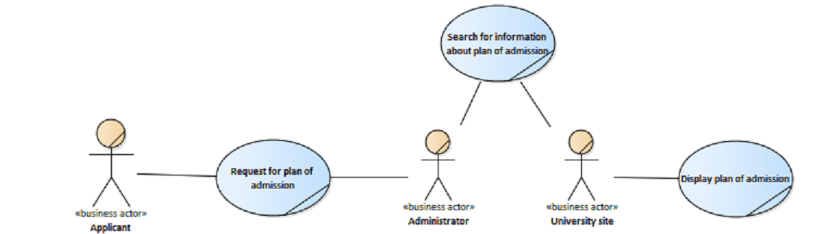

Business

## **Administrator**

*Actor «business actor» in package 'Business '*

University worker

Administrator

Version 1.0 Phase 1.0 Proposed

Veronika created on 27.02.2018. Last modified 27.02.2018

| **ASSOCIATIONS** | |
| --- | --- |
| Association (direction: Unspecified) | |
| Source: Public (UseCase) Search for information about plan of admission «business use case» | Target: Public (Actor) Administrator «business actor» |

|  |  |
| --- | --- |
| Association (direction: Unspecified) | |
| Source: Public (UseCase) Request for plan of admission «business use case» | Target: Public (Actor) Administrator «business actor» |

|  |  |
| --- | --- |
| Association (direction: Unspecified) | |
| Source: Public (UseCase) Update information «business use case» | Target: Public (Actor) Administrator «business actor» |

## **Applicant**

*Actor «business actor» in package 'Business '*

Applicant

Applicant

Version 1.0 Phase 1.0 Proposed

Veronika created on 21.02.2018. Last modified 27.02.2018

| **ASSOCIATIONS** | |
| --- | --- |
| Association (direction: Unspecified) | |
| Source: Public (Actor) Applicant «business actor» | Target: Public (UseCase) Request for plan of admission «business use case» |

## **University site**

*Actor «business actor» in package 'Business '*

University site

University site

Version 1.0 Phase 1.0 Proposed

Veronika created on 21.02.2018. Last modified 27.02.2018

| **ASSOCIATIONS** | |
| --- | --- |
| Association (direction: Unspecified) | |
| Source: Public (Actor) University site «business actor» | Target: Public (UseCase) Display plan of admission «business use case» |

|  |  |
| --- | --- |
| Association (direction: Unspecified) | |
| Source: Public (UseCase) Search for information about plan of admission «business use case» | Target: Public (Actor) University site «business actor» |

|  |  |
| --- | --- |
| Association (direction: Unspecified) | |
| Source: Public (UseCase) Update information «business use case» | Target: Public (Actor) University site «business actor» |

## **Display plan of admission**

*UseCase «business use case» in package 'Business '*

Display plan of admission

Version 1.0 Phase 1.0 Proposed

Veronika created on 27.02.2018. Last modified 27.02.2018

| **ASSOCIATIONS** | |
| --- | --- |
| Association (direction: Unspecified) | |
| Source: Public (Actor) University site «business actor» | Target: Public (UseCase) Display plan of admission «business use case» |

## **Forming necessary request**

*UseCase «business use case» in package 'Business '*

Forming necessary request

Version 1.0 Phase 1.0 Proposed

Veronika created on 27.02.2018. Last modified 27.02.2018

| **OUTGOING STRUCTURAL RELATIONSHIPS** |
| --- |
| Generalization from «business use case» Forming necessary request to «business use case» Request for plan of admission  [ Direction is 'Source -> Destination'. ] |

## **Request for plan of admission**

*UseCase «business use case» in package 'Business '*

Request for plan of admission

Version 1.0 Phase 1.0 Proposed

Veronika created on 27.02.2018. Last modified 27.02.2018

| **INCOMING STRUCTURAL RELATIONSHIPS** |
| --- |
| Generalization from «business use case» Submit general information to «business use case» Request for plan of admission  [ Direction is 'Source -> Destination'. ] |

|  |
| --- |
| Generalization from «business use case» Forming necessary request to «business use case» Request for plan of admission  [ Direction is 'Source -> Destination'. ] |

| **ASSOCIATIONS** | |
| --- | --- |
| Association (direction: Unspecified) | |
| Source: Public (UseCase) Request for plan of admission «business use case» | Target: Public (Actor) Administrator «business actor» |

|  |  |
| --- | --- |
| Association (direction: Unspecified) | |
| Source: Public (Actor) Applicant «business actor» | Target: Public (UseCase) Request for plan of admission «business use case» |

## **Search for information about plan of admission**

*UseCase «business use case» in package 'Business '*

Search for information about plan of admission

Version 1.0 Phase 1.0 Proposed

Veronika created on 27.02.2018. Last modified 27.02.2018

| **ASSOCIATIONS** | |
| --- | --- |
| Association (direction: Unspecified) | |
| Source: Public (UseCase) Search for information about plan of admission «business use case» | Target: Public (Actor) University site «business actor» |

|  |  |
| --- | --- |
| Association (direction: Unspecified) | |
| Source: Public (UseCase) Search for information about plan of admission «business use case» | Target: Public (Actor) Administrator «business actor» |

## **Submit general information**

*UseCase «business use case» in package 'Business '*

Submit general information

Version 1.0 Phase 1.0 Proposed

Veronika created on 27.02.2018. Last modified 27.02.2018

| **OUTGOING STRUCTURAL RELATIONSHIPS** |
| --- |
| Generalization from «business use case» Submit general information to «business use case» Request for plan of admission  [ Direction is 'Source -> Destination'. ] |

## **Update information**

*UseCase «business use case» in package 'Business '*

Update information

Version 1.0 Phase 1.0 Proposed

Veronika created on 27.02.2018. Last modified 27.02.2018

| **ASSOCIATIONS** | |
| --- | --- |
| Association (direction: Unspecified) | |
| Source: Public (UseCase) Update information «business use case» | Target: Public (Actor) Administrator «business actor» |

|  |  |
| --- | --- |
| Association (direction: Unspecified) | |
| Source: Public (UseCase) Update information «business use case» | Target: Public (Actor) University site «business actor» |

## **Use Case1**

*UseCase in package 'Business '*

Use Case1

Version 1.0 Phase 1.0 Proposed

Veronika created on 27.02.2018. Last modified 27.02.2018