Hello everyone, today I’d like to talk about

BIOMIMETICS

What does biomimetics mean?
It is a scientific approach that consists of observing and drawing inspiration from nature to develop innovative and sustainable technologies.

Why adopt this approach?
This approach is based on two observations:
- Planet Earth has its physical limits that must be respected
- Natural systems can meet these limits

Here are some examples:
- Burdock seeds: An engineer observed how these seeds clung to his dog's hair. He reproduced the hook and loop system to create Velcro.
- Termite mounds: This habitat has a multitude of small holes that allow air to circulate. Fresh air is stored indoors and heat is evacuated to the outside. An architect designed the Eastgate Center in Zimbabwe. A building without air conditioning that consumes up to 35% less energy than other buildings in the country.
- Lotus: the leaves of this plant are superhydrophobic: they repel water and dust. This property has inspired the design of spacesuits, self-cleaning paints, waterproof tiles, and water-repellent fabrics.
- The shark: its skin is covered with rough micro-structures that reduce the resistance of the water.
Currently, Airbus is inspired by it to develop a coating for aircraft. Tests show that this technology could reduce fuel consumption by 10% (no aircraft are yet marketed with this coating; the technology is currently in the process of certification).

Conclusion :
In terms of innovation, biomimetics opens up new avenues for us, in all fields: architecture, medicine, industry, transport, etc.).
It reminds us how important nature is in our lives, how we have evolved and that we need to be more respectful of our planet.

Thank you for listening

Theme | Image | Download link | Short Legend
Introduction to Biomimicry | Illustration Biomimicry | Pixabay | Drawing inspiration from nature to innovate
Introduction to Biomimicry | Nature & Innovation | Unsplash | Nature as a model
Introduction to Biomimicry | Inspiration Nature | Pexels | Natural Shapes and Structures
Burdock Seeds / Velcro | Burdock | Pixabay | Seeds that cling easily
Burdock Seeds / Velcro | Velcro inspiration | Wikimedia | Velcro, inspired by burdock
Termite mounds / Architecture | Termite hill | Wikimedia | Self-regulating temperature-controlled termite mounds
Termite mounds / Architecture | Eastgate Center | Wikimedia | Building inspired by termite mounds
Lotus Leaf | Lotus Leaf | Pixabay | Surface superhydrophobe
Lotus Leaf | Lotus Effect | Wikimedia | The drops slide off the sheet
Shark / Airbus | Shark skin | Pixabay | Rough skin to reduce drag
Shark / Airbus | Shark Riblets | Wikimedia | Inspiration for aircraft coatings
Space suits | Astronaut Suit | Unsplash | Protection and mobility in space
Space suits | NASA EVA Suit | Wikimedia | Nature-inspired space technology
Self-cleaning paints | Lotus Inspired Coating | Wikimedia | Paint that repels water and dust
Self-cleaning paints | Hydrophobic Surface | Pixabay | Example of self-cleaning effect
Waterproof tiles | Waterproof Tiles | Pixabay | Materials that repel water
Waterproof tiles | Impermeable Roof | Wikimedia | Nature-inspired roof
Water-repellent fabrics | Water-Repellent Fabric | Pixabay | Water-repellent textiles
Water-repellent fabrics | Hydrophobic Textile | Unsplash | Example of lotus textile application
Conclusion | Nature & Technology | Unsplash | Sustainable innovation is inspired by nature
Conclusion | Green Innovation | Pixabay | Preserving nature while innovating

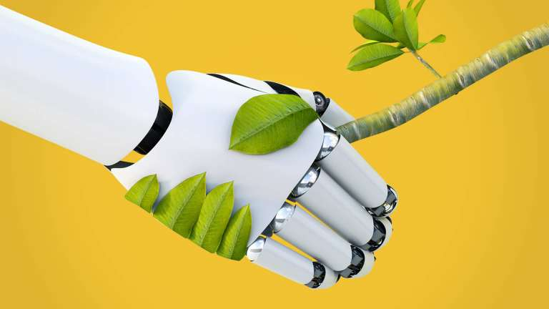

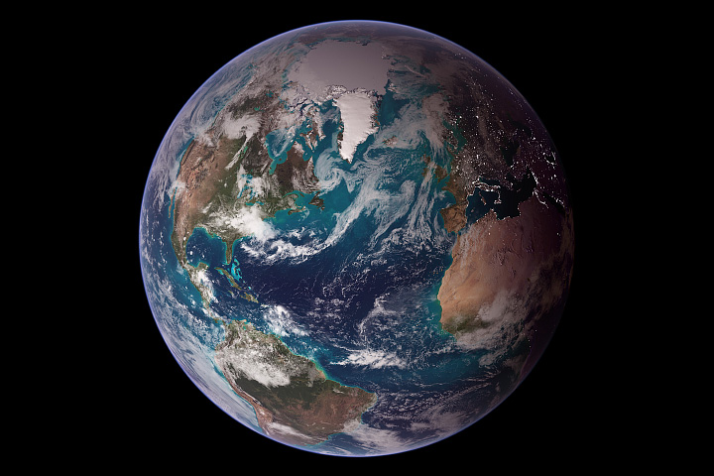
Image : NASA

