COLLABORATIVE PLATFORM
Real-Time Collaborative Code Editor

━━━━━━━━━━━━━━━━━━━━━━━━━━━━━━━━━━━━━━

PROJECT REPORT
Submitted in partial fulfillment of the project requirements

Student Name | [YOUR NAME]
College / Institute | [COLLEGE NAME]
Department | [DEPARTMENT]
Submission Date | June 2026
GitHub Repository | [GITHUB LINK]
Technology Stack | React · Node.js · Socket.io · Monaco Editor
Version | 1.0.0 | License: MIT

━━━━━━━━━━━━━━━━━━━━━━━━━━━━━━━━━━━━━━

1. Project Overview

1.1 Project Name
Collaborative Platform — Real-Time Collaborative Code Editor with AI-Powered Analysis

1.2 Problem Statement
In modern software development, teams increasingly work in distributed or remote environments. Existing collaborative coding tools either require expensive subscriptions (VS Code Live Share, CodePair) or lack integrated AI feedback, code execution, and structured problem sets. Students, interviewers, and hackathon teams need a free, browser-accessible platform where multiple developers can write, run, and discuss code simultaneously — without installing any software.

1.3 Objectives
- Design and develop a real-time multi-user code editor using WebSocket technology.
- Implement room-based session management supporting up to 4 concurrent users.
- Integrate remote code execution for 7+ programming languages via the JDoodle API.
- Integrate AI-powered code analysis using the OpenRouter API (DeepSeek v4 Flash model).
- Provide in-room live chat, remote cursor tracking, and room ownership controls.
- Include a built-in DSA problem set with multi-language boilerplate code templates.
- Deliver a polished, responsive UI with dark/light theme switching.

1.4 Target Users
User Group | Use Case
CS Students | Practice DSA problems collaboratively in a structured environment
Interview Candidates | Conduct mock coding interviews with real-time code sharing
Software Developers | Pair programming and remote debugging sessions
Educators / Mentors | Live teaching and code review with students
Hackathon Teams | Rapid prototyping in a shared, multi-language workspace

2. Technology Stack
The application is split into a React/Vite client and a Node.js/Express server. Real-time collaboration is handled with Socket.io. Remote code execution is powered by the JDoodle API (200 free credits/day) and AI analysis by OpenRouter (DeepSeek v4 Flash). No persistent database is used — all room state is maintained in server-side in-memory Map structures for zero-overhead development and deployment.

Frontend
Technology | Version | Purpose
React | 18.2.0 | Component-based UI rendering
Vite | 5.2.0 | Build tool & dev server
React Router DOM | 6.22.0 | Client-side routing (/, /room/:roomId)
Monaco Editor | 4.6.0 | VS Code-grade in-browser code editor
Socket.io Client | 4.7.2 | Real-time WebSocket communication
Tailwind CSS | 3.4.3 | Utility-first styling
Lucide React | 0.383.0 | SVG icon library
React Hot Toast | 2.4.1 | Toast notifications

Backend
Technology | Version | Purpose
Node.js | 18+ | Server-side JavaScript runtime
Express | 4.18.2 | HTTP API server and middleware
Socket.io | 4.7.2 | WebSocket room event management
Axios | 1.13.6 | External API calls (JDoodle, OpenRouter)
Helmet | 8.1.0 | HTTP security headers
cors | 2.8.5 | Cross-origin resource sharing
uuid | 9.0.0 | Unique 8-char room ID generation
dotenv | 17.3.1 | Environment variable management
nodemon | 3.0.1 | Dev server auto-restart

External APIs
API / Service | Purpose
JDoodle Execute API | Remote multi-language code compilation and execution (200 credits/day free)
OpenRouter Chat Completions | AI code analysis using DeepSeek v4 Flash model (credit-based quota)

3. System Architecture & Implementation

3.1 Architecture Overview
The application follows a Client-Server architecture with WebSocket-based real-time communication. The React SPA communicates with the Express server via both REST HTTP calls and persistent Socket.io WebSocket connections. The server maintains all shared room state in an in-memory Map and proxies code execution and AI analysis requests to external APIs.

3.2 API Endpoints
Endpoint | Method | Description
/api/health | GET | Server status and active room count
/api/create-room | GET | Generates unique 8-char room ID via UUID
/api/problems | GET | Returns built-in DSA problem dataset
/api/execute | POST | Proxies code to JDoodle; returns stdout/stderr/status
/api/analyze | POST | Sends code + output to OpenRouter AI; returns markdown analysis

3.3 Key Socket.io Events
Event (Client → Server) | Event (Server → Client) | Purpose
join-room | room-joined / user-joined | Create or join a room; sync state
code-change | code-updated | Broadcast code edits to all members
language-change | language-updated | Change room language and boilerplate
cursor-move | cursor-updated | Share real-time cursor positions
chat-message | chat-received | In-room timestamped chat messages
pause-user / kick-user | user-paused / user-kicked | Owner room management controls
transfer-ownership | ownership-transferred | Delegate host role to another user
select-problem | problem-selected | Load DSA problem with boilerplate
leave-room | user-left / new-owner | Handle departure and owner promotion

3.4 Folder Structure
collaborative-platform/
├── package.json ← Root scripts (dev, build, install:all)
├── server/
│ ├── index.js ← Express + Socket.io server (729 lines)
│ ├── problems.js ← DSA problem dataset (5 problems, 4 languages)
│ └── .env / .env.example
└── client/src/
├── pages/
│ ├── Home.jsx ← Lobby: name input, room create / join
│ └── Editor.jsx ← Main editor: all state + socket events
├── components/ ← ChatPanel, UserList, OutputPanel, AnalysisPanel …
├── socket.js ← Socket.io singleton with auto-reconnect
└── styles/pixel.css ← CSS variables, dark/light theme tokens

3.5 Key Implementation Details
- 300ms debounce on Monaco Editor onChange prevents socket flooding during fast typing.
- Socket singleton (SocketService class) implements exponential backoff — up to 5 reconnect attempts, 1 s → 5 s delay.
- Server-side authorization: pause/kick/transfer/problem selection validated on every socket event — not client-side.
- Empty rooms auto-deleted after a 60-second cleanup timeout; owner disconnection triggers automatic promotion.
- JDoodle responses normalized to { stdout, stderr, status: Accepted / Runtime Error / Time Limit Exceeded }.
- OpenRouter prompt: system role defines 4-section markdown output (Issue / Fix / Explanation / Suggestions); temperature 0.3.
- Helmet.js enforces HTTP security headers; JSON body size capped at 1 MB; code input capped at 50,000 chars.

4. Project Snapshots
The following screenshots were captured during a live 2-user collaborative session (developer_1 as Member, developer_2 as Owner/Host) demonstrating the platform's core features.

Figure 1 — Lobby / Home Screen
The application entry point. Users enter a display name, select a default programming language, and either Create Room or Join Room. The features panel highlights Real-Time Sync, 8+ Languages, AI Analysis, and Code Execution.
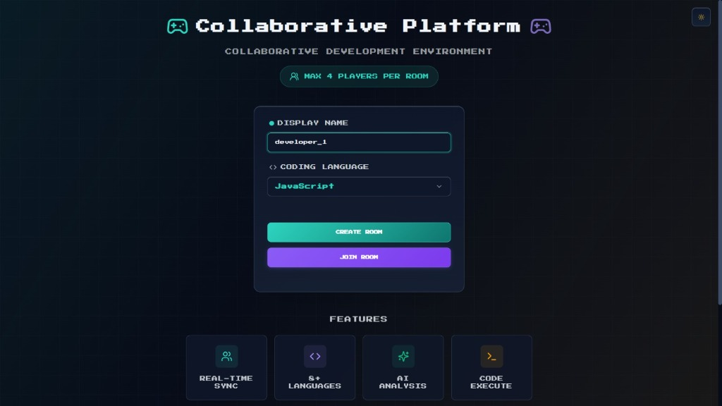
Figure: Home / Lobby Screen — Room creation with display name and language selection

Figure 2 — Live Collaborative Editor (Member View)
Two developers sharing the same room session (81D435E5) in real-time. developer_1 is logged in as a Member, developer_2 is the Room Owner. The sidebar shows both users with color-coded identifiers. The Monaco Editor displays the shared code, and the Output panel shows the accepted stdout.
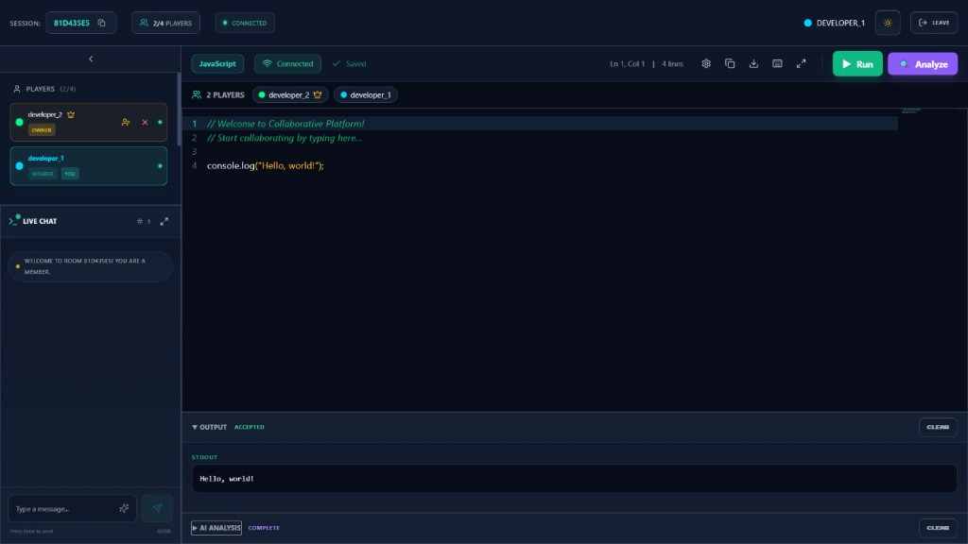
Figure: Collaborative Editor — Member View showing 2/4 Players, live chat, Monaco Editor, and STDOUT output

Figure 3 — AI Code Analysis (Member Perspective)
The AI Analysis panel after clicking Analyze. The DeepSeek v4 Flash model returns a structured markdown response: No Issues Detected, Suggested Fix, plain-English Explanation, and Improvement Suggestions. The Output panel simultaneously shows the accepted Hello, world! output.
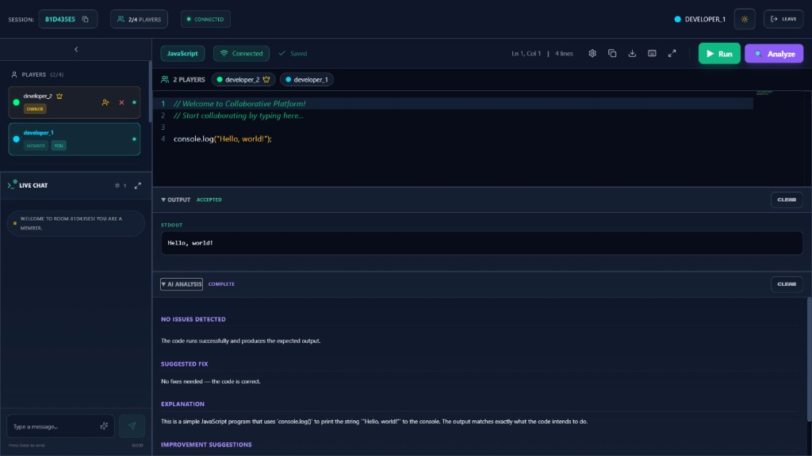
Figure: AI Analysis Panel — Member View showing Issue, Fix, Explanation, and Improvement sections

Figure 4 — AI Code Analysis (Host/Owner Perspective)
The host view of the same session with the AI analysis panel open. The Live Chat panel shows the full join/leave event history (DEVELOPER_1 JOINED THE ROOM, LEFT THE ROOM, JOINED AS MEMBER), demonstrating real-time event broadcasting. The Owner crown icon is visible on developer_2.
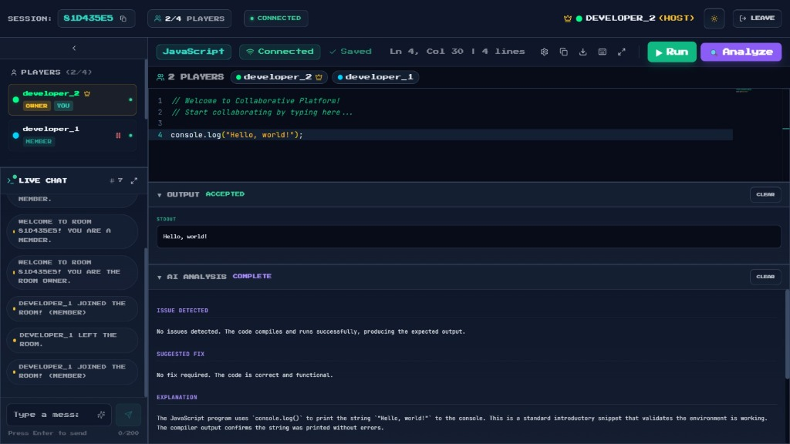
Figure: AI Analysis Panel — Host View with Owner crown icon, chat history, and AI feedback

Figure 5 — Editor Ready State (Pre-Execution)
The editor workspace in its idle state after code has been auto-saved. The Output panel shows 'OUTPUT READY — Click ▶ Run to execute' and the AI Analysis panel shows its placeholder prompt. Monaco displays the cursor position (Ln 4, Col 30 | 4 lines) and both players remain CONNECTED.
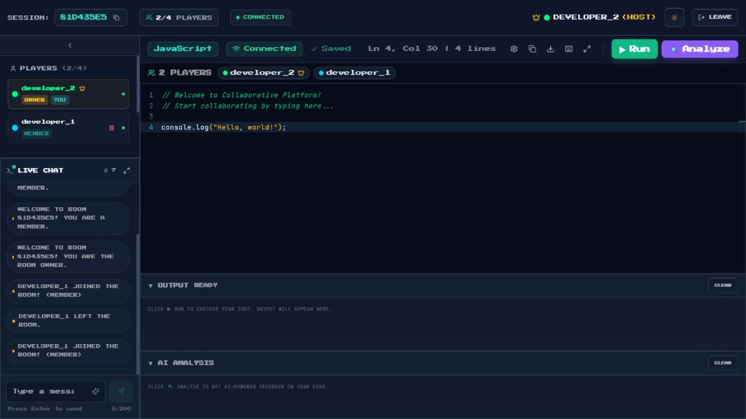
Figure: Editor Idle State — Saved code, Output Ready, AI Analysis ready, both players Connected

5. Challenges, Testing & Conclusion

5.1 Challenges Faced & Solutions
Challenge | Impact | Solution Implemented
Real-time sync without echo loops | High | 300 ms debounce + socket.to() excludes sender
Cursor tracking across updates | Medium | Monaco decoration API with per-user hex colors
Unexpected owner disconnect | High | Unified handleUserLeave() promotes room.users[0]
Third-party API rate limits | Medium | Layered error handling: 401/403/429/timeout/500
CORS in dev vs. production | Medium | CORS_ORIGINS env var parsed at runtime
In-memory state cleanup | Low | 60-second cleanup timeout on empty rooms

5.2 Testing Summary
Manual functional and integration testing was performed with two simultaneous browser sessions.
Test Case | Expected | Result
Create room | 8-char room ID, redirect to editor | ✅ PASS
Join same room | Both users in sidebar | ✅ PASS
Code sync | User B sees edits within 300 ms | ✅ PASS
Code execution | stdout: Hello, world! | ✅ PASS
AI analysis | Markdown sections rendered | ✅ PASS
Room full (5th user) | room-full toast, join rejected | ✅ PASS
Duplicate username | username-taken toast | ✅ PASS
Pause user | Paused user edit blocked | ✅ PASS
Kick user | User removed, session ends | ✅ PASS
Owner disconnect | Next user auto-promoted | ✅ PASS
Theme toggle | Dark ↔ Light persisted | ✅ PASS
DSA problem select | Boilerplate loads on all clients | ✅ PASS

5.3 Future Enhancements
- Persistent database (Redis / MongoDB) to survive server restarts.
- OAuth-based user authentication (GitHub / Google login).
- Automated test judge for DSA problems against expected outputs.
- WebRTC-based voice/video communication within rooms.
- Operational Transformation (OT) or CRDT for conflict-free code merging.
- Extended language support: Ruby, PHP, Swift, Kotlin via JDoodle.
- File system emulation — multiple code files (tabs) per room.
- Selectable AI model (GPT-4o, Claude, Gemini) via OpenRouter.

5.4 Learning Outcomes
- Real-Time Systems: WebSocket protocol, Socket.io event architecture, room-based pub/sub broadcasting.
- Frontend: React 18 hooks lifecycle, Monaco Editor API, debouncing, performance optimization.
- Backend: Express.js REST design, Helmet security, SIGTERM graceful shutdown, middleware chaining.
- AI / LLM Integration: OpenRouter API, prompt engineering, structured markdown output, temperature tuning.
- DevOps: Vite build config, Cloudflare Pages deployment, Wrangler CLI, environment-based configuration.
- Security: Server-side role authorization, CORS whitelisting, request size limits, API key management.

5.5 Conclusion
The Collaborative Platform project successfully demonstrates the integration of real-time WebSocket communication, cloud-based code execution, and AI-powered code analysis within a single cohesive web application. Built from scratch using a modern JavaScript stack — React 18 on the frontend and Node.js/Express on the backend — the platform handles complex real-time scenarios including multi-user code synchronization, cursor tracking, dynamic ownership transfer, and graceful disconnection handling.
The project provides direct practical value as a tool for educational, interview, and team collaboration contexts. It demonstrates proficiency in full-stack web development, real-time systems architecture, API integration, and software engineering best practices. Future development will focus on persistent storage, authentication, and automated test judging — transforming the platform into a production-ready competitive programming and interview preparation tool.

5.6 How to Run the Project
- Prerequisites: Node.js 18+, npm, JDoodle credentials, OpenRouter API key.
git clone [GITHUB LINK] && npm run install:all
# Configure server/.env and client/.env, then:
npm run dev # Starts server (:3001) + client (:5173) concurrently
- Open http://localhost:5173 in two browser tabs to test collaboration.

━━━━━━━━━━━━━━━━━━━━━━━━━━━━━━━━━━━━━━━━━━━━━━━━━━━━━━━━━━━━━━━━━━━━━━
Report prepared by [YOUR NAME] | [COLLEGE NAME] | [DEPARTMENT] | June 2026

