SALES PERFORMANCE AND PROFITABILITY ANALYSIS
A Data-Driven Study of the Nassau Candy Distributor Dataset

Prepared by: Versha Sharma
Data Analytics Internship Program
Unified Mentor
July 2026

Abstract
This research paper presents an exploratory data analysis (EDA) of the Nassau Candy Distributor dataset, a transactional record of 10,194 order lines covering 8,549 unique orders, 15 products, and 5,044 customers across the United States and Canada between January 2024 and December 2025. The objective of this study is to evaluate the company's sales performance, profitability structure, and revenue concentration risk using descriptive statistics, profitability segmentation, Pareto (80/20) analysis, and correlation analysis. The dataset generated a total revenue of $141,783.63 and a gross profit of $93,442.80, representing an overall gross margin of 65.91%. The analysis finds that the Chocolate division alone accounts for 92.9% of total revenue and 95.1% of total profit, and that just four of fifteen products (26.7%) are responsible for approximately 80% of both revenue and profit. These findings indicate a high degree of product and category concentration, which carries both operational efficiency benefits and business risk. The paper concludes with data-driven recommendations for diversification, pricing review, and regional investment strategy.
Keywords: exploratory data analysis, sales analytics, profitability, Pareto analysis, retail distribution, business intelligence

Table of Contents
Abstract 1
Table of Contents 1
1. Introduction 1
1.1 Background 1
1.2 Objectives 1
1.3 Scope and Data Source 1
2. Methodology 1
2.1 Tools and Environment 1
2.2 Data Cleaning and Validation 1
2.3 Feature Engineering 1
2.4 Analytical Techniques 1
3. Results and Analysis 1
3.1 Overall Business Performance 1
3.2 Division-Level Performance 1
3.3 Regional Performance 1
3.4 Product-Level Performance 1
3.5 Revenue and Profit Concentration (Pareto Analysis) 1
3.6 Time Trend 1
3.7 Customer Concentration 1
3.8 Correlation Analysis 1
3.9 Shipping Mode Distribution 1
4. Discussion 1
5. Business Recommendations 1
6. Limitations 1
7. Conclusion 1
References 1

1. Introduction

1.1 Background
Nassau Candy is a wholesale confectionery distributor supplying chocolate, sugar, and novelty products to retailers across North America. Like many distribution businesses, its profitability depends on a complex interaction between product mix, regional demand, shipping logistics, and customer purchasing behavior. Understanding these interactions through data analysis allows a distributor to make informed decisions about inventory investment, pricing, and market expansion.

1.2 Objectives
This study was conducted with the following objectives:
- To clean and validate the raw transactional dataset for analysis.
- To quantify overall sales, cost, and profitability performance.
- To evaluate performance across product, division, regional, and customer dimensions.
- To identify revenue and profit concentration risk using Pareto (80/20) analysis.
- To examine relationships between sales, cost, and profitability using correlation analysis.
- To translate analytical findings into actionable business recommendations.

1.3 Scope and Data Source
The analysis is based on the Nassau_Candy_Distributor.csv dataset, which contains order-level transaction records with 18 original fields, including Order ID, Order Date, Ship Date, Ship Mode, Customer ID, geographic fields (Country, City, State, Postal Code), Division, Region, Product ID, Product Name, Sales, Units, Gross Profit, and Cost. The dataset spans transactions recorded between January 2024 and December 2025.

2. Methodology

2.1 Tools and Environment
The analysis was performed in Python using a Jupyter Notebook environment. The primary libraries used were pandas for data manipulation, and Plotly Express for interactive visualization. Static figures for this paper were rendered using Matplotlib and Seaborn.

2.2 Data Cleaning and Validation
The following validation and cleaning steps were applied prior to analysis:
- Checked for and removed records with non-positive Sales or negative Cost values.
- Checked for and removed records with zero Sales or negative Gross Profit.
- Checked for missing values in the Units column and imputed using the median where applicable.
- Standardized text fields (Product Name, Division) by trimming whitespace and applying consistent title casing.
- Checked for and removed fully duplicated rows.
No invalid, missing, or duplicate records were found in the final dataset, confirming that the source data was clean prior to analysis (10,194 rows retained).

2.3 Feature Engineering
The following derived metrics were computed to support the analysis:
- Gross Margin % = (Gross Profit / Sales) × 100, calculated at the order-line, product, and division level.
- Profit per Unit = Gross Profit / Units.
- Profit Contribution % = an order line's share of total company profit.
- Shipping Days = Ship Date − Order Date, used to evaluate fulfilment speed by shipping mode.

2.4 Analytical Techniques
- Descriptive aggregation: sales, cost, and profit were aggregated by Product, Division, Region, and Customer.
- Profitability segmentation: products were classified into High-Profit/High-Margin, High-Sales/Low-Margin, and Low-Sales/Low-Profit groups relative to the dataset average.
- Pareto (80/20) analysis: products were ranked by cumulative revenue and cumulative profit share to identify the minimum subset of products generating 80% of each.
- Dependency risk analysis: revenue and profit shares by division were flagged as an over-dependency risk where any single division exceeded a 40% share of either metric.
- Correlation analysis: Pearson correlation coefficients were computed across Sales, Units, Cost, Gross Profit, and Gross Margin %.

3. Results and Analysis

3.1 Overall Business Performance
Table 1 summarizes the headline performance metrics across the full, cleaned dataset. The business generated a healthy overall gross margin of 65.91%, indicating strong pricing power relative to cost of goods across the product portfolio.
Metric | Value
Total Sales | $141,783.63
Total Cost | $48,340.83
Total Gross Profit | $93,442.80
Overall Gross Margin | 65.91%
Total Units Sold | 38,654
Unique Orders | 8,549
Unique Products | 15
Unique Customers | 5,044
Date Range | Jan 2024 – Dec 2025
Table 1. Overall Key Performance Indicators

3.2 Division-Level Performance
The product catalogue is organized into three divisions: Chocolate, Sugar, and Other (novelty items). As shown in Table 2 and Figure 2, the Chocolate division overwhelmingly dominates the business, contributing 92.88% of total revenue and 95.06% of total gross profit. Notably, Chocolate's profit share (95.06%) exceeds its revenue share (92.88%), meaning the division is more profitable per dollar of sales than the business average. The Other division, by contrast, carries a comparatively low gross margin of 44.84%, well below the company-wide average of 65.91%, despite contributing 6.82% of revenue. Applying a 40% share threshold, the Chocolate division was flagged as an over-dependency risk on both the revenue and profit dimensions.
Division | Sales | Gross Profit | Margin % | Revenue Share | Profit Share
Chocolate | $131,692.90 | $88,824.62 | 67.45% | 92.88% | 95.06%
Other | $9,663.25 | $4,333.45 | 44.84% | 6.82% | 4.64%
Sugar | $427.48 | $284.73 | 66.61% | 0.30% | 0.30%
Table 2. Division-Level Sales, Profit, and Share Analysis
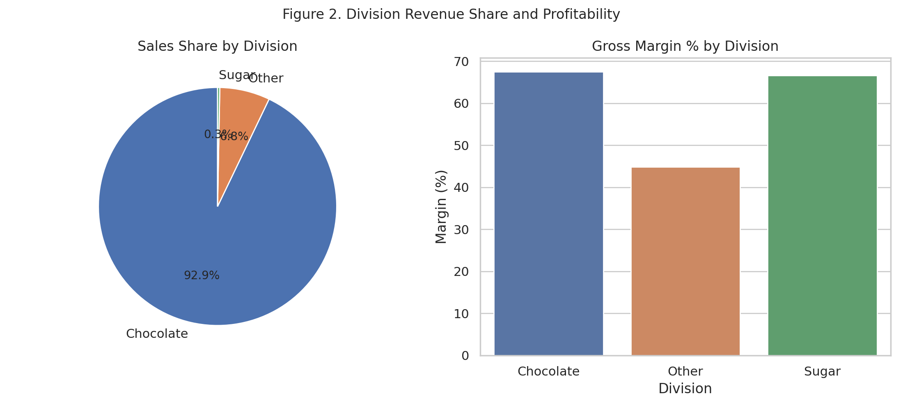
Figure 2. Division Revenue Share and Profitability

3.3 Regional Performance
Sales activity was analyzed across four operating regions: Pacific, Atlantic, Interior, and Gulf. The Pacific region leads in total revenue at $46,301.53, followed by Atlantic at $41,197.24. Gross margin is relatively stable across regions, ranging narrowly from 65.47% (Atlantic) to 66.43% (Interior), indicating that profitability is not strongly geography-dependent for this business — regional differences are driven primarily by sales volume rather than pricing or cost structure. Geographically, the United States accounts for the substantial majority of business activity ($138,830.34 in sales across 8,389 orders), compared to Canada ($2,953.29 across 160 orders), confirming the domestic U.S. market as the core of the business. At the state level, California ($27,917.40), New York ($15,541.03), and Texas ($13,416.09) are the top three contributors to revenue.
Region | Sales | Gross Profit | Margin %
Pacific | $46,301.53 | $30,485.94 | 65.84%
Atlantic | $41,197.24 | $26,973.70 | 65.47%
Interior | $32,037.60 | $21,282.49 | 66.43%
Gulf | $22,247.26 | $14,700.67 | 66.08%
Table 3. Regional Sales and Profitability
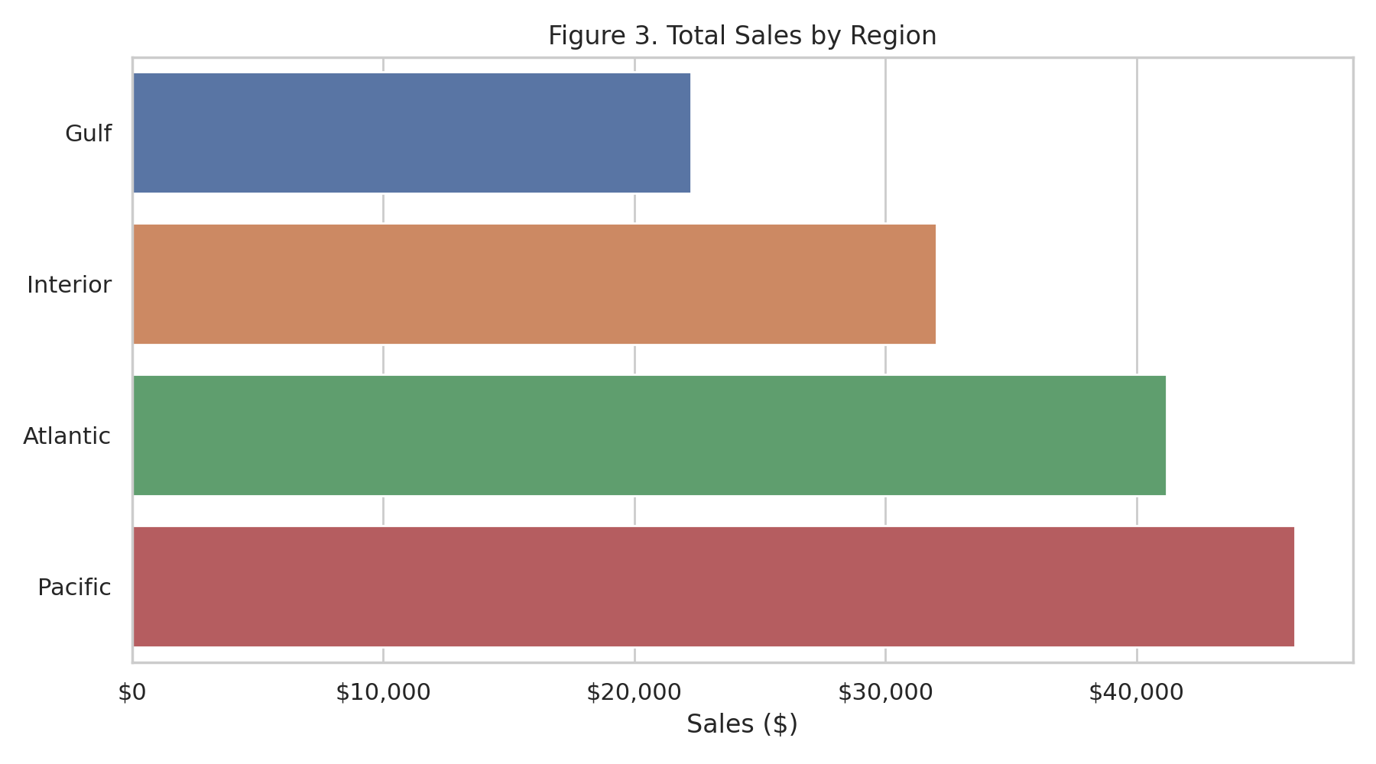
Figure 3. Total Sales by Region

3.4 Product-Level Performance
Table 4 lists the top five products by total sales. The Wonka Bar product line dominates the portfolio: five chocolate-bar variants account for the large majority of both revenue and profit, while novelty products such as Kazookles (7.69% margin) and Wonka Gum generate comparatively little profit despite non-trivial sales volume. Notably, Wonka Bar – Nutty Crunch Surprise achieves the highest margin among top-selling products at 71.35%, while Kazookles registers the lowest margin in the entire catalogue at 7.69%, marking it as a high-sales, low-margin outlier that merits pricing or cost review.
Product | Sales | Gross Profit | Margin %
Wonka Bar – Triple Dazzle Caramel | $28,485.00 | $18,610.20 | 65.33%
Wonka Bar – Scrumdiddlyumptious | $27,874.80 | $19,357.50 | 69.44%
Wonka Bar – Milk Chocolate | $26,867.75 | $17,443.37 | 64.92%
Wonka Bar – Fudge Mallows | $24,890.40 | $16,593.60 | 66.67%
Wonka Bar – Nutty Crunch Surprise | $23,574.95 | $16,819.95 | 71.35%
Table 4. Top 5 Products by Total Sales
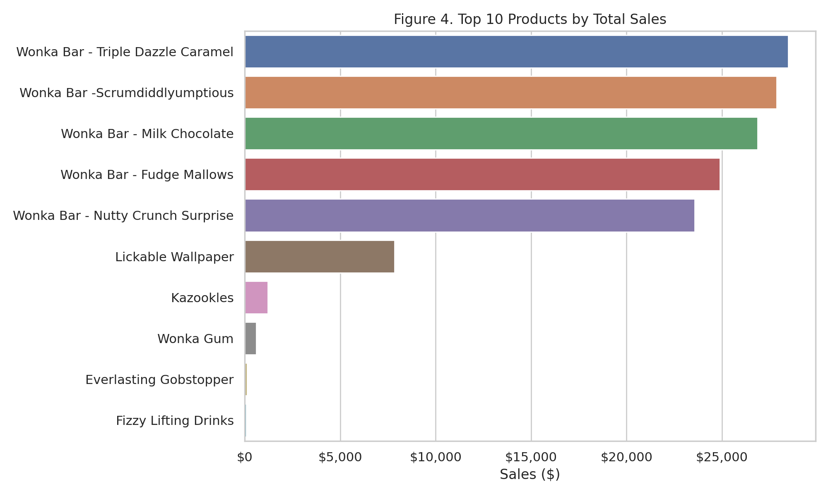
Figure 4. Top 10 Products by Total Sales

3.5 Revenue and Profit Concentration (Pareto Analysis)
A Pareto (80/20) analysis was conducted to assess how concentrated revenue and profit generation are across the product catalogue. The results show that just 4 of the 15 products (26.7%) are responsible for approximately 80% of total revenue, and the same four products also account for approximately 80% of total gross profit. This is a materially higher concentration than the classical 80/20 rule would suggest, and it reinforces the division-level finding that the business is heavily reliant on a small number of core chocolate products.
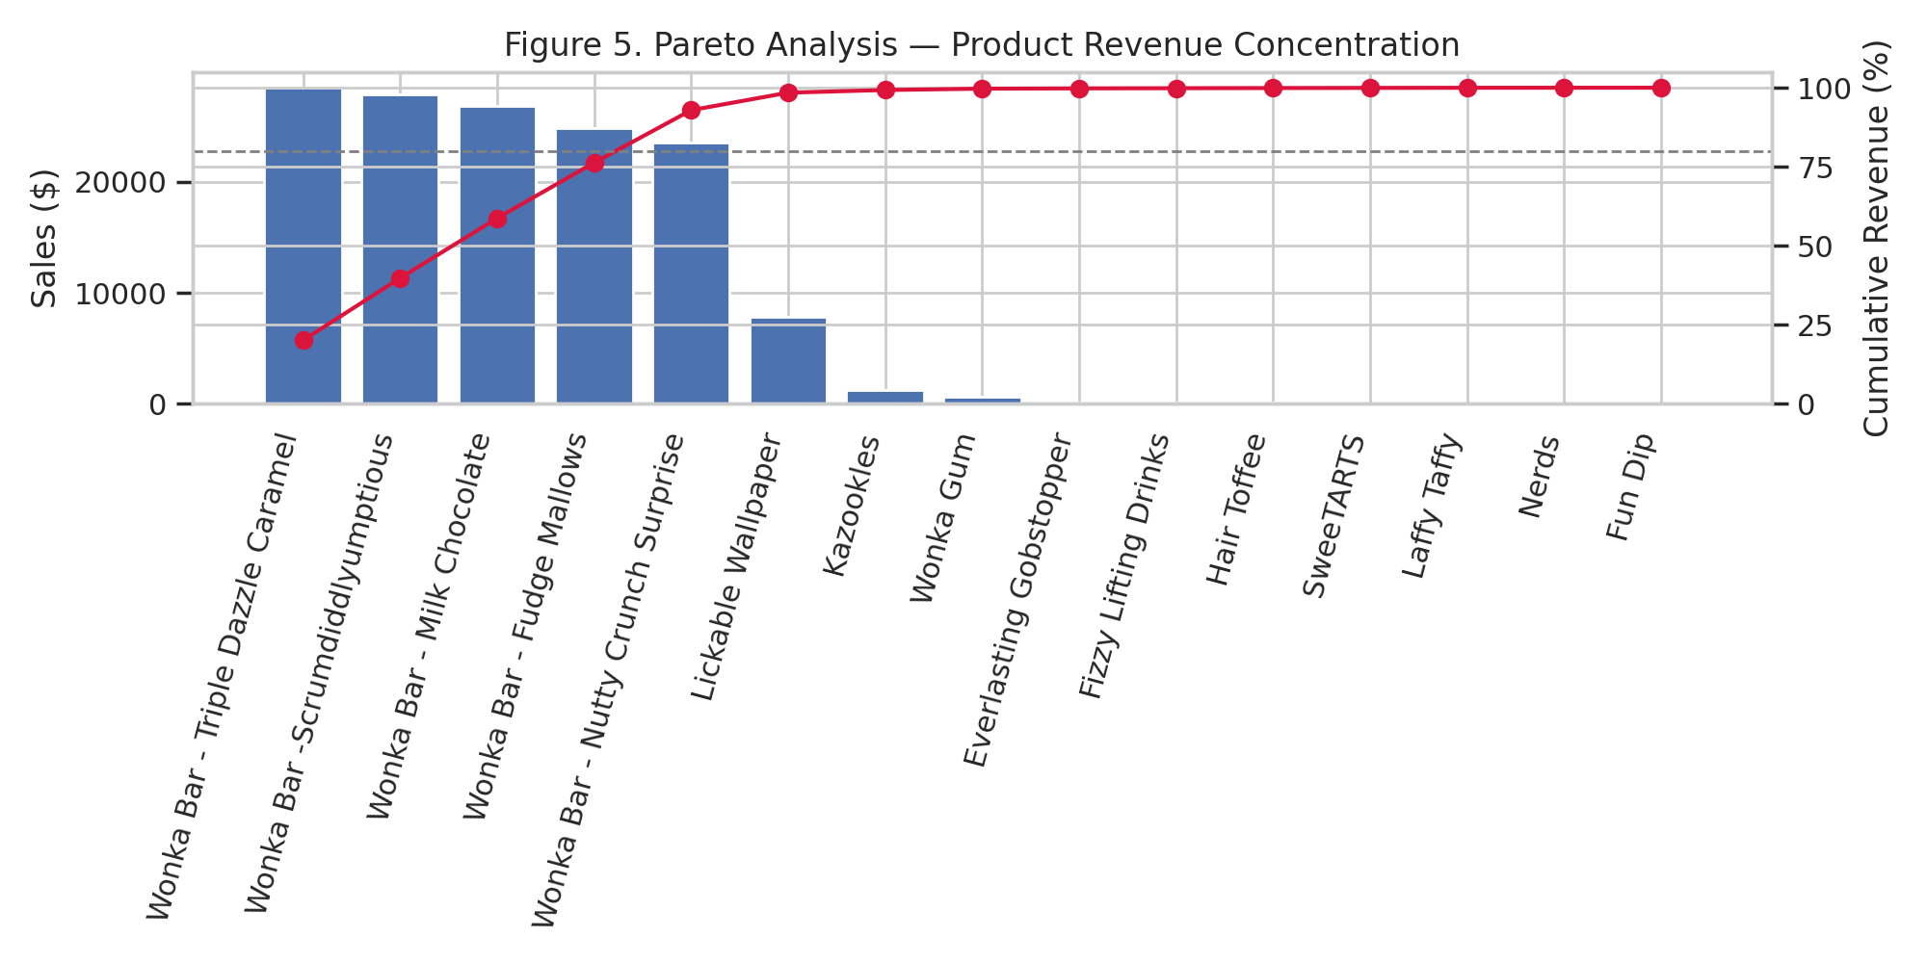
Figure 5. Pareto Analysis — Product Revenue Concentration

3.6 Time Trend
Monthly aggregation of sales and gross profit (Figure 1) shows the business's revenue and profit trajectory across the two-year observation window. Both series move closely together month to month, consistent with the stable ~66% gross margin observed at the aggregate level, indicating that profitability has remained structurally consistent over time rather than fluctuating independently of sales volume.
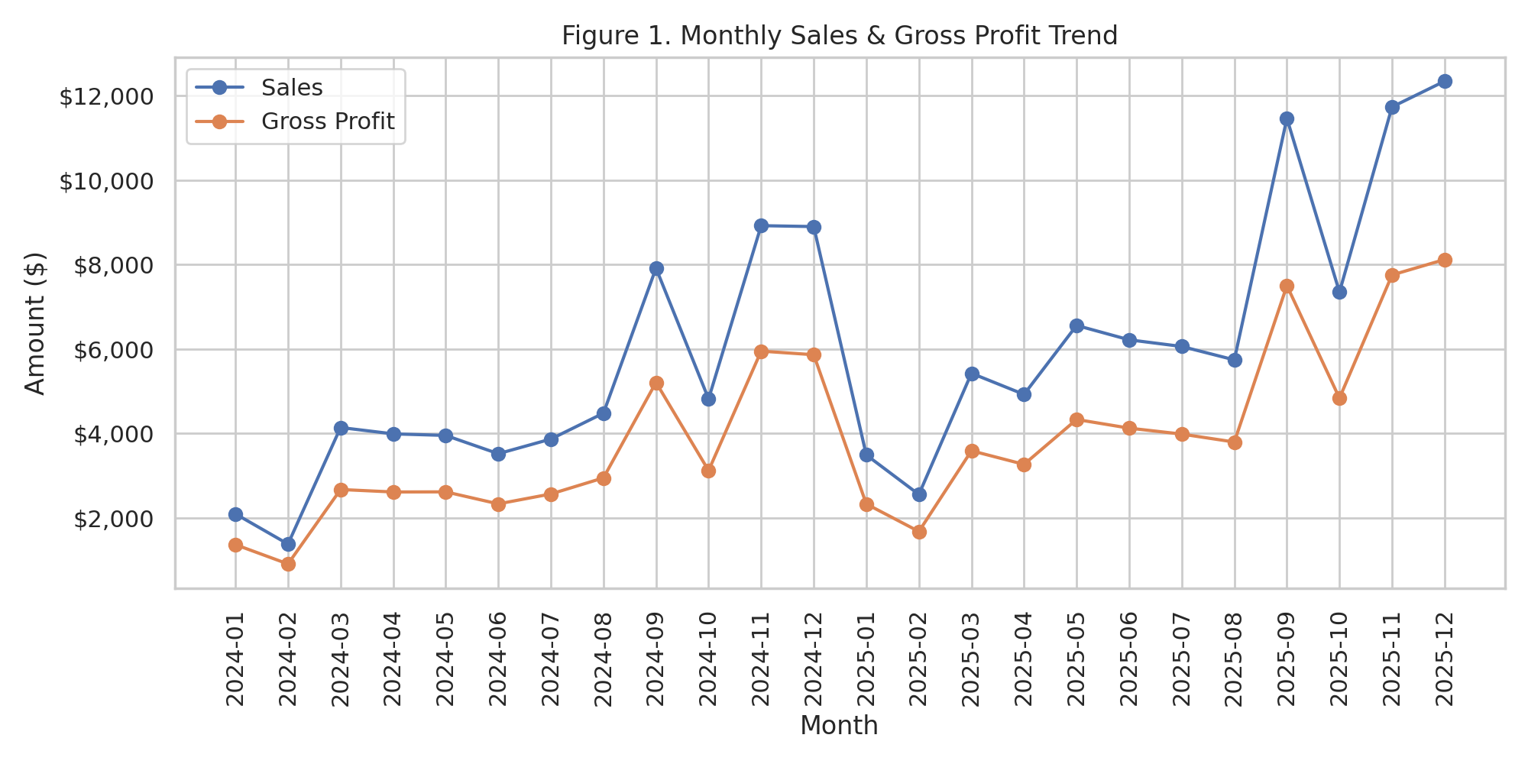
Figure 1. Monthly Sales and Gross Profit Trend

3.7 Customer Concentration
In contrast to the strong concentration observed at the product and division level, customer revenue is broadly distributed: the top five customers by sales (Customer IDs 131807, 115238, 122336, 164756, and 124163) each contribute between $247 and $455 in total sales, collectively representing roughly 1.2% of total company revenue across 5,044 unique customers. This indicates a healthy, diversified customer base with no single-customer dependency risk, which stands in useful contrast to the product-level concentration identified above.

3.8 Correlation Analysis
A correlation matrix (Figure 6) was computed across Sales, Units, Cost, Gross Profit, and Gross Margin %. As expected, Sales and Gross Profit are very strongly correlated (r = 0.976), and Sales and Cost are similarly strongly correlated (r = 0.959), reflecting consistent per-unit pricing and cost structures across transactions. Notably, Gross Margin % shows a very weak correlation with Sales (r = −0.111) and with order size (Units, r = −0.014), indicating that profitability margin is largely independent of transaction size — larger orders are not systematically more or less profitable on a percentage basis.
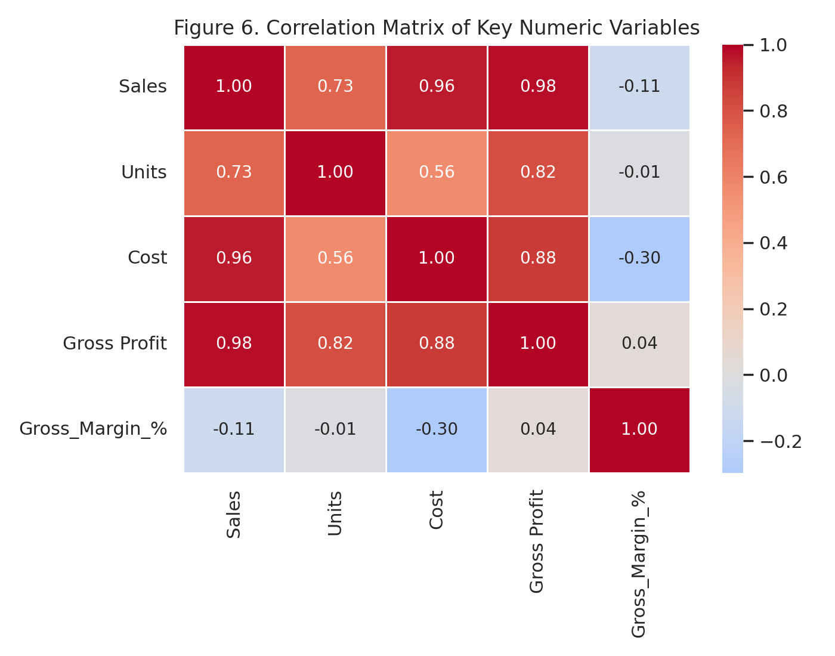
Figure 6. Correlation Matrix of Key Numeric Variables

3.9 Shipping Mode Distribution
Order volume by shipping mode shows Standard Class as the dominant fulfilment method (5,142 of 8,549 orders, approximately 60%), followed by Second Class (1,653 orders), First Class (1,312 orders), and Same Day (442 orders). It should be noted that the computed average shipping duration across all modes was found to be anomalously large and inconsistent with typical distribution timelines; this is attributed to a data quality issue in the source Ship Date field rather than a genuine operational finding, and is discussed further in the Limitations section.

4. Discussion
The findings of this study point to a business with strong, stable profitability driven by a narrow product base. The Chocolate division's 92.88% revenue share and 95.06% profit share demonstrate both the strength of the company's core product line and a structural concentration risk: any disruption to chocolate supply, pricing, or demand would disproportionately affect overall business performance. This is corroborated by the product-level Pareto analysis, which shows that just four SKUs drive roughly 80% of both revenue and profit.
At the same time, the near-independence of gross margin from transaction size (r = −0.111 with Sales) suggests the company maintains disciplined, consistent pricing across order sizes, which is a sign of pricing stability rather than a weakness. Regional performance differences appear to be driven by market size and demand rather than by differences in cost efficiency, since margin percentages are tightly clustered across all four regions (65.47%–66.43%).
The customer base presents a favorable contrast to the product concentration risk: with the top five customers accounting for only about 1.2% of total revenue among 5,044 customers, the business is not exposed to meaningful customer-concentration risk, which is a positive structural characteristic for long-term revenue stability.

5. Business Recommendations
- Diversify beyond the Chocolate division: given that Chocolate represents over 92% of revenue, the company should evaluate targeted investment in the Sugar and Other divisions to reduce category concentration risk, while continuing to protect the core Chocolate business.
- Review pricing or sourcing for low-margin, high-volume products: items such as Kazookles (7.69% margin) and Wonka Gum (52% margin) generate meaningful sales volume but comparatively little profit, and should be reviewed for cost renegotiation or price adjustment.
- Prioritize investment in the Pacific and Atlantic regions, which together account for the majority of national revenue, while exploring targeted growth initiatives in the Gulf region, the current lowest-revenue territory.
- Expand the Canadian market cautiously: Canada currently represents a very small share of total business (about 2% of revenue) and may present a long-term growth opportunity if warranted by further market research.
- Maintain the current customer diversification strategy, as the absence of customer concentration risk is a structural strength that should be preserved as the business scales.
- Audit the Ship Date data field: the anomalous shipping-duration figures identified in Section 3.9 suggest a data entry or system integration issue that should be corrected to enable reliable logistics analysis in future reporting.

6. Limitations
- The dataset's Ship Date field contains values that produce implausibly long average shipping durations across all shipping modes, indicating a likely data quality issue; shipping-time findings should therefore be treated as inconclusive pending data correction.
- The dataset is limited to 15 distinct products, which constrains the statistical robustness of product-level segmentation and Pareto analysis.
- The analysis is descriptive and correlational in nature; no causal claims are made regarding the drivers of sales or profitability.
- Customer-level analysis is limited to transaction totals and does not incorporate customer tenure, order frequency over time, or acquisition channel, which would enable deeper customer lifetime value analysis.

7. Conclusion
This study applied exploratory data analysis, profitability segmentation, Pareto analysis, and correlation analysis to the Nassau Candy Distributor dataset to evaluate the company's sales and profitability structure. The analysis found a financially healthy business with a 65.91% overall gross margin, but one that is heavily concentrated in its Chocolate division and in a small number of top-selling products, which together account for approximately 80% of both revenue and profit. Regional and customer-level analysis, by contrast, revealed a well-diversified geographic and customer footprint. These findings support a set of targeted recommendations centered on product and category diversification, pricing review for low-margin items, and continued investment in top-performing regions, while preserving the business's existing customer diversification strength.

References
Nassau Candy Distributor Dataset (CSV). Internal transactional dataset used for this analysis, provided as part of the Unified Mentor Data Analytics Internship Program.
McKinney, W. (2010). Data Structures for Statistical Computing in Python. Proceedings of the 9th Python in Science Conference (pandas’ library).
Plotly Technologies Inc. (2015). Collaborative data science. Plotly Express documentation.
Hunter, J. D. (2007). Matplotlib: A 2D Graphics Environment. Computing in Science & Engineering, 9(3), 90–95.

