DROP DATABASE IF EXISTS ECommerceDB;

CREATE DATABASE ECommerceDB;
USE ECommerceDB;

CREATE TABLE Categories (
CategoryID INT PRIMARY KEY,
CategoryName VARCHAR(50) NOT NULL UNIQUE
);

CREATE TABLE Customers (
CustomerID INT PRIMARY KEY,
CustomerName VARCHAR(100) NOT NULL,
Email VARCHAR(100) UNIQUE,
JoinDate DATE
);

-- Orders is a reserved keyword, so we use backticks
CREATE TABLE `Orders` (
OrderID INT PRIMARY KEY,
CustomerID INT,
OrderDate DATE NOT NULL,
TotalAmount DECIMAL(10,2),
FOREIGN KEY (CustomerID) REFERENCES Customers(CustomerID)
);

CREATE TABLE Products (
ProductID INT PRIMARY KEY,
ProductName VARCHAR(100) NOT NULL UNIQUE,
CategoryID INT,
Price DECIMAL(10,2) NOT NULL,
StockQuantity INT,
FOREIGN KEY (CategoryID) REFERENCES Categories(CategoryID)
);

-- Insert data into tables
INSERT INTO Categories VALUES
(1,'Electronics'),(2,'Books'),(3,'Home Goods'),(4,'Apparel');

INSERT INTO Customers VALUES
(1,'Alice Wonderland','alice@example.com','2023-01-10'),
(2,'Bob the Builder','bob@example.com','2022-11-25'),
(3,'Charlie Chaplin','charlie@example.com','2023-03-01'),
(4,'Diana Prince','diana@example.com','2021-04-26');

INSERT INTO Products VALUES
(101,'Laptop Pro',1,1200.00,50),
(102,'SQL Handbook',2,45.50,200),
(103,'Smart Speaker',1,99.99,150),
(104,'Coffee Maker',3,75.00,80),
(105,'Novel : The Great SQL',2,25.00,120),
(106,'Wireless Earbuds',1,150.00,100),
(107,'Blender X',3,120.00,60),
(108,'T-Shirt Casual',4,20.00,300);

INSERT INTO Orders VALUES
(1001,1,'2023-04-26',1245.50),
(1002,2,'2023-10-12',99.99),
(1003,1,'2023-07-01',145.00),
(1004,3,'2023-01-14',150.00),
(1005,2,'2023-09-24',120.00),
(1006,1,'2023-06-19',20.00);

-- Select data to see outputs

SELECT * FROM Categories;

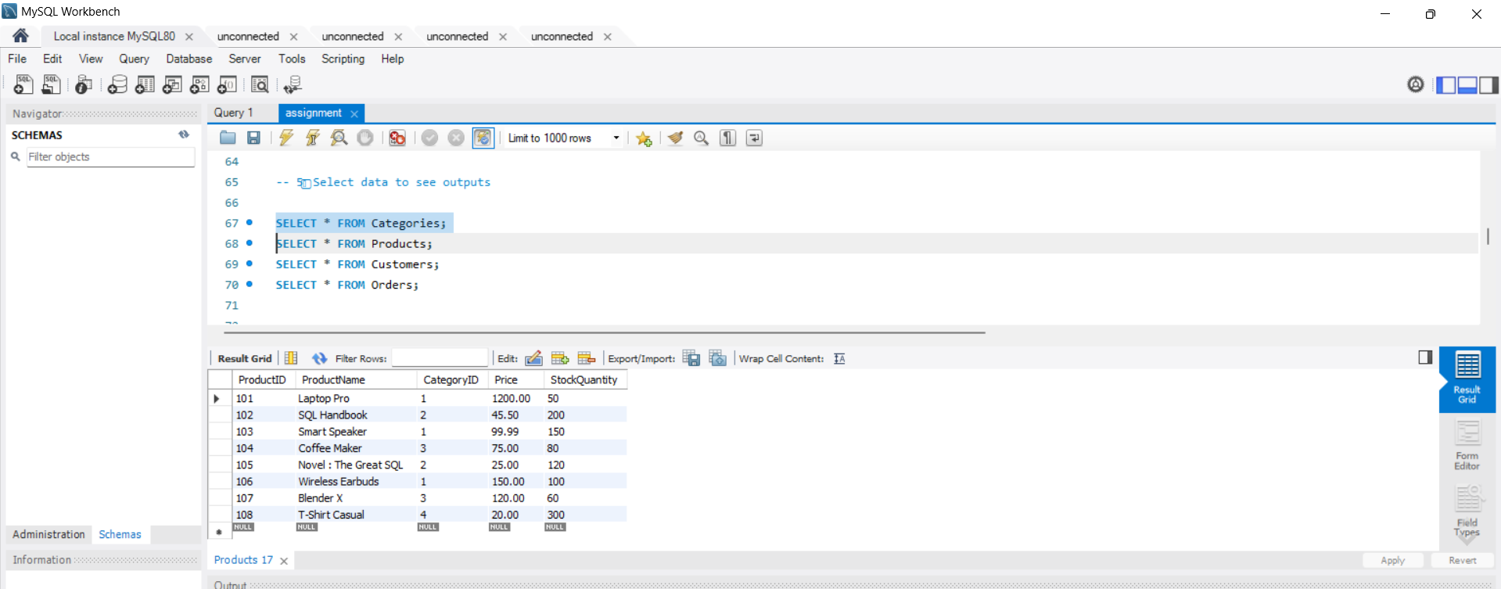

SELECT * FROM Products;

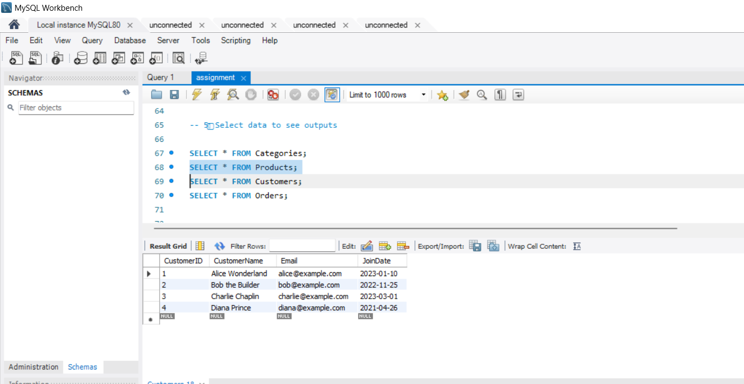

SELECT * FROM Customers;

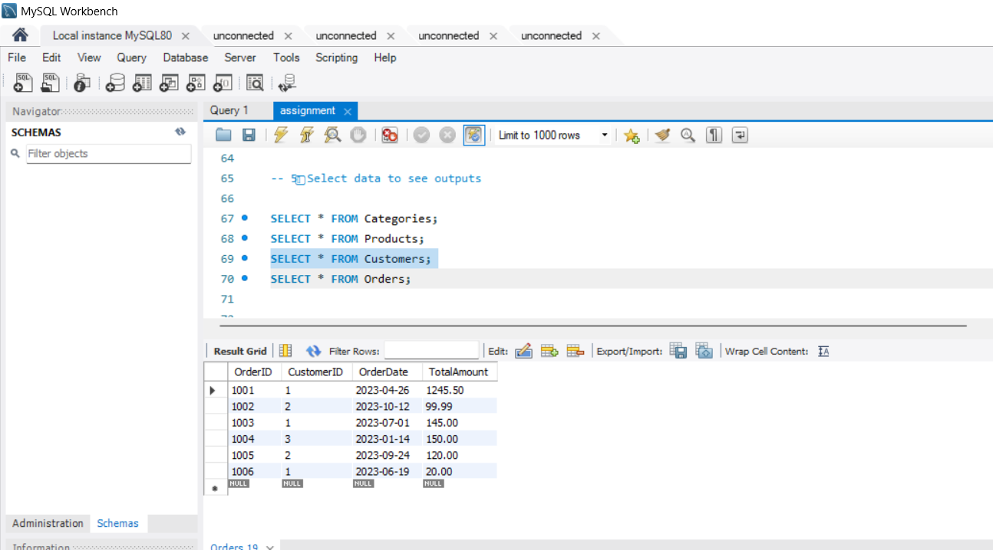

SELECT * FROM Orders;

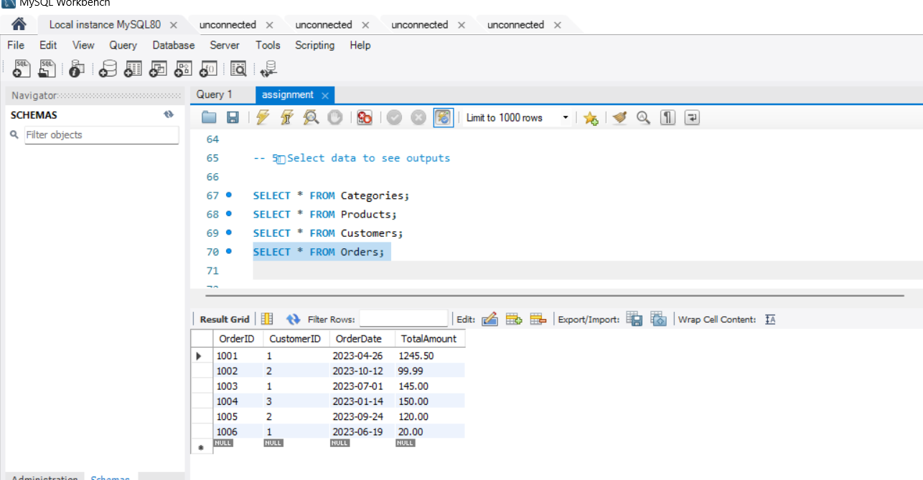

-- question 7

SELECT
c.CustomerName,
c.Email,
COUNT(o.OrderID) AS TotalNumberOfOrders
FROM Customers c
LEFT JOIN `Orders` o ON c.CustomerID = o.CustomerID
GROUP BY c.CustomerID, c.CustomerName, c.Email
ORDER BY c.CustomerName;

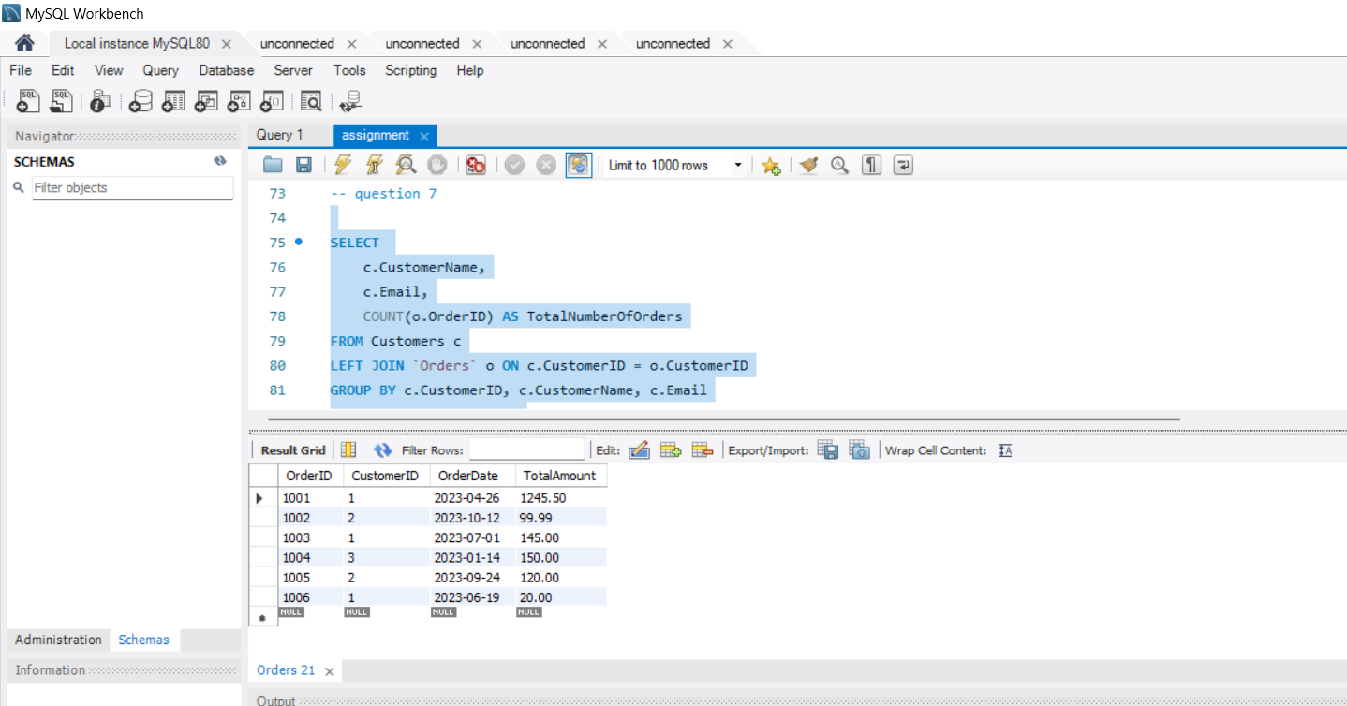
-- question 8

SELECT
p.ProductName,
p.Price,
p.StockQuantity,
c.CategoryName
FROM Products p
INNER JOIN Categories c ON p.CategoryID = c.CategoryID
ORDER BY c.CategoryName, p.ProductName;

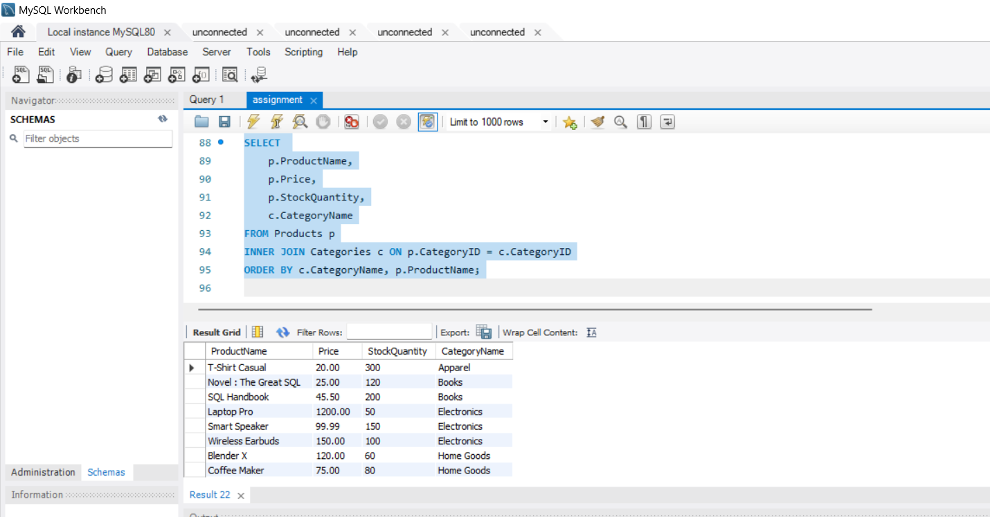

-- question 9

WITH RankedProducts AS (
SELECT
p.ProductName,
p.Price,
c.CategoryName,
ROW_NUMBER() OVER (
PARTITION BY c.CategoryID
ORDER BY p.Price DESC
) AS rn
FROM Products p
INNER JOIN Categories c ON p.CategoryID = c.CategoryID
)
SELECT
CategoryName,
ProductName,
Price
FROM RankedProducts
WHERE rn <= 2
ORDER BY CategoryName, Price DESC;

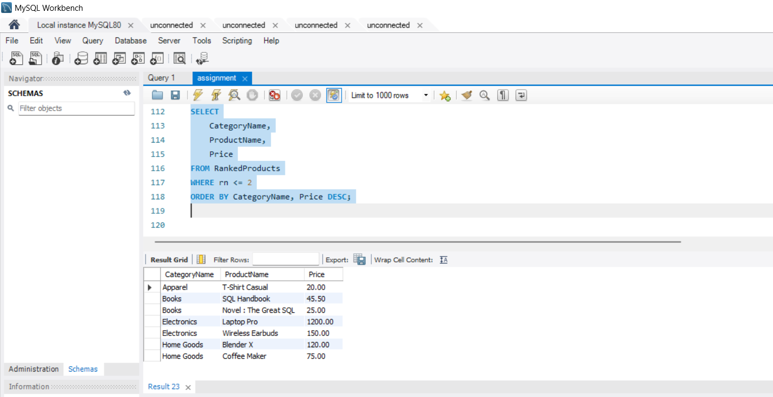

-- question 10

-- 1
SELECT
CONCAT(c.first_name, ' ', c.last_name) AS CustomerName,
c.email,
SUM(p.amount) AS TotalAmountSpent
FROM customer c
JOIN payment p ON c.customer_id = p.customer_id
GROUP BY c.customer_id, CustomerName, c.email
ORDER BY TotalAmountSpent DESC
LIMIT 5;

