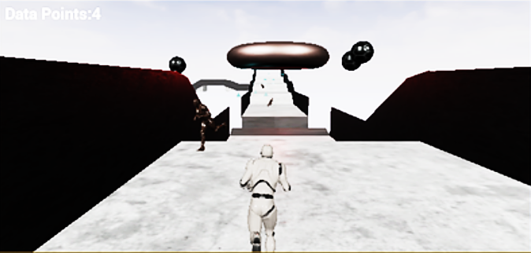

Play screen

Counter

Next pipes

Map