*Darwin Core Hour 1*  
**February 14th 2017, 2:52 pm EST**

**Please rate your level of agreement with the following statements about the webinar:**

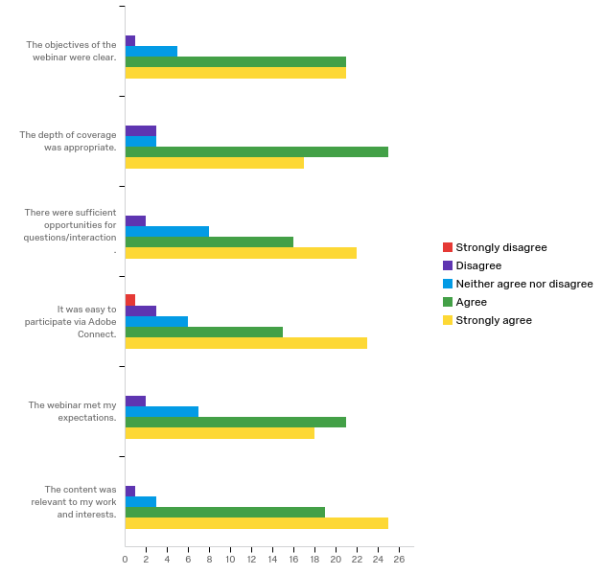

|  |  |  |  |  |  |  |  |  |  |  |  |
| --- | --- | --- | --- | --- | --- | --- | --- | --- | --- | --- | --- |
| Question | Strongly disagree |  | Disagree |  | Neither agree nor disagree |  | Agree |  | Strongly agree |  | Total |
| The objectives of the webinar were clear. | 0.00% | 0 | 2.08% | 1 | 10.42% | 5 | 43.75% | 21 | 43.75% | 21 | 48 |
| The depth of coverage was appropriate. | 0.00% | 0 | 6.25% | 3 | 6.25% | 3 | 52.08% | 25 | 35.42% | 17 | 48 |
| There were sufficient opportunities for questions/interaction. | 0.00% | 0 | 4.17% | 2 | 16.67% | 8 | 33.33% | 16 | 45.83% | 22 | 48 |
| It was easy to participate via Adobe Connect. | 2.08% | 1 | 6.25% | 3 | 12.50% | 6 | 31.25% | 15 | 47.92% | 23 | 48 |
| The webinar met my expectations. | 0.00% | 0 | 4.17% | 2 | 14.58% | 7 | 43.75% | 21 | 37.50% | 18 | 48 |
| The content was relevant to my work and interests. | 0.00% | 0 | 2.08% | 1 | 6.25% | 3 | 39.58% | 19 | 52.08% | 25 | 48 |

**The overall quality of the webinar was:**

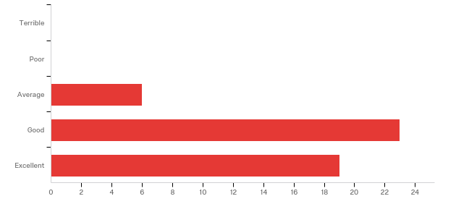

|  |  |  |
| --- | --- | --- |
| Answer | % | Count |
| Terrible | 0.00% | 0 |
| Poor | 0.00% | 0 |
| Average | 12.50% | 6 |
| Good | 47.92% | 23 |
| Excellent | 39.58% | 19 |
| Total | 100% | 48 |

**How does your current level of knowledge about the topic compare to that prior to the webinar?**

|  |  |  |  |  |  |  |  |  |
| --- | --- | --- | --- | --- | --- | --- | --- | --- |
| Field | Minimum | Maximum | Mean | Std Deviation | Variance | Count | Bottom 3 Box | Top 3 Box |
| How does your current level of knowledge about the topic compare to that prior to the webinar? | 2.00 | 4.00 | 2.77 | 0.59 | 0.34 | 48 | 91.67% | 100.00% |

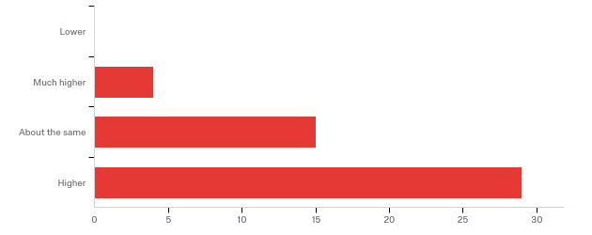

**Where did you learn about this webinar? Please check all that apply.**

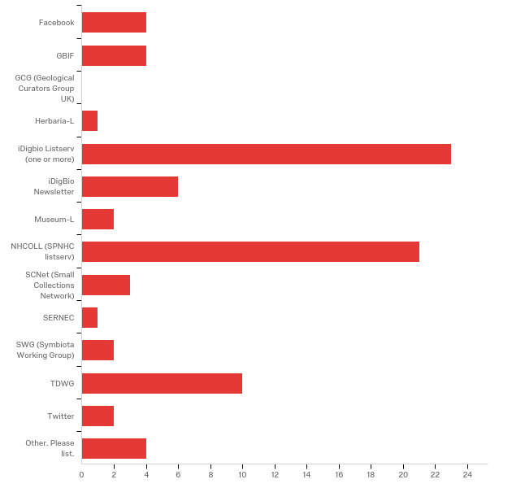

|  |  |  |
| --- | --- | --- |
| Answer | % | Count |
| Facebook | 8.33% | 4 |
| GBIF | 8.33% | 4 |
| GCG (Geological Curators Group UK) | 0.00% | 0 |
| Herbaria-L | 2.08% | 1 |
| iDigbio Listserv (one or more) | 47.92% | 23 |
| iDigBio Newsletter | 12.50% | 6 |
| Museum-L | 4.17% | 2 |
| NHCOLL (SPNHC listserv) | 43.75% | 21 |
| SCNet (Small Collections Network) | 6.25% | 3 |
| SERNEC | 2.08% | 1 |
| SWG (Symbiota Working Group) | 4.17% | 2 |
| TDWG | 20.83% | 10 |
| Twitter | 4.17% | 2 |
| Other. Please list. | 8.33% | 4 |
| Total | 100% | 48 |

Other. Please list.

|  |
| --- |
| Other. Please list. |
| Coworker |
| iDigBio Website |
| email for colleague |
| Smithsonian Colleague |

**Any other comments, questions, or suggestions for improvement?**

|  |
| --- |
| Bigger Webinar Capacity I wasn't able to watch live so it was great that it was recorded and posted |
| Would have preferred a little more detail and less history on DarwinCore. Perhaps a future webinar could start to address some of the ambiguous DarwinCore terms. |
| The webinar was very well done, and I appreciated all the links. I was hoping that the topics would include more about Darwin Core usage and additional examples, but it makes sense that this will be covered in later webinars. |
| the question/answer portion was confusing--some questioners were referred to the Darwin Core Hour input form, instead of being answered during the public hour. I wondered why that was happening and wasn't sure questions were welcome during the webinar or not after that. |
| Thanks for doing this!! (and please don't make it any earlier) |
| None |
| Two of us responding. |
| I had problems getting in since it seemed to be full. I just kept trying. The sound was a bit rough at times. This was very basic which might have been needed for most of the callers. But the examples need to go the next step and see each example actually IN darwin core. Some Darwin Core in action. |
| Bigger room please |
| It will be great to learn more about Darwin Core. Looking forward to the next one. |