*Darwin Core Hour 2*  
**March 20th 2017, 7:33 pm EDT**

**Please rate your level of agreement with the following statements about the webinar:**

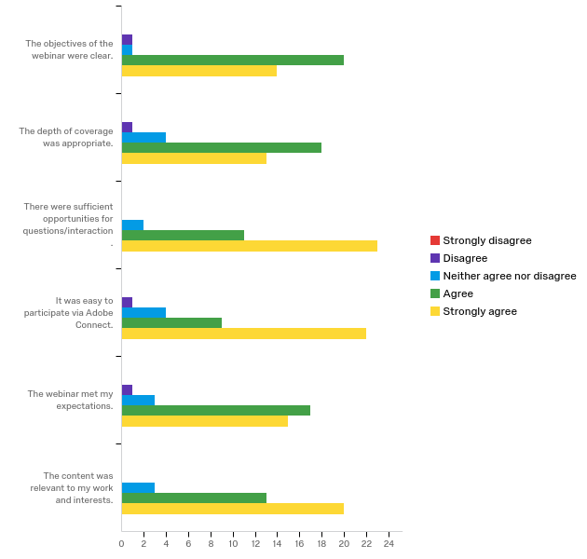

|  |  |  |  |  |  |  |  |  |  |  |  |
| --- | --- | --- | --- | --- | --- | --- | --- | --- | --- | --- | --- |
| Question | Strongly disagree |  | Disagree |  | Neither agree nor disagree |  | Agree |  | Strongly agree |  | Total |
| The objectives of the webinar were clear. | 0.00% | 0 | 2.78% | 1 | 2.78% | 1 | 55.56% | 20 | 38.89% | 14 | 36 |
| The depth of coverage was appropriate. | 0.00% | 0 | 2.78% | 1 | 11.11% | 4 | 50.00% | 18 | 36.11% | 13 | 36 |
| There were sufficient opportunities for questions/interaction. | 0.00% | 0 | 0.00% | 0 | 5.56% | 2 | 30.56% | 11 | 63.89% | 23 | 36 |
| It was easy to participate via Adobe Connect. | 0.00% | 0 | 2.78% | 1 | 11.11% | 4 | 25.00% | 9 | 61.11% | 22 | 36 |
| The webinar met my expectations. | 0.00% | 0 | 2.78% | 1 | 8.33% | 3 | 47.22% | 17 | 41.67% | 15 | 36 |
| The content was relevant to my work and interests. | 0.00% | 0 | 0.00% | 0 | 8.33% | 3 | 36.11% | 13 | 55.56% | 20 | 36 |

**How does your current level of knowledge about the topic compare to that prior to the webinar?**

|  |  |  |  |  |  |  |  |  |
| --- | --- | --- | --- | --- | --- | --- | --- | --- |
| Field | Minimum | Maximum | Mean | Std Deviation | Variance | Count | Bottom 3 Box | Top 3 Box |
| How does your current level of knowledge about the topic compare to that prior to the webinar? | 2.00 | 4.00 | 2.89 | 0.46 | 0.21 | 36 | 94.44% | 100.00% |

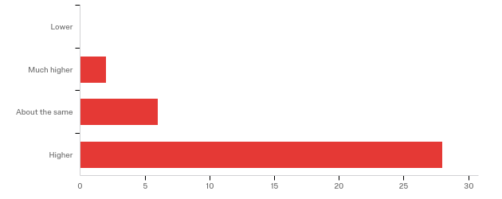

**The overall quality of the webinar was:**

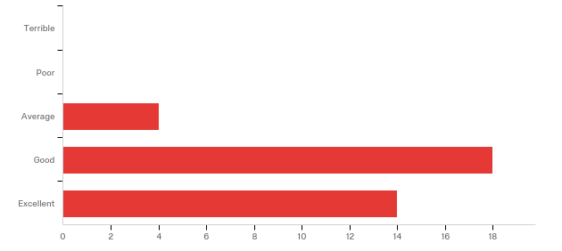

|  |  |  |
| --- | --- | --- |
| Answer | % | Count |
| Terrible | 0.00% | 0 |
| Poor | 0.00% | 0 |
| Average | 11.11% | 4 |
| Good | 50.00% | 18 |
| Excellent | 38.89% | 14 |
| Total | 100% | 36 |

**Where did you learn about this webinar? Please check all that apply.**

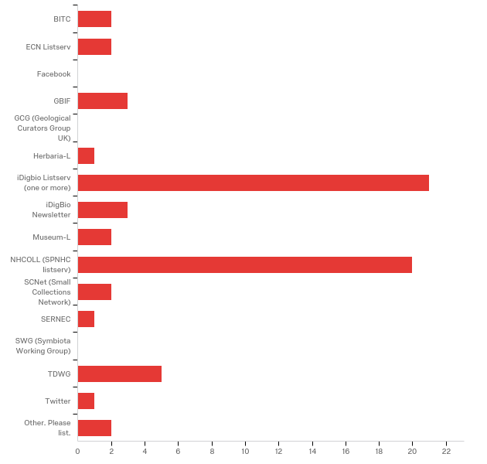

|  |  |  |
| --- | --- | --- |
| Answer | % | Count |
| BITC | 5.56% | 2 |
| ECN Listserv | 5.56% | 2 |
| Facebook | 0.00% | 0 |
| GBIF | 8.33% | 3 |
| GCG (Geological Curators Group UK) | 0.00% | 0 |
| Herbaria-L | 2.78% | 1 |
| iDigbio Listserv (one or more) | 58.33% | 21 |
| iDigBio Newsletter | 8.33% | 3 |
| Museum-L | 5.56% | 2 |
| NHCOLL (SPNHC listserv) | 55.56% | 20 |
| SCNet (Small Collections Network) | 5.56% | 2 |
| SERNEC | 2.78% | 1 |
| SWG (Symbiota Working Group) | 0.00% | 0 |
| TDWG | 13.89% | 5 |
| Twitter | 2.78% | 1 |
| Other. Please list. | 5.56% | 2 |
| Total | 100% | 36 |

Other. Please list.

|  |
| --- |
| Other. Please list. |
| colleague |
| I'm dwc hour staff. |

**Any other comments, questions, or suggestions for improvement?**

|  |
| --- |
| I was disappointed that the webinar was marketed as being about controlled vocabulary but felt I left with little guidance about how to work within the bounds of or outside of controlled vocabularies. For example, even when a controlled vocabulary is not required, it seems beneficial to point users to useful existing vocabularies already being submitted to databases, with some recommendations for things to avoid. Sharing links to vocabularies employed by high-level users seems better than a Wild West approach where anything goes until something is developed. I'd like to see more examples of what has been submitted (like the pie charts that were shared) but for each property. |
| As a person processing data for export into a DwC-A it was really helpful to see the type term and basisofrecord term broken out and explained in this way. Although our export seems pretty straight forward at first glance, as you see the different combinations possible between the two terms (an example chart was shown in the webinar) you can start to think of ways to better represent your data. |
| I'm not sure if it is feasible, but is there any way to improve the audio quality? Even with headphones in, The excessive bass and background buzz made the audio muddy. |
| We did have some sound issues (John - slightly muffled, Paula very soft). But, everyone - very engaged and asking very astute questions! |
| Was surprised that I needed to download an app this time, but it was OK (glad I started early). One thing that didn't work though was my headphone set (rather than through my internal speakers). I don't know yet if this were the app or my headphones have suddenly failed. Will have to test. Thanks for doing this!!! |