***Darwin Core Hour 3***

**How does your current level of knowledge about the topic compare to that prior to the webinar?**

**Please rate your level of agreement with the following statements about the webinar:**

**The overall quality of the webinar was:**

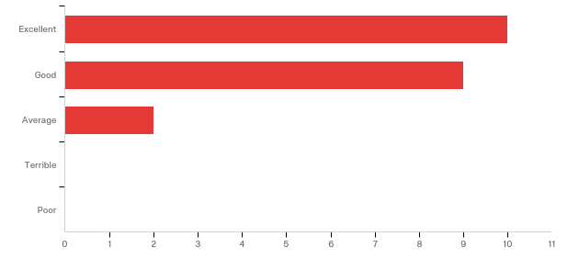

**Where did you learn about this webinar? Please check all that apply.**

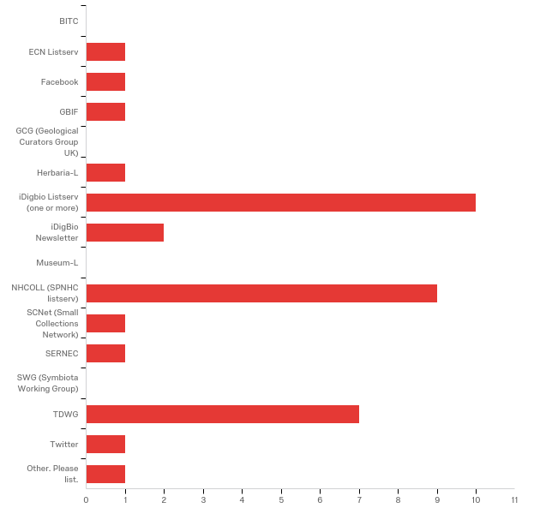

|  |
| --- |
| Other. Please list. |
| I am DMIG - Darwin Core Team member |

**Any other comments, questions, or suggestions for improvement?**

|  |
| --- |
| Paula, thank you so much for an excellent presentation on a great topic. Such fun - and so needed. Can't wait to start work with the discipline specific groups to make some head-way with data quality for these fields! |
| Change the name to Darwin Core 1.5 Hour or figure out how to end on time. |
| I've created a controlled vocabulary for taxonomic status terms based on actual usages in 4000 Pensoft articles. |
| I am not sure why, but this seminar didn't hold my interest; perhaps there were too many obvious details at the beginning. I wasn't sure of what we were supposed to glean from the information provided. |