*Darwin Core Hour 4*  
**May 5th 2017**

**Please rate your level of agreement with the following statements about the webinar:**

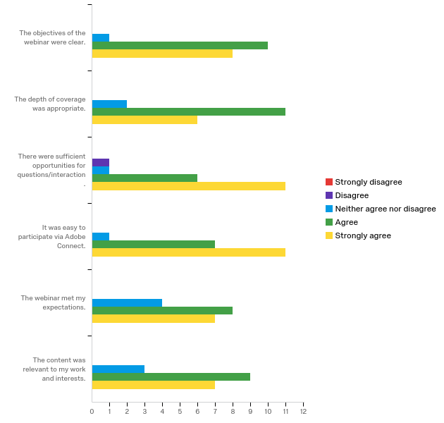

|  |  |  |  |  |  |  |  |  |  |  |  |
| --- | --- | --- | --- | --- | --- | --- | --- | --- | --- | --- | --- |
| Question | Strongly disagree |  | Disagree |  | Neither agree nor disagree |  | Agree |  | Strongly agree |  | Total |
| The objectives of the webinar were clear. | 0.00% | 0 | 0.00% | 0 | 5.26% | 1 | 52.63% | 10 | 42.11% | 8 | 19 |
| The depth of coverage was appropriate. | 0.00% | 0 | 0.00% | 0 | 10.53% | 2 | 57.89% | 11 | 31.58% | 6 | 19 |
| There were sufficient opportunities for questions/interaction. | 0.00% | 0 | 5.26% | 1 | 5.26% | 1 | 31.58% | 6 | 57.89% | 11 | 19 |
| It was easy to participate via Adobe Connect. | 0.00% | 0 | 0.00% | 0 | 5.26% | 1 | 36.84% | 7 | 57.89% | 11 | 19 |
| The webinar met my expectations. | 0.00% | 0 | 0.00% | 0 | 21.05% | 4 | 42.11% | 8 | 36.84% | 7 | 19 |
| The content was relevant to my work and interests. | 0.00% | 0 | 0.00% | 0 | 15.79% | 3 | 47.37% | 9 | 36.84% | 7 | 19 |

**How does your current level of knowledge about the topic compare to that prior to the webinar?**

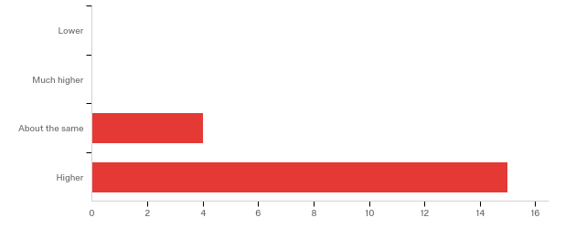

**The overall quality of the webinar was:**

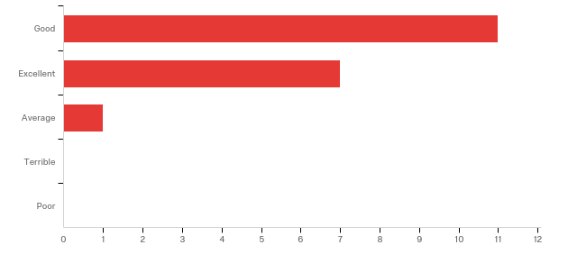

**Any other comments, questions, or suggestions for improvement?**

|  |
| --- |
| Most people had questions on the preparation which is a vast subject and so only few questions were asked about invasive species, which is also an important subject. I would suggest to have not such important topics on the same time .. so we can go more in depth on both subjects .. |
| Thanks Quentin and Andy, great webinar! |

**Where did you learn about this webinar? Please check all that apply.**

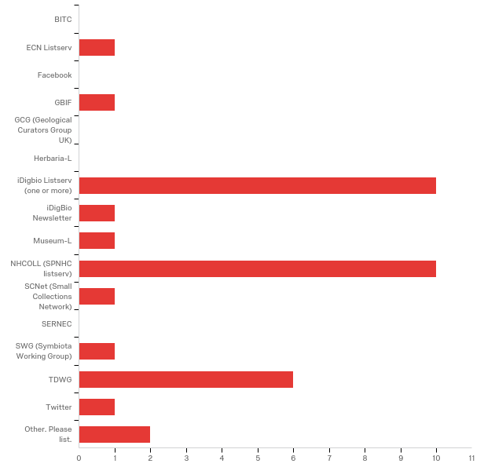

|  |  |  |
| --- | --- | --- |
| Answer | % | Count |
| BITC | 0.00% | 0 |
| ECN Listserv | 5.26% | 1 |
| Facebook | 0.00% | 0 |
| GBIF | 5.26% | 1 |
| GCG (Geological Curators Group UK) | 0.00% | 0 |
| Herbaria-L | 0.00% | 0 |
| iDigbio Listserv (one or more) | 52.63% | 10 |
| iDigBio Newsletter | 5.26% | 1 |
| Museum-L | 5.26% | 1 |
| NHCOLL (SPNHC listserv) | 52.63% | 10 |
| SCNet (Small Collections Network) | 5.26% | 1 |
| SERNEC | 0.00% | 0 |
| SWG (Symbiota Working Group) | 5.26% | 1 |
| TDWG | 31.58% | 6 |
| Twitter | 5.26% | 1 |
| Other. Please list. | 10.53% | 2 |
| Total | 100% | 19 |

|  |
| --- |
| Other. Please list. |
| I'm part of the DwC Hour team |
| ResearchGate |

**In what country do you currently live?**

|  |
| --- |
| USA = 15 |
| Belgium |
| Germany |
| Canada |