*Darwin Core Hour 5*  
**June 16th 2017, 1:12 pm EDT**

**How does your current level of knowledge about the topic compare to that prior to the webinar?**

|  |  |  |  |  |  |  |  |  |
| --- | --- | --- | --- | --- | --- | --- | --- | --- |
| Field | Minimum | Maximum | Mean | Std Deviation | Variance | Count | Bottom 3 Box | Top 3 Box |
| How does your current level of knowledge about the topic compare to that prior to the webinar? | 1.00 | 4.00 | 2.86 | 0.83 | 0.69 | 14 | 78.57% | 92.86% |

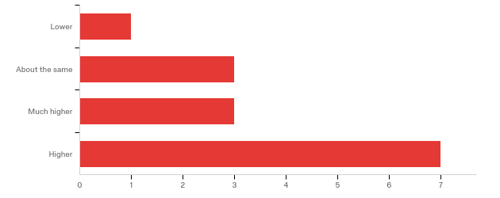

**Please rate your level of agreement with the following statements about the webinar:**

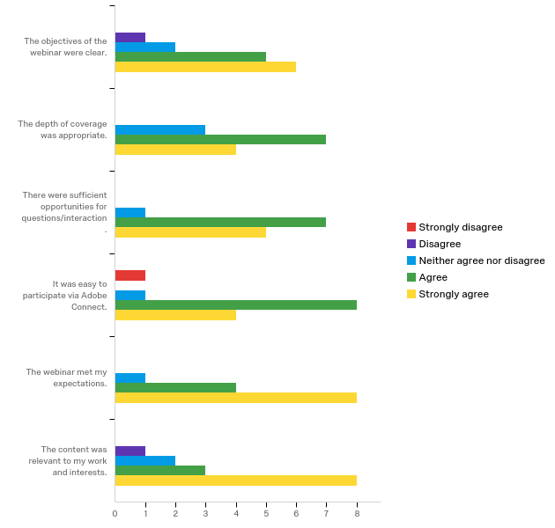

|  |  |  |  |  |  |  |  |  |  |  |
| --- | --- | --- | --- | --- | --- | --- | --- | --- | --- | --- |
| Question | Strongly disagree |  | Disagree |  | Neither agree nor disagree |  | Agree |  | Strongly agree |  |
| The objectives of the webinar were clear. | 0.00% | 0 | 50.00% | 1 | 20.00% | 2 | 14.71% | 5 | 17.14% | 6 |
| The depth of coverage was appropriate. | 0.00% | 0 | 0.00% | 0 | 30.00% | 3 | 20.59% | 7 | 11.43% | 4 |
| There were sufficient opportunities for questions/interaction. | 0.00% | 0 | 0.00% | 0 | 10.00% | 1 | 20.59% | 7 | 14.29% | 5 |
| It was easy to participate via Adobe Connect. | 100.00% | 1 | 0.00% | 0 | 10.00% | 1 | 23.53% | 8 | 11.43% | 4 |
| The webinar met my expectations. | 0.00% | 0 | 0.00% | 0 | 10.00% | 1 | 11.76% | 4 | 22.86% | 8 |
| The content was relevant to my work and interests. | 0.00% | 0 | 50.00% | 1 | 20.00% | 2 | 8.82% | 3 | 22.86% | 8 |
| Total | Total | 1 | Total | 2 | Total | 10 | Total | 34 | Total | 35 |

**The overall quality of the webinar was:**

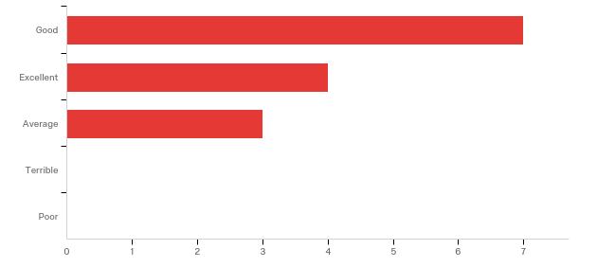

|  |  |  |
| --- | --- | --- |
| Answer | % | Count |
| Terrible | 0.00% | 0 |
| Poor | 0.00% | 0 |
| Average | 21.43% | 3 |
| Good | 50.00% | 7 |
| Excellent | 28.57% | 4 |
| Total | 100% | 14 |

|  |
| --- |
| **Do you have any comments, questions, or suggestions for improvement?** |
| none for now |
| Keep up giving these seminars. I'm not much of a participant, more of a lurker, but I appreciate them very much. Love that you call them 'happy hours'! |
| I would appreciate a future lesson on the process(es) for successfully 'removing' datasets from the GBIF data portal using the IPT. |
| The time at which the webinar was held was poorly chosen. Please consider that not all participants are on EST. The whole point of doing this over the web is so people from far away places and time zones can participate. |

**Where did you learn about this webinar? Please check all that apply.**

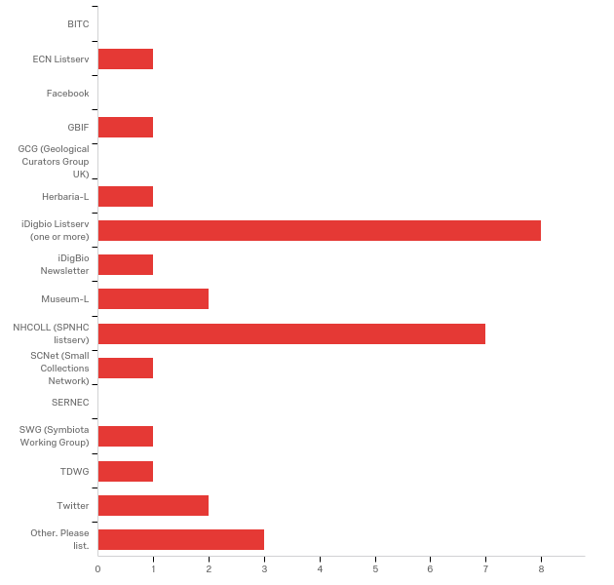

|  |  |  |
| --- | --- | --- |
| Answer | % | Count |
| BITC | 0.00% | 0 |
| ECN Listserv | 3.45% | 1 |
| Facebook | 0.00% | 0 |
| GBIF | 3.45% | 1 |
| GCG (Geological Curators Group UK) | 0.00% | 0 |
| Herbaria-L | 3.45% | 1 |
| iDigbio Listserv (one or more) | 27.59% | 8 |
| iDigBio Newsletter | 3.45% | 1 |
| Museum-L | 6.90% | 2 |
| NHCOLL (SPNHC listserv) | 24.14% | 7 |
| SCNet (Small Collections Network) | 3.45% | 1 |
| SERNEC | 0.00% | 0 |
| SWG (Symbiota Working Group) | 3.45% | 1 |
| TDWG | 3.45% | 1 |
| Twitter | 6.90% | 2 |
| Other. Please list. | 10.34% | 3 |
| Total | 100% | 14 |

Other. Please list.

|  |
| --- |
| Other. Please list. |
| Email referral |
| colleague forwarded |
| A colleague forwards the notices to me via email. |

**Which statement describes you?**

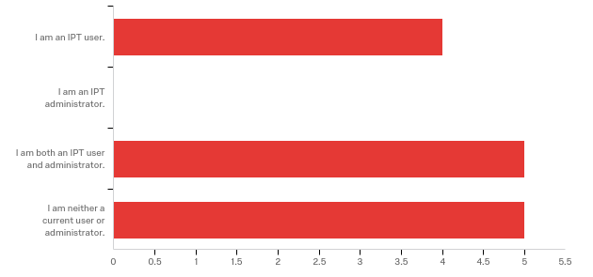

|  |  |  |
| --- | --- | --- |
| Answer | % | Count |
| I am an IPT user. | 28.57% | 4 |
| I am an IPT administrator. | 0.00% | 0 |
| I am both an IPT user and administrator. | 35.71% | 5 |
| I am neither a current user or administrator. | 35.71% | 5 |
| Total | 100% | 14 |

**How many active users are there on your IPT?**

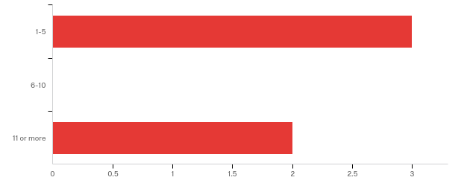

|  |  |  |
| --- | --- | --- |
| Answer | % | Count |
| 1-5 | 60.00% | 3 |
| 6-10 | 0.00% | 0 |
| 11 or more | 40.00% | 2 |
| Total | 100% | 5 |

**How likely are you to consider using a trusted data centre IPT instead of your own IPT instance?**

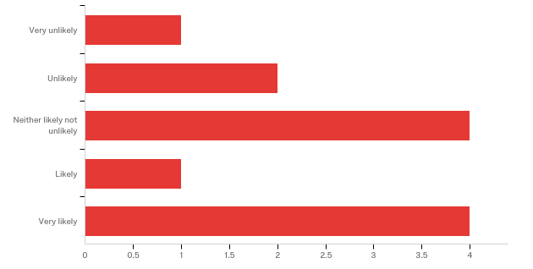

|  |  |  |
| --- | --- | --- |
| Answer | % | Count |
| Very unlikely | 8.33% | 1 |
| Unlikely | 16.67% | 2 |
| Neither likely not unlikely | 33.33% | 4 |
| Likely | 8.33% | 1 |
| Very likely | 33.33% | 4 |
| Total | 100% | 12 |

**What feature of the GBIF IPT interface do you enjoy using the most?**

|  |
| --- |
| I use this through Specify- like the data mapping aspects |
| The metadata section is quite nice to fill in |
| flexibility for user rights to control what goes into the public |
| The improvements to make it user friendly and allow multiple mapping. |
| N/A |
| Comprehensive listing/display of fields. |
| Metadata management and saved mapping |

**What feature of the GBIF IPT interface do you find most frustrating to use?**

|  |
| --- |
| Use though Specify- filtering is difficult |
| Main Page : maybe put the publish/register button below the private/public one (given that you have to put your resource in public mode before being able to publish/register it to GBIF), or add step numbers next to each button. Mapping page : the long list of DwC fields can be intimidating for new IPT users; unmapped fields can be hidden but maybe could we highlight the mandatory and recommended terms for each core/extension with a color code? |
| Non so far |
| When I take too long and it resets and loses what I've entered. |
| N/A |
| The logo graphic upload/display feature. I can't for the life of me get 'some' of the logos to display (instead of as a broken logo link) in the IPT interface - even when I use/upload the exact same logo graphic file; or duplicate the IPT logo URL in two different metadata records - one will display as expected, the other will display as a broken link. I've given up trying to fix them. |
| setting up the IPT |
| Data Mapping and how it moves to the top of the page after saving. |

**How helpful do you find the IPT how-to publish guide (https://github.com/gbif/ipt/wiki/howToPublish)?**

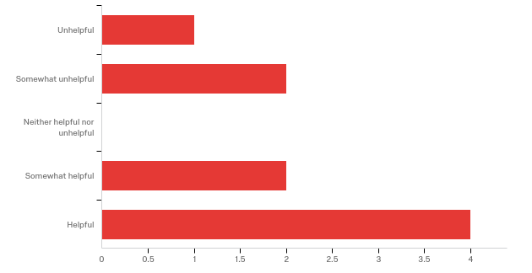

|  |  |  |
| --- | --- | --- |
| Answer | % | Count |
| Unhelpful | 11.11% | 1 |
| Somewhat unhelpful | 22.22% | 2 |
| Neither helpful nor unhelpful | 0.00% | 0 |
| Somewhat helpful | 22.22% | 2 |
| Helpful | 44.44% | 4 |
| Total | 100% | 9 |

**In what country do you currently live?**

|  |
| --- |
| USA |
| US |
| France |
| United States |
| Kenya |
| US |
| USA |
| USA |
| USA |
| USA |
| Canada |
| United States |
| USA |
| USA |