*Darwin Core Hour 6 Where am I, exactly?*  
**July 11, 2017**

**Please rate your level of agreement with the following statements about the webinar:**

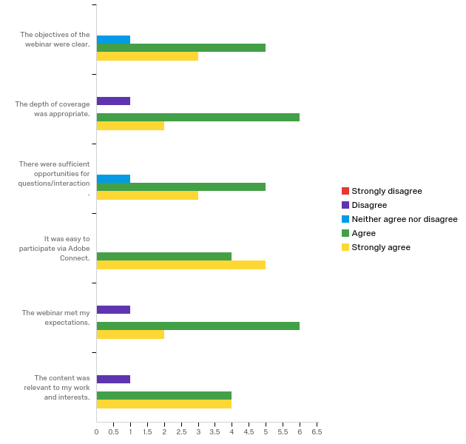

**The overall quality of the webinar was:**

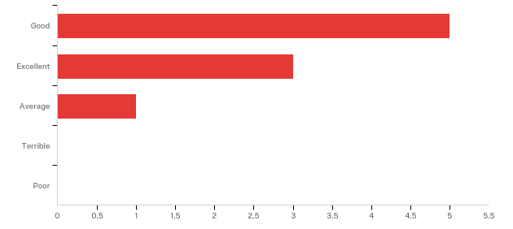

**How does your current level of knowledge about the topic compare to that prior to the webinar?**

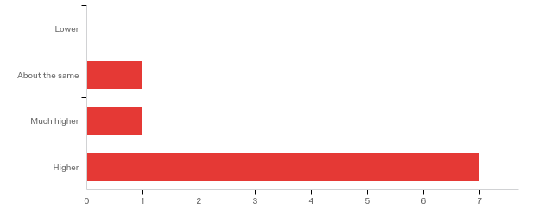

**Any other comments, questions, or suggestions for improvement?**

|  |
| --- |
| It would be great to have a couple questions or examples that maybe you could give for localities, and then participants could take them away and try to calculate the precision and uncertainty themselves and compare to the answers. |

**Where did you learn about this webinar? Please check all that apply.**

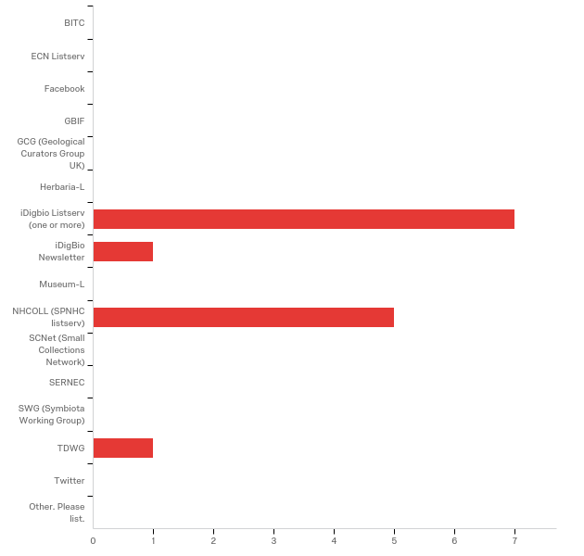

**In what country do you currently live?**

|  |
| --- |
| United States (n = 9) |