*Darwin Core Hour 7*  
**August 19th 2017, 1:25 pm EDT**

**How does your current level of knowledge about the aggregators compare to that prior to the webinar?**

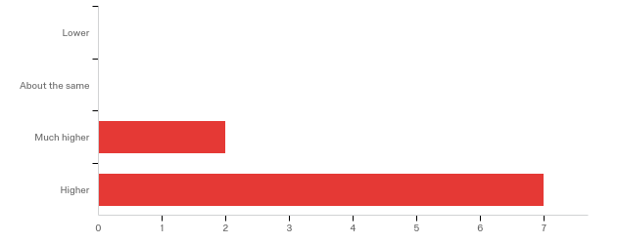

**Please rate your level of agreement with the following statements about the webinar:**

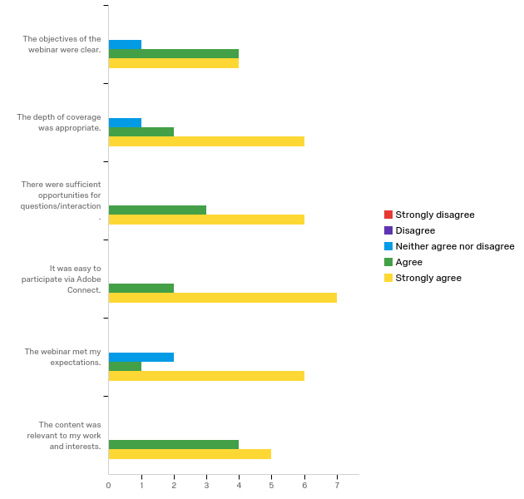

|  |  |  |  |  |  |  |  |  |  |  |
| --- | --- | --- | --- | --- | --- | --- | --- | --- | --- | --- |
| Question | Strongly disagree |  | Disagree |  | Neither agree nor disagree |  | Agree |  | Strongly agree |  |
| The objectives of the webinar were clear. | 0.00% | 0 | 0.00% | 0 | 25.00% | 1 | 25.00% | 4 | 11.76% | 4 |
| The depth of coverage was appropriate. | 0.00% | 0 | 0.00% | 0 | 25.00% | 1 | 12.50% | 2 | 17.65% | 6 |
| There were sufficient opportunities for questions/interaction. | 0.00% | 0 | 0.00% | 0 | 0.00% | 0 | 18.75% | 3 | 17.65% | 6 |
| It was easy to participate via Adobe Connect. | 0.00% | 0 | 0.00% | 0 | 0.00% | 0 | 12.50% | 2 | 20.59% | 7 |
| The webinar met my expectations. | 0.00% | 0 | 0.00% | 0 | 50.00% | 2 | 6.25% | 1 | 17.65% | 6 |
| The content was relevant to my work and interests. | 0.00% | 0 | 0.00% | 0 | 0.00% | 0 | 25.00% | 4 | 14.71% | 5 |
| Total | Total | 0 | Total | 0 | Total | 4 | Total | 16 | Total | 34 |

**The overall quality of the webinar was:**

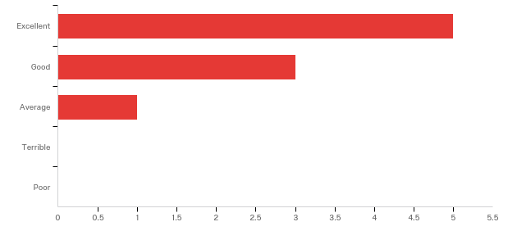

|  |  |  |
| --- | --- | --- |
| Answer | % | Count |
| Terrible | 0.00% | 0 |
| Poor | 0.00% | 0 |
| Average | 11.11% | 1 |
| Good | 33.33% | 3 |
| Excellent | 55.56% | 5 |
| Total | 100% | 9 |

**Any other comments, questions, or suggestions for improvement?**

|  |
| --- |
| It was great to see the fabulous literature citation aspect of the GBIF demo! This is very helpful for institutions that track use and outcomes of specimen collections and their data. |
| Great webinar! |

**Where did you learn about this webinar? Please check all that apply.**

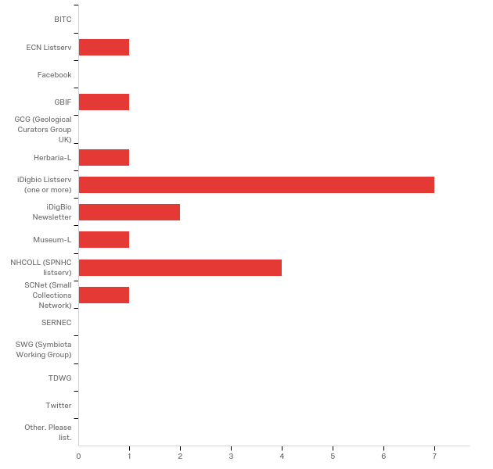

|  |  |  |
| --- | --- | --- |
| Answer | % | Count |
| BITC | 0.00% | 0 |
| ECN Listserv | 5.56% | 1 |
| Facebook | 0.00% | 0 |
| GBIF | 5.56% | 1 |
| GCG (Geological Curators Group UK) | 0.00% | 0 |
| Herbaria-L | 5.56% | 1 |
| iDigbio Listserv (one or more) | 38.89% | 7 |
| iDigBio Newsletter | 11.11% | 2 |
| Museum-L | 5.56% | 1 |
| NHCOLL (SPNHC listserv) | 22.22% | 4 |
| SCNet (Small Collections Network) | 5.56% | 1 |
| SERNEC | 0.00% | 0 |
| SWG (Symbiota Working Group) | 0.00% | 0 |
| TDWG | 0.00% | 0 |
| Twitter | 0.00% | 0 |
| Other. Please list. | 0.00% | 0 |
| Total | 100% | 18 |

**Do you have any questions about the aggregators that were not addressed in the webinar?**

|  |
| --- |
| Theme BIFs? Are these a thing? Is there a list of active ThemeBIFs somewhere? |

**Please share suggestions on how the aggregators could be improved or more relevant to your work.**

|  |
| --- |
| Data usage statistics for use with administrators, grant requests Improved tools to detect data quality issues |

**In what country do you currently live?**

|  |
| --- |
| United States |
| USA |
| Canada |
| US |
| USA |
| United States |
| United States of America |
| USA |
| Ireland |