*Vertnet Aggregator*  
**September 1st 2017, 6:20 am EDT**

**How does your current level of knowledge about VertNet compare to that prior to the webinar?**

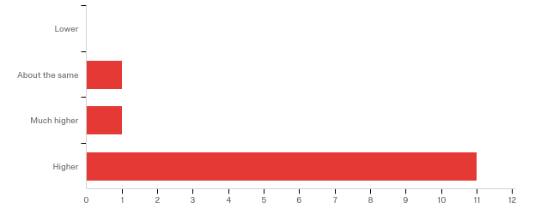

**Please rate your level of agreement with the following statements about the webinar:**

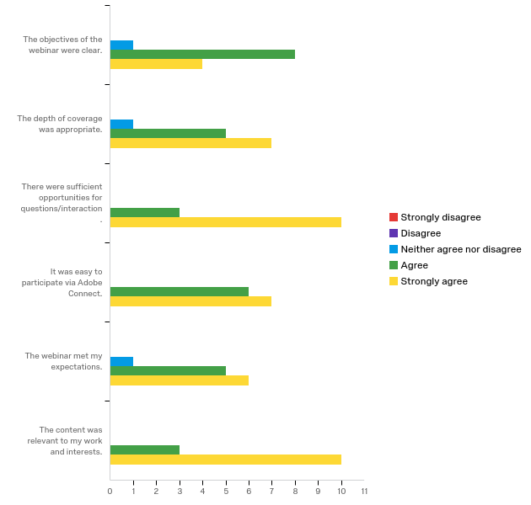

|  |  |  |  |  |  |  |  |  |  |  |
| --- | --- | --- | --- | --- | --- | --- | --- | --- | --- | --- |
| Question | Strongly disagree |  | Disagree |  | Neither agree nor disagree |  | Agree |  | Strongly agree |  |
| The objectives of the webinar were clear. | 0.00% | 0 | 0.00% | 0 | 33.33% | 1 | 26.67% | 8 | 9.09% | 4 |
| The depth of coverage was appropriate. | 0.00% | 0 | 0.00% | 0 | 33.33% | 1 | 16.67% | 5 | 15.91% | 7 |
| There were sufficient opportunities for questions/interaction. | 0.00% | 0 | 0.00% | 0 | 0.00% | 0 | 10.00% | 3 | 22.73% | 10 |
| It was easy to participate via Adobe Connect. | 0.00% | 0 | 0.00% | 0 | 0.00% | 0 | 20.00% | 6 | 15.91% | 7 |
| The webinar met my expectations. | 0.00% | 0 | 0.00% | 0 | 33.33% | 1 | 16.67% | 5 | 13.64% | 6 |
| The content was relevant to my work and interests. | 0.00% | 0 | 0.00% | 0 | 0.00% | 0 | 10.00% | 3 | 22.73% | 10 |
| Total | Total | 0 | Total | 0 | Total | 3 | Total | 30 | Total | 44 |

**The overall quality of the webinar was:**

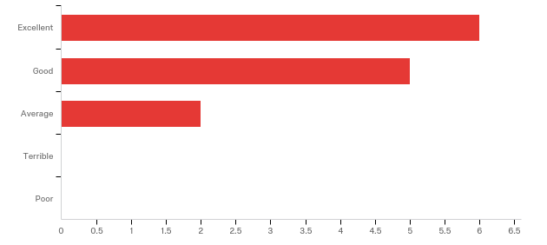

|  |  |  |
| --- | --- | --- |
| Answer | % | Count |
| Terrible | 0.00% | 0 |
| Poor | 0.00% | 0 |
| Average | 15.38% | 2 |
| Good | 38.46% | 5 |
| Excellent | 46.15% | 6 |
| Total | 100% | 13 |

**Where did you learn about this webinar? Please check all that apply.**

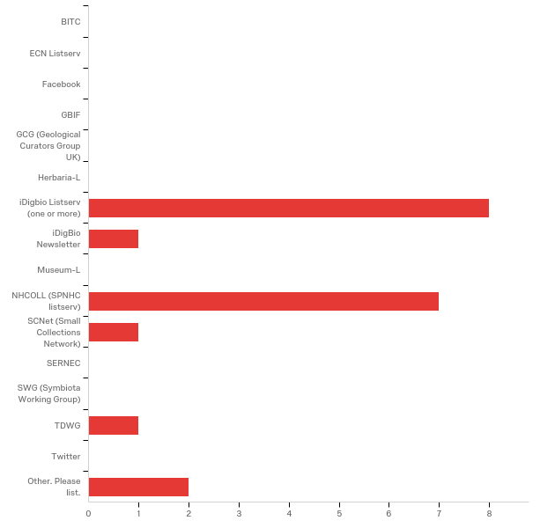

|  |  |  |  |
| --- | --- | --- | --- |
| 16 | iDigbio Listserv (one or more) | 40.00% | 8 |
| 8 | iDigBio Newsletter | 5.00% | 1 |
| 18 | NHCOLL (SPNHC listserv) | 35.00% | 7 |
| 19 | SCNet (Small Collections Network) | 5.00% | 1 |
| 22 | TDWG | 5.00% | 1 |
| 7 | Other. Please list. | 10.00% | 2 |
|  | Total | 100% | 20 |

|  |
| --- |
| google search got me to idigbio page with this series |
| idigBio FaceBook |

**Do you have any questions about VertNet's aggregator capabilities that were not addressed in the webinar?**

|  |
| --- |
| No |
| If there is a waiting list for data publishing in VertNet, there could probably be a larger dark waiting list - and anyway enabling users to engage in data publishing of their own data is likely to improve data quality because they are the ones to know what the data itself means. In my experience from a national GBIF Node making the data standardization and formatting into Darwin Core require active interaction with the data owner, and tools for the data owner to take more ownership of the data transformation process improves data quality. |
| no |

**Please share suggestions on how VertNet could be improved or more relevant to your work.**

|  |
| --- |
| VertNet, while meaningful that they possess 20+ years worth of impeccable expertise AND have the dedication and willingness to assist in improving the data from others institutions, is seemingly built on a service model that is very business like in its transactions. They've got a corner on the market and want people to come to them for their "expert" work and data curation. While this is good and admirable that this service is provided to the community, further opportunities for engagement, education, and especially empowerment will further expand the broad adoption and understanding of DwC as a standard and how its proper use can and should permeate the research ecosystem. |
| I had questions about the future of Vertnet answered and it would be good to continue to get updates on this issue into the future. |
| It would be helpful to have some transparency in VertNet task priorities, e.g. a ticketing system through GitHub. Obviously as it is a free, external service we institutions can't rationally expect the moon from VertNet, but it would be nice for us to know where we stand on the waiting list. I for one had no idea you all had SUCH a long wait list. |
| It seems they need help with their waiting list! |
| I would like to be able to put my collection metadata in ONE PLACE and have every aggregator pick it up from there (currently I have to create metadata for Arctos, VertNet, GrBio, and my website. |

**In what country do you currently live?**

|  |
| --- |
| United States |
| USA |
| Norway |
| United States |
| USA |
| USA |
| U.S.A. |
| USA |
| USA |
| United States |
| USA |
| USA |
| USA |

**Were you familiar with VertNet before this webinar?**

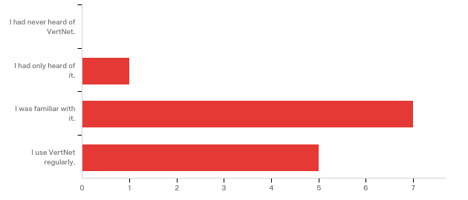

|  |  |  |
| --- | --- | --- |
| Answer | % | Count |
| I had never heard of VertNet. | 0.00% | 0 |
| I had only heard of it. | 7.69% | 1 |
| I was familiar with it. | 53.85% | 7 |
| I use VertNet regularly. | 38.46% | 5 |
| Total | 100% | 13 |

**Does your institution use services provided by VertNet (data cleaning, data publishing, etc.)?**

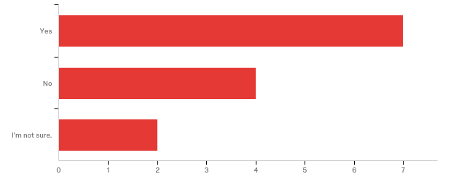

|  |  |  |
| --- | --- | --- |
| Answer | % | Count |
| Yes | 53.85% | 7 |
| No | 30.77% | 4 |
| I'm not sure. | 15.38% | 2 |
| Total | 100% | 13 |

**In which aggregator(s) does your institution share data?**

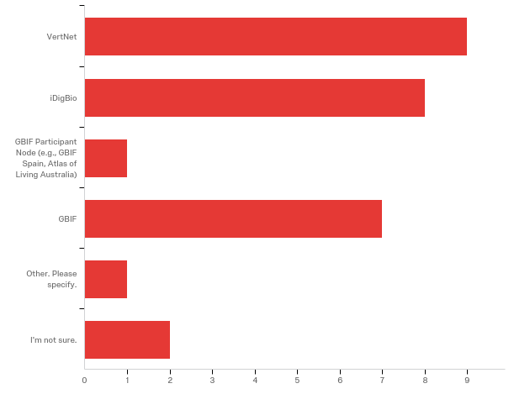

|  |  |  |
| --- | --- | --- |
| Answer | % | Count |
| VertNet | 32.14% | 9 |
| iDigBio | 28.57% | 8 |
| GBIF Participant Node (e.g., GBIF Spain, Atlas of Living Australia) | 3.57% | 1 |
| GBIF | 25.00% | 7 |
| Other. Please specify. | 3.57% | 1 |
| I'm not sure. | 7.14% | 2 |
| Total | 100% | 28 |

|  |
| --- |
| Other. Please specify. FishNet 2 |

**Any other comments, questions, or suggestions for improvement?**

|  |
| --- |
| John should use a headset, his voice was muddied and has a certain basso blare (making listening on a headset a little painful) - he should listen to himself on the recording if he is not convinced. |
| thanks |
| I said above that we use VertNet, but I think its more accurate to say we are in the queue and hope to be using VertNet soon. |
| Very helpful session - thank you very much! |