***Darwin Core Hour 8*  
September 5, 2017**

**Please rate your level of agreement with the following statements about the webinar:**

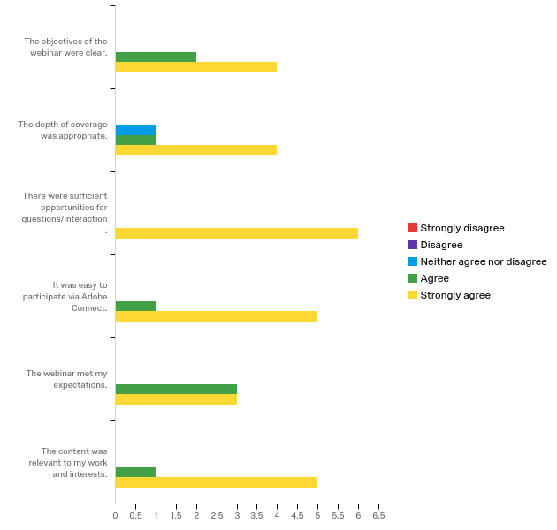

**The overall quality of the webinar was:**

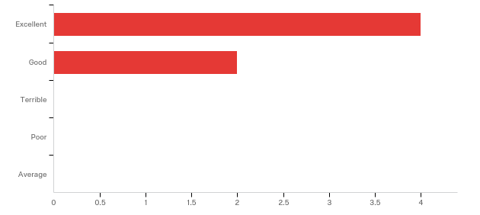

**How does your current level of knowledge about efforts to develop tests of data quality compare to that prior to the webinar?**

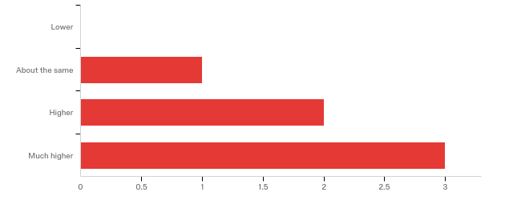

**Do you have any questions about core tests and assertions that were not addressed in the webinar?**

|  |
| --- |
| This was an excellent overview-level presentation. I'm sure I'll have more questions as I learn more and these tests become implemented, but for now this was perfect. |

**Please share suggestions you have on further work in the area of Darwin Core and data quality.**

|  |
| --- |
| Tools for standardized tests in as many environments as possible. |

**Any other comments, questions, or suggestions for improvement?**

|  |
| --- |
| I would have loved to see an example test, and the subsequent documentation of corrected data, in action. But this was a darn good start. Thanks. |

**In what country do you currently live?**

|  |
| --- |
| United States (n = 4) |
| Guam |

**Where did you learn about this webinar? Please check all that apply.**

