*Darwin Core Hour 9*  
**November 14th 2017, 11:55 am EST**

**How does your current level of knowledge about Kurator compare to that prior to the webinar?**

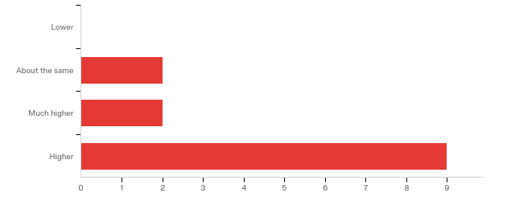

**Please rate your level of agreement with the following statements about the webinar:**

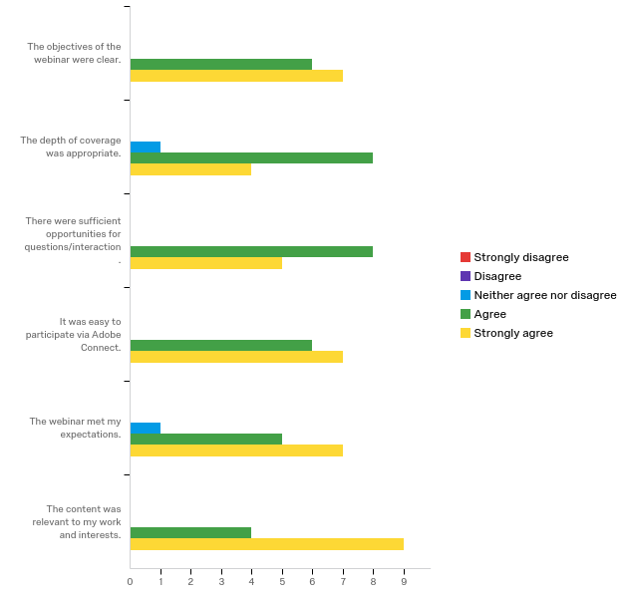

**The overall quality of the webinar was:**

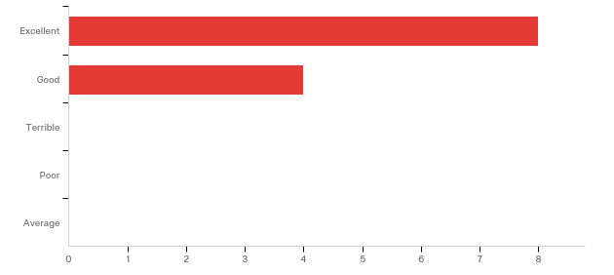

|  |  |  |  |
| --- | --- | --- | --- |
| # | Answer | % | Count |
| 25 | Terrible | 0.00% | 0 |
| 26 | Poor | 0.00% | 0 |
| 27 | Average | 0.00% | 0 |
| 28 | Good | 33.33% | 4 |
| 29 | Excellent | 66.67% | 8 |
|  | Total | 100% | 12 |

**Do you have any questions about Kurator that were not addressed in the webinar?**

|  |
| --- |
| It would be helpful to have some advice about how Kurator could be worked into a digitizing workflow. |
| How do we make suggestions for additional tools to be added to Kurator? |
| I got connected when the webinar was on its end |

**Please share suggestions you have regarding Kurator and/or data cleaning.**

|  |
| --- |
| For those of us with existing databases it would perhaps be most helpful to see a report of only the "errors" found rather than the full file. Much of our data may already be fairly clean. If we have 2 counties out of 2000 mis-spelled a report is a much more efficient way to communicate how our data needs to be improved, particularly for geography where it is easy to update the tree (at least in Specify). Looking through our entire database.csv to find where Kurator has made changes would be time consuming. Or a report on which terms do not match the community standard defined vocabulary for a particular field. We can easily find the affected records in our database if we know what to look for. I'll admit that I haven't used Kurator yet so if such a report exists then problem already solved. Related to this it would be very helpful to see a list of DwC terms for which there is a defined vocabulary and what the acceptable terms are (like in John's slide for basisOfRecord). We're happy to adopt these vocabularies if we can find out what they are. I haven't seen this in the TDWG presentation of Darwin Core but that would be a good place to put it. Or on the Kurator site. Related to the topic of getting data into and out of databases, many of us have had to depend on outside people to help us (like the georeference repatriation work Ornis did). Someone familiar with database back ends can do this sort of thing easily as John said. But how can a curator or collections manager find someone with that expertise that we can hire to do this for us? Is it worth $500-$1000 to have a professional put georeferences back in my database- absolutely. How about a registry of qualified database professionals that we could refer to? Perhaps not a Kurator idea but one for iDigBio? |
| It would be extremely useful to incorporate Kurator workflows into the data cleaning options in the symbiota and specify platforms. This would allow a streamlined process with less moving of data in and out. |
| Tools should be available for curators to create personal, multi-relational databases to use with cleaning datasets. |

**Any other comments, questions, or suggestions for improvement?**

|  |
| --- |
| I typically have a lot of problems with the audio during DwC Hour. I just close out and relaunch and that solves the problem (at least temporarily), but I do miss a little of the presentation each time this happens. |
| Presenter's (John) microphone was overmodulating and sounded distorted. Reducing microphone gain would improve the quality of the audio. This was only a slight critique, because I thought the presenter did an absolutely outstanding job communicating. |
| about meta data |

**Where did you learn about this webinar? Please check all that apply.**

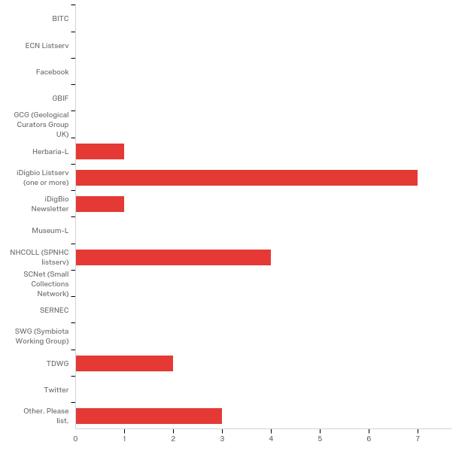

|  |
| --- |
| Other. Please list. - Text |
| Email |
| Coordinator of African Biodiversity Challenge |
| From the Coordinator of African Biodiversity Challenge project |

**In what country do you currently live?**

|  |
| --- |
| United States |
| Canada |
| Canada |
| United States of America |
| Israel |
| United States of America |
| USA |
| Rwanda |
| USA |
| Belgium |
| USA |
| United States |
| Rwanda |