*Darwin Core Hour 10 – Audubon Core and 3D Biodiversity Data*  
**November 22nd 2017, 8:44 am EST**

**Please rate your level of agreement with the following statements about the webinar:**

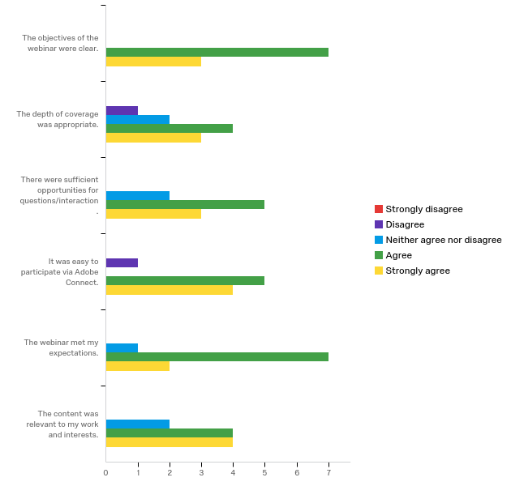

**How does your current awareness of issues related to Audubon Core and 3D data compare to that prior to the webinar?**

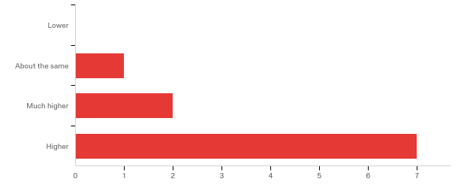

**The overall quality of the webinar was:**

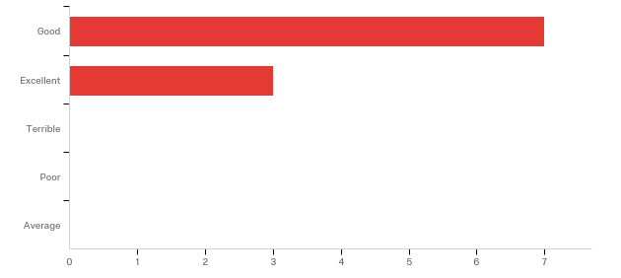

**Do you have any questions about Audubon Core and 3D data that were not addressed in the webinar?**

|  |
| --- |
| Thank you for the links on your current list of terms/vocabulary that are being standardized. It's seemed a little small, but I'm guessing that's because it's in the development phase. I'm curious about adding info about resolution, point cloud density, or standardizing this? |

**Please share suggestions you have regarding Audubon Core and 3D data.**

|  |
| --- |
| See above, and would love to be kept in the loop or included in the conversation! -Lvietti@uwyo.edu I'm currently starting to investigate adding our digitized files to database (specify), and am thinking about the best way to include the metadata (and make sure it's standardized), so it can easily be incorporated into data-aggregators... |

**Any other comments, questions, or suggestions for improvement?**

|  |
| --- |
| For collections managers, the formation of a top key 3d meta data fields to include/record would be awesome (and I'm sure what your working towards too. ). thank you all! |

**Where did you learn about this webinar? Please check all that apply.**

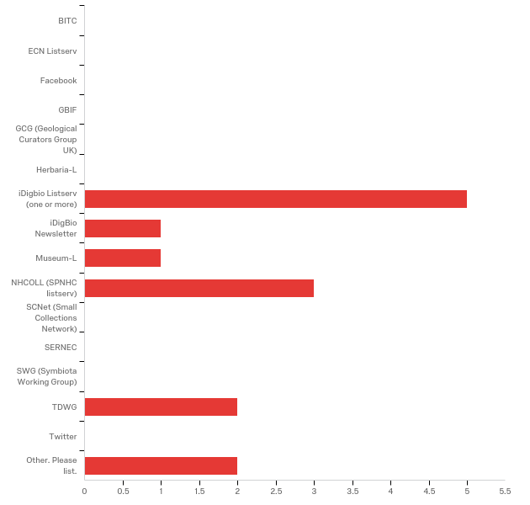

Other. Please list.

|  |
| --- |
| Colleague |
| email from colleague who got it via iDigBio |

**In what country do you currently live?**

|  |
| --- |
| United States |
| USA |
| USA |
| USA |
| USA |
| Canada |
| USA |
| United States |