***Darwin Core Hour 2018 April***

**How does your current awareness of issues of chronology and Darwin Core now compare to that prior to the webinar?**

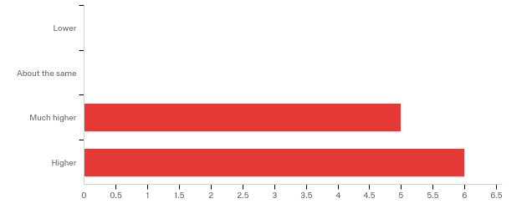

**The overall quality of the webinar was:**

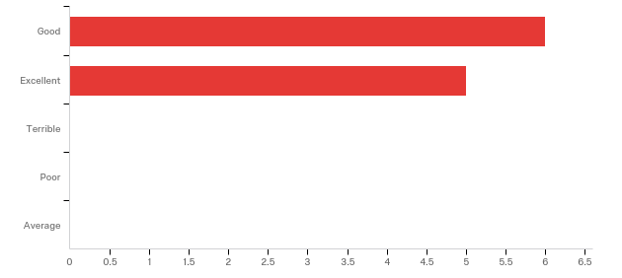

**Please rate your level of agreement with the following statements about the webinar:**

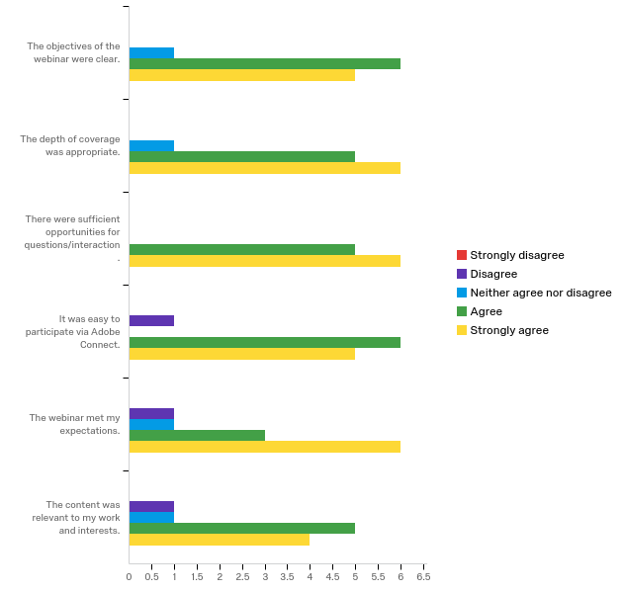

**Any other comments, questions, or suggestions for improvement?**

|  |
| --- |
| I was a bit surprised by the narrow objectives of the discussion vs the title given, particularly since much more extensive efforts have already been made by other groups (Chronos project; EFG; PBDB &lt;somewhat&gt;; GBDB; our own NSB/Neptune). But this surprise reflects possibly my own limited awareness of the interests and goals of the people active in Darwin Core development. Good to have a chance to communicate between communities of workers. |
| I thought it was helpful that the leaders gave instructions to people about adding their institutions and wish more of the participants had done so. I still have no clue who Rob or Old Fossil are, which is especially sad because Rob was offering help to the group. |
| I wish this one could have been longer! This also means I should probably be more involved in TDWG/iDigBio than at present! |

**Now that you have participated in this webinar, do you feel that an extension to Darwin Core describing the chronology of specimens is necessary?**

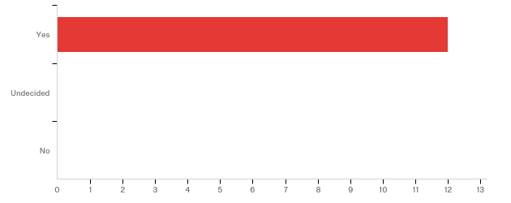

**Do you have any specific questions, comments, or constructive criticism on what was shared about the proposed chronometric extension?**

|  |
| --- |
| A useful first step in dealing with the issue of geologic age metadata for fossils, but there is much more to do, and several other sources of ideas not really explored in the discussion. The issue is embedded in a much broader one (geochronology) and should be more closely linked to data standards work in this area. |
| I would second the recommendation from multiple webinar participants that verbatim fields be named as such and be distinct from controlled vocabulary/interpreted fields. |
| The problem I know we would have is that our inherent CMS does not have a field for this information, so it might be recorded in a field with other information, making it difficult (not impossible) to map. Searching across different units on reportedAge is also something I'm wondering about? |
| I think it would be helpful to do more of a crosswalk to Neotoma's concepts of time and controlled vocabularies. Ed Davis is a good point of contact. Also glad to help. (Jack Williams) |
| I agree we need to place this information in a defined place and aide in searchability. |

**How likely is it that you or a colleague you know would use this extension in work as a collection manager or researcher?**

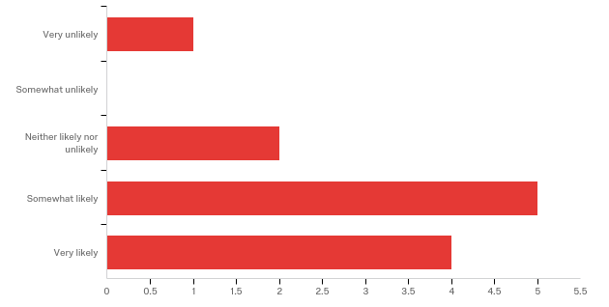

|  |  |  |
| --- | --- | --- |
| Answer | % | Count |
| Very unlikely | 8.33% | 1 |
| Somewhat unlikely | 0.00% | 0 |
| Neither likely nor unlikely | 16.67% | 2 |
| Somewhat likely | 41.67% | 5 |
| Very likely | 33.33% | 4 |
| Total | 100% | 12 |

**If you would like to explain why you personally would or would not use the extension, please do so below.**

|  |
| --- |
| Our specific needs derive from quantitative age estimates in geologic sections and with the broad range of methods and data that are used to make such estimates. We have our own data management solutions to at least some of these and work on extending them. At the moment I do not see that the structures presented in the discussion are of much use to our work. For us geochronologic age is very interdisciplinary, and a solution that is restricted to tagging ages for fossil specimens is much too narrow in scope. |
| We already have chronometric dates saved in our database, but just in freeform text in a remarks field. |
| Right now we don't have collections data for these fields, but I could see it being a possibility in the future. |
| Right now the data fields and metadata seem a bit sparse, but all heading in the right direction. |
| This does not directly relate to my work at this time. |

**We welcome any other thoughts or suggestions about further work in the area of Darwin Core and chronology.**

|  |
| --- |
| The topic needs to be further developed and I would be happy to continue discussing it - Dave Lazarus |
| Keep it up - looking forward to seeing what gets developed here! |

**Would you be willing to participate as a user case study? This would involve filling out the chronomertic extension terms using specimen data from your own work of collection. If yes, please provide your name and email below or contact Laura Brenskelle at lbrensk@ufl.edu (if you would like your survey responses to remain anonymous).**

Name

No responses here

**Where did you learn about this webinar? Please check all that apply.**

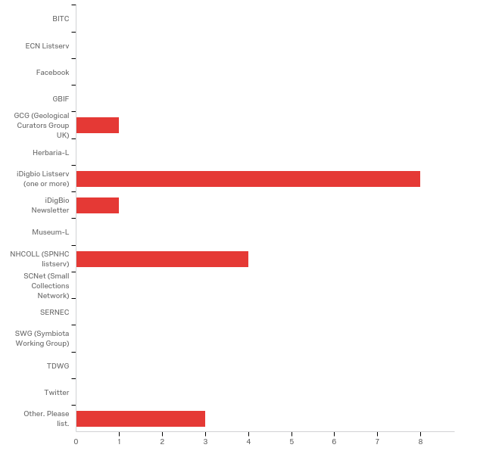

|  |
| --- |
| Other. Please list. |
| email from Denne Reed |
| Supervisor |
| From Laura. |

**In what country do you currently live?**

|  |
| --- |
| In what country do you currently live? |
| Germany |
| United States n = 10 |
| Canada |